IIIPPPEEEDDDSSS DDDAAATTTAAA FFFEEEEEEDDDBBBAAACCCKKK RRREEEPPPOOORRRTTT 222000222444

What Is IPEDS?

The Integrated Postsecondary Education Data System (IPEDS) is a system of survey components that collects data from all institutions that provide postsecondary education and are eligible to receive Title IV funding across the United States and other
U.S. jurisdictions.
These data are used at the federal and state level for policy analysis and development; at the institutional level for benchmarking and peer analysis; and by students and parents, through the College Navigator (https://nces.ed.gov/collegenavigator/), an online tool to aid in the college search process. Additional information about IPEDS can be found on the website at https://nces.ed.gov/ipeds.

What Is the Purpose of This Report?

The Data Feedback Report is intended to provide institutions a context for examining the data they submitted to IPEDS. The purpose of this report is to provide institutional executives a useful resource and to help improve the quality and comparability of IPEDS data.

What Is in This Report?

The figures in this report provide a selection of indicators for your institution to compare with a group of similar institutions. The figures draw from the data collected during the 2023-24 IPEDS collection cycle and are the most recent data available. The inside cover of this report lists your selected comparison group of institutions and the criteria used for their selection. The Methodological Notes at the end of the report describe additional information about these indicators and the pre-selected comparison group.

Where Can I Do More with IPEDS Data?

Each institution can access previously released Data Feedback Reports from 2005 and customize this 2024 report by using a different comparison group and IPEDS variables of its choosing. To learn how to customize the 2024 report, visit this resource page https://nces.ed.gov/Ipeds/Help/View/2. To download archived reports or customize the current Data Feedback Report, visit the `Use the Data’ portal on the IPEDS website https://nces.ed.gov/ipeds and click on Data Feedback Report.




Stony Brook University Stony Brook, NY

Stony Brook University

COMPARISON GROUP
Comparison group data are included to provide a context for interpreting your institution’s indicators. If your institution did not define a custom comparison group for this report by July 15, 2023 NCES selected a comparison group for you. (In this case, the characteristics used to define the comparison group appears below.) The customized Data Feedback Report function available at https://nces.ed.gov/ipeds/use-the-data/ can be used to reproduce the figures in this report using different peer groups.
The custom comparison group chosen by Stony Brook University includes the following 37 institutions:

Arizona State University Campus Immersion (Tempe, AZ)
Georgia Institute of Technology-Main Campus (Atlanta, GA)
Indiana University-Bloomington (Bloomington, IN)
Michigan State University (East Lansing, MI)
Ohio State University-Main Campus (Columbus, OH)
Pennsylvania State University-Main Campus (University Park, PA)
Purdue University-Main Campus (West Lafayette, IN)
Rutgers University-New Brunswick (New Brunswick, NJ)
Texas A & M University-College Station (College Station, TX)
The University of Texas at Austin (Austin, TX)
University at Buffalo (Buffalo, NY)
University of Arizona (Tucson, AZ)
University of California-Berkeley (Berkeley, CA)
University of California-Davis (Davis, CA)
University of California-Irvine (Irvine, CA)
University of California-Los Angeles (Los Angeles, CA)
University of California-Riverside (Riverside, CA)
University of California-San Diego (La Jolla, CA)
University of California-Santa Barbara (Santa Barbara, CA)
University of California-Santa Cruz (Santa Cruz, CA)
University of Colorado Boulder (Boulder, CO)
University of Florida (Gainesville, FL)
University of Illinois Urbana-Champaign (Champaign, IL)
University of Iowa (Iowa City, IA)
University of Kansas (Lawrence, KS)
University of Maryland-College Park (College Park, MD)
University of Michigan-Ann Arbor (Ann Arbor, MI)
University of Minnesota-Twin Cities (Minneapolis, MN)
University of Missouri-Columbia (Columbia, MO)
University of North Carolina at Chapel Hill (Chapel Hill, NC)
University of Oregon (Eugene, OR)
University of Pittsburgh-Pittsburgh Campus (Pittsburgh, PA)
University of South Florida (Tampa, FL)
University of Utah (Salt Lake City, UT)
University of Virginia-Main Campus (Charlottesville, VA)
University of Washington-Seattle Campus (Seattle, WA)
University of Wisconsin-Madison (Madison, WI)

The figures in this report have been organized and ordered into the following topic areas:

Topic Area | Figures | Pages
1) Admissions (only for non-open-admissions schools) | 1 and 2 | 3
2) Student Enrollment | 3, 4, 5 and 6 | 3 and 4
3) Awards | 7 | 4
4) Charges and Net Price | 8 and 9 | 5
5) Student Financial Aid | 10, 11, 12, 13, 14 and 15 | 5 and 6
6) Military Benefits* | [Not applicable]
7) Retention and Graduation Rates | 16, 17, 18, 19, 20, 21, 22, 23 and 24 | 7, 8, 9 and 10
8) Finance | 25 and 26 | 11
9) Staff | 27 and 28 | 11 and 12
10) Libraries* | 29 and 30 | 12
*These figures only appear in customized Data Feedback Reports (DFRs), which are available through Use the Data portal on the IPEDS website.

IPEDS DATA FEEDBACK REPORT
2

Figure 1. Number of first-time undergraduate students who applied, were admitted, and enrolled full-time and part-time: Fall 2023
Figure 2. Percent of first-time undergraduate applicants admitted, and percent of admitted students enrolled full-time and part-time: Fall 2023

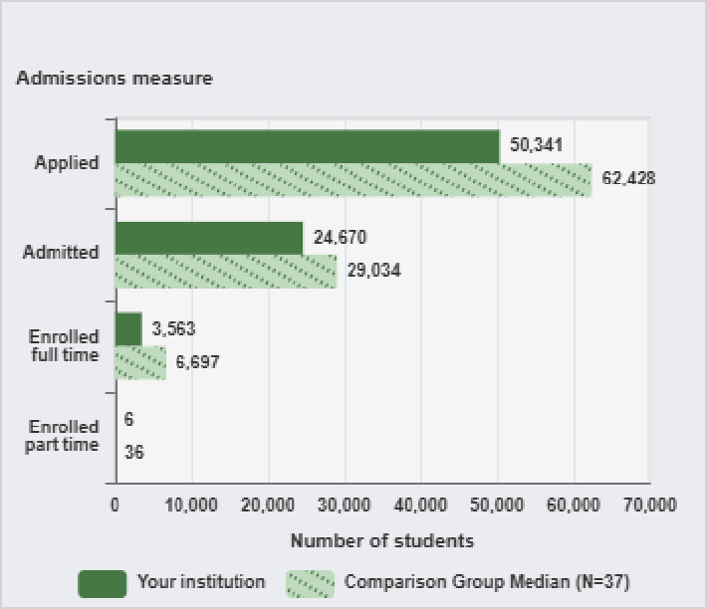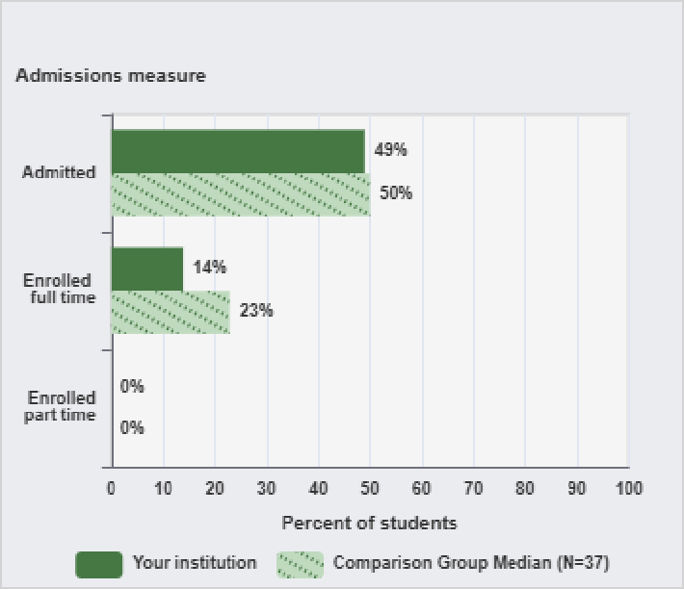

NOTE: Admissions data are presented only for institutions that do not have an open admission policy, and apply to first-time, degree/certificate-seeking undergraduate students only. For details, see the Methodological Notes. N is the number of institutions in the comparison group.
SOURCE: U.S. Department of Education, National Center for Education Statistics, Integrated Postsecondary Education Data System (IPEDS): Winter 2023-24, Admissions survey component.
NOTE: Admissions data are presented only for institutions that do not have an open admission policy, and apply to first-time, degree/certificate-seeking undergraduate students only. For details, see the Methodological Notes. See 'Use of Median Values for Comparison Group' for how median values are determined. N is the number of institutions in the comparison group.
SOURCE: U.S. Department of Education, National Center for Education Statistics, Integrated Postsecondary Education Data System (IPEDS): Winter 2023-24, Admissions survey component.

Figure 3. Percent of all students enrolled, by race/ethnicity, and percent of students who are women: Fall 2023
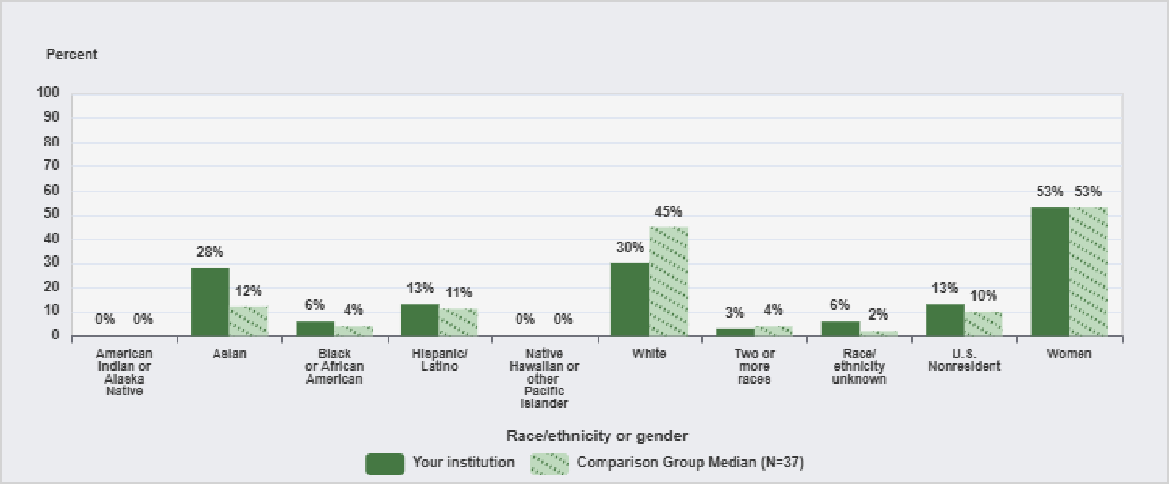
NOTE: For more information about disaggregation of data by race and ethnicity, see the Methodological Notes. Median values for the comparison group will not add to 100%. See 'Use of Median Values for Comparison Group' for how median values are determined. N is the number of institutions in the comparison group.
SOURCE: U.S. Department of Education, National Center for Education Statistics, Integrated Postsecondary Education Data System (IPEDS): Spring 2024, Fall Enrollment survey component.

IPEDS DATA FEEDBACK REPORT

Figure 4. Total 12-month enrollment, full-time and part-time 12-month enrollment, 12-month FTE enrollment (2022-23), and total fall enrollment, full-time and part-time fall enrollment (Fall 2023)
Figure 5. Total 12-month undergraduate enrollment, by attendance and degree/certificate-seeking status: 2022-23

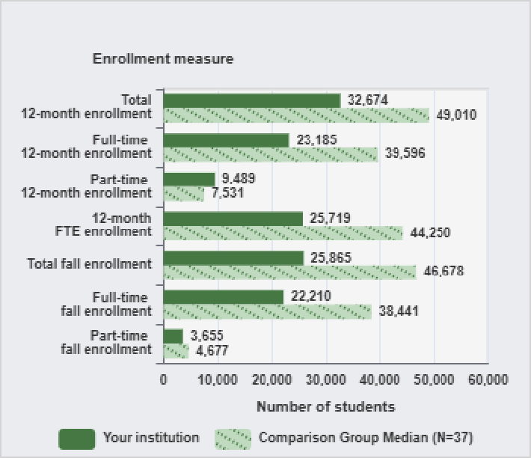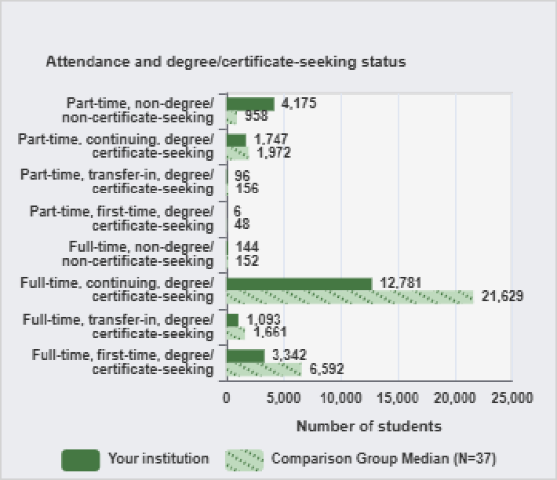

NOTE: For details on calculating full-time equivalent (FTE) enrollment, see Calculating FTE in the Methodological Notes. Total headcount, FTE, and full- and part-time fall enrollment include both undergraduate and postbaccalaureate students, when applicable. N is the number of institutions in the comparison group.
SOURCE: U.S. Department of Education, National Center for Education Statistics, Integrated Postsecondary Education Data System (IPEDS): Fall 2023, 12-month Enrollment survey component and Spring 2024, Fall Enrollment survey component.
NOTE: N is the number of institutions in the comparison group.
SOURCE: U.S. Department of Education, National Center for Education Statistics, Integrated Postsecondary Education Data System (IPEDS): Fall 2023, 12-month Enrollment survey component.

Figure 6. Percent of students enrolled in distance education courses, by distance education status and student level: Fall 2023
Figure 7. Number of degrees conferred, by award level: 2022-23

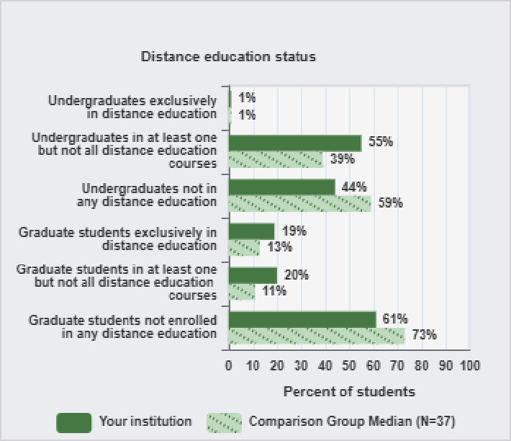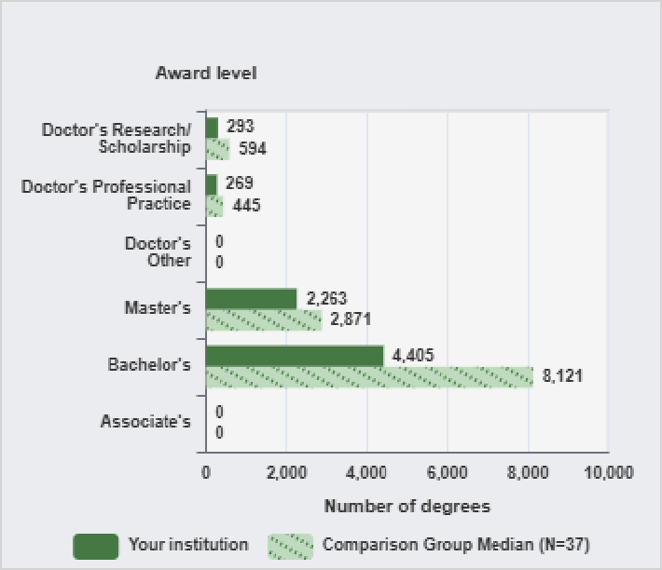

NOTE: N is the number of institutions in the comparison group.
SOURCE: U.S. Department of Education, National Center for Education Statistics, Integrated Postsecondary Education Data System (IPEDS): Spring 2024, Fall Enrollment survey component.
NOTE: N is the number of institutions in the comparison group.
SOURCE: U.S. Department of Education, National Center for Education Statistics, Integrated Postsecondary Education Data System (IPEDS): Fall 2023, Completions survey component.

Figure 8. Tuition and required fees for full-time, first-time degree/certificate-seeking undergraduate students: Academic years 2020-21 to 2023-24
Figure 9. Average net price of attendance for full-time, first-time degree/certificate-seeking undergraduate students, who were awarded grant or scholarship aid: Academic years 2020-21 to 2022-23

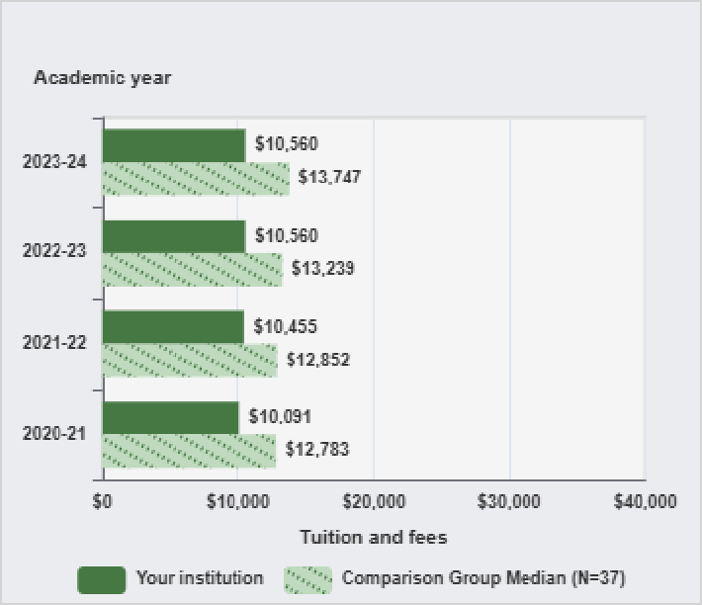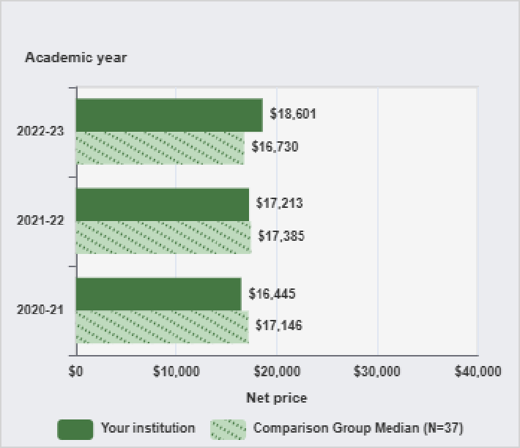

NOTE: The tuition and required fees shown here are the lowest reported from the categories of in-district, in-state, and out-of-state. N is the number of institutions in the comparison group.
SOURCE: U.S. Department of Education, National Center for Education Statistics, Integrated Postsecondary Education Data System (IPEDS): Fall 2023, Institutional Characteristics survey component.

Figure 10. Percent of full-time, first-time degree/certificate-seeking undergraduate students who were awarded grant or scholarship aid, or loans, by type of aid: Academic year 2022-23
NOTE: Average net price is for full-time, first-time degree/certificate-seeking undergraduate students and is generated by subtracting the average amount of federal, state/local government, and institutional grant and scholarship awarded aid from the total cost of attendance. Total cost of attendance is the sum of published tuition and required fees (lower of in-district or in-state for public institutions), books and supplies, and the weighted average of food and housing and other expenses. For details, see the Methodological Notes. N is the number of institutions in the comparison group.
SOURCE: U.S. Department of Education, National Center for Education Statistics, Integrated Postsecondary Education Data System (IPEDS): Fall 2023, Institutional Characteristics survey component and Winter 2023-24, Student Financial Aid survey component.

Figure 11. Average amounts of awarded grant or scholarship aid, or loans awarded to full-time, first-time degree/certificate-seeking undergraduate students, by type of aid: Academic year 2022-23

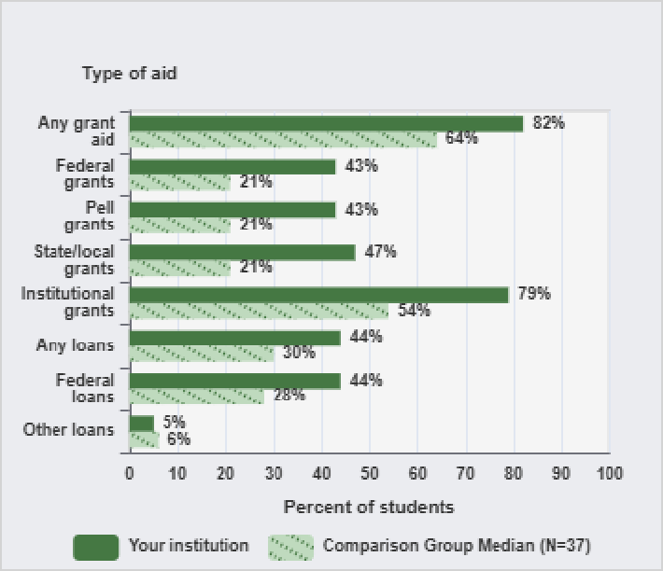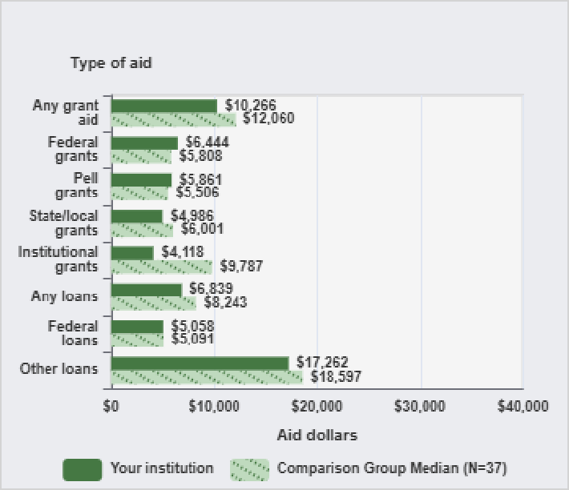

NOTE: Any grant aid above includes grant or scholarship aid awarded from the federal government, state/local government, or the institution. Federal grants include Federal Pell grants and other federal grants. Any loans include federal loans and other loans awarded to students. For details on how students are counted for financial aid reporting, see Cohort Determination in the Methodological Notes. N is the number of institutions in the comparison group.
SOURCE: U.S. Department of Education, National Center for Education Statistics, Integrated Postsecondary Education Data System (IPEDS): Winter 2023-24, Student Financial Aid survey component.
NOTE: Any grant aid above includes grant or scholarship aid awarded from the federal government, state/local government, or the institution. Federal grants include Federal Pell grants and other federal grants. Any loans include federal loans and other loans awarded to students. Average amounts of aid were calculated by dividing the total aid awarded by the unduplicated count of recipients at each institution. N is the number of institutions in the comparison group.
SOURCE: U.S. Department of Education, National Center for Education Statistics, Integrated Postsecondary Education Data System (IPEDS): Winter 2023-24, Student Financial Aid survey component.

IPEDS DATA FEEDBACK REPORT

Figure 12. Percent of degree/certificate-seeking undergraduate students awarded Federal Pell grants and Federal Student loans : Academic year 2022-23
Figure 13. Average amount of Federal Pell grants and Federal Student loans awarded to degree/certificate-seeking undergraduate students: Academic year 2022-23

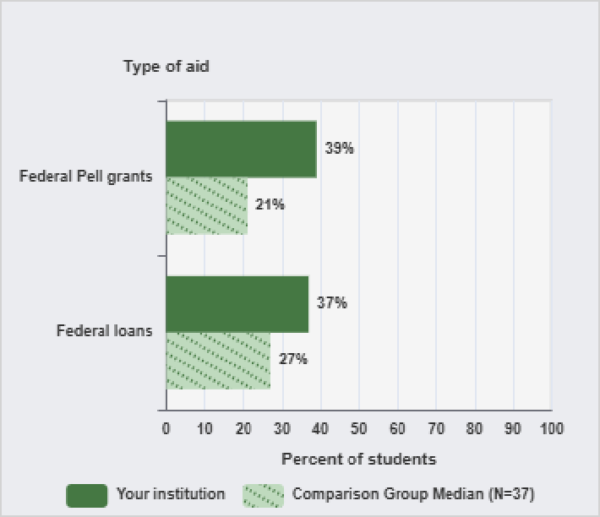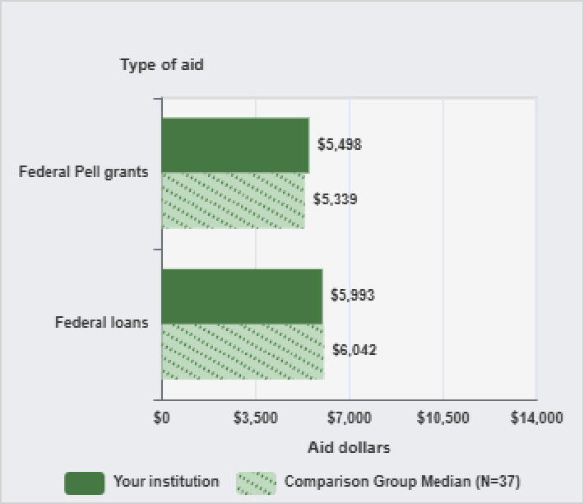

NOTE: Federal loans include federal loans awarded to students. N is the number of institutions in the comparison group.
SOURCE: U.S. Department of Education, National Center for Education Statistics, Integrated Postsecondary Education Data System (IPEDS): Winter 2023-24, Student Financial Aid survey component.
NOTE: Federal loans include federal loans to students. Average amounts of aid were calculated by dividing the total aid awarded by the unduplicated count of recipients at each institution. N is the number of institutions in the comparison group.
SOURCE: U.S. Department of Education, National Center for Education Statistics, Integrated Postsecondary Education Data System (IPEDS): Winter 2023-24, Student Financial Aid survey component.

Figure 14. Percent of undergraduate students awarded grant or scholarship aid, by degree/certificate-seeking status: Academic year 2022-23
Figure 15. Average amount of grant or scholarship aid awarded to undergraduate students, by degree/certificate-seeking status: Academic year 2022-23

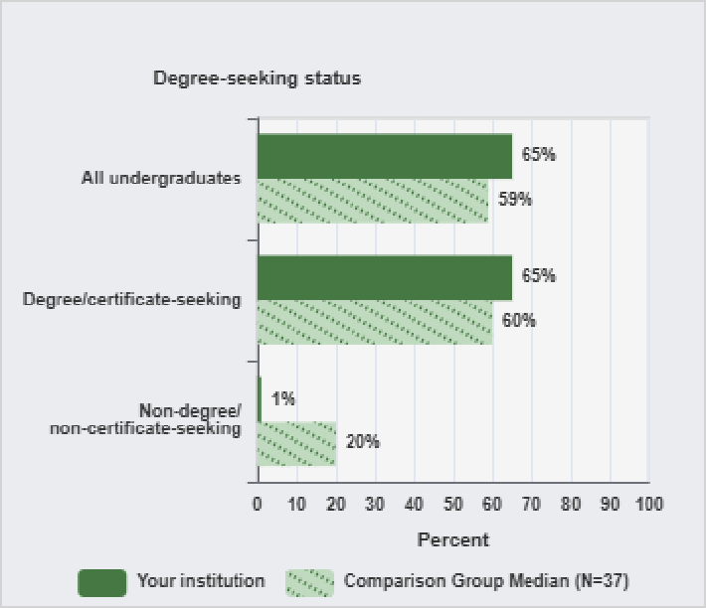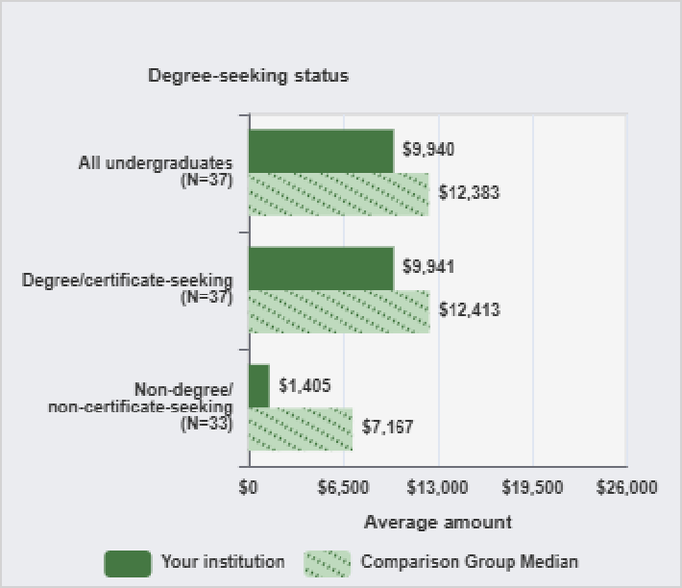

NOTE: Grant or scholarship aid includes grant or scholarship aid from the federal government, state/local government, the institution, or other sources. N is the number of institutions in the comparison group.
SOURCE: U.S. Department of Education, National Center for Education Statistics, Integrated Postsecondary Education Data System (IPEDS): Winter 2023-24, Student Financial Aid survey component.
NOTE: Grant or scholarship aid includes grant or scholarship aid from the federal government, state/local government, the institution, or other sources. Average amounts of aid were calculated by dividing the total aid awarded by the unduplicated count of recipients at each institution. N is the number of institutions in the comparison group that have a value for each indicator.
SOURCE: U.S. Department of Education, National Center for Education Statistics, Integrated Postsecondary Education Data System (IPEDS): Winter 2023-24, Student Financial Aid survey component.

Figure 16. Retention rates of first-time bachelor's degree-seeking students, by attendance status: Fall 2022 cohort
Figure 17. Graduation and transfer-out rates of all full-time, first-time degree/certificate-seeking undergraduate students within 150% of normal time to program completion: 2017 cohort

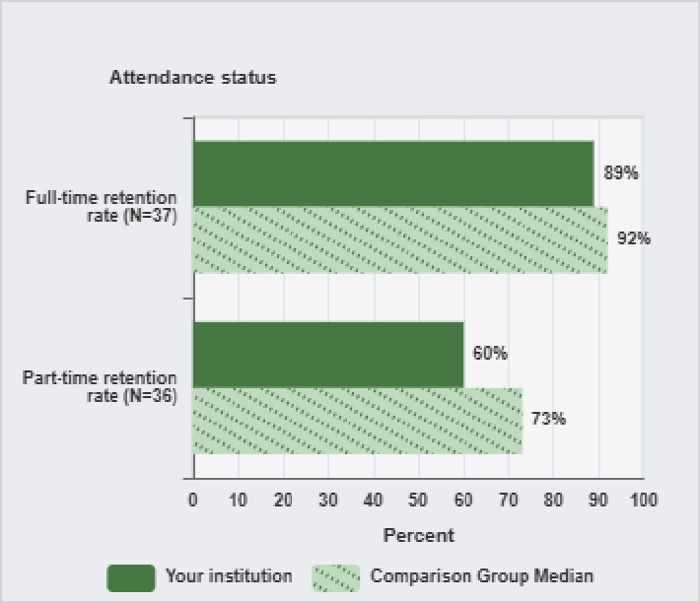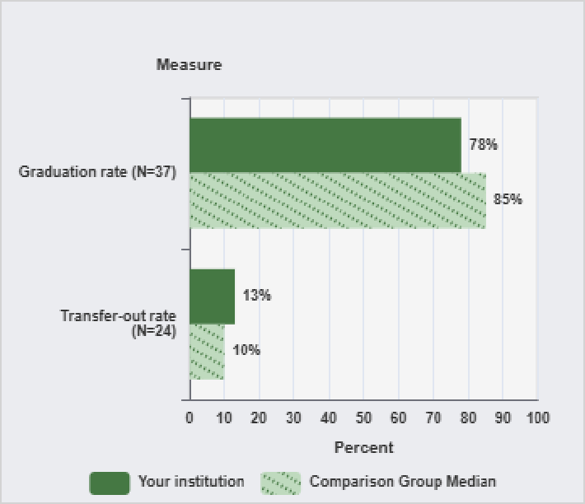

NOTE: Retention rates are measured from the fall of first enrollment to the following fall. Academic reporting institutions report retention data for the Fall 2022 cohort of students who are still enrolled as of the institution's official fall reporting date or as of October 15, 2023. Program reporters determine the cohort with enrollment any time between August 1 - October 31, 2022 and retention based on August 1, 2023. Four-year institutions report retention rates for students seeking a bachelor's degree. For more details, see the Methodological Notes. N is the number of institutions in the comparison group that have a value for each indicator.
SOURCE: U.S. Department of Education, National Center for Education Statistics, Integrated Postsecondary Education Data System (IPEDS): Spring 2024, Fall Enrollment survey component.
NOTE: Graduation rate cohort includes all full-time, first-time degree/certificate-seeking undergraduate students. Graduation and transfer-out rates are the Student Right-to-Know rates. Only institutions with mission to prepare students to transfer are required to report transfer out. For more details, see the Methodological Notes. N is the number of institutions in the comparison group that have a value for each indicator.
SOURCE: U.S. Department of Education, National Center for Education Statistics, Integrated Postsecondary Education Data System (IPEDS): Winter 2023-24, Graduation Rates survey component.

Figure 18. Graduation rates of all full-time, first-time degree/certificate-seeking undergraduate students within 150% of normal time to program completion, by race/ethnicity: 2017 cohort
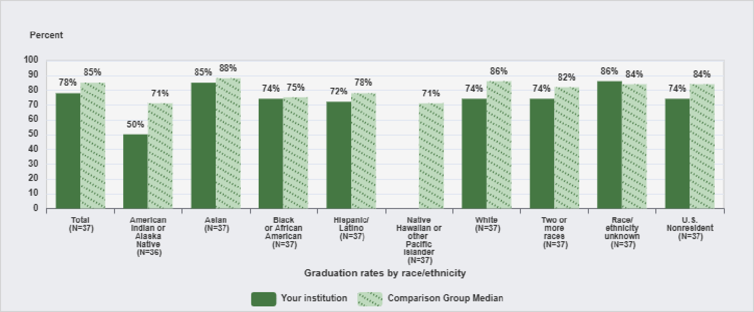
NOTE: For more information about disaggregation of data by race and ethnicity, see the Methodological Notes. The graduation rates are the Student Right-to-Know (SRK) rates. Median values for the comparison group will not add to 100%. N is the number of institutions in the comparison group that have a value for each indicator.
SOURCE: U.S. Department of Education, National Center for Education Statistics, Integrated Postsecondary Education Data System (IPEDS): Winter 2023-24, Graduation Rates survey component.

IPEDS DATA FEEDBACK REPORT

Figure 19. Graduation rates of all full-time, first-time degree/certificate-seeking undergraduate students within 150% of normal time to program completion, by type of aid: 2017 cohort
Figure 20. Bachelor's degree graduation rates of full-time, first-time bachelor's degree-seeking undergraduate
students within 100%, 150% and 200% of normal time to completion: 2015 cohort

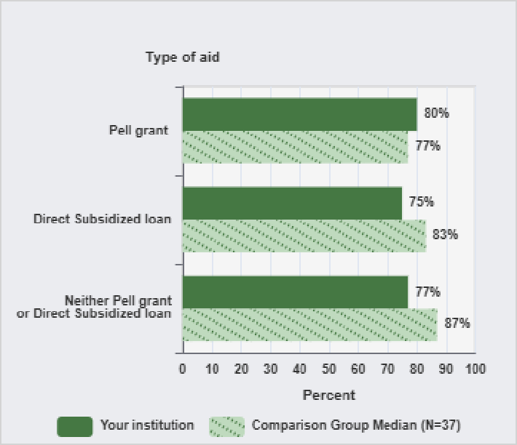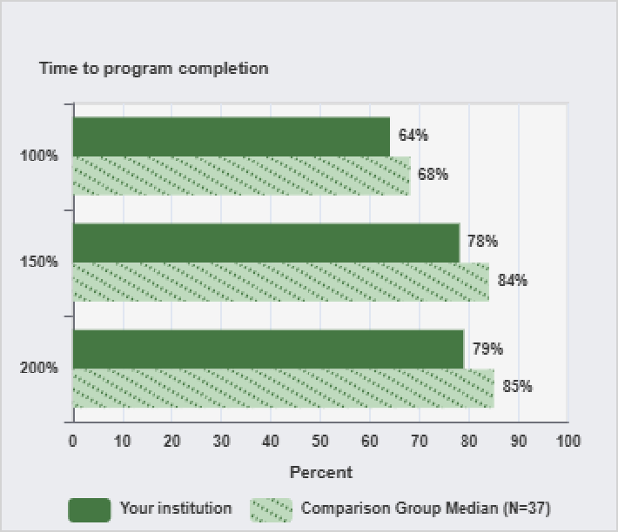

NOTE: Graduation rate cohort includes all full-time, first-time degree/certificate-seeking undergraduate students. Data were collected on those students, who at entry of the cohort, were awarded a Pell Grant and students who were awarded a Subsidized Stafford loan, but did not receive a Pell Grant. Graduation rates are the Student Right-to-Know rates. For more details, see the Methodological Notes. N is the number of institutions in the comparison group.
SOURCE: U.S. Department of Education, National Center for Education Statistics, Integrated Postsecondary Education Data System (IPEDS): Winter 2023-24, Graduation Rates survey component.
NOTE: The 100%, 150% and 200% graduation rates are calculated using the number of students who completed a bachelor's or equivalent degree from a cohort of students who entered the institution seeking a bachelor's or equivalent degree. For details, see the Methodological Notes. N is the number of institutions in the comparison group. Medians are not reported for comparison groups with less than three values.
SOURCE: U.S. Department of Education, National Center for Education Statistics, Integrated Postsecondary Education Data System (IPEDS): Fall 2023, Institutional Characteristics survey component and Winter 2023-24, Student Financial Aid survey component.

Figure 21. Award and enrollment rates of first-time, full-time, degree/certificate-seeking undergraduate students after 8 years of entry, by Pell status: 2015-16 cohort

Pell Non-Pell
(N=37) (N=37)
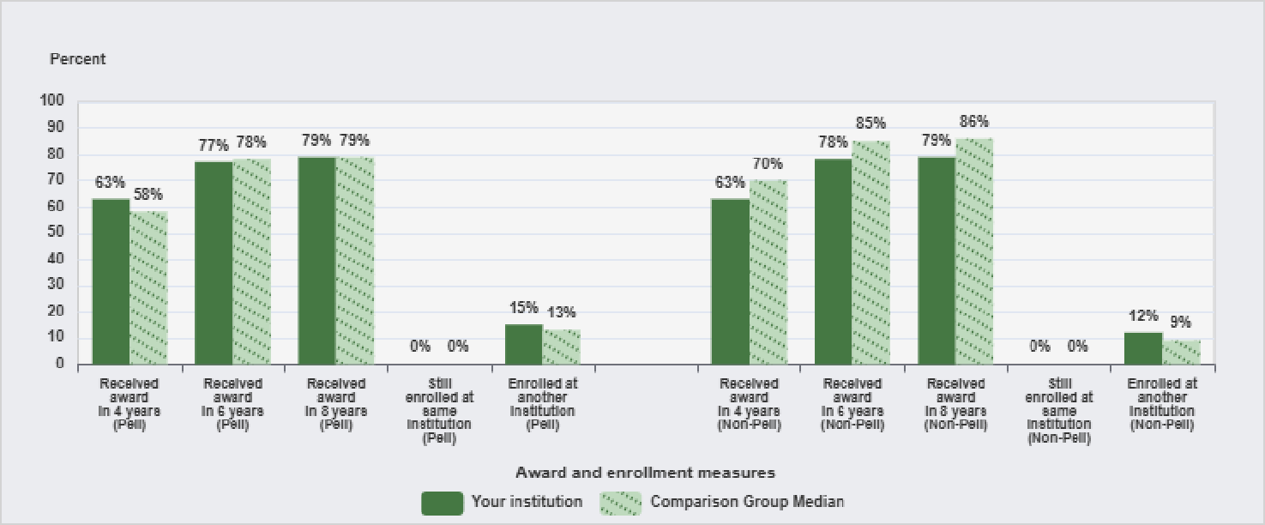

NOTE: Award measures are based on the highest award received after 8 years of entry and enrollment measures are based on students who did not receive an award after 8 years of entry. Student cohorts (i.e., first-time, full-time; first-time, part-time; non-first-time, full-time; and non-first-time, part-time) are degree/certificate-seeking undergraduate students who entered the institution between July 1, 2015-June 30, 2016. Pell recipients are students with demonstrated financial need. For more details, see the Methodological Notes. N is the number of institutions in the comparison group. Medians are not reported for comparison groups with less than three values.
SOURCE: U.S. Department of Education, National Center for Education Statistics, Integrated Postsecondary Education Data System (IPEDS): Winter 2023-24, Outcome Measures survey component.

Figure 22. Award and enrollment rates of first-time, part-time, degree/certificate-seeking undergraduate students after 8 years of entry, by Pell status: 2015-16 cohort

Pell Non-Pell
(N=32) (N=37)
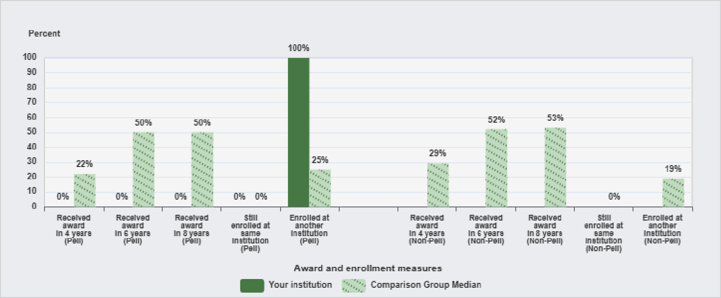

NOTE: Award measures are based on the highest award received after 8 years of entry and enrollment measures are based on students who did not receive an award after 8 years of entry. Student cohorts (i.e., first-time, full-time; first-time, part-time; non-first-time, full-time; and non-first-time, part-time) are degree/certificate-seeking undergraduate students who entered the institution between July 1, 2015-June 30, 2016. Pell recipients are students with demonstrated financial need. For more details, see the Methodological Notes. N is the number of institutions in the comparison group. Medians are not reported for comparison groups with less than three values.
SOURCE: U.S. Department of Education, National Center for Education Statistics, Integrated Postsecondary Education Data System (IPEDS): Winter 2023-24, Outcome Measures survey component.
IPEDS DATA FEEDBACK REPORT

Figure 23. Award and enrollment rates of non-first-time, full-time, degree/certificate-seeking undergraduate students after 8 years of entry, by Pell status: 2015-16 cohort

Pell Non-Pell
(N=37) (N=37)
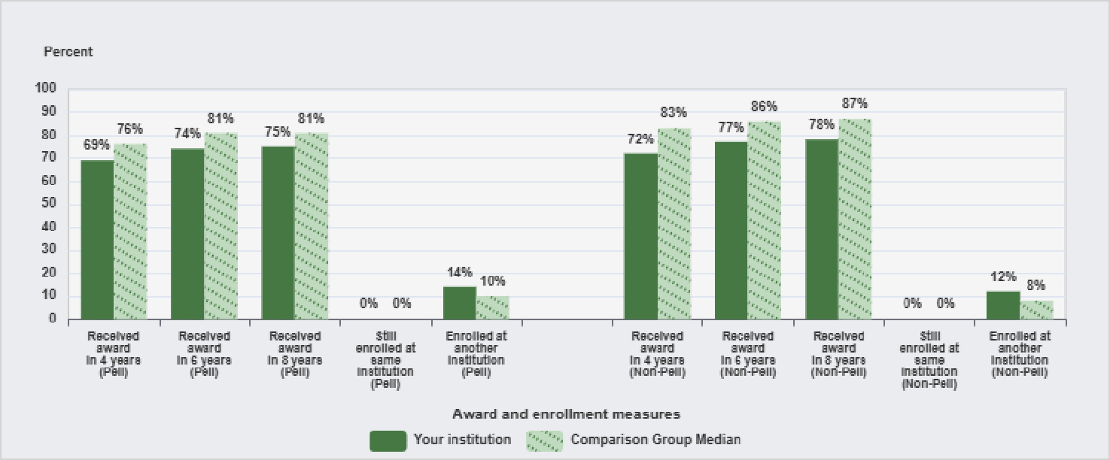

NOTE: Award measures are based on the highest award received after 8 years of entry and enrollment measures are based on students who did not receive an award after 8 years of entry. Student cohorts (i.e., first-time, full-time; first-time, part-time; non-first-time, full-time; and non-first-time, part-time) are degree/certificate-seeking undergraduate students who entered the institution between July 1, 2015-June 30, 2016. Pell recipients are students with demonstrated financial need. For more details, see the Methodological Notes. N is the number of institutions in the comparison group. Medians are not reported for comparison groups with less than three values.
SOURCE: U.S. Department of Education, National Center for Education Statistics, Integrated Postsecondary Education Data System (IPEDS): Winter 2023-24, Outcome Measures survey component.

Figure 24. Award and enrollment rates of non-first-time, part-time, degree/certificate-seeking undergraduate students after 8 years of entry, by Pell status: 2015-16 cohort

Pell Non-Pell
(N=37) (N=37)
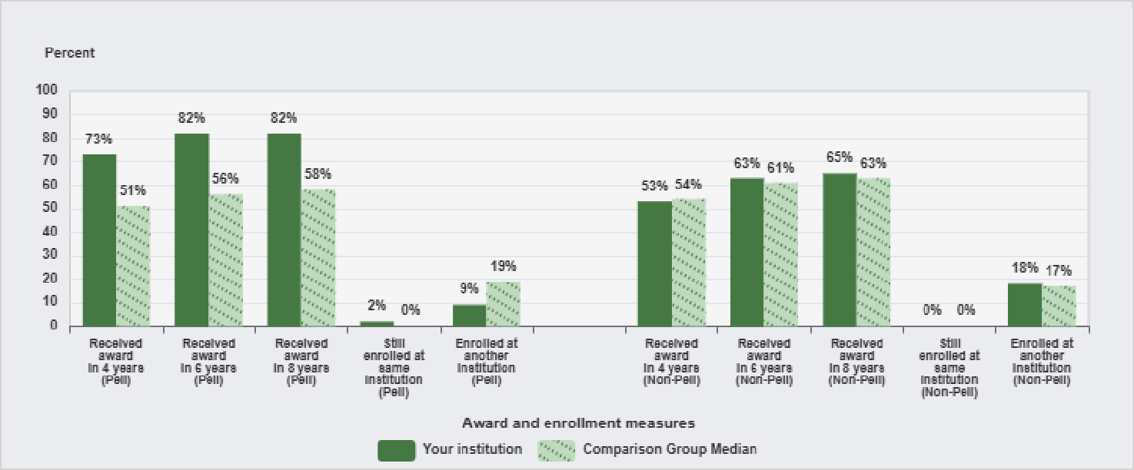

NOTE: Award measures are based on the highest award received after 8 years of entry and enrollment measures are based on students who did not receive an award after 8 years of entry. Student cohorts (i.e., first-time, full-time; first-time, part-time; non-first-time, full-time; and non-first-time, part-time) are degree/certificate-seeking undergraduate students who entered the institution between July 1, 2015-June 30, 2016. Pell recipients are students with demonstrated financial need. For more details, see the Methodological Notes. N is the number of institutions in the comparison group. Medians are not reported for comparison groups with less than three values.
SOURCE: U.S. Department of Education, National Center for Education Statistics, Integrated Postsecondary Education Data System (IPEDS): Winter 2023-24, Outcome Measures survey component.

Figure 25. Percent distribution of core revenues, by source: Fiscal year 2023
Figure 26. Core expenses per FTE enrollment, by function: Fiscal year 2023

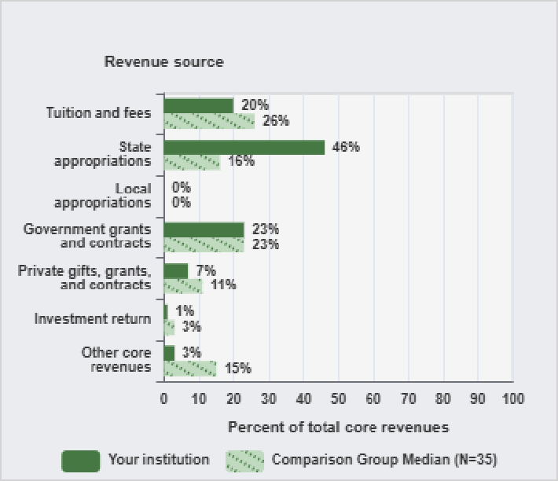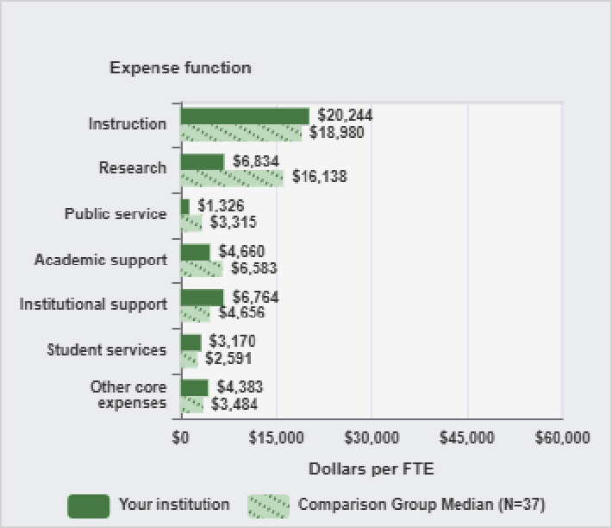

NOTE: The comparison group median is based on those members of the comparison group that report finance data using the same accounting standards as the comparison institution. For more information, see the Methodological Notes. N is the number of institutions in the comparison group.
SOURCE: U.S. Department of Education, National Center for Education Statistics, Integrated Postsecondary Education Data System (IPEDS): Spring 2024, Finance survey component.
NOTE: Expenses per full-time equivalent (FTE) enrollment, particularly instruction, may be inflated because finance data includes all core expenses while FTE reflects credit activity only. For details on calculating FTE enrollment and a detailed definition of core expenses, see the Methodological Notes. N is the number of institutions in the comparison group.
SOURCE: U.S. Department of Education, National Center for Education Statistics, Integrated Postsecondary Education Data System (IPEDS): Fall 2023, 12-month Enrollment survey component and Spring 2024, Finance survey component.

Figure 27. Full-time equivalent staff, by occupational category: Fall 2023
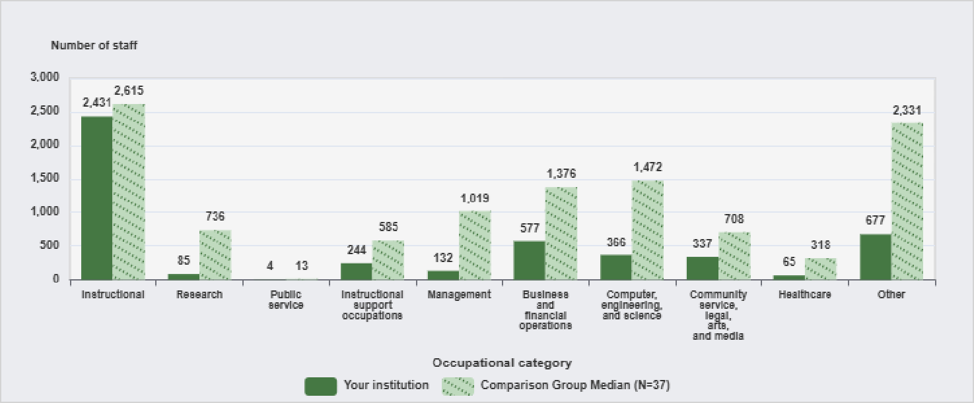
NOTE: Graduate assistants are not included. For calculation details, see the Methodological Notes. N is the number of institutions in the comparison group.
SOURCE: U.S. Department of Education, National Center for Education Statistics, Integrated Postsecondary Education Data System (IPEDS): Spring 2024, Human Resources survey component.

Figure 28. Average salary outlays of full-time non-medical instructional staff equated to 9-months worked, by academic rank: Academic year 2023-24
Figure 29. Percent distribution of library collection, by material type: Fiscal year 2023

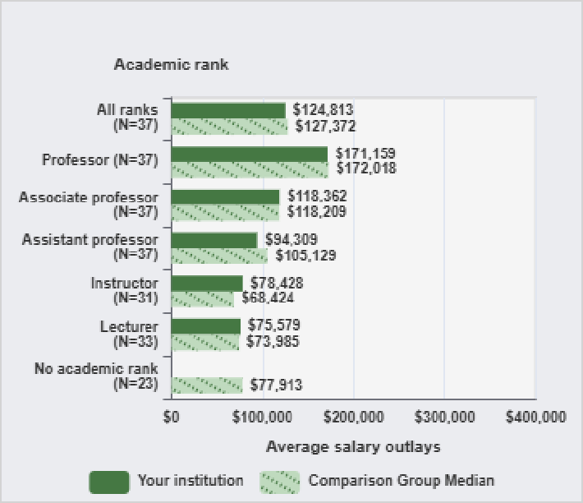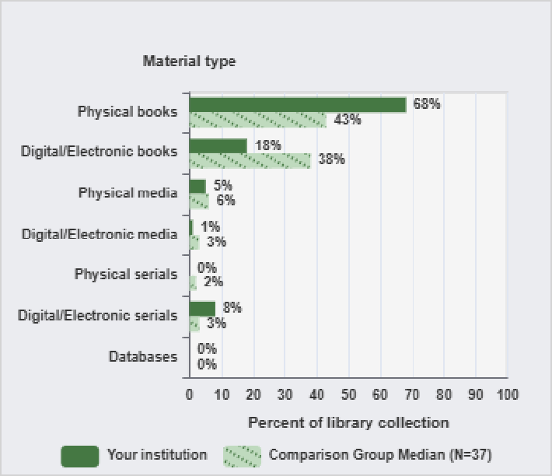

NOTE: See Methodology Notes for more details on average salary. N is the number of institutions in the comparison group that have a value for each indicator.
SOURCE: U.S. Department of Education, National Center for Education Statistics, Integrated Postsecondary Education Data System (IPEDS): Spring 2024, Human Resources survey component.
NOTE: N is the number of institutions in the comparison group.
SOURCE: U.S. Department of Education, National Center for Education Statistics, Integrated Postsecondary Education Data System (IPEDS): Spring 2024, Academic Libraries survey component.

Figure 30. Percent distribution of library expenses, by function: Fiscal year 2023

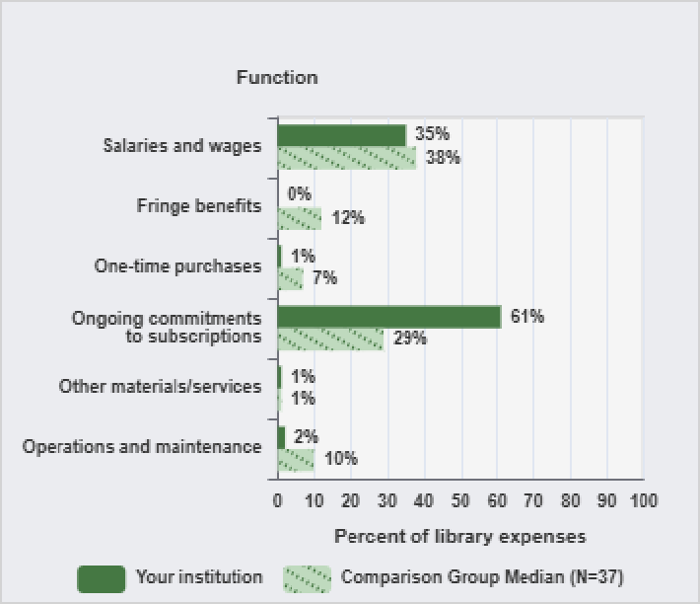
NOTE: N is the number of institutions in the comparison group.
SOURCE: U.S. Department of Education, National Center for Education Statistics, Integrated Postsecondary Education Data System (IPEDS): Spring 2024, Academic Libraries survey component.

METHODOLOGICAL NOTES

Overview
This report is based on data supplied by institutions to IPEDS during 2023-24 data collection year. Response rates exceeded 99% for most survey components. IPEDS data release memos at https://nces.ed.gov/ipeds/use-the-data/survey-components provide an overview of the number of institutions responding to the survey components. Furthermore, data used in this report are provisional level and may be revised for a limited time through the IPEDS Prior Year Revision system.

Use of Median Values for Comparison Group
This report compares your institution’s data to the median values of the comparison group for each indicator shown in the figure. If a figure contains multiple indicators, median values are determined separately for each indicator. The N value represents the number of institutions in the comparison group that has a value for each indicator. If all institutions in the comparison group have values for all indicators within a figure, the N value is displayed. Medians are not displayed for comparison groups with fewer than three values. When percentage distributions are presented, median values may not add to 100%. To access all the data used to create the figures included in this report, go to `Use the Data’ portal on the IPEDS website at this provided link (https://nces.ed.gov/ipeds).

Missing Indicators
If an indicator is not reported for your institution, the omission implies that the indicator is not relevant to your institution and the data were not collected. Not all notes may be applicable to your report.

Use of Imputed Data
All IPEDS data are subject to imputation for total (institutional) and partial (item) nonresponse. If necessary, imputed values were used to prepare your report.

Data Confidentiality
IPEDS data are not collected under a pledge of confidentiality.

Disaggregation of Data by Race/Ethnicity
When applicable, some indicators are disaggregated by race/ethnicity. Data disaggregated by race/ethnicity have been reported using the 1997 Office of Management and Budget categories. Detailed information about the race/ethnicity categories can be found at https://nces.ed.gov/IPEDS/report-your-data/resource-center-race-ethnicity.

Cohort Determination for Reporting Student Financial Aid, Graduation Rates, and Outcome Measures
Student cohorts for reporting Student Financial Aid and Graduation Rates data are based on the reporting type of the institution. For institutions that report based on an academic year (those operating on standard academic terms), student counts and cohorts are based on fall term data. Student counts and cohorts for program reporters (those that do not operate on standard academic terms) are based on unduplicated counts of students enrolled during a full 12-month period, from July 1 to June 30.

Student cohorts for reporting Outcome Measures are based on a full-year cohort from July 1 to June 30 for all degree-granting institutions.

DESCRIPTION OF INDICATORS USED IN THE FIGURES

Admissions (only for non-open-admissions schools)
Admissions and Test Score Data

Admissions and test score data are presented only for institutions that do not have an open admission policy, and apply to first-time, degree/certificate-seeking undergraduate students only. Applicants include only those students who fulfilled all requirements for consideration for admission and who were notified of one of the following actions: admission, non-admission, placement on a wait list, or application withdrawn (by applicant or institution). Admitted applicants (admissions) include wait-listed students who were subsequently offered admission. Early decision, early action, and students who began studies during the summer prior to the fall reporting period are included. For customized Data Feedback Reports, test scores are presented only if scores are required for admission.

Student Enrollment
Enrollment Counts

12-month Enrollment captures a cumulative unduplicated headcount of enrollment over the full 12-month period beginning July 1 and ending June 30. In contrast, Fall Enrollment captures number of students enrolled on a particular date in the fall. Fall enrollment is often referred to as a "snapshot" of an institution’s enrollment at a specific time.
FTE Enrollment

The full-time equivalent (FTE) enrollment used in this report is the sum of the institution’s FTE undergraduate enrollment and FTE graduate enrollment (as calculated from or reported on the 12-month Enrollment survey component). Undergraduate and graduate FTE are estimated using 12-month instructional activity (credit and/or clock hours). See “Calculation of FTE Students (using instructional activity)” in the IPEDS Glossary at https://surveys.nces.ed.gov/ipeds/VisGlossaryAll.aspx.

Completions
Completions and Completers

The Completions survey component collects data on undergraduate and graduate completions and completers in a 12-month period, from July 1 to June 30. Completions are the counts of recognized postsecondary credentials conferred by the postsecondary institution as a result of completion of an academic or occupational/vocational program of study. Each award is counted only once, regardless of whether the student earned multiple awards. Completers are the counts of students who earned a postsecondary award. This data is collected in two ways:
- Unduplicated count of total completers.
- Counts by award level (e.g., number of associate’s degree completers, number of bachelor’s degree completers)

Student Financial Aid
Financial Aid Recipients and Amounts

For the purpose of the IPEDS reporting, aid awarded refers to financial aid that was awarded to, and accepted by, a student. This amount may differ from the aid amount that is disbursed to a student.

Student Financial Aid collects the counts of undergraduate students awarded different types of financial aid and the total amounts of aid awarded. The average dollar amount of aid awarded is then calculated. In addition, Student Financial Aid collects counts of full-time, first-time undergraduate students awarded aid and amounts of aid, and counts and disbursed amounts for undergraduate and graduate students receiving select military education benefits.

Charges and Average Net Price
Tuition and Required Fees (Published)

Tuition is defined as the amount of money charged to students for instructional services, and required fees are those fixed sum charges to students for items not covered by tuition and that are required of such a large proportion of all students that the student who does not pay the charge is an exception. The amounts used in this report are for full-time, first-time degree/certificate-seeking undergraduate students and approximate those used by the financial aid office to determine the financial need. For institutions that have differential tuition rates for in-district or in-state students, the lowest tuition rate is used in the figure. Only institutions that operate on standard academic terms will have tuition figures included in their report.
Average Institutional Net Price

IPEDS collects data to calculate average net price at each institution for two groups of undergraduate students: those awarded grant and scholarship aid and those awarded Title IV federal aid.

Average net price is calculated for full-time, first-time degree/certificate-seeking undergraduate students who were awarded grant or scholarship aid from the federal government, state/local government, or the institution anytime during the academic year. For public institutions, this includes only students who paid the lower of in-state or in-district tuition rate. Other sources of grant aid are excluded. Average net price is generated by subtracting the average amount of federal, state/local government, and institutional grant and scholarship aid from the total cost of attendance. Total cost of attendance is the sum of published tuition and required fees (lower of in-district or in-state for public institutions), books and supplies, and the weighted average of food and housing, and other expenses.

Retention, Graduation Rates, and Outcome Measures
Retention Rates

Retention rates are measures of the rate at which students persist in their educational program at an institution, expressed as a percentage. For four-year institutions, this is the percentage of first-time bachelors (or equivalent) degree-seeking undergraduate students from the previous fall who are still enrolled in the current fall. For all other institutions this is the percentage of first-time degree/certificate-seeking undergraduate students from the previous fall who either re-enrolled or successfully completed their program by the current fall. The full-time retention rate is calculated using the percentage of full-time, first-time degree/certificate-seeking undergraduate students, while the part-time rate is calculated using the percentage of part-time, first-time degree/certificate-seeking undergraduate students.
Graduation Rates and Transfer-out Rate

Graduation rates are those developed to satisfy the requirements of the Student Right-to-Know Act and Higher Education Act of 1965, as amended, and are defined as the total number of individuals from a given cohort of full-time, first-time degree/certificate-seeking undergraduate students who completed a degree or certificate within a given percent of normal time to complete all requirements of the degree or certificate program; divided by the total number of students in the cohort of full-time, first-time degree/certificate-seeking undergraduate students minus any allowable exclusions. Institutions are permitted to exclude from the cohort students who died or were totally and permanently disabled; those who left school to serve in the armed forces or were called up to active duty; those who left to serve with a foreign aid service of the federal government, such as the Peace Corps; and those who left to serve on an official church mission.

A further extension of the traditional Graduation Rates (GR) survey component which carries forward 100% and 150% graduation rates data previously reported in the GR survey component is the Graduation Rates 200% (GR200) survey component, which requests information on any additional completers and exclusions from the cohort between 151% and 200% normal time for students to complete all requirements of their program of study.

Transfer-out rate is the total number of students from the cohort who are known to have transferred out of the reporting institution (without earning a degree/award) and subsequently re-enrolled at another institution within the same time period; divided by the same adjusted cohort (initial cohort minus allowable exclusions) as described above. Only institutions with a mission that includes providing substantial preparation for students to enroll in another eligible institution are required to report transfers out.
Outcome Measures Data

Alternative measures of student success are reported by degree-granting institutions to describe the outcomes of four degree/certificate-seeking undergraduate student groups: first-time, full-time entering (FTFT); first-time, part-time entering (FTPT); non-first-time, full-time entering (NFTFT); and non-first-time, part-time entering (NFTPT). Additionally, each of the four cohorts collects data on two subcohorts: Pell grant recipients and non-Pell grant recipients. These measures provide the 4-year, 6-year, and 8-year award rates (or completions rates) after entering an institution. NCES calculates award rates by dividing a cohort’s or subcohort’s adjusted cohort into the number of total awards at 4-year, 6-year, and 8-year status points.
The initial cohort can be revised for allowable exclusions resulting in an adjusted cohort. Institutions are permitted to exclude from the initial cohort students who died or were totally and permanently disabled; those who left school to serve in the armed forces or were called up to active duty; those who left to serve with a foreign aid service of the federal government, such as the Peace Corps; and those who left to serve on an official church mission.

The highest award and the type of award (i.e., certificate, Associate’s, or Bachelor’s) are reported at each status point. For students who did not earn an undergraduate award after 8-years of entry, the enrollment statuses are reported as either still enrolled at the institution, or subsequently transferred out of the institution. Unlike the Graduation Rates data, all institutions must report on a full-year cohort (students entering July 1 of one year to June 30 of the next year) and on their transfer out students, regardless if the institution has a mission that provides substantial transfer preparation.

Finance
Core Revenues

Core revenues for public institutions reporting under GASB reporting standards include tuition and fees; government (federal, state, and local) appropriations and operating and nonoperating grants/contracts; private gifts, grants, and contracts (private operating grants/contracts plus gifts and contributions from affiliated entities); sales and services of educational activities; investment income; other operating and nonoperating sources; and other revenues and additions (capital appropriations and grants and additions to permanent endowments). “Other core revenues” include federal appropriations, sales and services of educational activities, other operating and nonoperating sources, and other revenues and additions.

Core revenues for private, not-for-profit institutions (and a small number of public institutions) reporting under FASB reporting standards include tuition and fees; government (federal, state, and local) appropriations and grants/contracts; private gifts, grants and contracts (including contributions from affiliated entities); investment return; sales and services of educational activities; and other sources (a generated category of total revenues minus the sum of core and noncore categories on the Finance survey component). “Other core revenues” include government (federal, state, and local) appropriations, sales and services of educational activities, and other sources.
Core revenues for private, for-profit institutions reporting under FASB reporting standards include tuition and fees; government (federal, state, and local) appropriations and grants/contracts; private grants/ contracts; investment income; sales and services of educational activities; and other sources (a generated category of total revenues minus the sum of core and noncore categories on the Finance survey component). “Other core revenues” include government (federal, state, and local) appropriations and other sources.
At degree-granting institutions, core revenues exclude revenues from auxiliary enterprises (e.g., bookstores and dormitories), hospitals, and independent operations. Non-degree-granting institutions do no report revenue from auxiliary enterprises in a separate category, and thus may include these amounts in the core revenues from other sources.
Core Expenses

Core expenses include expenses for instruction, research, public service, academic support, student services, institutional support, scholarships and fellowships (GASB) or net grant aid to students (FASB) and other expenses. Core expenses exclude expenses for auxiliary enterprises, hospitals, and independent operations. “Other core expenses” is the sum of grant aid/scholarships and fellowships and other expenses.
Endowment Assets [Customized Data Feedback Reports only]

Endowment assets, for public institutions under GASB reporting standards, and private, not-for-profit institutions under FASB reporting standards, include gross investments of endowment funds, term endowment funds, and funds functioning as endowment for the institution and any of its foundations and other affiliated organizations. Private, for-profit institutions under FASB do not hold or report endowment assets.
Salaries and Wages [Customized Data Feedback Reports only]

Salaries and wages for public institutions under GASB reporting standards and private (not-for-profit and for-profit) institutions under FASB reporting standards, include amounts paid as compensation for services to all employees regardless of the duration of service, including all regular or periodic payments to a person for the regular or periodic performance of work or a service and payment to a person for more sporadic performance of work or a services (e.g., overtime, extra compensation, summer compensation, bonuses, sick or annual leave, etc.)

Staff
FTE Staff

The full-time-equivalent (FTE) by occupational category is calculated by summing the total number of full-time staff on the payroll as of November 1, along with one-third of the total number of part-time staff on that same date. Occupational categories include instructional staff, research staff, public service staff, instructional support staff, management staff, and other occupations. Instructional staff are primarily engaged in teaching and do a combination of teaching, research, and/or public service. Research staff are staff whose primary function is research while public service staff are staff whose primary function is public service. Instructional support occupations include archivists, curators, and museum technicians; librarians and media collections specialists; librarian technicians; student and academic affairs and other education services occupations. Other staff include staff in service occupations; sales and related occupations; office and administrative support occupations; natural resources, construction, and maintenance occupations; production, transportation and material moving occupations; and military specific occupations. Graduate assistants are not included.
Equated Non-Medical Instructional Staff Salaries

Institutions report the number of full-time non-medical instructional staff and their salary outlays by academic rank, gender, and the number of months worked (9-, 10-, 11-, and 12-months). Salary outlays for staff who worked 10-, 11-, and 12-months were equated to 9-months of work by multiplying the outlays reported for 10-months by 0.90, the outlays reported for 11 months by 0.818, and the outlays reported for 12-months by 0.75. The equated 10-, 11-, and 12-outlays were then added to the outlays for instructional staff that worked 9-months to generate a total 9-month equated salary outlay. The total 9-month equated outlay was then divided by total number of non-medical instructional staff to determine an equated 9-month average salary. This calculation was done for each academic rank. Salary outlays were not reported for staff that work less than 9-months and were excluded.

Student-to-Faculty Ratio [Customized Data Feedback Reports only]

Institutions can provide their institution’s student-to-faculty ratio (i.e., student-to-instructional staff) for undergraduate programs or follow the NCES guidance in calculating their student-to-faculty ratio, which is as follows: the number of FTE students (using Fall Enrollment survey component data) divided by total FTE instructional staff (using the total primarily instruction + instruction/research/public service staff reported in Human Resources survey component and adding any not primarily instructional staff that are teaching a credit course). For this calculation, FTE for students is equal to the number of the full-time students plus one-third the number of part-time students; FTE for instructional staff is similarly calculated. Students in "stand-alone" graduate or professional programs (such as, medicine, law, veterinary, dentistry, social work, or public health) and instructional staff teaching in these programs are excluded from the FTE calculations.

Libraries
Library Collections

Library collections comprise of documents held locally and remote resources for which permanent or temporary access rights have been acquired. Access rights may be acquired by the library itself, by a consortium and/or through external funding. Interlibrary lending and document delivery are excluded from the collection.
Degree-granting institutions with total library expenses greater than zero and/or had access to a library collection report their physical books, media, and serials collections and their digital/electronic books, media, serials, and database collections.
Counts in each category (i.e., physical books, media, and serials as well as digital/electronic books, media, serials, and databases) are the number of held at the end of the most recent fiscal year. The percent distribution of each resource is derived by dividing the counts in each category by the total of all categories.
Digital/electronic books and media are reported by titles owned or leased by the library if individual titles are cataloged and/or searchable through the library catalog or discovery system. E-serials are reported by titles that are accessible through the library’s catalog or discovery system. Digital and Electronic databases are reported by the total number of licensed digital/electronic databases in the institutions collection if there is bibliographic or discovery access at the database level.
Library Expenses

Library expenses are funds expended by the library (regardless of when received) from its regular budget and from all other sources (e.g., research grants, special projects, gifts and endowments, and fees for services) for the most recent 12-month period that corresponds to your institution’s fiscal year that ends before October 1.
Degree-granting institutions with total library expenses less than $100,000 are not required to report their expenses to IPEDS. Salaries and wages are reported from the library budget or all other institutional sources that are identifiable. Fringe benefits are reported only if paid from the library budget. The percent distribution of each category of expense is derived by dividing each expense category by the sum of total library expenses.

Additional Resources
Additional information on the IPEDS survey components, including survey methodology, survey forms, and frequently asked questions, can be found at https://nces.ed.gov/ipeds/use-the-data/survey-components.

Additional information on the timing of IPEDS data collection, data coverage, and data release cycle, can be found at https://nces.ed.gov/ipeds/use-the-data/timing-of-ipeds-data-collection.

Additional definitions of variables used in this report can be found in the IPEDS glossary available at https://surveys.nces.ed.gov/ipeds/VisGlossaryAll.aspx.

Additional resources on the IPEDS Data Feedback Report, including the instructions on creating a custom comparison report, FAQs, and video tutorials, can be found at https://nces.ed.gov/Ipeds/Help/View/2.

