Institutional Benchmark Report
November 2003

State University of New York-Stony Brook University

C:11National Survey of
� •, Student Engagement
Em The College Student Report

[IIJNational Survey of
� • Student Engagement
ma .
The College Student Report
2003 Institutional Benchmark Report State University of New York-Stony Brook University

Introduction
The National Survey of Student Engagement (NSSE) annually assesses the extent to which undergraduate students are involved in educational practices empirically linked to high levels oflearning and development. In an effort to make it easier for people on and off campus to talk productively about student engagement and its importance to student learning, collegiate quality, and institutional improvement, NSSE created five clusters or benchmarks of effective educational practice:
- Level of academic challenge
- Active and collaborative learning
- Student-faculty interactions
- Enriching educational experiences
- Supportive campus environment.
The benchmarks are made up of groups of items on the survey and are expressed in 100-point scales. Each year, NSSE calculates benchmark scores to monitor performance at the institutional, sector, and national level. This year's analysis is based on approximately 185,000 randomly selected students at 649 four-year colleges and universities that participated in 2001, 2002, and 2003. The students represent a broad cross-section of first-year and senior students from every region of the country. The institutions are similar in most respects to the universe of four-year schools.
More detailed information about the benchmarks can be found in the annual report that accompanies this mailing and on the NSSE website at www.iub.edu/-nsse.

Benchmark Report
The Benchmark Report presents your institution's benchmark scores and compares them to schools in your Carnegie Classification, and the NSSE national norms. In addition, it provides summary statistics, a decile chart that gauges your institution's performance compared with other schools, and your Institutional Engagement Index. This index represents the degree to which your students do more or less than expected in terms of their engagement in the five areas of effective educational practice after adjusting for the types of students that attend your school and various institutional characteristics.
NSSE and the benchmarks of effective educational practice provide an instructive way to look at and talk about teaching and learning. Thus, they are intended to help stimulate conversations on campus and help determine whether student behavior and institutional practices are headed in the right direction. •
Level of Academic Challenge
Challenging intellectual and creative work is central to student learning and collegiate quality. Colleges and universities promote high levels of student achievement by emphasizing the importance of academic effort and setting high expectations for student performance. | 100  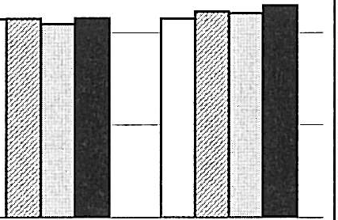  75  .,,  �  Cu |  |  |  |  | Le,·el of Academic Challenge Survey llcms:  Preparing for class (studying, reading, writing, rehearsing, etc. related 10 academic program)  Number of assigned 1cx1books, books, or book-length packs of course readings  Number ofwriuen papers orrepons of20 pages or more;
 | t/J  ,t; 50  "E'  ii  C  c":i'  25  0  □SUNY Stony  Brook  IZIAAUDE  □Doc-Ext  - National | First-Year  53.6  53.7  52.3  53.9 | -- | - | Senior  53.8  55.7  55.2  57.3 | number of wriuen papers or repons of between 5 and I9  pages; and number of wriucn papers or repons of fewer than 5 pages  Coursework emphasizinganalysis of the basic clements of an idea, experience or theory  Coursework emphasizing synthesis and organizing of ideas. infonnation, or experiences intonew, more complc,cinterpretations and relationships  Coursework emphasizing lhe making of judgments about the value of information, arguments. or methods  Coursework emphasizing application of1heories or concepts 10 practical problems or in new situations  Working harder than you thought you could 10 meet an  instructor's standards or expectations  Campus environment emphasizing time studying and on academic work

�[f'J National Survey of

�M Student Engagement
��1f,'W�] TheCollege Student Report
2003 Institutional Benchmark Report State University of New York-Stony Brook University

Active and Collaborative Learning
Students learn more when they are intensely involved in their education and asked to think about what they are learning in different settings. Collaborating with others in solving problems or mastering difficult material prepares students for the messy, unscripted problems they will encounter daily during and after college. | 100  75  �"'  a  u  Cl)  -1:: | Active and Collaborative Learning Survey Items:  Asked questions in class or contributed lo class  discussions  Made a class presentation  Worked with other students on projects during class Worked with classmates outside of class lo prepare class
0: 50
§ assignments
u
5
m Tutored or taught other students

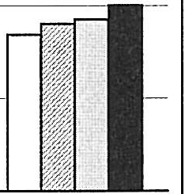
25 Participated in a community-based project as part of a
regular course

Discussed ideas from your readings or classes with
0 others outside of class (students, family members, co-
First-Year Senior workers, etc.)
□SUNY Stony 35.7 42.2
Brook E:JAAUDE 38.6 45.1
□Doc-Ext 38.J 46.2
- National 41.8 50.1

Student-Faculty Interaction

Students learn firsthand how experts think about and solve practical problems by interacting with faculty members inside and outside the classroom. As a result, their teachers become role models, mentors, and guides for continuous, life-
long learning.
100
Student-Faculty Interaction Survey Items:

Discussed grades or assignments with an instructor
75
Talked about career plans with a faculty member or
advisor
�
-i=
C"l)
a
Discussed ideas from your readings or classes with
faculty members outside of class
u
§
50
m
5
Worked with faculty members on activities other than coursework (committees, orientation, student-life activities, etc.)
25 Received prompt foedback from faculty on your
academic performance (written or oral)
0
□SUNY Stony
First-Year
33.4
Senior
38.0
Worked or planned to work with a faculty member on a research project outside of course or program
requirements
Brook
IZIAAUDE
- National
□Doc-E-xt----
34.-3 ---
34.0
37.2
39.3
39.9
44.2


National Survey of Student Engagement
The College Student Report
2003 Institutional Benchmark Report State University of New York-Stony Brook University

Enriching Educational Experiences
Complementary learning opportunities in and out of class augment academic programs. Diversity experiences teach students valuable things about themselves and others. Technology facilitates collaboration between peers and instructors.  Internships, community service, and senior capstone courses provide opportunities to integrate and apply knowledge. | 100  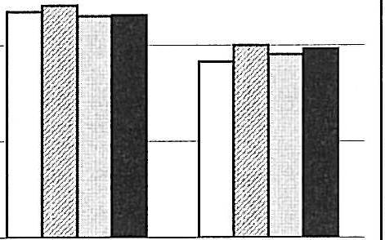  75  ,r.  �  C |  |  | Enriching Educational Experiences Sunoey Items:  Panicipating in co-curricular activi1ies (organizations.  publications, stu,knt government, spons, etc.)  Practicum. internship, field experience, co-op  experience, or clinical assignment
 | u  �"'  s"' 50  ci  C""l  25  0  □SUNY Stony  Brook  EilAAUDE  □Doc-Ext  - National | First-Year 58.7  60.3  57.6  57.7 | Senior 45.7  50.0  47.6  49.1 | Community service or volunteer work Foreign language coursework & study abroad Independent study or self-designed major  Culminating senior experience (comprehensive exam, capstone course, thesis, project. etc.)  Serious conversations with students of different religious beliefs, political opinions, or personal values  Serious conversations with students of a different race or ethnicity  Using electronic technology to discuss or complete an assignment  Campus environment encouraging contact among  students from different economic, social, and racial or ethnic back�rounds

Supportive Campus Environment
Students perform |   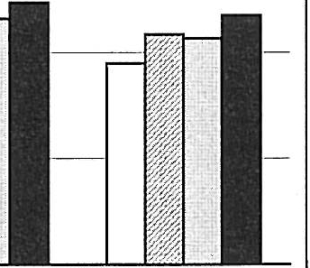  100 |  |  | Supportive Campus Environment Survey Items:
better and are more satisfied at  colleges that are | 75 |  |  | Campus environment provides the support you need to help you succeed academically  Campus environment helps you cope with your non-
committed to their success and cultivate positive the working and  social relations | 50 |  |  | academic responsibilities(work, family, etc.)  Campus environment provides the support you need to thrive socially  Quality of relationships with other students
among different groups on campus. | 25 |  |  | Quality of relationships with faculty members  Quality of relationships with administrative personnel
 |  |  |  | and offices
 | 0
 |  | First-Year | Senior
 | □SUNY Stony Brook | 54.7 | 47.4
 | I!IAAUDE |  | 54.3
 | □Doc-Ext | 58.0 | 53.4
 | - National | 61.8 | 58.8

a National Survey of
■
-..-�. -., Student Engagement
lii1E The College Student Report

2003 Institutional Benchmark Report State University of New York-Stony Brook University

First-Year
I SUNY Stony i Comparison Group Statistics
I Brook I
I
Benchmark Benchmark Score , Doc-Ext National
I Benchmark Score 52.3 53.9
Explanation of Statistics
Benchmark Score: The weighted arithmetic average (mean) of the corresponding survey items, calculated by dividing the sum of values

Level of Academic
53.6
Score Difference 1.3 -0.3
for each item by the total number of students
responding to that item. Each benchmark was

Challenge Standard Devia1ion 3.4 4.2
Standard Score 0.4 -0.1
Active and Collaborative Learning | Bi:nchmark Score  35.7 Score Difference Standard Deviation Standard Score |  | 38.1  -2.5  2.9  -0.8 | 41.8  -6.l  4.8  -1.3
 | Benchmark Score |  | 34.0 | 37.2
Student-Faculty | 33.4 Score Difference |  | -0.6 | -3.8
Interaction | Standard Deviation |  | 2.9 | 5.7
 | Standru"d Score |  | -0.2 | -0.7
Enriching Educational  �xperiences | 58.7 | Benchmark Score Score Difference Standard Deviation | 57.6  I.I  4.7 | 57.7  0.9  7.3
Enriching Educational  �xperiences | Standard Score |  | 0.2 | 0.1

Benchmark Score 58.0 61.8
Supportive Campus 54.7 Score Diffen.'Tlce -3.3 -7.1
Environment Standard Deviation 3.5 5.3
Standard Score -1.0 -1.3
Number of Institutions 79 646

Senior
Benchmark | SUNY Stony Brook  Benchmark Score | Comparison Group Statistics  Doc-Ext National

I Benchmark Score 55.2 57.3
put on a I00-point scale. Comparison group benchmark scores are the average of all institutional benchmark scores within the group.
Score Difference: The result of subtrJcting the comparison group score (Carnegie Classification or national) from your institution's score on each benchmark.
Standard Deviation: The average amount each institution's benchmark score deviates from the mean of all benchmark scores in the comparison group. The greater the dispersion of scores the larger the standard deviation.
Standard Score (SS): In statistical tenns, this is a z score, the standardized magnitude of the difference between your school's benchmark score and the mean of the comparison group. It is calculated by dividing the score difference by the standard deviation of the distribution of scores for the comparison group.

Assuming the group means are nonnally distributed, a SS of 0.5 refers to a benchmark score that is greater than 69% of all comparison group schools, and 1.0 is greater than 84%.
Likewise, a negative SS of-0.5 corresponds to a score that is better than 31% of the comparision group, and a -1.0 corresponds to an institution score better than only 16% of the comparison
group. A SS of zero indicates that the

Level of Academic I
Challenge | I | Standard Dcvfation  Standard Score | ? .�,  -0.6 | 3.9  -0.9
Active and Collaborative Learning |  | Benchmark Score | 46.2 | 50.1
Active and Collaborative Learning | 42.2 | Score Diffc:tence  Standard Devio.tion  Standard Score | -4.0  2.8  -1.4 | -7.9  4.3  -1.8
 |  | Benchmark Score | 39.9 | 44.2
Student-Faculty | 38.0 | Score Diff,,-cncc | -1.9 | -6.2
Interaction | 38.0 | Standard Deviation | 3.5 | 6.8
 |  | Standard Score | -0.6 | -0.9

53.8
Score Difference -1.4 -3.5
institution and comparison group benchmark scores are equal, and that the institution's score is higher than roughly 50% of the other schools in the group. These values are illustrated in the table and chart at the bottom of page 8 of this report.

Also note the sign of the SS. A positive sign means that your institution's score was greater than the comparison group average, thus showing an affinnative result for the institution. A negative sign indicates the institution lags behind, suggesting that the student behavior or

Enriching Benchmark Score 47.6 49.1
Educational 45.7 Score Difference -1.9 -3.3
Experiences |  | Standard OC\'ia1ion  Standard Score | 4.2  -0.5 | 7.3  -0.5
 |  | Benchmark Score | 53.4 | 58.8
Supportive Campus | 47.4 | Score Difference | -6.0 | -11.4
Environment | 47.4 | S1am!.ird Deviation | 3.9 | 5.7
 |  | Standard Score | -1.5 | -2.0

Number of lnstilutions 79 648
institutional practice represented by the benchmark may wamnt attention.

�l\t\W National Survey of
a_g;,� Student Engagement
Ell
The College Student Report
2003 National Benchmark Deciles State University of New York-Stony Brook University

These tables present the range of institutional scores by decile for the tive benchmarks of effective educational practice for both first-year and senior students. Deciles are percentile scores that divide the range of benchmark scores into ten equal groups. A percentile is the point in a distribution at or below which a given percentage of institutional benchmark scores fall. For example, the 60th percentile represents the point at or below which 60 percent of the institutional benchmark scores fall for the respective comparison group. Deciles are listed for both the NSSE national results and for each of the Carnegie Classifications. To help you gauge your institution's perfonnance relative to the comparison groups, the shaded areas on the national and Carnegie Classification tables indicate the deciles that are less than or equal to your benchmark score. For example, if your benchmark score on Academic Challenge for tirst-year students is 56.1, then your institution falls within the 70th and 80th percentile range on the national table, and between the 80th and 90th percentiles on the Doc-Extensive table.

First-Year Senior

Nntionnl
Level of Academic Challenge
0% 10% 20% 3mo 40°11 50% 60% 70% SO% 90�0 1001!-o
44.6 48.9 50.2 51.2 • 52.4_ 53.5 54.9 55.9 57.4 59.7 68.2 40.3 52.6 54.2 55.1 56.0 56.8 57.7 59.0 60.2 62.6 74.0

Active and Collaborative Leaming 30.5 35.6 37.4 39.1 4D.4 41.5 42.8 44.0 45.8 47.9 59.8 38.1 44.8 46.6 47.8 48.9 49.8 50.8 52.0 53.5 55.5 65.8
i
Student-Faculty Interaction 23.1 30.7 32.4 33.7 35.1 36.3 37.6 39.5 41.5 44.8 74.0 28.1 36.0 38.2 40.0 41.8 43.3 45.3 47.3 49.7 53.5 69.8
Enriching Educational faperiences 39.9 48.4 51.4 53.4 55.7 57.6' 59.3 61.3 63.8 67.3 80.3 30.5 40.6 42.5 44.4 45.9 47.7 50.6 52.6 55.1 59.0 75.3
Supportive Campus Environment 45.6 55.1 57.3 58.7 60.1 61.6 63.0 64.5 66.4 68.8 85.4 44,8 51.3 53.7 55.4 57.1 58.6 60.4 61.8 63.7 66.2 76.4

Doc-Extensive
Level of Academic Challenge
o�;, 10% 20% 30% -tO�O 50% 60% 70%, SO% 90!11 100% O�-Cl 10% 20�0 30% 40�11 50% 60�0 70% 80% 90% IOO%
47:0 48.5 49.5 50.0 50.6 51.4 5_2.5 53.6 55.2 57.1 62.1 50.5 52.4 53.2 53.8 54.8 54.9 SD 56.6 57.D 59.0 61.5

ActiveandCollaborativeLeaming 33.I 34.7 35.3 36.1 37.1 37.6 38.1 39.7 40.5 41.8 47.1 3·9_3 42.8 43.7 44.8 45.5 46.2 46.7 47.4 48.3 49.5 55.7
Student-Faculty Interaction 28.7 30.5 31.9 32.4 32.9 33.5 34.0 35.2 36.D 37.8 44.2 30.S 36.2 37_1 37.9 38.5 39.0 40.6 41.7 43.4 44.4 49.7
1
Enriching Educational Experiences 47.9 51.7 53.2 54.6 56.3 57.6 58.9 59.6 60.S 63.6 71.0 39.0 42.6 44:,4• 45.2 46.0 46.7 47.6 49.3 51.9 54.2 57.6
Supportive Campus Environment 50.0 53.8, 55.0 56.5 57.5 58.2 58.7 59.5 60.4 61.1 72.3 44.9 48.5 50.1 51.2 52.2 53.-1 54.1 55.3 56.7 58.1 69.1

Doc-Intensive
Level of Academic Challenge
0% 10% 10% 30% 40% 50% 60°0 70% 80% 90% 100°/o 0% 10% 20�0 30% 40�0 50�0 60% 70% 80% 90% I00°o
46.0 48.5 50.2 51.0 51.8 52.8 53.4 54.0 55.5 57.1 60.2 50.9 52.4 53.6 54.2 54.7 55.2 56.1 57.0 58.0 58.9 59.6

Active and Collaborative Leaming 31.4 34.6 35.5 37.5 38.2 39.4 40.5 41.9 44.0 47.7 54.0 39.9 43.4 44.8 45.6 46.5 47.8 48.5 49.6 51.0 52.8 61.2
Student-Faculty Interaction 27.1 29.3 31.0 32.4 33.6 35.3 36.0 37.2 39.4 41.2 46.4 30.5 34.5 35.9 37.1 39.5 41.4 42.7 43.4 44.5 47.3 50.8
Enriching Educational faperiences 45.3 48.8 50.1 51.2 52.9 55.6 57.4 59.6 60.7 64.5 68.2 38.3 40.4 41.4 42.3 43.6 44.8 45.9 47.9 51.7 55.5 65.6
Supportive Campus Environment 49.3 52.2 55.3 56.6 57.5 58.5 59.1 61.2 61.8 62.3 67.3 45.6 48.8 51.4 52.6 53.6 55.2 55.6 56.8 57.7 60.8 65.6

Master's I & II
Level of Academic Challenge

0% to% 10% 30% -m% 50% 60�0 10% so% 90% 100% 0%1 10% 20% 30% .w110 so% 60!o 70% so% 90% 100%
45.2 48.3 49.7 50.4 51.5 52.4 53.2 54.8 55.8 57.4 64.4 48,5 52.6 53.7 54.9 55.6 56.2 56.9 57.7 59.D 60.7 65.4

Active and Collaborative Leaming 30.5 35.5 37.1 38.8 40.0 41.D 41.8 43.5 44.7 46.5 54.5 38.7 45.8 47.3 48.2 49.2 50.0 50.8 51.9 53.3 54.6 63.9
Student-Faculty Interaction 23.1 30.0 31.6 33.2 34.4 35.4 36.6 37.7 39.7 41.6 50.0 28.1 35.4 37.5 39.3 4D.9 42.2 43.5 45.-1 47.2 49.6 57.1
Enriching Educational Experiences 40.5 47.6 49.7 51.8 53.2 55.0 57.0 58.9 60.9 63.4 71.4 30.5 39.9 41.4 42.6 44.5 45.7 47.3 49.4 51.9 54.7 64.0
Supportive Campus Environment 45.6 55.0 56.9 58.6 59.7 61.2 62.6 63.8 65.3 67.5 73.7 44.S 52.2 54.3 55.8 57.4 58.7 59.9 61.3 62.7 64.8 71.8

Bnc-Libernl Arts
Level of Academic Challenge
0% 10% 20% 30% 40% jQ�O 60% 70% 80�0 90�0 100% 0% 10% 20% 30% 40�0 50% 60% 7mo 80% 90°0 100%
48.9 52.6 54.4 55.7 56.9 58.0 58.9 6D.2 62.1 63.2 68.2 52.0 56.2 58.0 59.1 60.0 60.9 62.1 63.1 64.2 66.4 72.3

Active and Collaborative Leaming 35.9 39.7 41.0 41.9 42.8 43.7 44.7 46.1 47.1 49.1 55.3 41.9 47.1 48.9 49.9 51.0 51.8 52.6 53.7 54.4 56.9 62.0
Student-Faculty Interaction 30.6 35.8 38.1 39.6 40.8 41.7 43.4 45.0 47.1 48.6 59.5 34.4 42.9 47.0 49.1 50.4 51.5 53.4 54.7 56.8 58.9 66.2
Enriching Educational Experiences 48.4 55.2 59.5 63.0 64.5 65.9 67.9 69.4 72.3 74.1 80.3 35.2 47.8 51.9 53.8 55.4 56.7 58.7 60.7 63.2 67.2 75.3
Supportive Campus Environment 54.7 59.7 61.5 63.0 64.6 65.5 66.7 68.2 69.5 71.3 78.8 51.3 57.3 59.8 60.7 61.7 62.5 63.9 64.8 66.1 67.1 72.5

Bae-General Colleges
Level of Academic Challenge
0% 10% .20°0 30% 40�0 50% 60% 70% 80% 90% 100%
44.6 49.4 51.2 52.5 53.4 53.7 54.9 55.6 56.4 57.6 61.8 48.5 51.4 54.8 55.8 56.5 57.J 58.2 59.0 60.2 62.0 74.D

Active and Collaborative Leaming 34.0 36.7 39.8 40.9 42.3 43.4 44.4 45.8 47.4 50.4 55.9 42.0 46.7 48.3 49.2 50.0 50.8 51.7 54.2 55.9 58.7 65.8
Student-Faculty Interaction 27.2 31.8 32.8 34.7 35.9 37.1 38.6 39.6 42.1 44.7 56.5 32.5 36.6 39.3 41.5 44.5 45.5 46.9 48.8 49.4 52.3 69.8
Enriching Educational Experiences 42.2 44.6 50.5 53.7 56.3 57.6 58.7 60.3 61.7 64.3 71.0 32.5 40.1 42.6 45.3 46.5 49.0 51.5 52.6 54.8 58.9 64.8
Supportive Campus Environment 49.1 56.3 60.9 62.0 63.5 64.6 65.5 67.0 68.7 70.0 73.9 48.7 54.5 56.5 58.1 59.6 60.7 63.6 64.8 66.8 70.0 73.9
page 6

�- National Survey of
�m
... •. Student Engagement
The College Student Report
2003 Institutional Engagement Index State University of New York-
Stony Brook University

This report represents the degree to which your students engage more or less than expected in the five areas of effective educational practice described in the NSSE 2003 A11n11al Report. The scores are statistically adjusted for the types of students that attend your school and other institutional characteristics.¹ Thus, the Institutional Engagement Index provides an alternative way to view institutional performance.
The report answers three main questions:
I) If your actual benchmark scores were statistically adjusted for the types of students at your school and other institutional characteristics, what would happen to your benchmark scores?
- Is your institution doing better or worse than expected given your student and institutional characteristics?
- How does the difference between your actual and predicted benchmark scores compare to other NSSE colleges and universities?

First-Year Senior
Be11ch11111rk | Act1111l' | Predicted3 | Resid1t11/ | Sta11dardized  Residua/⁴ | Actua/² | Predicte,1³ | Resid1111l | Stamlm·,lized  Residua/⁴
Level of Academic Challenge | 53.6 | 52.2 | 1.4 | 0.5 | 53.5 | 54.7 | -1.2 | -0.4
Active and Collaborative Learning | 35.7 | 38.5 | -2.9 | -0.8 | 42.2 | 45.1 | -2.9 | -0.9
Student-Faculty Interaction | 33.4 | 32.3 | 1.1 | 0.3 | 38.0 | 39.5 | -1.5 | -0.4
Enriching Educational Experiences | 58.7 | 5Q.7 | -1.0 | -0.3 I | 45.7 | 49.7 | -4.0 | -0.9
Sueeortive Cameus Environment | 54.7 | 54.5 | 0.2 | 0.1 | 47.4 | 51.3 | -3.9 | -1.0
The first column "Actual" highlights your institution's first-year and senior actual benchmark scores, which correspond to the numbers reported in the Institutional Benchmark Report, with the exception of Level of Academic Challenge².
The second column "Predicted" represents what your students are predicted or expected to do across this range of important activities, given their background characteristics and selected institutional information.³
The third column "Residual" is the difference between the actual and predicted scores. A positive score indicates that students are more engaged in the respective educational practice (and likely benefiting more) than expected. A negative score indicates that students are doing less than expected in these areas of effective educational practice.
The last column is a standardized residual (SR), an estimate of the degree to which your institution exceeded or fell short of its predicted score on each benchmark relative to all other NSSE institutions. It expresses the residual score in standard deviation units. When your school's actual benchmark score is equal to the predicted score both the residual score and the SR are equal to zero. A large, positive SR indicates that your school exceeded its predicted score by a larger margin than most other schools.⁴
The chart below highlights the value of your institution's standardized residuals for each benchmark.
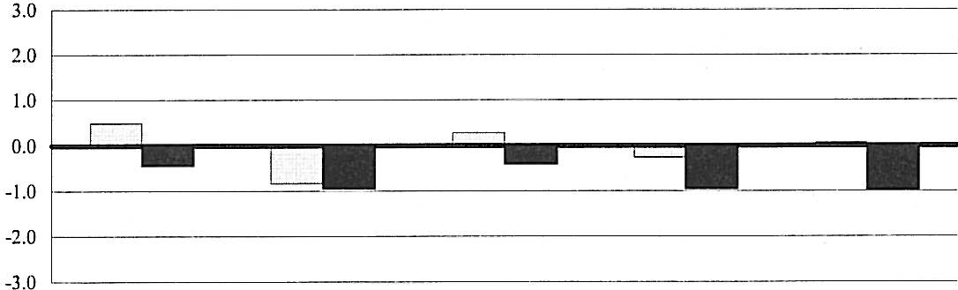
Standardized Residuals □First-Year
- Senior

Level of Academic Challenge
Active & Collaborative Leaming
Student-Faculty Interaction
Enriching Educational Experiences
Supportive Campus Environment

[ttJNational Survey of
_.. Student Engagement
��I'W'!IJI TheCollege Student Report

Notes to NSSE 2003 Institutional Engagement Index
The information in these notes will help in understanding the Institutional Engagement Index.
1 Supporting materials related to the Institutional Engagement Index, including the adjusted R² and regression coefficients, are available on NSSE's website at www.iub.edu/-nsse.
The actual score for Level of Academic Challenge reported here may differ somewhat from what is reported on previous pages in the Benchmark Report. The score in the Benchmark Report includes an enrollment status adjustment. This adjustment was not included here because enrollment status is included in the regression model to create the predicted scores for the Institutional Engagement Index.

³ The following student and institutional characteristics were included in an ordinary least squares regression model to produce the predicted benchmark scores: (a) public/private institutional control, (b) admissions selectivity rating from Barron ·s Profiles of American Colleges, (c) Carnegie Classification (d) undergraduate enrollment, (e) level of urbanization, (t) proportion full-time, (g) proportion female, (h) proportion of different races/ethnicities, (i) proportion of different student-reported major fields, G) mean student-reported age and, (k) proportion of students reporting on-campus residence. Unless noted otherwise, institutional and student characteristics were obtained from IPEDS data, the most complete database available. These student and institutional characteristics were included in the regression model since they are not easily changed.
⁴ Statistically speaking, the standardized residual is known as the studentized deleted residual or externally stud.entized residual. To understand how your institution's residuals compare to other NSSE institutions, refer to the table and chart below that applies to both the benchmark standard scores (page 5) and the standardized residual scores.

Understanding Standard Scores
A standard score of 1.0 indicates a score that is greater than approximately 84 percent of all institutions' scores; a standard score of .5 indicates the score is greater than about 69 percent of all institutions' scores. In contrast, a negative standard score of -.5 indicates the score exceeds about 31 percent of all NSSE institutions, and a standard score of -1.0 indicates the score is greater than only 16 percent of the scores of all other NSSE institutions.

-2.5 1%

100%

80%
A Standard ... indicates n score that
Score of...
is greater than npproximntely
of NSSE schools
%
Percent of Schools At or Below a Particular Standard Score

-2.0
-1.5
-1.0
-0.5
0.0
0.5
1.0
1.5
2.0
2.5
2%
7%
16%
31%
50%
69%
84%
93%
98%
99%
60%

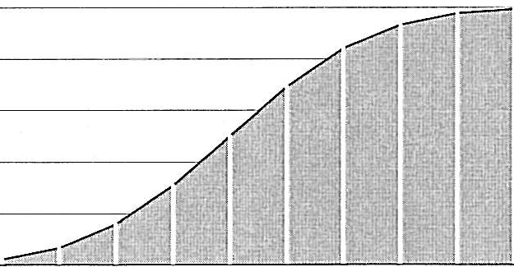
40%

20%

0%
-2.5 -2 -1.5 -1 -0.5 0 0.5 1.5 2 2.5
Standard Score
State University of New York-Stony Brook University IPEDS: 196097
page 8

