





Advancing Social Mobility and Academic Excellence

Braden J. Hosch, PhD
Asst. Vice President for Institutional Research, Planning & Effectiveness
Charles Robbins, DSW, LCSW
Vice Provost for Undergraduate Education and Dean of the Undergraduate Colleges
1

Overview
Institutional Profile
- Profile | Graduation rate improvement
Mobility Report Cards (Chetty, et al.)
- Method | Rankings | Geography | Parents’ income
Why is Stony Brook so successful?
- Value proposition | Geography | Programs
Student Success Strategy & Programs
- Leadership | Analytics | Success Programs | Male Student Success

2

Stony Brook University Institutional Profile

3

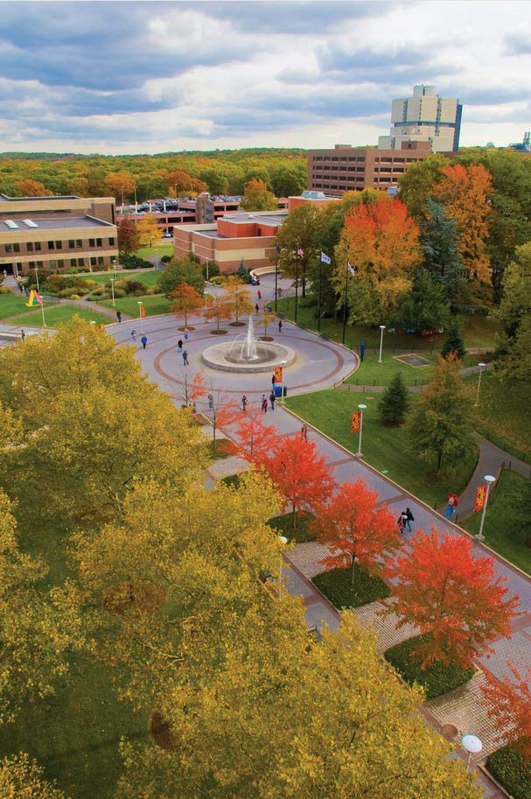
4 4


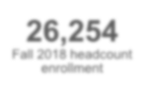


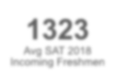

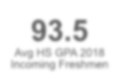

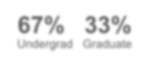

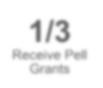

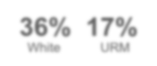

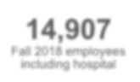

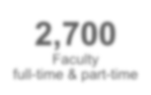

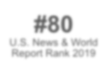

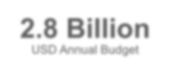
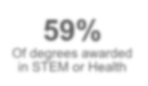
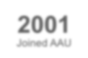
Stony Brook University Profile
26,254
Fall 2018 headcount enrollment
1323
Avg SAT 2018
Incoming Freshmen
93.5
Avg HS GPA 2018
Incoming Freshmen
36% 17%
White URM
1/3
Receive Pell Grants
67% 33%
Undergrad Graduate
14,907
Fall 2018 employees including hospital
2,700
Faculty
full-time & part-time
#80
U.S. News & World Report Rank 2019
2001
Joined AAU
59%
Of degrees awarded in STEM or Health
2.8 Billion
USD Annual Budget

Freshman graduation rates increased fifteen percentage points in the last five years
15
Percentage point increase in 4-yr grad rate over 5 years
Top 3%
of colleges or universities for improvement over a 5-year period

Six-year grad rate
63%
47%

Four-year grad rate

62%

40%
74%

Fall of Entry
2002
2009
2014

5

Economic benefit to students
1,300
additional students graduated on time

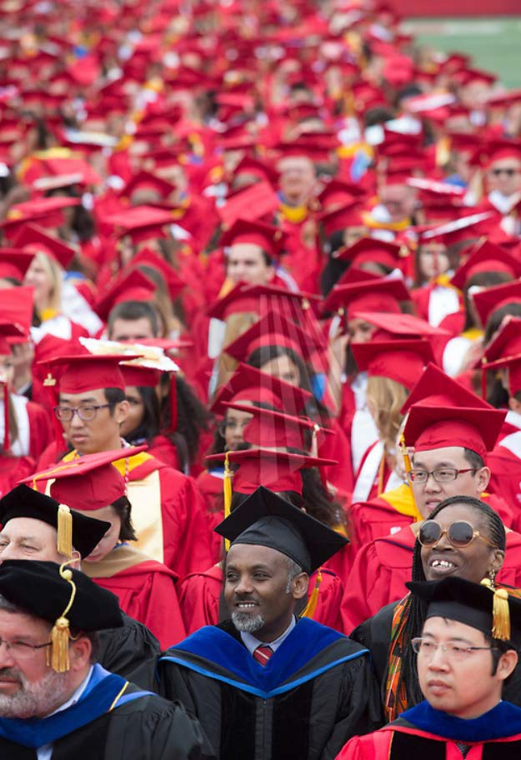
$88 million
economic benefit to students

$16 million saved in tuition & fees
$72 million in additional earning capacity

6 6

Equity gaps in graduation rates are largely closed
4-year grad rate (2014 cohort) 6-year grad rate (2012 cohort)
78%
68%
70%
73% 71% 72%
72% 76%
57%
58% 62% 61%
62% 64%

7
Women
Men
Black
Hispanic
White
No Pell
Pell
Women
Men
Black
Hispanic
White
No Pell
Pell

Mobility Report Cards:

The Role of Colleges in Intergenerational Mobility

Raj Chetty, Stanford University John N. Friedman, Brown University Emmanuel Saez, UC-Berkeley Nicholas Turner, US Treasury
Danny Yagan, UC-Berkeley

January 2017, Stanford Center on Poverty & Equality

8

Mobility Report Card Research Approach
Research question
- What role do colleges play in intergenerational income mobility?
Primary Sample
- 11 million children born 1980-82 claimed as dependents by tax filers in the U.S.
Data source
- De-identified data from 1996-2014 income tax returns
- Attendance data reported by institutions to IRS on Form 1098-T
Focus on change in percentile ranks
- What proportion of students from bottom fifth of parental income distribution reach the top fifth of graduate income distribution?

9 9

Mobility Report Major Findings
Differences by Sector
Elite institutions provided low-income students with most access to top 1%
Comprehensives and community colleges provided most access to top 20%
[Stony Brook is an exception]
“Overplacement” Not a Concern
Low-income students exhibited similar outcomes to peers at selective institutions
When they got in
Solutions to mobility may reside in comprehensive sector
Because Cal State and CUNY exhibit high mobility rates look there for answers
[I will complicate this in a moment]
Access declining at high mobility institutions
Calls for some reconsideration of aid policies, state support
New America follow-up

10

Stony Brook’ calculated mobility rate

Mobility

Access
16.5%

of students came from the lowest quintile of family income
(under $25,000)

Success

X =
54.5%
of these students reached the top quintile of graduate income in their 30s (over $58,000)

Rate

8.4%
Stony Brook ranked #3 among all
institutions and #1 among highly selective institutions

Median income of all Stony Brook graduates in their 30s: $64,700
Source: Chetty, et al. online data table 3, amounts are 2015 dollars, adjusted by CPI-U. Graduate income is a non-zero median.

11

Stony Brook ranked #3 on social mobility rate; #1 among highly selective universities

Rank | Name | Mobility Rate = | Access X | Success Rate
1 | Cal State, LA | 9.9% | 33.1% | 29.9%
2 | Pace Univ. | 8.4% | 15.2% | 55.6%
3 | Stony Brook U. | 8.4% | 16.5% | 51.2%
4 | Technical Career Insts. | 8.0% | 40.3% | 19.8%
5 | U of Texas – Pan American | 7.6% | 38.7% | 19.8%
6 | CUNY System | 7.2% | 28.7% | 25.2%
7 | Glendale Comm. Coll. | 7.1% | 32.4% | 21.9%
8 | South Texas College | 6.9% | 52.4% | 13.2%
9 | Cal State, Poly.-Pomona | 6.8% | 14.9% | 45.8%
10 | U of Texas – El Paso | 6.8% | 28.0% | 24.4%
Access: share of children at a college with parents in the bottom quintile of the income distribution
Success rate: share of children with parents in the bottom quintile of the income distribution that reach the top quintile of the income distribution
Source: Published Table III (Table IV in later versions) Many institutions rolled up into systems
12

Association between geographic location and mobility rate
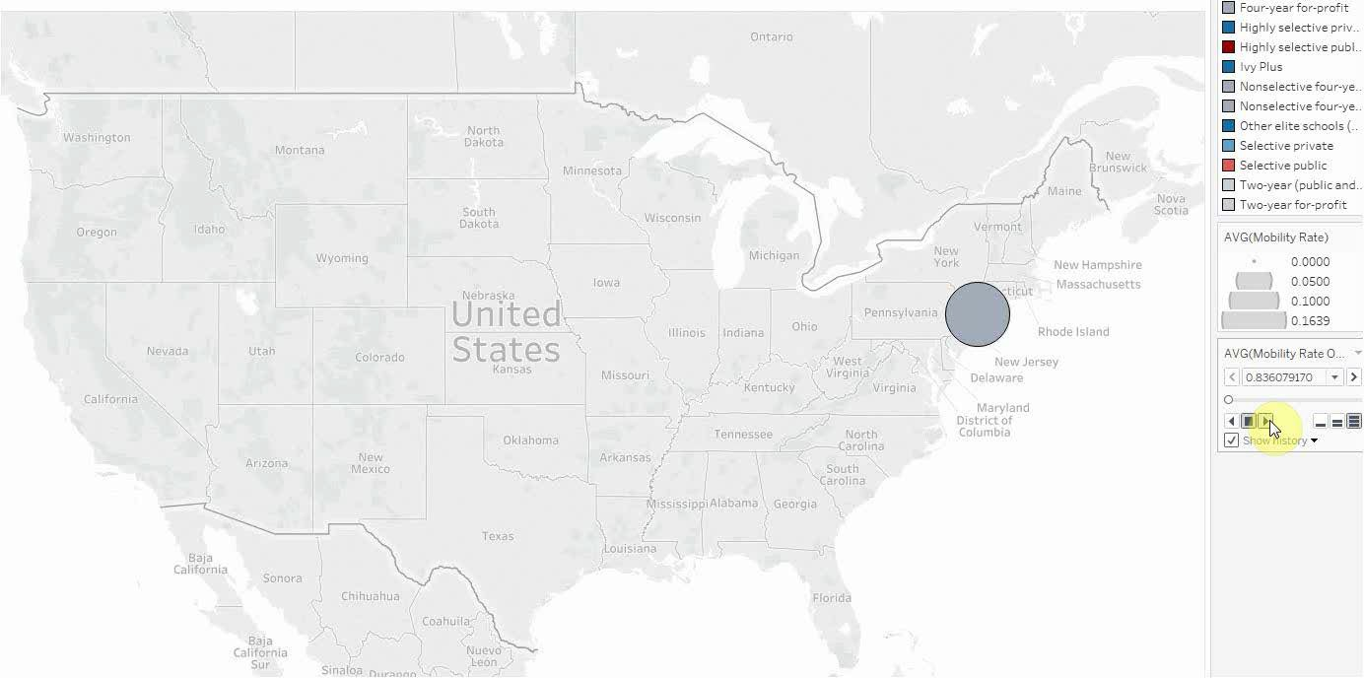

Source: Chetty, et al. (2017) Web data table 3 13

Consolidation of public systems masks some of the data
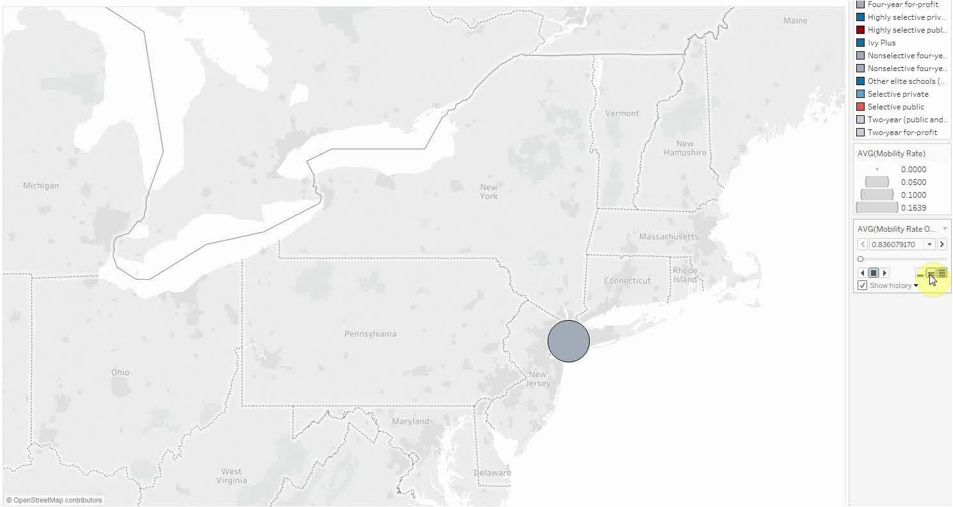

Source: Chetty, et al. (2017) Web data table 3 14

Change in access at Stony Brook requires context

$75,100
Median parental income
$88,300

38% 40%

Pell Pct US students 40%

17%
Parents in
37% 37% 35%
Pell Pct a20%ll UG

bottom income
11%
studen0% ts

quintile

Birth cohort College mid-point
1980
2000-01
1991
2011-12
1998
2018-19

Source: Chetty, et al. (2017) Web data table 3; Stony Brook Institutional Research; submissions to IPEDS 15

Stony Brook remained among the most accessible highly selective institutions
Name | Birth Cohort 1980 |  | Name | Birth Cohort 1991
Name | parent income ($) | rank | Name | parent income ($) | rank
Name | parent income ($) | (out of 157) | Name | parent income ($) | (out of 157) | Δ
Stony Brook | 75,100 | 1 | UC-San Diego | 82,000 | 1 | 42
Illinois Inst Technology | 84,900 | 2 | Stony Brook | 88,300 | 2 | -1
UC-Irvine | 86,200 | 3 | UT Dallas | 89,800 | 3 | 8
Stevens Inst Technology | 87,300 | 4 | Kettering U | 92,700 | 4 | 24
Milwaukee Sch Eng. | 88,100 | 5 | Milwaukee Sch Eng. | 93,600 | 5 | 0
U of Tulsa | 88,800 | 6 | U Wisconsin System | 95,700 | 6 | 2
U Pittsburgh System | 89,500 | 7 | Loyola U New Orleans | 96,300 | 7 | 39
U Wisconsin System | 95,100 | 8 | UC-Irvine | 98,500 | 8 | -5
Bennington College | 96,600 | 9 | Illinois Inst Technology | 99,100 | 9 | -7
Loyola U Chicago | 96,600 | 9 | Gustavus Adolphus C | 101,800 | 10 | 34

Source: Chetty, et al. online data table 3, amounts are 2015 dollars, adjusted by CPI-U; selectivity tiers include highly selective, Ivy
+, and other elite institutions, excludes institutions with data missing in either year. 16

Why is Stony Brook so successful with social mobility?

Value Proposition
Geography
Programs & Strategy

17

Stony Brook’s Value Proposition
2018-19 Undergraduate Tuition & Fees – Public Research Universities in Northeast

Nonresident
20,030

18,499

18,454

18,078

15,887

15,730

14,974

14,138

10,099

9,625

Vermont Connecticut Penn State Massachusetts New Hampshire Pittsburgh Rutgers
42,516

38,098

34,858

34,570

33,879

33,002

31,282

30,858

27,769

27,295
Rhode Island Buffalo Stony Brook

Pittsburgh New Hampshire
Penn State Vermont Massachusetts Connecticut
Rutgers Rhode Island
Buffalo Stony Brook
Resident

Source: Institutional web sites; consistent with IPEDS Data Center 18

Value Proposition – US News Rank vs. Tuition & Fees

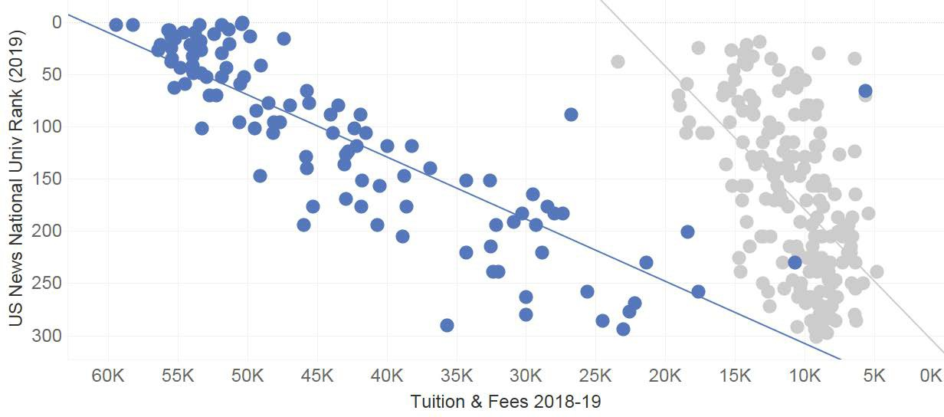


Stony Brook
$9,625 #80

Private Public
Source: US News and World Report, IPEDS Data Center 19

US News Rank vs. Mobility Rate
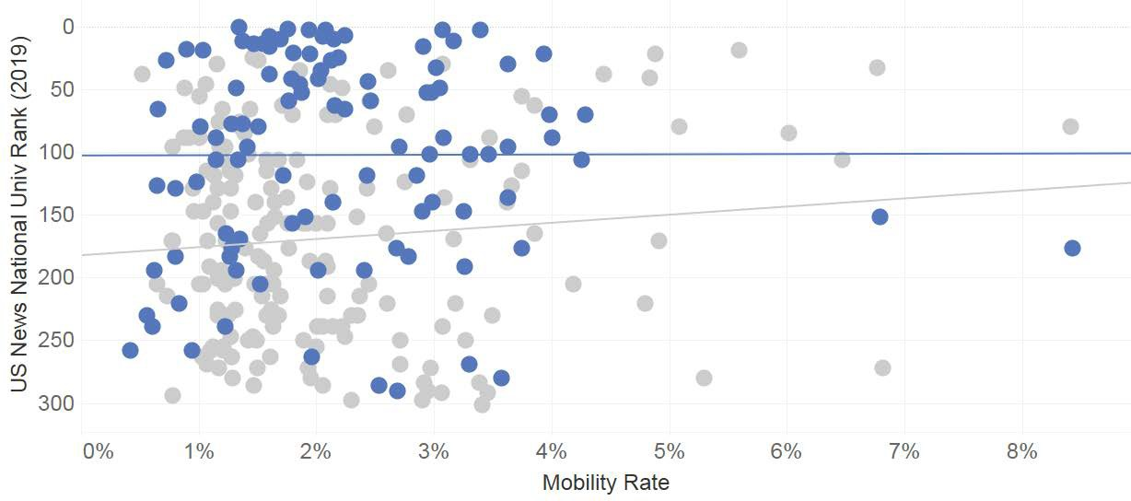
UC-Berkeley UCLA

UC-San Diego
UC-Irvine
Stony Brook

UC-Riverside Binghamton
NJIT

U of Houston

Cal State Fullerton

TX A&M
Kingsville

St. John’s U (NY)

UT-El Paso

Pace U (NY)

Private Public
Source: US News and World Report; Chetty, et al. (2017) Web data table 3 20

Stony Brook’s Location
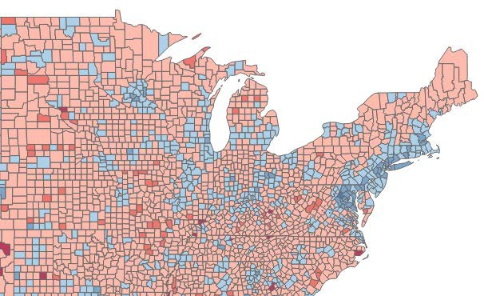
Access to dense HS populations with quality schools

16
public high schools in US News Top 100 located in NYC / Long Island

13%
of Stony Brook’s entering freshmen come from these 16 schools

57%
of these students received Pell grants

Access to hot labor market

Median earnings bachelor’s recipients, age 25+

NYC/Long Island
$63-75k median

U.S. = $52,519

Source: Stony Brook Institutional Research; US Census ACS 2017, 5-year estimates 21

Stony Brook attracts Pell recipients with academic backgrounds comparable to non-Pell recipients
Distribution of Entering First-Time Freshmen by HS GPA

Public 4-Year
Private, Not-for-profit 4-Year
Stony Brook
55%

43%
41%

33%

42%

40%

45%

Pell No Pell
40%
51%
38%

Pell 18%
16%

25%

Pell 14% 12%
32%

Pell 9%

No Pell 10% 13%
9%
No Pell 6%
No Pell 7%

Below B- B- to B B to A- A- to A
HS GPA
Below B- B- to B B to A- A- to A
HS GPA

< 87 87-93 93+
HS GPA

Data sources: NCES Beginning Postsecondary Student Survey 2012/14, Stony Brook IR Office (fall 2014 cohort) 22

Stony Brook attracts Pell recipients with academic backgrounds comparable to non-Pell recipients
Six-year bachelor’s completion rates of first-time undergraduates by HS GPA

Public 4-Year
Private, Not-for-profit 4-Year
Stony Brook

Pell

67%
No Pell
63%
50%
38% 41%
24%
27%
27%

77%

Pell
Pell
No Pell
62%
53%
46%
35%
30%
43%
37%
No Pell

63%
54%

75%
68%
84%
81%

Below B- B- to B B to A- A- to A
HS GPA
Below B- B- to B B to A- A- to A
HS GPA
< 87 87-93 93+
HS GPA

Data sources: NCES Beginning Postsecondary Student Survey 2004/09, Stony Brook IR Office (fall 2014 cohort) 23

Student Success Strategy & Programs

24
24

Leadership and Academic Success Team

25

The President made success a priority

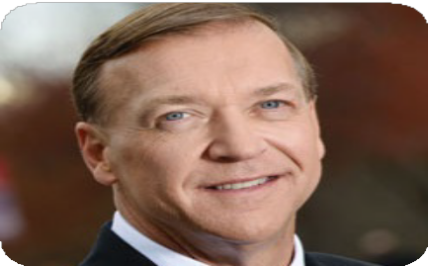

President Stanley participated in the White House Conference in January 2014 and announced that we would achieve a 60% 4-year graduation rate by 2020

While we embraced the challenge – we understood it would be a stretch goal!

26

27

Improvements realized through multi-pronged approach
Academic success team
Inst. Research
- Expansion
- New mission
Analytics
- In-house
-3rd-party
Academic Success Center
Policy reform
- Class retake
- Registration expectations
Finish in Four
- Mini grants
- Student-facing app
Segmentation
- Men
- GPA 2.0-2.5
- Behind in credts
Advising
- Expansion
- Focus on 3rd & 4th yrs.
Courses
- Class availability
- High DFW classes

27

Broad-Based Academic Success Team

Goals
Systematic 360 degree review

- Improve student outcomes
  - Retention
  - 4-Year graduation rate
- Improve quality of undergraduate
- All policies and procedures affecting student success

experience
Values and approach

- Student-centric
- Data-informed
- Evidence-based practices
- Predictive analytics
- Public health/population health model
- Vice Provost UG Ed.
- Advising (all units)
Broad Representation
- Bursar
- Career Center
- Deans Offices
- Enrollment Mgmt.
- Finance
- Financial Aid
- Information Technology
- Institutional Research
- Orientation
- Registrar
- Special Programs
- Student Affairs
- UG Colleges

28

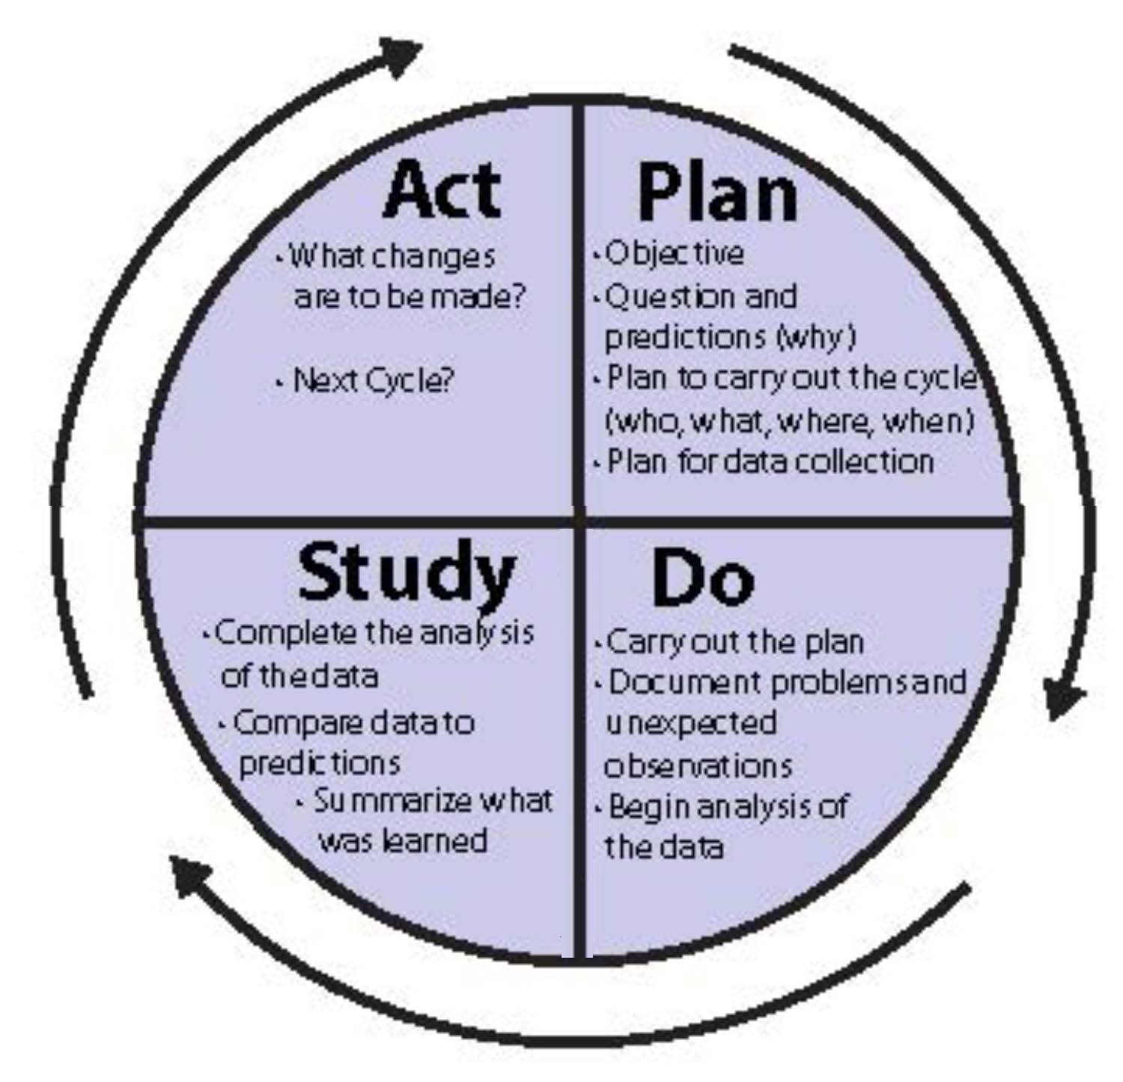

PDSA Cycle for Learning and Improvement

The Plan, Do, Study, Act model developed by Arthur Deming (1950) and incorporated into quality improvement across many industries including health care and education is the basis for Academic Success Team Activities.

29

Data, Research, and Analytics

30

31

Address Courses with Higher DFW Rates

Top 18 Fall 2010 courses
23.5%-37.9%
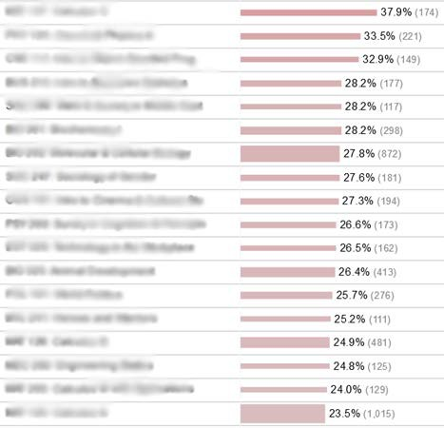

Top 18 Fall 2018 courses
17.5%-27.9%

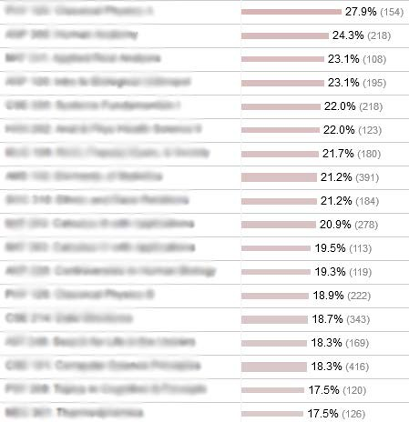

31

32

Predictive Factors: 1st Term GPA
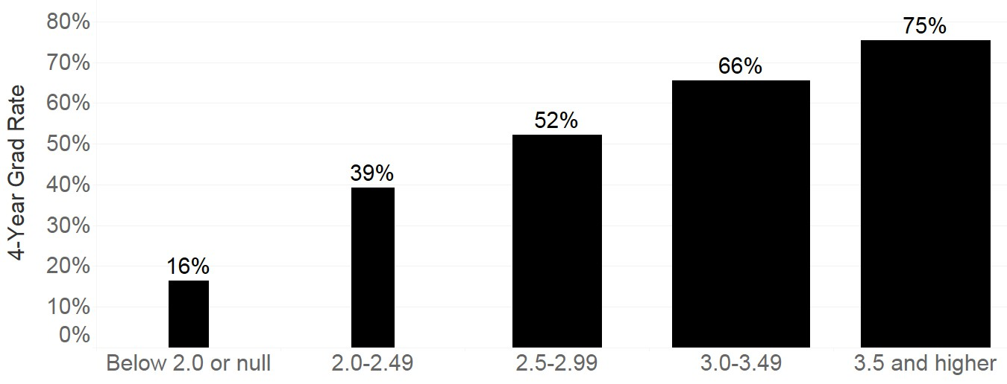
1st Semester Grade Point Average
Earning no course grades of “A” in the first term was more predictive of departure than earning a D, F or W

Avg. of cohorts entering in 2012, 2013, and 2014. Bar width represents number of students in group
Source: IRPE FT FT grad rate data set v23 32

33

Predictive modeling – significant factors*
Demographics
- Gender
- Race/ethnicity

- geographic residence when admitted.
Pre-college academic characteristics
- SAT scores

- high school GPA

- average SAT scores of the high school (to control for high school GPA).
College academic characteristics
- Credits accepted when admitted
- AP credits

- number of STEM and non-STEM courses current term

- enrollment in high DFW courses
- area of major.
Transactions, service utilization, activities.
- Learning management system (LMS) logins
- advising visits

- tutoring center utilization

- intramural and fitness class participation

Financial aid
- Expected family contribution AGI

- types and amounts of disbursed aid

- Pell, Tuition Assistance Program (TAP).

* Card swipes entered into model but did not improve prediction of success 33

Student Success Programs

34

Educational Opportunity Program / Advancement on Individual Merit (EOP/AIM)

Comprehensive support services
for students whose educational and economic circumstances have limited their college opportunities

Financial Support
$450/term book stipend + small living cost grant

Summer Academy
Mandatory 5 week academically intensive preparation program for incoming freshmen

1-on1 Counseling
EOP students assigned a specific advisor for personal, career, academic, and financial aid counseling

Tutoring Program
Academic support is a key component to EOP success

Mentoring Program guidance and support through peer interaction

Program Success
No gap in completion rate with non-EOP students

35

STEM Success Programs
Collegiate Science and Technology Entry Program (CSTEP)
- NY Dept. of Education program to increase URM and income-eligible students in scientific, technological, health, and health-related fields
Louis Stokes Alliance for Minority Participation (SUNY LSAMP)
- NSF funded alliance program to increase URM students pursuing careers in science, technology, engineering and mathematics
S-STEM ASSETS
- NSF funded program for transfer students with associate’s degrees pursing STEM degrees but identified as likely to need additional support
Women in Science & Engineering (WISE)
- Program to increase number of women in science, math and engineering fields through outreach, recruitment and retention efforts

36

Stony Brook Strong – First Generation Program

Based in Residence Life
Focused on understanding the strengths students bring to their educational experience.

StrengthsFinder inventory (Gallup)

Work with a dedicated advisor to receive support and resources

Paired in first two weeks of classes

Review StrengthsFinder results and proactively connect with resources

37

Finish in Four Initiative
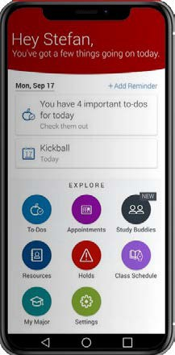
Fall of Entry
2017
2002
40%
90% 2nd fall
83% 3rd fall
80% 4th fall
63%
4-yr grad rate
87%
73%
69%
Retention:
Class Advisors Advisors to students in 3rd & 4th years improved retention after the 2nd year and on-time graduation
98%
Success Rate
Mini-Grants Mini-grants are made to seniors with unexpected
financial need and a clear path to 4-year graduation
Student Mobile App Provides students with reminders, real-time alerts, and planning tools

38

Financial Aid
NY State Tuition Assistance Program (TAP)
- Provides 45% of undergraduates with up to $5,165, plus additional support from campus
- Audit in 2012 found aid disbursed for courses not directly required by first major
NY Excelsior Scholarship program
- Covers tuition for NY residents up to $125,000 in family income
- Restrictions apply. Requirements differ from TAP
Registration review procedures
- Financial aid compliance placed increased review of student registrations
- Schedule review and certification at individual level

39

The Missing Men At Graduation

40
40




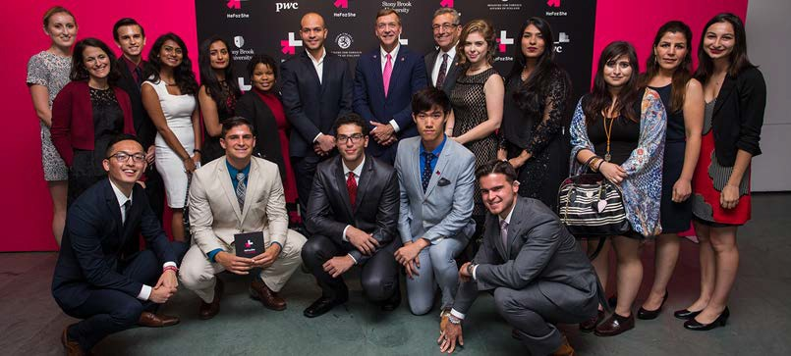
41

41

Four-Year Graduation Rates by Gender

Gender Gap

2006*

2018**
Men Women

Men Women
58%
32%

* Freshman entering in fall 2002
** Freshman entering in fall 2012

49%

17%

69%
11%

42

Context

- As early as elementary school concerns about ‘the boys’
- More recently colleges/universities
- Not all men…enough to be concerned about
- Societal & employer concerns
- Background in men and masculinities

43

Male Completion Sub-committee

Goal: understand factors that contribute to gap and develop interventions

Broad-based group; meets weekly

Literature review

Focus groups/individual interviews

Center for the Study of Men and Masculinities

44

Who is a role model for what it means to be a full-hearted man in the 21st Century?

45





46
46

Issues that emerged from the literature review/focus groups/interviews
Masculinity/Toxic masculinity & higher education
Emotional and developmental readiness – frontal lobe
Lack of focus
Inadequate academic preparation

47

Issues that emerged from the literature review/focus groups/interviews

Inability to deal with frustrations

Inability to delay gratification
Financial realities of higher education
Never previously experienced anything close to failure
Inability and unwillingness to ask for help

Impact of alcohol and drug usage

Immersive video games
Pornography and addictive masturbation

Poor decision making

48

Raising Campus Awareness
Communications Campaign
Presentations to

- President’s Cabinet
- Advising Units
- University Senate
- Student Affairs Professionals
- RA Training
- Athletic Leadership Council
- Fraternity Council

49

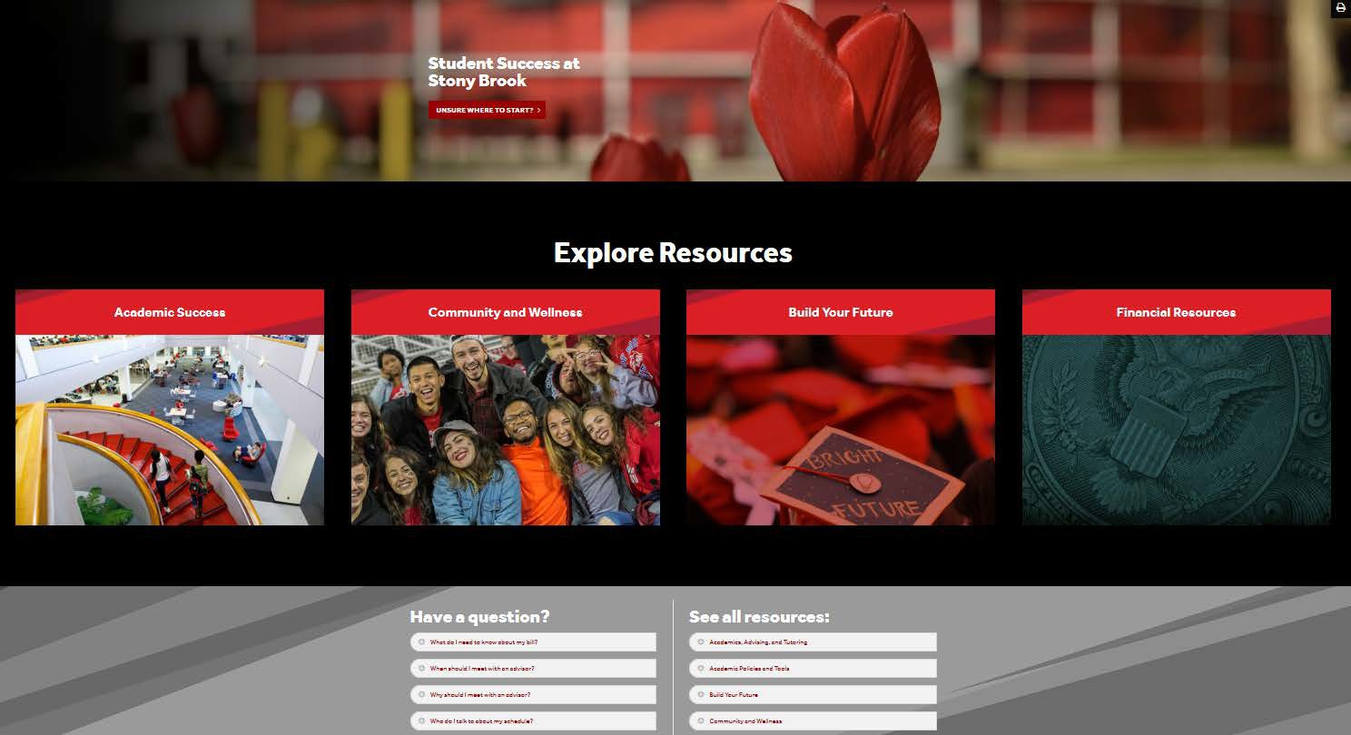
Student Success Website

Aggregates relevant resources

***

Focus group tested with men

***

Mobile optimized

50

Initial Interventions

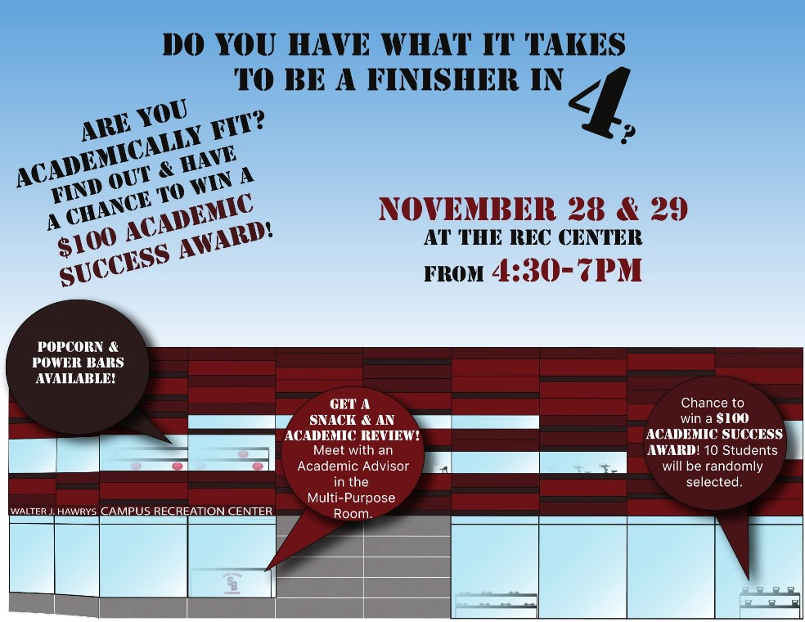
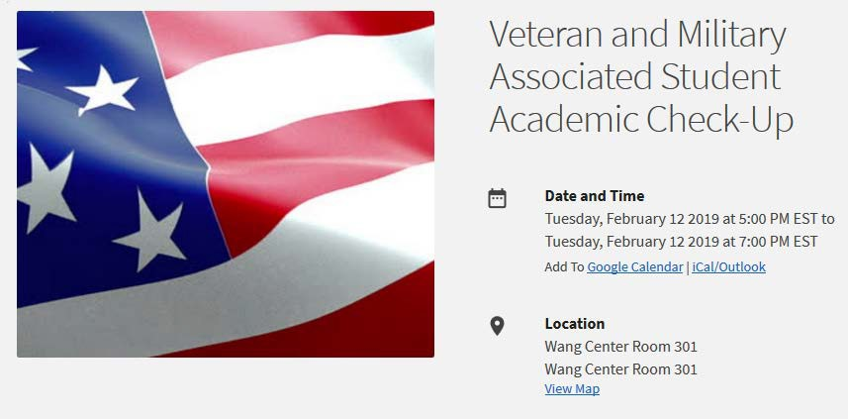
Pop-up advising

Academic check-ups for Veterans

51

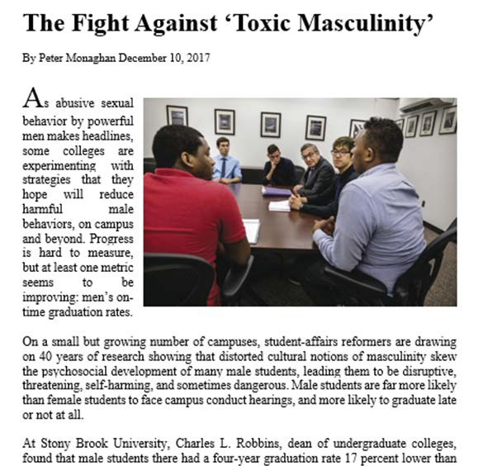
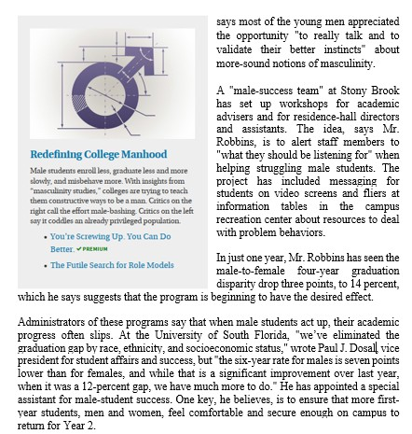

52
52

Next Steps to Improve Male Success
Working with men to diminish the impact of negative thinking and behavior will benefit everyone

Continue to engage with male students to refine understanding

Engage other Universities
- SUNY
- University of South Florida
- APLU (SBU, UMBC, USF, UVM)

Corporate Impact Champions

53

Conclusions
Achievements
- Most equity gaps closed
- Improvement is in top 3 pct of 4yr institutions
- 15 point increase in 5 years
Full-Court Press
- Implemented any initiative we could identify
- Annual investment of hundreds of thousands of dollars
- Senior leadership commitment
Lessons learned
- Telling the story of “One Thousand and One Initiatives” presents challenges
- No magic bullets
- Change requires sustained effort

54

