

Creating Tableau Dashboards with IPEDS Data: How To, Tips, and Tricks
2016 Association for Institutional Research Annual Forum

Sean V. Hoffman, Institutional Research Analyst Office of Institutional Research, Planning & Effectiveness
Stony Brook University

GOALS

Goals

- To learn what data are available in the IPEDS data center, and how to retrieve them.

- To be able to use these data to create a basic benchmarking dashboard with Tableau.

- To review some advanced techniques for creating more useful and
informative visualizations in Tableau.

- To gain an understanding of how these dashboards can be used to aid in institutional research and planning.

AGENDA

Agenda

Tableau basics
The IPEDS Data Center
Building a dashboard – Admissions Data
  - Basic – Filters and calculated fields
  - Intermediate – Parameters and more calculated fields Advanced techniques
  - Comparison charts
  - Chart switching on a dashboard
  - Dashboard actions
Uses for Institutional Research Questions

TABLEAU BASICS

Tableau Desktop
- Create, manage, edit, and update workbooks locally. Can be deployed to a server (campus, public or online).
- Personal vs Professional – Need professional for DB connections
Tableau Server
- View and edit published workbooks in a secure environment Tableau Online
Tableau Public
- Free, but not secure Tableau Reader
- View and interact with dashboards
Backwards compatibility issues

IPEDS DATA CENTER: WHAT’S AVAILABLE
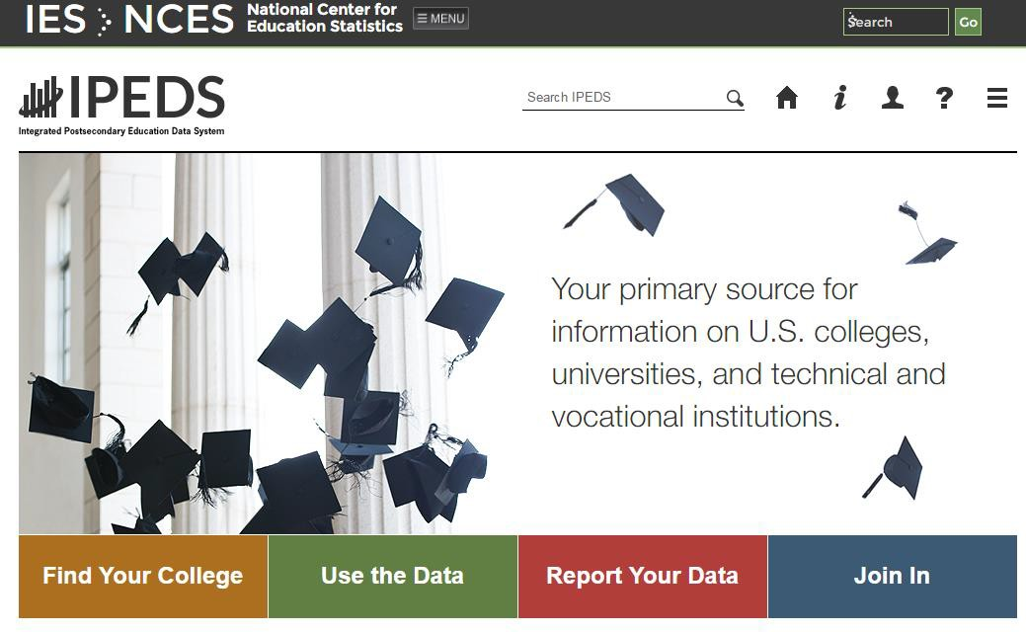
All data reported to IPEDS is available, as well as copies of
the actual surveys submitted
Find Your College
-College navigator
-College scorecard

Use the Data
-IPEDS Data Center
-Customizable, downloadable data

Report Your Data
-Log in to complete
surveys
-Collection Level Data Center (Most recent data available)

Join In
-Training
-Resources

IPEDS DATA CENTER: WHAT’S AVAILABLE

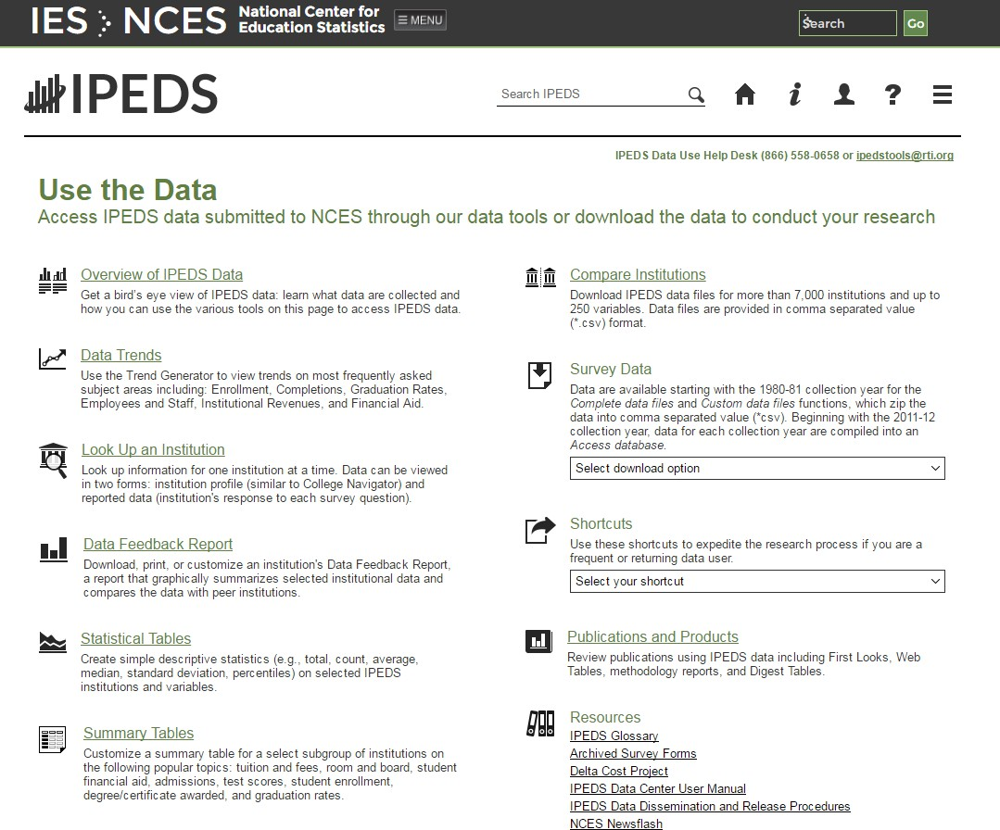
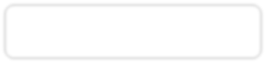
  - For this exercise we will use “Compare Institutions”

IPEDS DATA CENTER: WHAT’S AVAILABLE

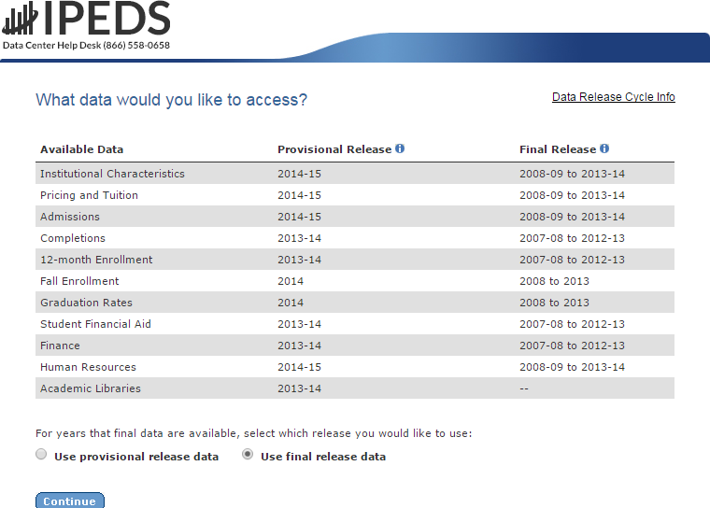
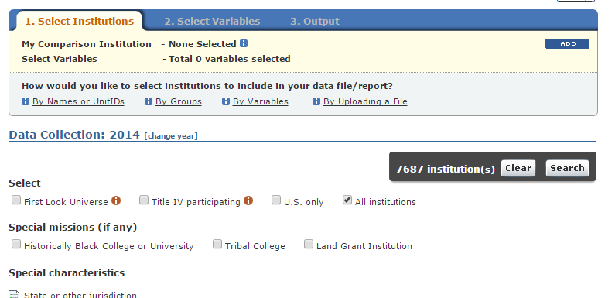
    - Data from all surveys are available (final or provisional)
    - Collection level data center allows access to current year (Go back to main page → Click Report Your Data → “Answer The Current Survey” → Log In → Click “Tools” → Click “Go to Collection Level Data Center)
    - Select institutions: can create groups, use groups, or download all (By groups → EZ Group → “All Institutions”)

IPEDS DATA CENTER: EXPORTING DATA

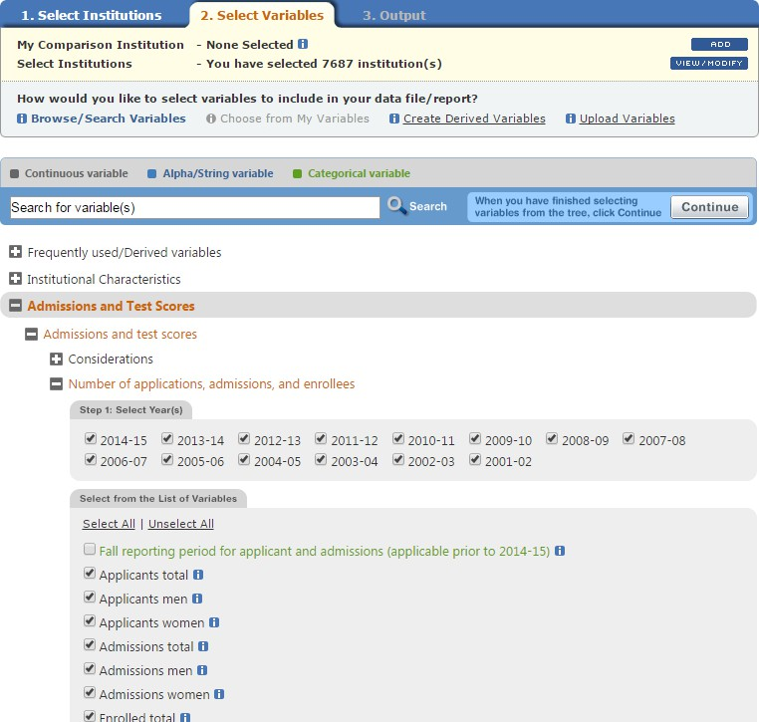
-Select the variables you would like (up to 250 for “Compare Institutions”)

-Click continue

-Download a CSV file

-You can create derived variables if you desire

IPEDS DATA CENTER: EXPORTING DATA

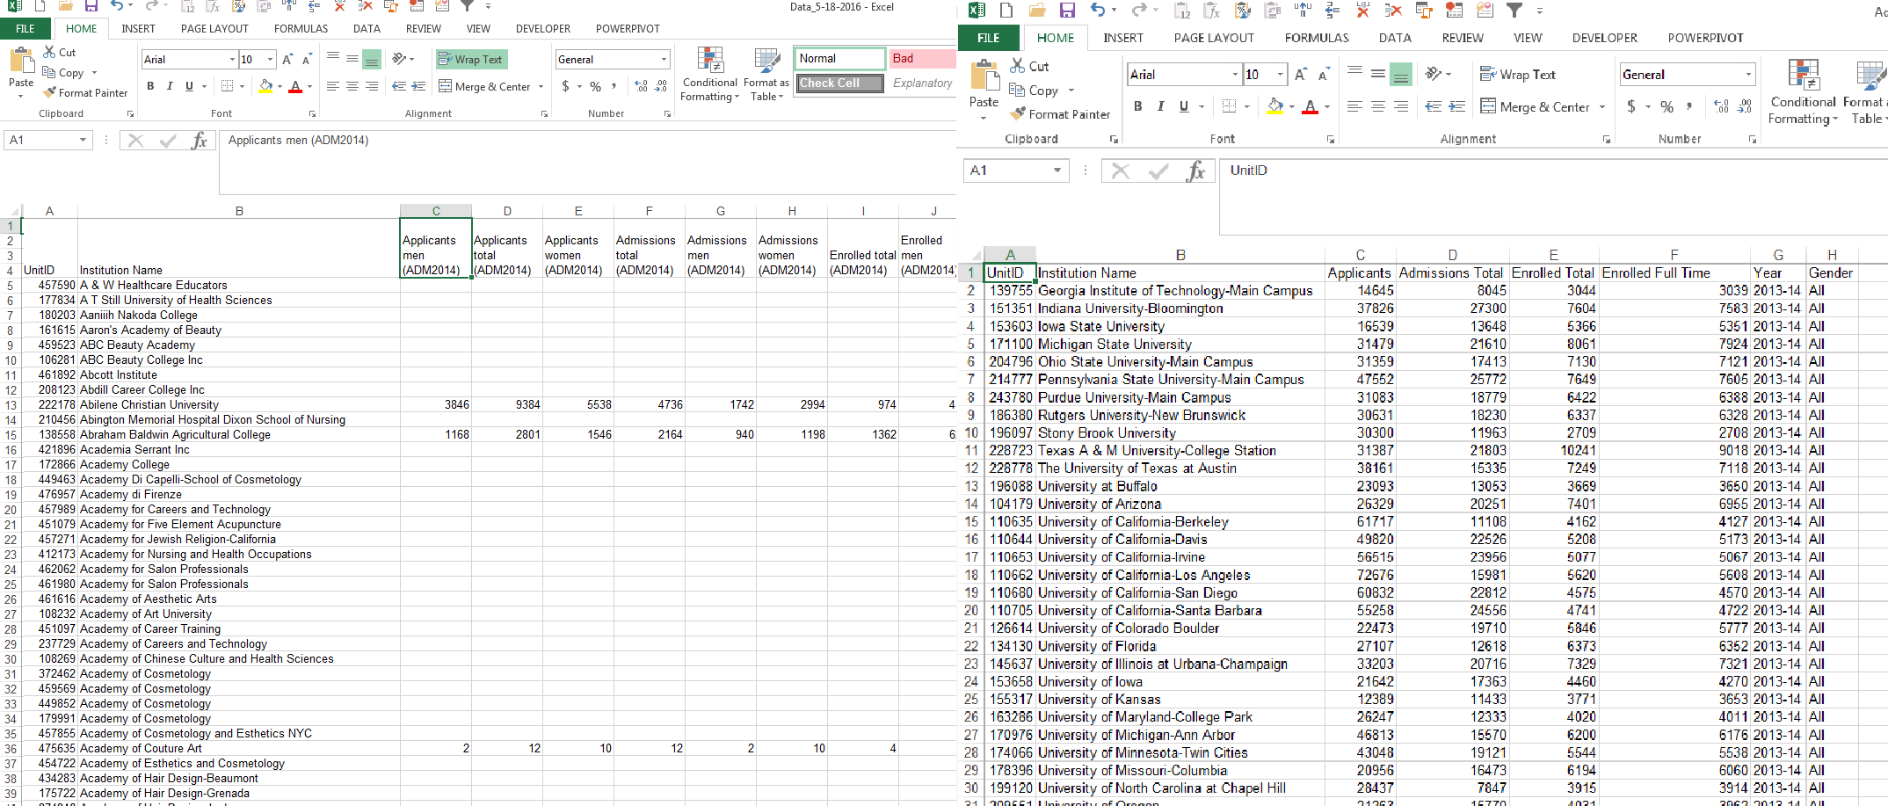
CSV from IPEDS Stacked Panel
-Each element is downloaded as a separate column. This file can be quickly chopped up to work well in Tableau.
-For this example, we can stack the panel based on year and gender, leaving only 8 columns. This will allow for a better layout in Tableau.

BASIC DASHBOARD: IMPORTING DATA

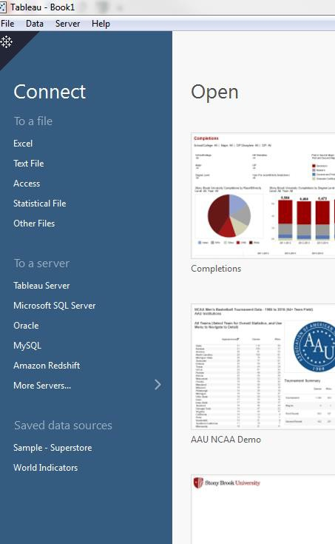
Connect to a file →
-You can edit the file and refresh
once you’ve started.

Connect to a server →
-Need Tableau Desktop
Professional
-Can create an extract

BASIC DASHBOARD

- Let’s begin with:

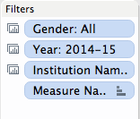
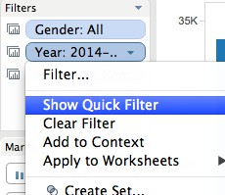
– Filters
» Filters are based off of certain fields (columns)
» Because of the way we stacked the example panel, we can
filter, gender, year and school
» To create, drag the item to the filter shelf. To show, right click and choose “Show Quick Filter”
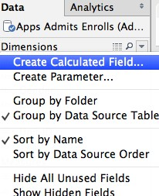
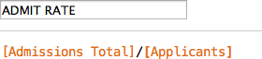
- Calculated fields
» Calculated fields are similar to excel formulas
» We can create fields to calculate admit rate and yield
» To create, right click in the data tab and select “Create Calculated Field”

- Now let’s create two charts based on the items we have:
- A column chart to display Applications, Admissions and Enrollments
- A table to display Admit rate and yield

BASIC DASHBOARD

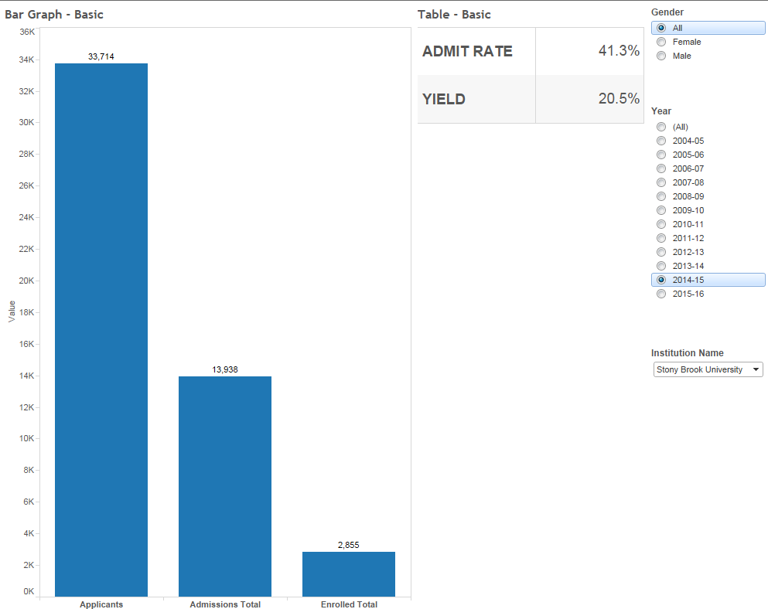
  - Now, we can create a new dashboard and add the two charts to it

  - Drag the sheets from the dashboard shelf to the dashboard page

  - All charts and filters from the sheets will be brought to the dashboard

  - We can select each object, and use the dropdown menu to choose to make the object floating (free placement)

SOME REFERENCE NOTES

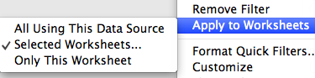
Notes about filters:
- A filter can be set to apply to a sheet, or all sheets using the same source. This allows for you to only need one filter with multiple charts
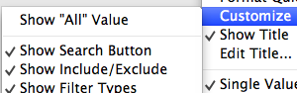
- A filter can be set to only show relevant values. This is helpful with long lists of related items. Example: Colleges/Schools and Majors
- Filters can be set to include an “All” option. In this example, it has been deactivated, as the data set already has an all option

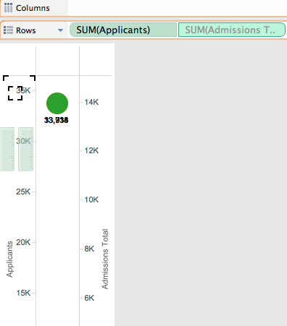

All options can be accessed from the drop down menu
on the quick filter

Notes about the charts:
- To add multiple measures to the measure shelf, start by adding two measures to the row shelf. Then drag one from the row shelf into the axis of the other. This will bring the measures shelf up, and allow you to add more measures directly to it.

INTERMEDIATE DASHBOARD

  - Here is another step to add some functionality to our dashboard. We will use a
parameter and calculated field to select one metric to display at a time.

– Parameter
» Parameters allow you to create more complex filters
» Let’s create a parameter to choose what specific metric we want to look at in a chart
» Create a parameter that allows you to choose from the strings: “Applications”, “Admissions”, “Enrollments”, “Admit Rate” or “Yield Rate”
» To create, right click in the data tab and select “Create Parameter”

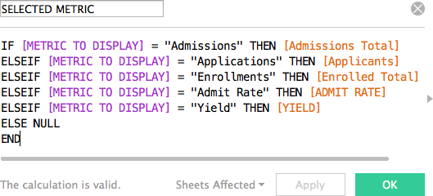
– Calculated field
» We can now create a calculated field that uses the parameter to select the item. For example, this field
will show Admissions if parameter selected is Admissions.
» This will be a multiple IF statement. In Tableau you must
end an IF statement with “END”

  - Now let’s update our dashboard!

INTERMEDIATE DASHBOARD

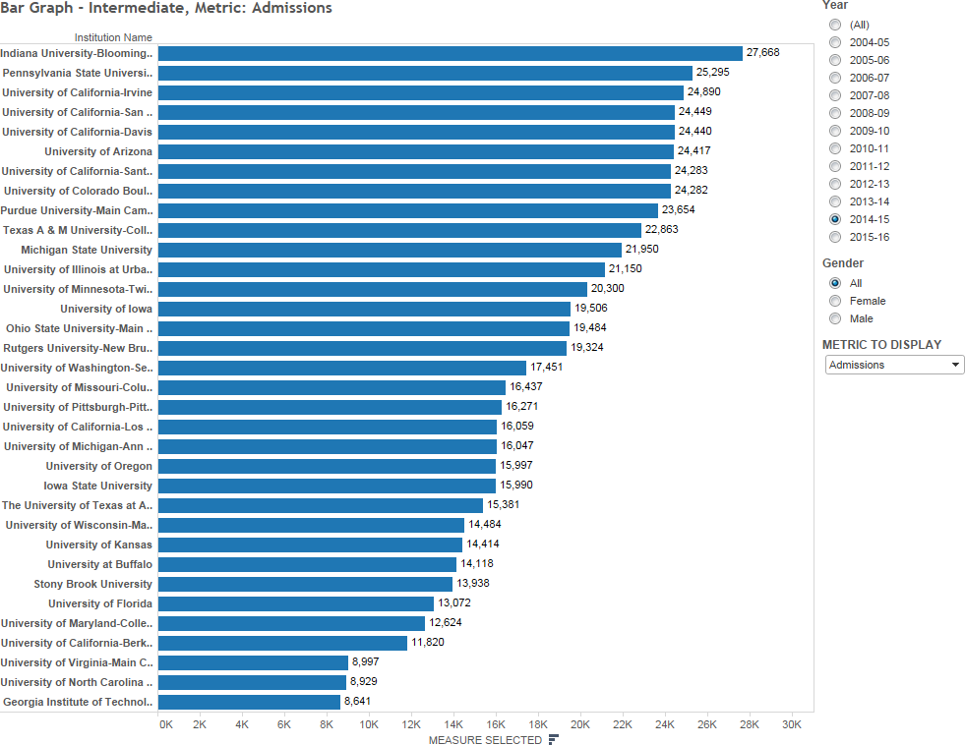
  - Observe that we do not need to store multiple metrics in multiple tables (or one table with multiple columns)

  - This can help when space is limited

  - This allows for easy benchmarking on one metric

LIMITATIONS

Limitations of the dashboard

- Benchmarking: What if we want to focus on our institution, or another selected institution?
- Data types: Our graphs and labels will not work for multiple data types
- Size and content: How much is too much for one dashboard?

Advanced techniques to address the limitations

- Comparison Charts – Create a benchmarking chart
- Chart Switching – Select a chart based on the data you wish to display
- Dashboard Actions – Switch between dashboards (or other links) and create
filters that pass between charts

ADVANCED: COMPARISON CHART

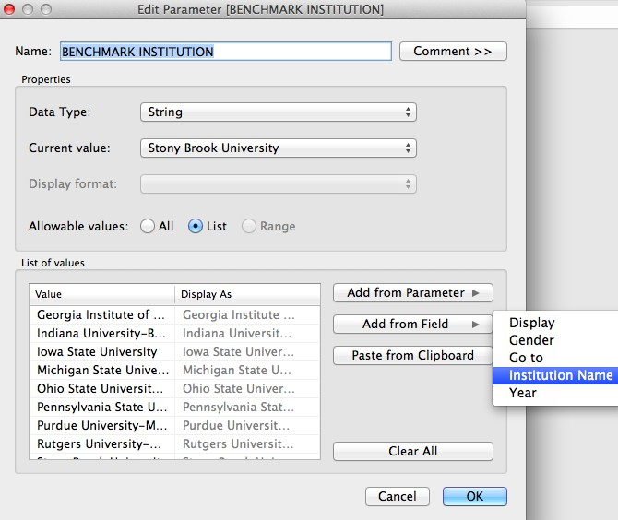
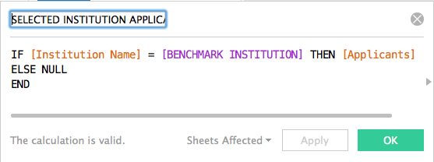
Goal – Highlight a selected institution and compare to the average (quartiles also possible)

Solution – Create a comparison chart
  - Step 1 – Add a parameter using the
Step 1
institution names field

  - Step 2 – Create a calculated field that sets its value based on the parameter. For example, create a parameter called: “Selected Institution Applications”

  - Step 3 – Set this field to be equal to the number of applications when the Institution Name field is equal to the parameter, and null otherwise. This will make sure this field only displays data for the institution you are interested in
Step 2/3

ADVANCED: COMPARISON CHART

Let’s examine how to merge this with the chart we created in the intermediate dashboard
  - In that chart, we created a calculated field to display our metric of choice.
  - Now, we will create another calculated field to display our metric of choice for our focus institution. For example, call the calculated field: “Selected Institution Metric”
  - We can then add both metrics to a chart, and create a dual axis chart.
  - To merge both axis, ensure both calculated fields are the same data type, by adding the float function to your calculated field: ( FLOAT(calculation) ) Not applicable for this data set.
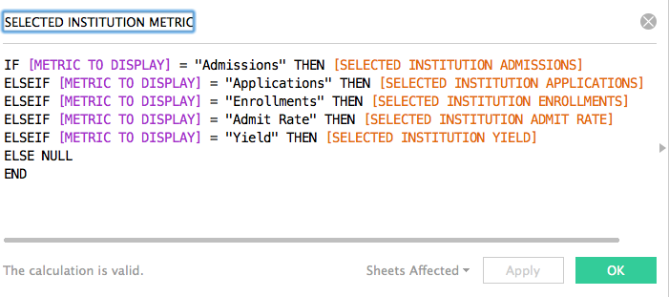

ADVANCED: COMPARISON CHARTS

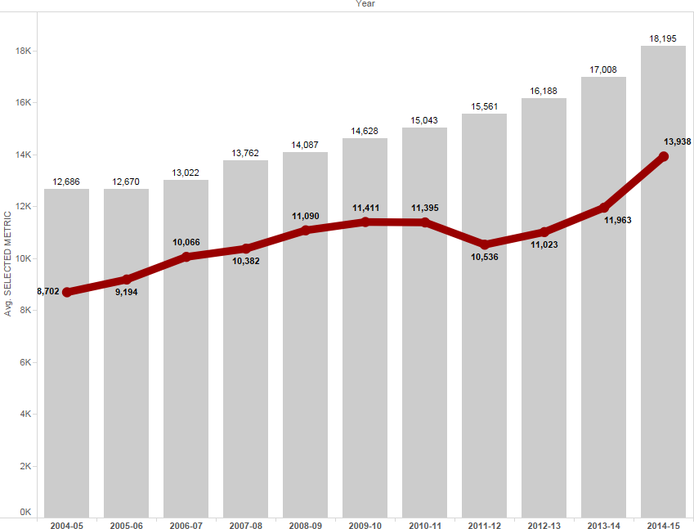
    - Gray = Average selected measure for all institutions – this is determined by the metric parameter

    - Red = Selected measure for our focus institution – determined by the metric and focus institution parameters

COMPARISON CHARTS

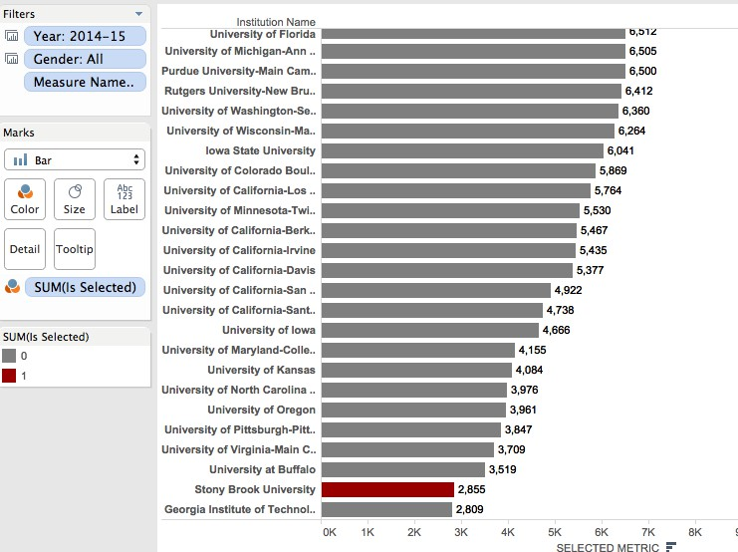
Alternate Comparison Chart

Highlighting the selected institution
  - Create a calculated field called “Is Selected”. This will be binary ( 1 or 0 )
  - Drag the field over to the color shelf, change it to discrete, and assign a highlight color to 1 and standard color to 0.

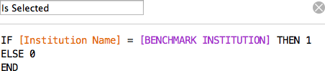

ADVANCED: CHART SWITCHING

Goal – Display all metrics in one chart area
  - This is made challenging by different data types, and different trend representations (we would like to trend admit rate along a reversed axis and yield along a regular axis).

Solution – Place multiple charts in the same location on the dashboard, and display only one at a time
  - This is will be done through the use of a parameter, a calculated field, and custom list filters.
  - For this dashboard, there will be three charts
- Admissions, Applications, and Enrollments displayed as numbers, trended along a regular axis
- Admit Rate displayed as a percentage, trended along a reversed axis
- Yield displayed as a percentage, trended along a normal axis
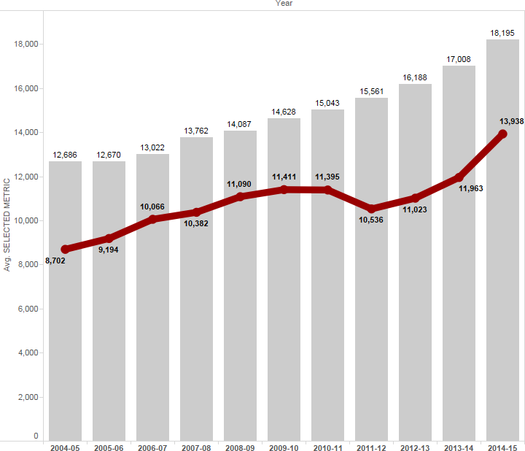
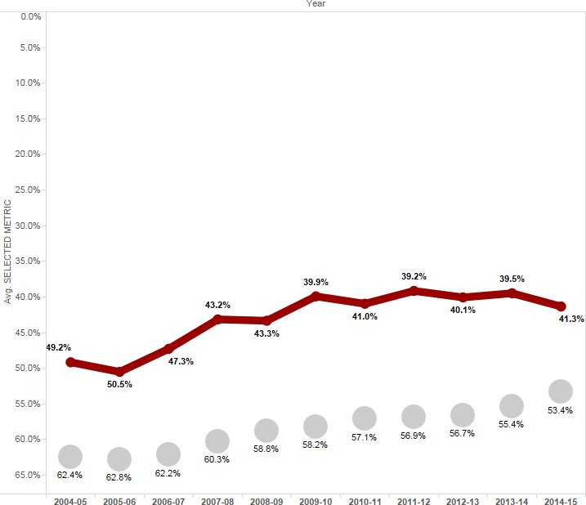
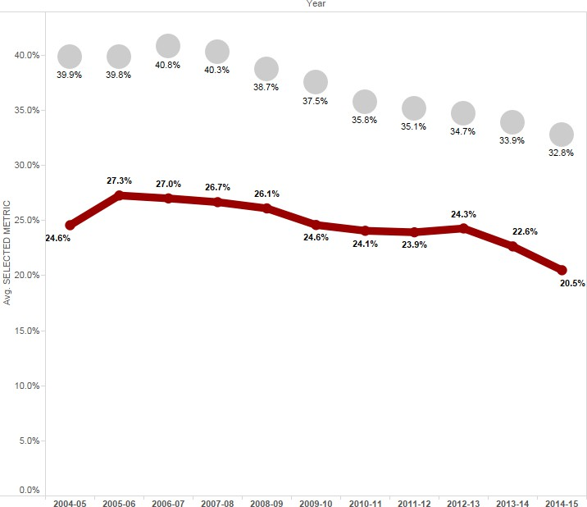

ADVANCED: CHART SWITCHING

Step 1 – Create all charts needed for the dashboard
  - Three, as mentioned previously

Step 2 – We will need a parameter that has the values we want to switch between
  - Use the parameter created in the intermediate dashboard

Step 3 – Create a calculated field that is equal to the parameter
  - This will help to switch between charts
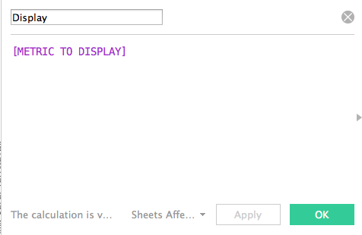

Step 4 – On each chart, add the calculated field as a filter, using a custom list. Set the custom list to the appropriate metrics for the chart

ADVANCED: CHART SWITCHING
- For example, the Admit Rate chart should have the calculated field filtered only on “Admit Rate”. When the parameter is switched to “Admit Rate”, it will trigger the calculated field filter and display any chart with “Admit Rate” filtered

Step 5 – Apply filters to all charts, and stack them on the dashboard
- As long as each value in the parameter is included in only ONE of the stacked charts, then only one chart at a time will be visible

Note: if chart titles are different, hide the titles, and use a separate sheet to create a universal title

To stack, set all charts to “floating” and place them at the same coordinate location, using the manual coordinate entry section of the dashboard (bottom left)

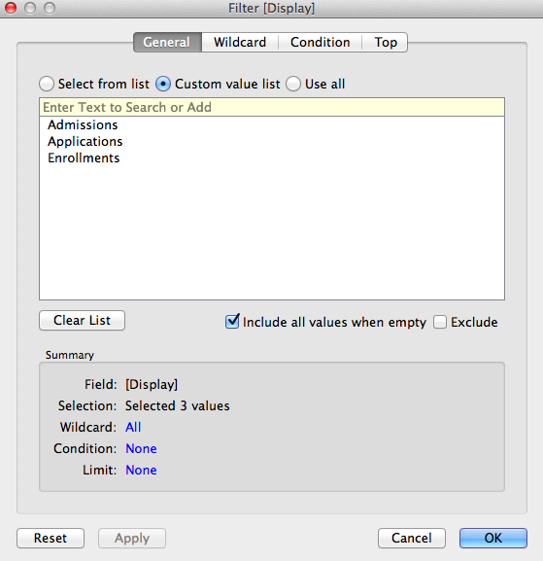
Filter for the Applications, Admissions, and Enrollments chart. The Admit Rate and Yield charts will only have one element each.

ADVANCED: DASHBOARD ACTIONS

Dashboard Actions

  - Actions allow for dynamic interaction between objects on dashboards

  - These actions can be used to communicate between sheets, dashboards,
and external objects as well

  - To add a dashboard action go to “Dashboard” → “Actions” → “Add Action”

  - All actions offer the choice to run on: Hover, Select, or Menu
    - Hover – When the mouse hovers over the target, the action will trigger
    - Select – When the target is selected, the action will trigger (the target will have to be unselected and then selected again to re-trigger)
    - Menu – When the target is selected, a menu will display, giving you the option to trigger the action

ADVANCED: DASHBOARD ACTIONS

Dashboard Action – Filter

For passing filters between sheets
  - Choose a source and a target. The source is the object being clicked, and
the target is what will be filtered.
  - For example, if there is a table showing all institutions, we can use a filter action to display institution detail when the name is clicked.
  - If the target sheet is on another dashboard, this will switch to that dashboard.

For switching between dashboards
  - Using the above knowledge, we can use the filter actions to navigate between sheets without passing filters as well. Simply choose all items as targets on the dashboard you wish to navigate to
  - Instead of using a chart as a source, a navigation button can be created by adding a calculated field with the value of “image”, and setting the mark type to Shape (see example Tableau workbook)

ADVANCED: DASHBOARD ACTIONS

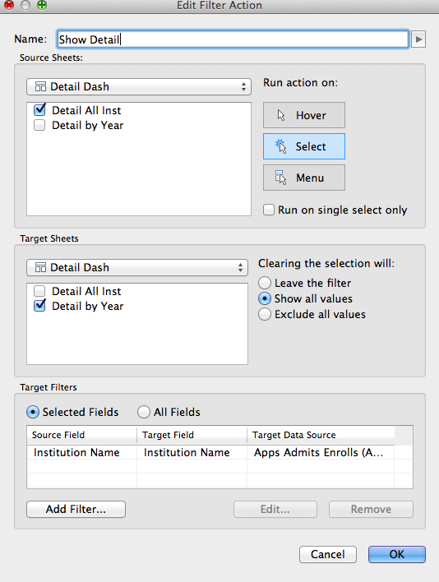
Dashboard Action – Filter

  - “Show all values” will pass the filter when selected, but remove it when the source is unselected (Exclude all will pass the filter as an exclusion filter)
  - “Leave the filter” will leave the filter until a different element of the source is selected
  - This filter will show the detail for institution name that is clicked on the “Detail All Inst” chart (Source). It will be displayed on the “Detail by Year” chart (Target).

ADVANCED: DASHBOARD ACTIONS

Dashboard Action – URL

  - URL actions all for navigation to external addresses, such as a webpage or a file on a file share
  - When adding the action, choose the target on the dashboard that will activate
the action, then input the URL. Dashboard Action – Highlight
  - Highlight actions allow for focusing on subsets of the dashboards. You can pass the action between sheets to filter a graph based on something clicked in a table
  - We will not add a highlight action to this visualization, but their uses are well
documented in the Tableau forums

USES FOR INSTITUTIONAL RESEARCH

Planning
- Examining position
- Trends and projections

Research
- Highlights areas of interest

Benefits
- Quick, relatively simple, and publicly available
- Well populated
- Customizable peer groups

Going further
- Adding institutional data (dashboard example on next slides)

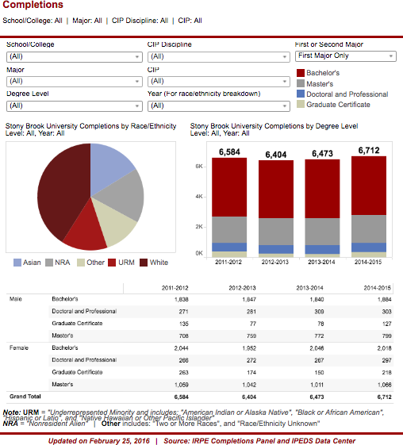
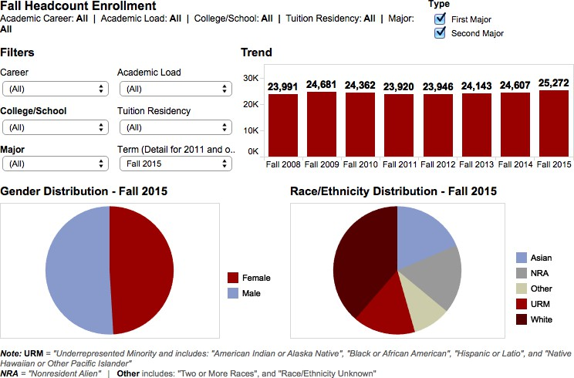
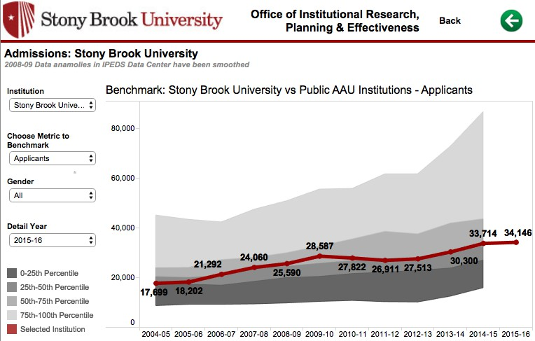

USES FOR INSTITUTIONAL RESEARCH

Questions or comments?

Feel free to contact me:
Sean Hoffman
Stony Brook University
Office of Institutional Research, Planning & Effectiveness sean.hoffman@stonybrook.edu
(631)632-1462

http://www.stonybrook.edu/commcms/irpe/index.html (Main IRPE site) http://www.stonybrook.edu/commcms/irpe/reports/ (Presentations) http://paintbynumbersblog.blogspot.com/2014/10/a-rough-guide-to-tableau-
dashboard.html (Dashboard Actions)
https://community.tableau.com/community/forums (Tableau Community Forums)

