Brookhaven National Laboratory
Leading Facilities for Innovation and Invention
Brookhaven National Laboratory
The Economic Engine of World-Class Science

Economic Impact Report

National Synchrotron Light Sources
NSLS provides intense beams of high-frequency light and sophisticated imaging techniques to capture nano-scale details of materials ranging from proteins to semiconductors, with more than 2,400 researchers from about 400 universities, labs, and companies using the facility every year. In 2015, NSLS will
be replaced by NSLS-II—10,000 times brighter and designed to advance technologies including hydrogen nanocatalysts and lithium-ion batteries.

Center for Functional Nanomaterials
The CFN provides state-of-the-art tools for creating and exploring nanoscale materials.
CFN scientists specialize in atomic-level tailoring of materials to address a wide range of energy frontiers, including solar cell technology, nanocatalyst synthesis and characterization,
and fabrication of biological materials.

Relativistic Heavy Ion Collider
RHIC smashes particles together at nearly the speed of light to recreate the conditions of the early universe. These collisions reveal the
fundamental building blocks of matter and unlock the secrets of the force that holds together 99 percent of the visible universe—everything from stars to planets and people.

Interdisciplinary Science Building
This hub for energy research offers customized laboratories for multidisciplinary research
that tackles the world’s most pressing energy and environmental challenges. Scientists at the ISB collaborate to engineer and optimize
breakthrough technologies for batteries, biofuels, and solar panels.
The technologies of tomorrow are tough to predict, but one thing is certain: innovation forms the foundation of a healthy economy. In an un-certain economic climate, the greatest opportunities for local, national, and global growth rest with the time-tested impact of large-scale research and devel-opment. Brookhaven National Laboratory’s discoveries at the most exciting frontiers of science
— from the fabric of the cosmos
to zero-emission vehicles — generate the kinds of unprece-dented, game-changing advances that help shape the future.
Owned and primarily funded by the U.S. Department of Energy’s Office of Science, Brookhaven Lab is one of New York State’s largest scientific research centers. Located on a 5,300-acre site in central Long Island, the Lab employs more than 3,000 full-time workers and is host to just as many visiting researchers each year
from universities, industry, and
government agencies that use its cutting-edge facilities.
The world’s foremost scientists join with the local workforce in the enterprise of exploration, including massive construction projects and ever-expanding support services. But beyond the hundreds of millions in federal funding coming to Long Island and the thousands of jobs created, Brookhaven Lab anchors New York as a leading center for innovation.
Breakthrough science also helps foster a sense of wonder and ambition in the Long Island community, bolstered by strong educational outreach and a robust partnership with Stony Brook University.
The scientific strides taken every day at Brookhaven Lab spark ripples across the entire economic landscape, from inspiring local entrepreneurs to powering global industries.

The figures in this report were prepared by Appleseed Inc., www.appleseedinc.com September 2013
By the Numbers...





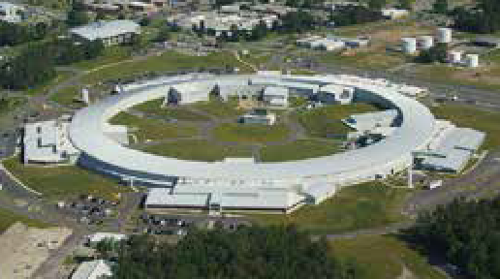
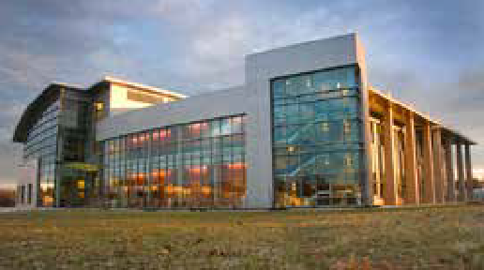
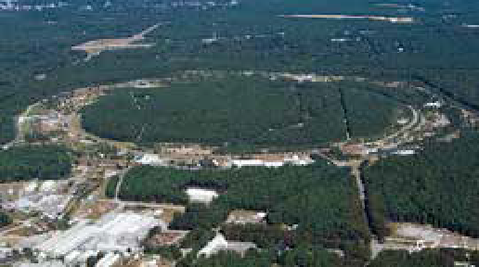
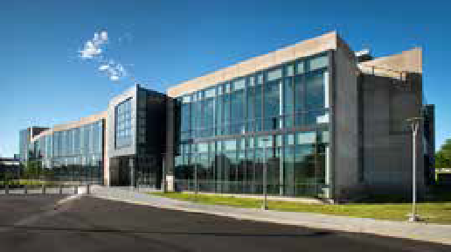


Contact Us:
Brookhaven National Laboratory Media & Communications Office (631) 344-2345

managed for the U.S. Department of Energy by Brookhaven Science Associates, a company founded by Stony Brook University and Battelle

www.bnl.gov

$678 million
in economic output in New York State generated by Brookhaven Lab and its visitors
National Influence
Global Reach
State and Local Impacts

$42.3 million
in goods and services purchased from

From Exploring the Origin of the Universe to Developing the Technology of Tomorrow
Brookhaven Lab’s extensive core research capabilities advance the missions of the U.S Department of Energy’s Office of Science and help sustain a competitive and innovative national economy. Brookhaven combines a rich history of scientific breakthroughs—including seven Nobel

$696 million
in total funding
New York State companies, including

245

$31.7 million
from Long Island companies

Prizes and countless other awards—with leading expertise and cutting-edge facilities.

York State
created throughout New
5,480 jobs
full-time-equivalent jobs directly supported throughout New York State, including 187
on Long Island

employe

3,474

98%
3,100

ving on Long Island

$47.4 million
invested in new construction and renovation

$45.8 million
paid to New York State contractors, including

$30.6 million

Energy Security
blazing innovative trails toward a sustainable future powered by solar, wind, hydrogen, and other renewable sources
es
li

Physics of the Universe
exploring cosmic mysteries across the smallest and largest scales imaginable, from subatomic neutrinos to dark energy

visiting ding
researchers, inclu
fr
1,089
om New York State

258
paid to Long Island contractors

QCD Matter
colliding subatomic particles to recreate matter from the dawn of time and

Photon Sciences
focusing ultra-bright light to reveal the nanoscale structures of materials

o 2012
in employment from 2009 t
7% growth
jobs directly supported in construction and related industries in New York State, including 174
with Long Island contractors
probe the force that gives shape to all visible matter in the universe today
critically important to biology, technology, and more

Climate, Environment,
Biosciences
mapping climate change, tracking







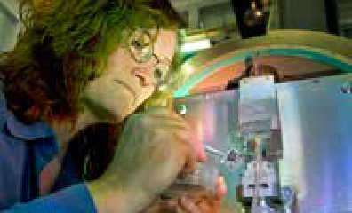

The Enterprise of Exploration
greenhouse gas emissions, and decoding plant biology to protect our planet’s future

