Graduate Program in Genetics


Stony Brook University College of Arts & Sciences
Doctoral Dissertation Defense

The role of CCR2⁺ inflammatory monocytes in Salmonella-induced colitis

Nelson Gautier
Advisor: Dr. Adrianus Van Der Velden

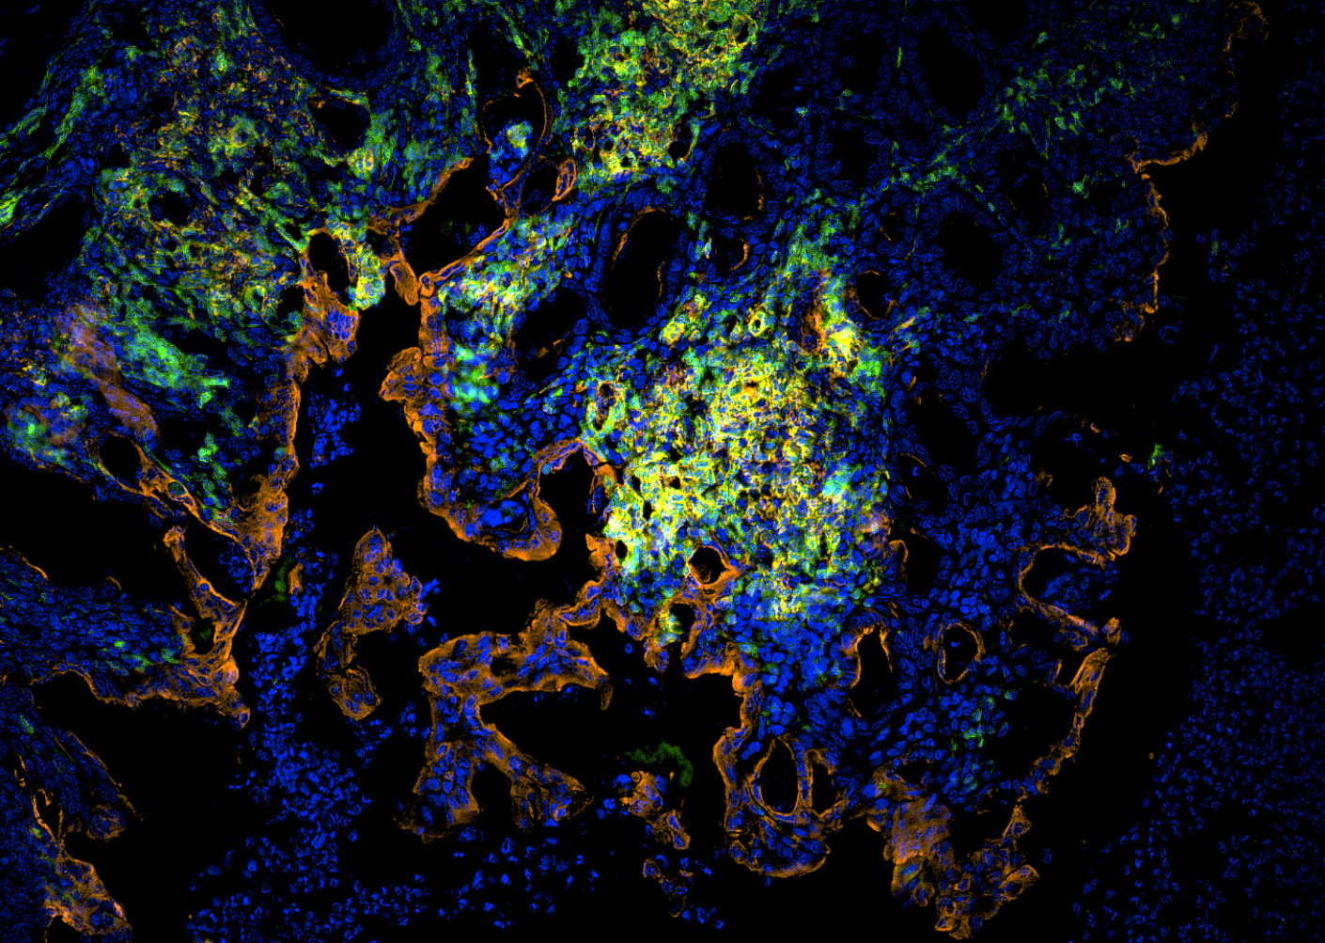

July 10, 2026 10:00 a.m.
Laufer Center, Room 101

To join virtually Click Here. Meeting ID: 946 3969 6777, Passcode: 097109

Stony Brook University Cold Spring Harbor Laboratory Brookhaven National Laboratory

