Graduate Program in Genetics


Stony Brook University College of Arts & Sciences
Doctoral Dissertation Defense

Mechanisms of Bone Morphogenetic Protein Mesoderm Patterning

Courtney Tello
Advisor: Dr. Benjamin Martin

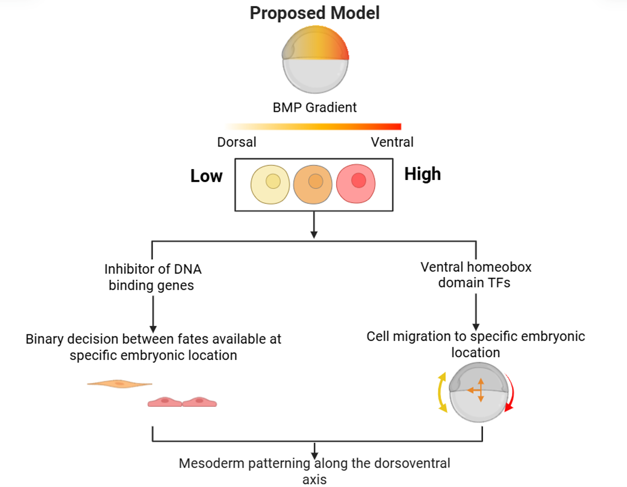

July 7, 2026 12:00 p.m.
Laufer Center, Room 101

To join virtually Click Here
Meeting ID: 868 993 5523

Stony Brook University Cold Spring Harbor Laboratory Brookhaven National Laboratory

