Closed Captioning and Transcription with Zoom for Students
By: Lindsay Bryde
Table of Contents
How Videos Improve the Learning Experience 1
Best Practices When Sharing/Embedding Videos 2
Why Transcripts and Closed Captions Matters 2
Enable Transcripts and Captions 4
Saving Transcripts and Captions 4
As the Meeting's Host 4
As the Meeting's Participant 4
Where Captions are Saved 5
Best Practices for Editing Transcripts/Captions 5
Listen carefully 5
Keep captions short 5
Avoid filler words 5
Use proper punctuation 5
Track speakers 5
Add tone and visual cues 6
Additional Resources 6
Uploading Zoom Recordings to YouTube 6
Sharing Zoom Recordings from the Cloud 6
Learn More About Document Accessibility 6

How Videos Improve the Learning Experience
Using videos in a course can significantly enhance engagement and comprehension. Videos provide a dynamic and visual way to present information, making complex concepts easier to understand through animations, demonstrations, and real-life examples.
When shared, videos can be paused and replayed, allowing learners to review material at their own pace. This flexibility helps reinforce learning and retention, making videos a powerful tool in educational settings.

Best Practices When Sharing/Embedding Videos
- Do not share content that contains blinking or flashing. It can cause seizures in individuals with photo-sensitivity. If your Zoom call contains blinking or flashing, it is better to share the audio-only version of the content.
- Check that all videos have closed captions or transcripts. This benefits anyone who prefers to read content or needs it for translation purposes.

Why Transcripts and Closed Captions Matters
Transcripts and closed captions ensure content is accessible for individuals who are deaf or hard of hearing, allowing them to fully engage with what's being shown. They can also aid in comprehension for non-native speakers and those with learning disabilities.
Transcripts are a written document with the audio content of a video and descriptions of any visuals displayed on screen. They do not break down the timing of when certain actions take place or when certain words are spoken.
Closed captions are when the content of a transcript is chunked out based on the video's timing. They can enhance the viewing experience in noisy environments where audio might be difficult to hear (e.g., a big lecture hall).
Overall, transcripts and closed captioning promotes inclusivity and ensures that video content is accessible to a broader audience. To be accessible, they need to be edited for at least 98% accuracy.
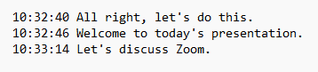
Figure 1 A copy of a Zoom transcript without editing, it contains when a certain sentence began.
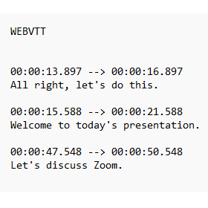
Figure 2 A copy of a Zoom closed captioning file without editing, it contains the dialogue and more specific timings than a transcript.
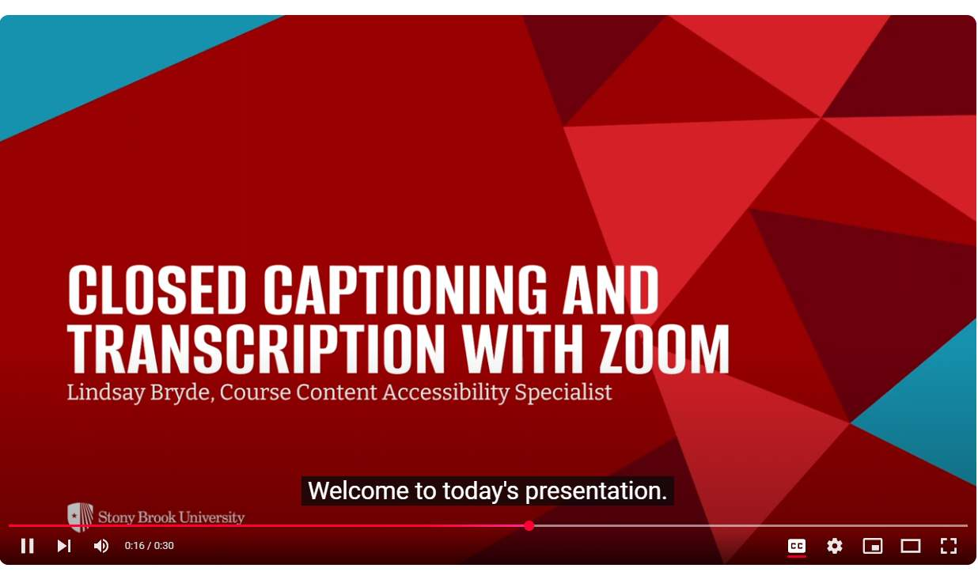
Figure 3 What a Zoom closed captioning file appears like when in a media player, it's white text on a black background. The text appears based on the timings set.

Enable Transcripts and Captions
If you're using Zoom to record lectures or meetings, all recordings can have downloadable machine-generated transcriptions (ASR) generated automatically if you enable transcripts and captions in the settings:
- Sign in to the Zoom web portal (opens in a new tab); login required.
- In the navigation menu, click Settings.
- Click the Meeting tab.
- Under In Meeting (Advanced), click the Full Transcript and Save Captions sliders to enable them.
- If a verification dialog appears, click Save to verify the change.
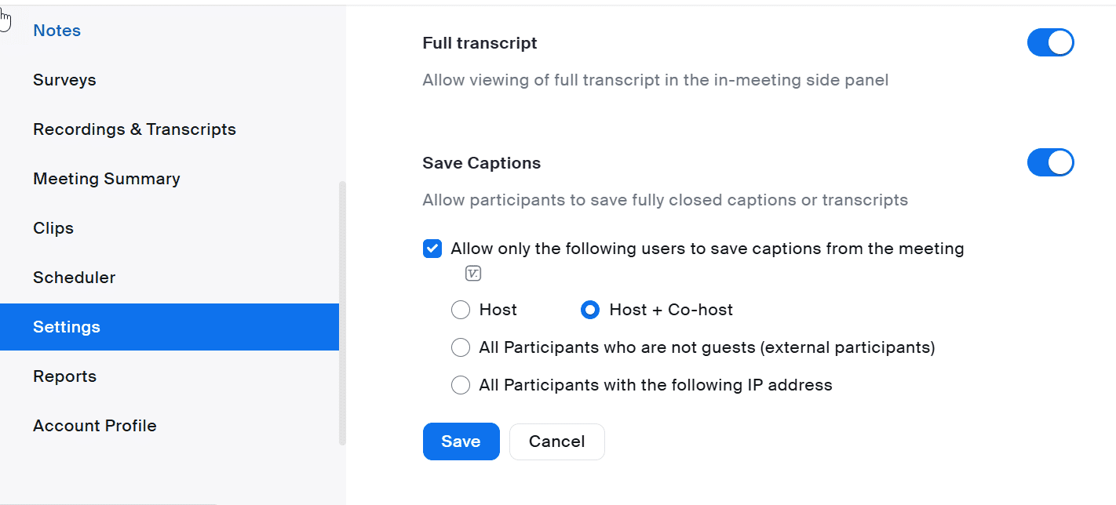
Figure 4 The Settings for Full Transcript and Save Captions have been enabled.

Saving Transcripts and Captions

As the Meeting's Host
- Click Closed Caption in the toolbar.
- In the Closed Caption window, click Save closed caption history.
- Click Show in Folder or Finder to access your saved captions.

As the Meeting's Participant
- Click Closed Caption in the toolbar.
- Click on the following:
  - Windows/macOS: View Full Transcript.
  - Linux: Show Subtitle.
- In the Transcript window, click Save Transcript.
- Click Show in Folder or Finder to access your saved captions.

Where Captions are Saved
- Windows: C:\Users\[Username]\Documents\Zoom
- Mac: /Users/[Username]/Documents/Zoom
- Linux: home/[Username]/Documents/Zoom

Best Practices for Editing Transcripts/Captions
ASR transcripts and closed captions need to be manually checked and edited for accuracy.

Listen carefully
Play the video while editing to ensure you capture the exact words spoken.

Keep captions short
Limit captions to 20–30 characters per second.

Avoid filler words
Eliminate unnecessary fillers like "um," "uh," and "you know" unless they add value to the content (i.e., you need to show how lost or awkward the conversation is).

Use proper punctuation
Spell check in context of the dialogue
Check the context of words to ensure the accurate word is displaying (e.g., SUNY versus sunny).

Track speakers
When you have more than one speaker, you want to identify each of them in the transcript.
You can do this by:
- Adding their names (if known), or
- Identifying them with numbers of letters (e.g., Speaker A or Speaker 1).

Add tone and visual cues
Notes about tone and visual cues in video transcripts provide a comprehensive understanding of the content.
Tone indicators, such as noting when someone is speaking sarcastically or emotionally, help convey the speaker's intent and nuances that might be lost in text alone. Visual cues, like describing significant gestures, facial expressions, or on-screen actions, ensure that viewers can fully grasp the context and subtleties of the video.
In the transcript, non-verbal cues should be placed in brackets.
Examples:
- [angrily] How dare you.
- [bird chirping] What was that?
- [music starts] Want to dance?

Additional Resources

Uploading Zoom Recordings to YouTube
To learn more about sharing a Zoom meeting through YouTube, see the Division of Information Technology's page on Zoom to YouTube.

Sharing Zoom Recordings from the Cloud
To learn more about sharing a Zoom meeting through their cloud, see the Division of Information Technology's page on Sharing Zoom Recordings.

Learn More About Document Accessibility
For more information about document accessibility, please reach out to CELT by emailing celt@stonybrook.edu (opens in a new tab).
To view additional tutorials and resources, visit CELT's Student Accessibility page (opens in a new tab).
Please fill out the Feedback Survey Form (opens in a new tab) to record your completion of this course and to provide feedback for improvements.

Figure 5 Stony Brook University's logo

