Checking a Webpage for Accessibility for Students
By: Lindsay Bryde
Table of Contents
Checking a Webpage for Accessibility 1
Why You Want to Check a Page's Accessibility 1
Bookmarklets 2
Areas to Check for All Pages 2
Alternative Text (Alt Text) 2
Page Title 3
Headings 4
Color Contrast 4
Visible Keyboard Focus 5
Language of the Page 6
Zoom 6
Areas to Check for Audio/Visual Materials 7
Closed Captions 7
Transcripts 8
Audio Description 8
Additional Resources 9
Learn More About Document Accessibility 9

Why You Want to Check a Page's Accessibility
Checking a website for basic accessibility ensures that all users can access and navigate the site effectively. This not only promotes inclusivity and equal access to information, but it enhances the overall user experience.
Before providing a link to a new site or article online in your course, you need to check that the content is accessible, meeting the Web Content Accessibility Guidelines (WCAG)'s Level AA technical standard. Ultimately, prioritizing accessibility reflects a commitment to social responsibility and can positively impact a website's reputation and user satisfaction.
Important: this tutorial provides guidance on general best practices for when reviewing a new site; this is not an exhaustive list of all the WCAG guidelines required to meet the standard.

Bookmarklets
Paul J. Adam's Bookmarklets(opens in a new tab) are a collection of free accessibility tools that help you check a page of content and find where accessibility errors are quickly. Each bookmarklet checks for a different type of accessibility concern.
Before you attempt to check a page, you want to add the Bookmarklets to your web browser's bookmarks area. On their site, drag each Bookmarklet from the "Install Link" column, and drop it in your web browser's bookmarks.
Once the Bookmarklet is added, you can go to the page you want to check to begin the manual review.
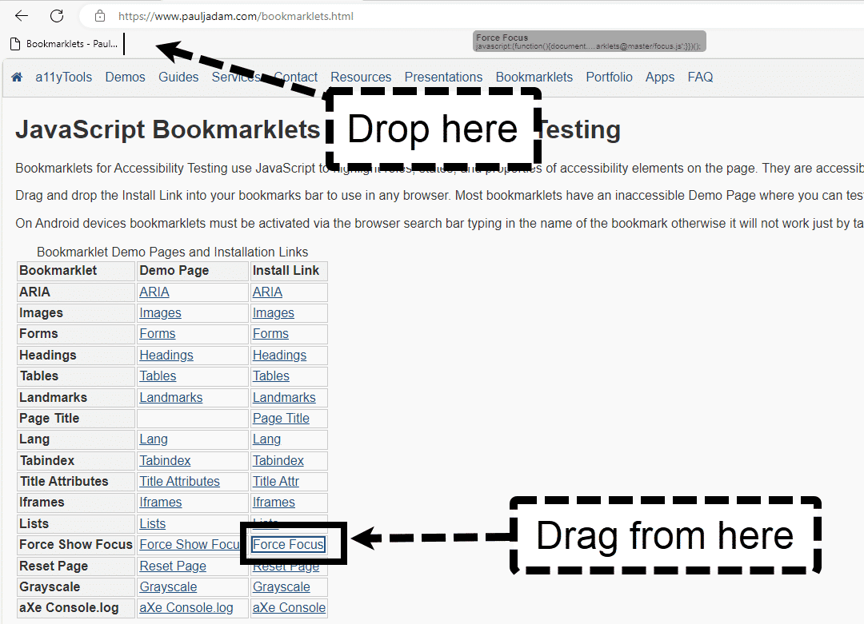
Figure 1 The Bookmarklets site. An arrow is pointing to the Force Focus link with an arrow and a callout stating "Drag from here" and a second callout pointing to the bookmarks bar at the top of the screen with a callout stating "Drop here."

Areas to Check for All Pages

Alternative Text (Alt Text)

What is it?
Alt text is a short description that conveys the purpose of an image.

How do I check it?
When you're on the page, select the Images Bookmarklet in your bookmarks area. All instances of alt text will appear in the upper right-corner of the image.
Check that every image has a concise and accurate description of the image's purpose following the IMG tag, or that it's marked as decorative (i.e., it has two double quotation marks following the IMG tag). Alt text is missing from the image if there is no IMG tag at all on the image.
Note: Complex images, like graphs and charts, need to have short alt text and a more detailed, longer description, elsewhere on the page or on a separate page with a link.
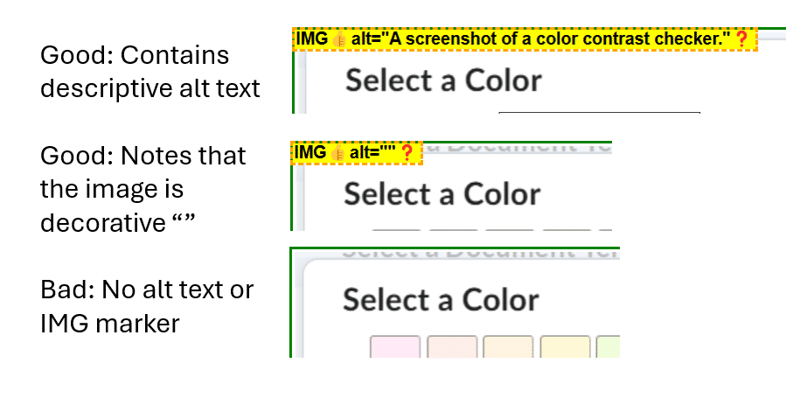
Figure 2 The same image is repeated three times with small adjustments on the left-hand side of the screen. The first image includes an IMG = alt text tag to show best practice for sufficient alt text. The second image contains an IMG = "" to note the image is d

Page Title

What is it?
It's the first thing read on a page by a screen reader, so they know what type of page is loading.

How do I check it?
Use the Page Title Bookmarklet, which will display the page's title at the top of the screen. Check that the page title is accurately and briefly describing the content that is uniquely on that page (i.e., the same generic title isn't being used across the site).
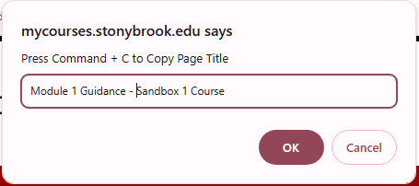
Figure 3 The top of a webpage and the Page title Bookmarklet is displaying the page's official title for review.

Headings

What is it?
Headings communicate how a page is organized. They help screen reader users navigate a page.

How do I check it?
When you're on the page, select the Headings Bookmarklet in your bookmarks area. All heading tagged on the page will appear with on a yellow background with black text. Check that every page has at least a Heading 1 tag, and that all tags are in semantic order without skipping levels (e.g., you should not see the headings jump from Heading 2 to 4 without a level 3 in the middle).
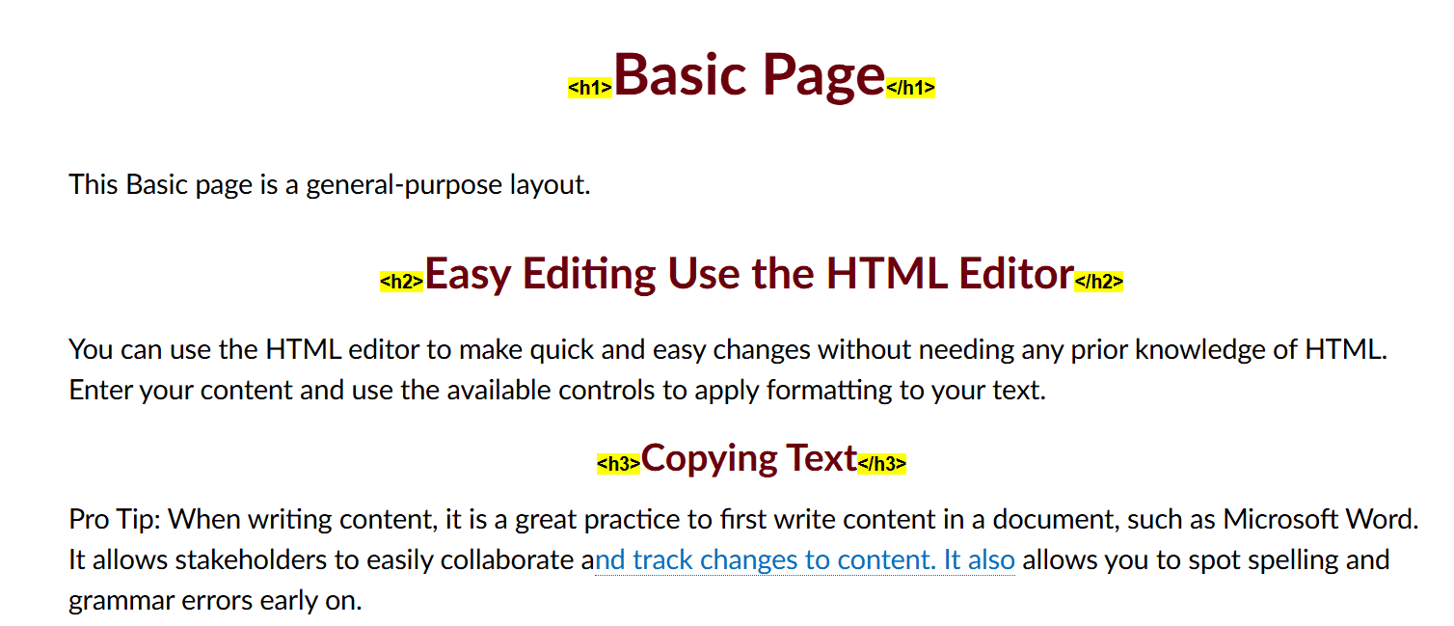
Figure 4 A webpage showing the heading Bookmarklet with yellow tags before each heading noting it's level (e.g., h1, h2, h3).

Color Contrast

What is it?
The term "color contrast" describes the difference between:
- Text and its background
- Interactive elements like focus indicators and their background
- the text and background color components of a map, chart, or graph that require comprehension

How do I check it?
There are two options:
- Use the Grayscale Bookmarklet on the page to get a rough idea of whether the content has sufficient color contrast.
- Use the Web Aim Color Contrast Checker(opens in a new tab) to take samples of any foreground and background colors that you're uncertain about. The checker will show you a pass or fail score based on your selections.
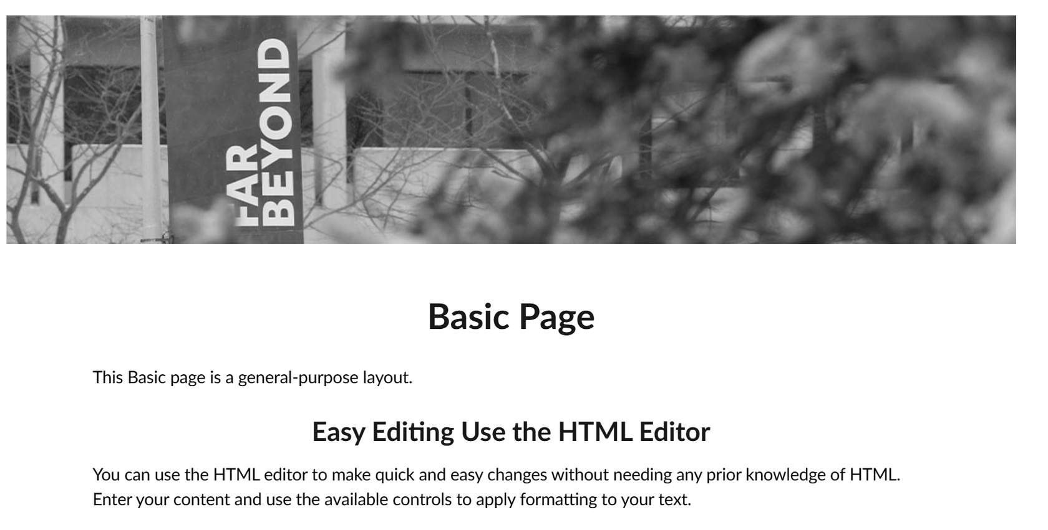
Figure 5 A basic page in Brightspace using the Grayscale Bookmarklet.

Visible Keyboard Focus

What is it?
To have visible keyboard focus, each interactive element on the page (e.g., link, button, form field) has a distinct visual change when a user used the tab key to navigate there.

How do I check it?
Use the Force Focus Bookmarklet on the page. Proceed to hit the tab key, watching where the focus indicator moves. With each key stroke, the focus should be moving to the next interactive element without skipping any or stopping on an invisible element (e.g., the focus indicator is on a white space, indicating an empty or missing link that's not visible to users).
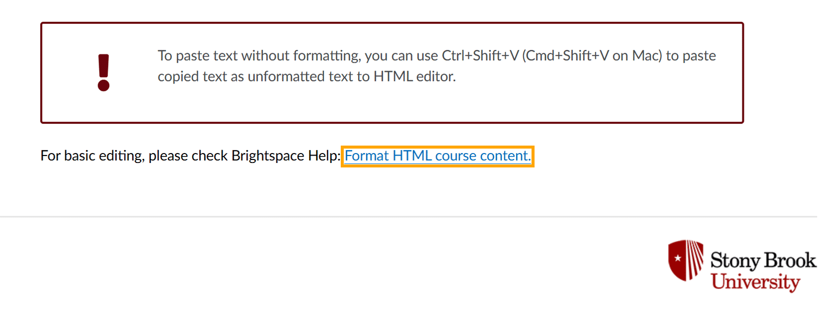
Figure 6 A page with the Force Focus Bookmarklet on, displaying a box around a link that has been tabbed to.

Language of the Page

What is it?
In their code, all web pages should identify the language that it is in. This allows a screen reader and other technologies to pronounce and interpret text accurately.

How do I check it?
Select the Lang Bookmarklet. This will prompt a message at the top of the screen to indicate if a language has been set, and if so, which one.
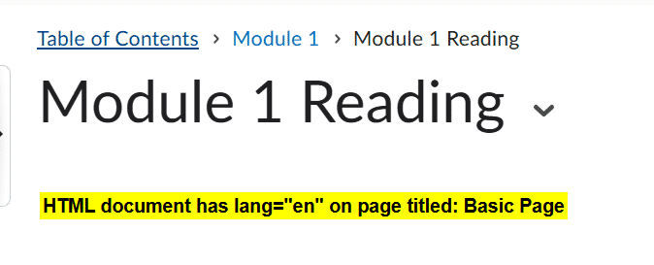
Figure 7 The Lang Bookmarklet indicates a page is in English at the top of the screen.

Zoom

What is it?
Zoom is used to magnify the text and images on the screen. When magnified, the text and images need to still be legible and usable (e.g., you can still click a link or button).

How do I check it?
- Make sure your browser window is not overly big or wide (especially if your monitor is large). If necessary, resize your browser so that it is quite narrow.
- Press "Ctrl" or "Cmd" and ‘+’ to enlarge the text to 200%, the browser typically displays the percent with each time you press the combined keys.
- Check that:
  - all the text wraps around and remains visible within the window as you zoomed in (i.e., no content becomes hidden behind other text or images).
  - the page continues to have horizontal text, so no vertical scrolling is required.
  - All navigation menus are still accessible and can be clicked.
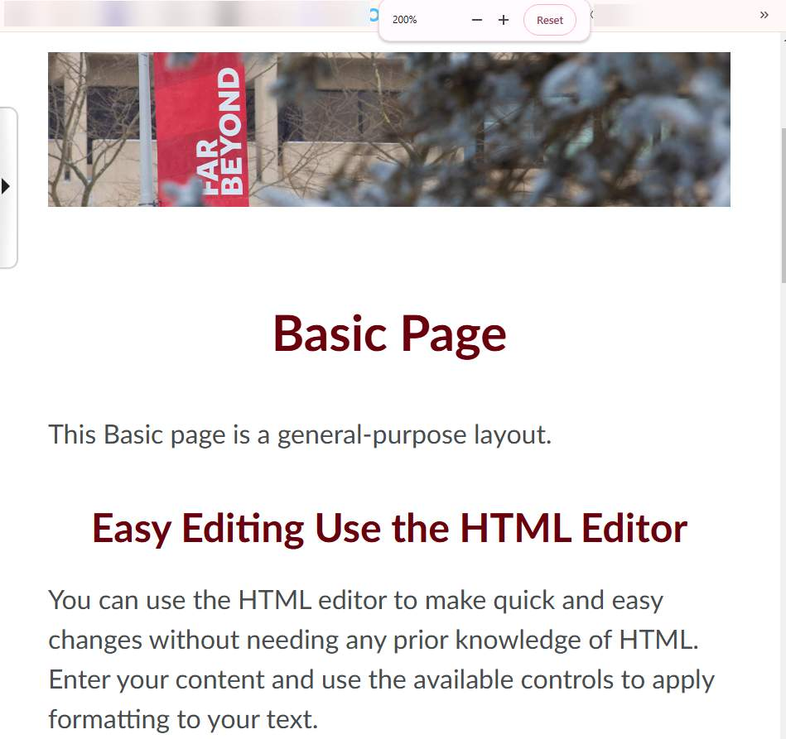
Figure 8 A narrow web page that is being zoomed into 200% with all the text and images wrapping correctly on the page.

Areas to Check for Audio/Visual Materials

Closed Captions

What is it?
Closed captions are when a user can choose to enable a transcript of the video to play over the video and the text is chunked out based on the video's timing.

How do I check it?
Play the video and check that:
- You see a closed captions button in the player, and that when you select it that captions appear. If no captions are available, some players are set to not show a button at all.
- There are no open captions (when captions are permanently embedded, overlaying the video without a user being able to control whether the captioning appears or not).
- The captions are accurate to what's being said in the video in terms of what's being said and grammatically (e.g., no spelling or punctuation errors). Generally, if the captions were auto-generated, they are not sufficient.
- The captions are in sync with the spoken content.
- Any important sounds, like screaming or a crashing sound, are included.

Transcripts

What is it?
Transcripts are a written document with the audio content of a video and descriptions of any visuals displayed on screen. They do not break down the timing of when certain actions take place or when certain words are spoken.

How do I check it?
Watch the video and check that:
- The transcript is easy to find near the audio or video (e.g., it's in the description or attached in a visible place on the page).
- Any visual content that is not addressed in the dialogue/narration is described when it appears.
- All speech is accurately reflected in the transcript without any technical or grammatical errors.
- All speakers are identified.
- All sounds are described (e.g., whispering or a sound effect).

Audio Description

What is it?
Audio description describes any visual information needed to understand a video's content that is not conveyed through dialogue (e.g., a car is driving recklessly down a street while the passengers are having a non-driving related discussion).
Audio description can be provided as:
- integrated description — included in the speaker's script and/or closed captioning.
- alternative video — description is included in a separate video.
- separate file — description is incorporated into the transcript.

How do I check it?
Watch the video and check that:
- A description is needed. Are there any visual elements presented that are important to understand that aren't being described by speaker or noted through the closed captions?
- Are you viewing the alternate video (the title or description would note it)? If not, is there a link to an alternate video available in the video's description?
- Is there a separate file available to download on the page to view the audio description/transcript?

Additional Resources
Learn more about how to conduct a preliminary accessibility check of a page using guidance from WCAG.

Learn More About Document Accessibility
For more information about document accessibility, please reach out to CELT by emailing celt@stonybrook.edu (opens in a new tab).
To view additional tutorials and resources, visit CELT's Student Accessibility page (opens in a new tab).
Please fill out the Feedback Survey Form (opens in a new tab) to record your completion of this course and to provide feedback for improvements.

Figure 9 Stony Brook University's logo

