Basic Google Slides Accessibility for Students
By: Lindsay Bryde
Table of Contents
Welcome 2
Learning Objectives 3
Note on links 3
Layouts, Groups, and Reading Order 3
Why Are Layouts Important? 3
Stony Brook Presentation Template 4
Slide Layouts 4
Adding Content to Slides 4
Reading Order 7
Knowledge Check 1: Layouts, Groups, and Reading Order 8
Summary 8
Lists 9
Why Lists Matter 9
How to Apply Lists 9
Additional Resource 10
Knowledge Check 2: Lists 10
Summary 10
Images and Non-textual Content 10
Make Images Accessible with Alt Text 10
How to Apply Alt Text 11
Title vs. Description 11
Mark an Image as Decorative or Null 11
Knowledge Check 3: Images and Non-textual Content 12
Summary 12
Transitions and Animations 12
A Warning on Slide Transitions and Animation 12
How to Add an Animation 12
Knowledge Check 4: Transitions and Animations 13
Summary 14
Tables 14
Tables in Google Slides 14
Inaccessible Table Formats 14
Remediating Exported Content 15
Knowledge Check 5 Answers: Tables 15
Summary 16
Color Contrast 16
Check Your Contrast 16
Control Your Contrast 17
Knowledge Check 6 Answers: Color Contrast 18
Summary 18
Conclusion 19
Knowledge Check Answer Key 19
Knowledge Check 1 Answers: Layouts, Groups, and Reading Order 19
Knowledge Check 2 Answers: Lists 19
Knowledge Check 3 Answers: Images and Non-textual Content 19
Knowledge Check 4 Answers: Transitions and Animations 19
Knowledge Check 5 Answers: Tables 19
Knowledge Check 6 Answers: Color Contrast 19


Figure 1 Stony Brook University Logo

Welcome
In this course, we provide a brief introduction and guidance on creating accessible Google Slide presentations. There are many elements that go into making content accessible; this guide is not exhaustive.
It is recommended that you review our training "Picking the Most Accessible Format for Your Content: PDF, Word, or PowerPoint(opens in a new tab) " to ensure that a Word document is the best format for your content.
The estimated time to complete this course is 15-20 minutes.

Learning Objectives
By the end of this guide, you will be able to
- Explain the importance of slide layouts and how to use them effectively.
- Provide alt text to images, charts, and other non-text elements.
- Select appropriate text colors, sizes, and fonts for readability.
- Design tables and charts that are accessible to screen readers.
For more information about document accessibility, please reach out to CELT by emailing celt@stonybrook.edu.
If you come across an accessibility barrier in this guide, please let us know by emailing celt@stonybrook.edu.

Note on links
All links in this course open to a new tab.

Layouts, Groups, and Reading Order

Why Are Layouts Important?
Layouts in Google Slides provide a consistent structure for the presentation, helping users understand where to find specific types of content (e.g., titles, text, images). By creating a predictable structure, you'll be able to maintain a logical flow of information, making it easier for all users, including those with cognitive disabilities, to follow along.

Using templates and built-in layouts within PPT also ensures the intended reading order of the slides is maintained, which helps screen readers present information in the order it is meant to be consumed. They also enhance the readability of content by providing adequate spacing, alignment, and contrast, which benefits users with low vision or color blindness.

Stony Brook Presentation Template
Stony Brook University (SBU) provides official university-branded templates for presentations. It includes accessible layouts and imagery to support your work.
It is best to download the template you'll be using before developing content.
It is possible to copy existing content to the template. You will need to run an Accessibility Check before sharing/presenting your PPT to ensure nothing needs to be addressed.

Presentation Template
Download the SBU template that best fits the type of presentation you'll be delivering.

Slide Layouts
Using the built-in slide layouts within Google Slides ensures your content is organized and can be read by a screen reader. Each layout presents you with different options for arranging objects (e.g., text boxes, images, videos, etc...) on the slide.
When starting a new slide, select Layout from the toolbar and you can then choose the layout that best fits your content from the drop-down.
Note: Any new objects added to a default layout need to have their reading order checked. This will be addressed later in the module.

Adding Content to Slides
Source: The Golden Rules of Presentation Design(opens in a new tab)
When developing the content and formatting of your slides, there are many things you can do to support your audience and help them better process the main ideas you want to convey.
Some best practices include:

Provide Unique Titles
Each slide needs a header/title, and it needs to be unique to help users navigate between the slides.
If you want to include some type of visible section label, it's best to put it in the sub-header or use a colon method. So instead of labeling all slides about heading levels as "Headers," we could add sub-headers with additional details, such as:
- Headers: Make Them Unique
- Headers: How to Set Them
- Headers: Provide Direction to Your Audience.

Use Key Words
What's the main idea you want to convey? That's what should be the focus. It's better to avoid using full sentences/paragraphs to convey information and focus on key words or phrases.
This is where bullets can be helpful to distill the information.

Embrace White Space
While it can be tempting to fill every pixel of space on the slide, you must resist. White space is good for a few reasons:
- It doesn't overwhelm or overstimulate your audience.
- It can create direct and deeper meaning between text and imagery.
- It focuses everyone on the details you did include.
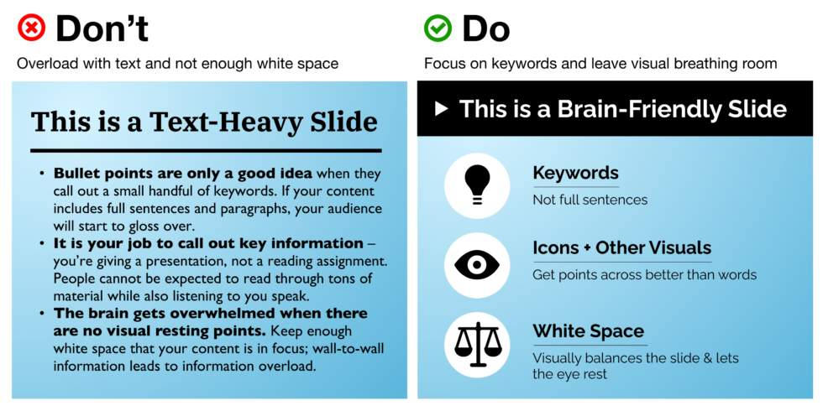
Figure 2 Examples of good and bad combinations of text and imagery, showing how they need to have a relationship.

Organize Ideas and Provide Breaks
Don't be afraid to break up information across more than one slide or include transition slides (e.g., introducing a new section). This helps pace your presentation and it can give natural breaks for the audience to process what's being said/presented.

Simplify Fonts and Colors
Less is more. It's better to use two sans-serif fonts (or a maximum of three). Similarly, you want to use two or three primary colors throughout your presentation. This will keep your presentation vibrant without being too cluttered.
If you want to emphasize a point, use a bold font. It's better to avoid using all capital letters whenever possible since that can be considered yelling (rudely) at your audience.
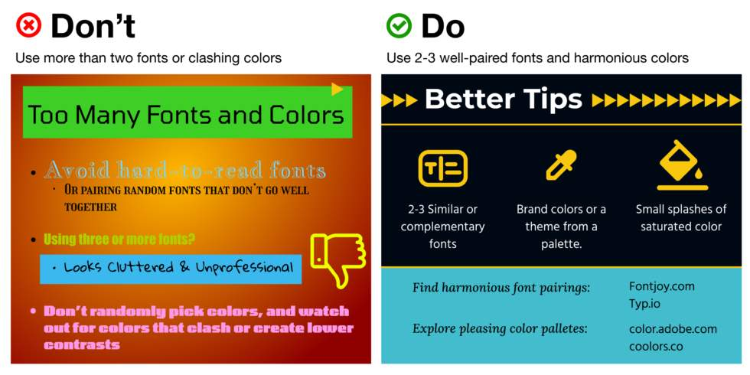
Figure 3 Examples of good color contrast and bad color contrast between foreground text and backgrounds.

Consistently Size and Align Text
Keep font sizes at least 30pt or higher so it's visible from a distance. This also helps you avoid being overly wordy.
Headers should be at least 50% bigger than your text so it pops.
Keep text alignments simple and consistent throughout the presentation. This can help group/align your text with any images.
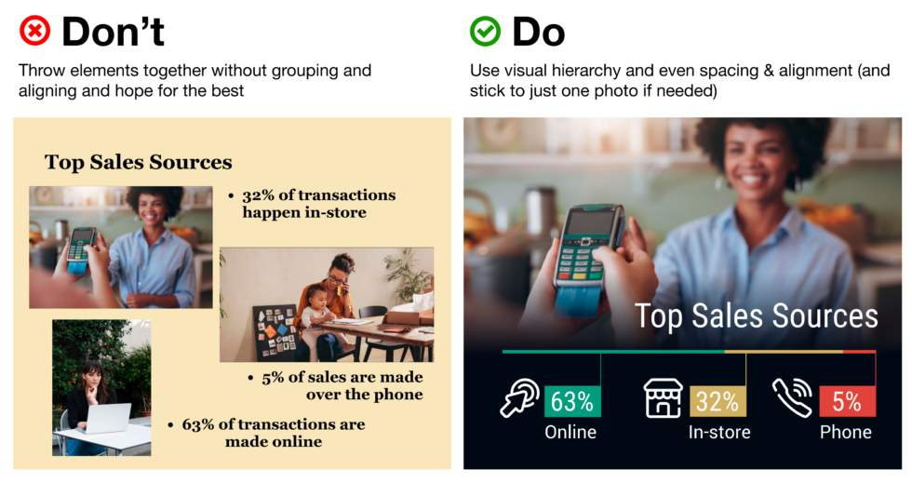
Figure 4 Examples of good and poorly aligned text.

Reading Order
When students with visual impairments are reviewing content on slides, they may use a screen reader. This is why it's critical that all objects on the slide are in a logical reading order.
In Google Slides:
- The further back an object is, the higher up it is in the reading order
- The further toward the front an object is, the lower down in the reading order it will be read.
- The slide title/header should be to the very back/the first object read.

Check Reading Order
To check the reading order in Google Slides, place your cursor on the top-left most element of your slide and press the "Tab" key on your keyboard. The order in which elements are highlighted as you tab through them indicates the reading order that screen readers will use. 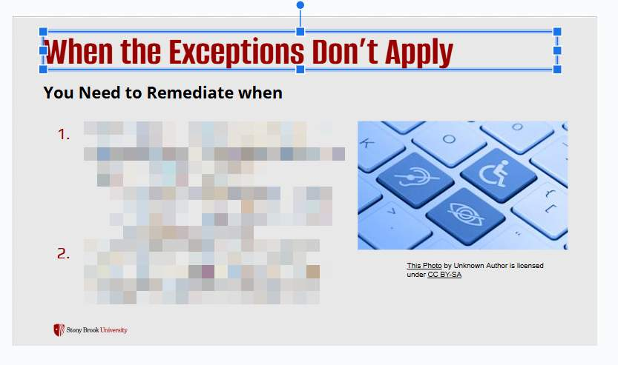
Figure 5 A slide is on display. A blue box appears around one object to display visual focus.

Adjust Reading Order
- Right-click the object you'd like to move.
- Click the Order option from the drop-down.
- Select one of the following options from the drop-down:
  - Bring to front: make this object the last in the reading order.
  - Bring forward: move this object down in the reading order.
  - Bring backward: move this object up in the reading order.
  - Bring to back: make this object the first in the reading order.
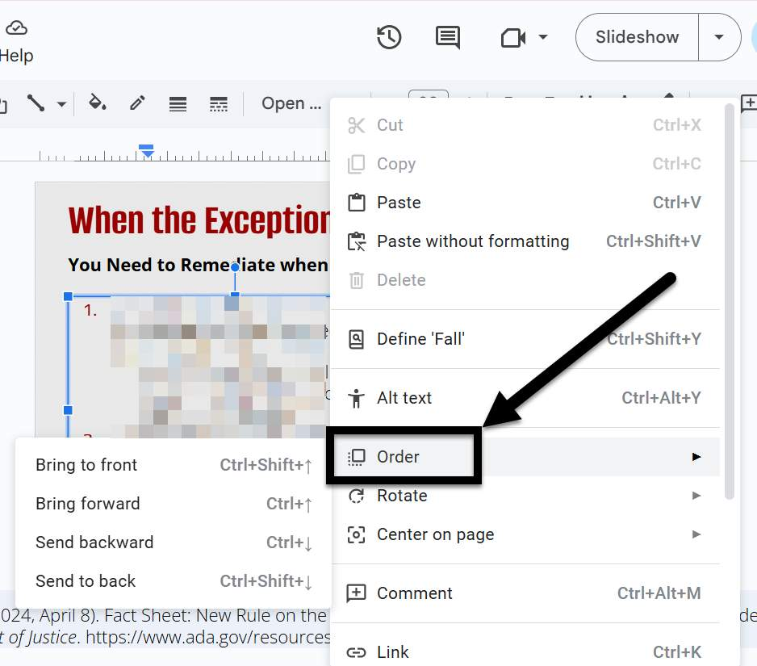
Figure 6 An object in a slide is right-clicked and the "Order" option in drop-down has an arrow pointing toward it.

Knowledge Check 1: Layouts, Groups, and Reading Order
Answer the following question to self-check your knowledge (answers are at the end of the document).
- Which of the following are best practices for creating slide content in Google Slides?
  - Use full sentences and paragraphs
  - Embrace white space
  - Use a variety of fonts and colors
  - Organize ideas and provide breaks

Summary
It's important to layout your content consistently to improve the accessibility and effectiveness of your presentations.
Here are some key takeaways:
- Utilize built-in layouts. They help maintain a logical flow and ensure accessibility.
- Embrace white space. It prevents overwhelming your audience and enhances focus.
- Check reading order. Ensure all slide elements are in a logical sequence for screen readers.
- Use unique titles. Each slide should have a distinct header to aid navigation.

Lists

Why Lists Matter
Google Slides makes creating lists very easy. Lists give a presentation a hierarchical structure.
While it may seem simple to use dashes or manually add numbers to give the appearance of list, it doesn't give assistive technology users the document structure they require. This is why it's key to use built-in tools.


How to Apply Lists
- Click the textbox that you want to contain your list in or highlight the written text that you would like to format as a list.
- Select the More option in the toolbar.
- Click the Bullets or Numbering icons.
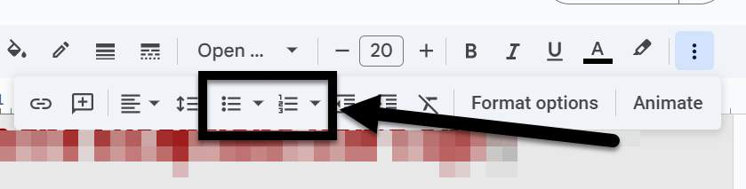
Figure 7 The Bullets and Numbering options in the Home tab of PPT are featured with a box and arrow pointing toward them.
You can use the increase or decrease indent level buttons to give the appearance of a nested list.
Click the chevron next to the icon to open the Bullets and Numbering dialog box to customize your list. You can adjust the shape and starting number.

Additional Resource

Lists Article
Learn more about formatting lists in Google Slides.

Knowledge Check 2: Lists
Answer the following question to self-check your knowledge (answers are at the end of the document).
- Why is it important to use built-in tools for creating lists in Google Slides?
  - It makes the presentation look more professional.
  - It ensures the document structure is accessible to assistive technology users.
  - It saves time when creating lists.
  - It allows for more customization options.

Summary
Properly formatted lists enhance document structure for assistive technology users, ensuring inclusivity and professionalism.
Here are some key takeaways:
- Utilize the Bullets and Numbering options. This helps in creating organized and visually appealing lists.
- Adjust indent levels for nested lists. This allows for better hierarchy and clarity in your content.

Images and Non-textual Content

Make Images Accessible with Alt Text
Since our computers can't tell us what's in a picture, we have to include an image description when we create a document in order for it to be accessible.
The exact process you use to describe an image will change based on the document creation software you are using. On the other hand, the term "Alt Text" describing the textual description of an image is used across many tools.
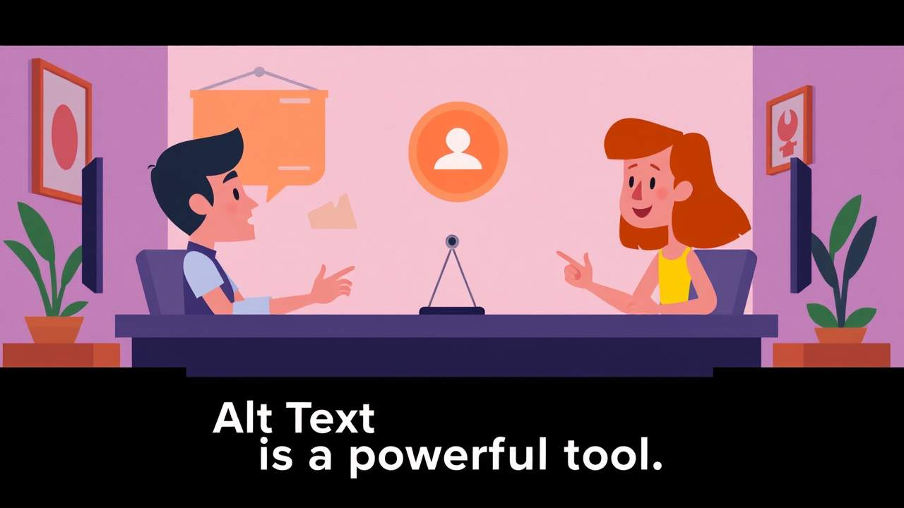

How to Apply Alt Text
Alt text can be added to a variety of objects, including: images, emojis, gifs, charts, tables, and videos.
- Right-click the image.
- Select Alt Text from the drop-down menu.
- Under the Alt Text section of the Image Pane, enter your alt text in the Description textbox.
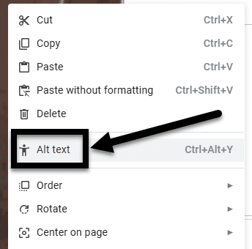
Figure 8 The image drop-down menu, the Alt Text option is noted with an arrow.

Title vs. Description
When entering alt text, Google Slides provides two distinct fields: Title and Description.
A screen reader can access both of these fields in Google Slides, but if you export to Microsoft Word and have content in both fields, the Title field will be removed and the Description field will remain intact. Therefore, instead of using the Title field, its better to only use the Description field to enter alternative text.

Mark an Image as Decorative or Null
When an image is decorative, meaning it does not add meaningful content or context (e.g., decorative borders or background images), then it needs to be accordingly marked. When it is marked as decorative, screen readers will ignore the image, allowing users to navigate the document more efficiently without unnecessary interruptions.
In Google Docs, you need to enter two double quotation marks "" into the Alt Text>Description box to mark the image as decorative. Remember, the image must either contain alt text or be marked as decorative, this field cannot be left blank.
Note: Do not mark all images as decorative to expedite your remediation process. According to the WCAG guidelines, images should only be marked as decorative if they are not adding meaningful context to the image.

Knowledge Check 3: Images and Non-textual Content
Answer the following question to self-check your knowledge (answers are at the end of the document).
- Why is it recommended to use the Description field instead of the Title field when entering alt text in Google Slides?
  - The Title field is not accessible by screen readers.
  - The Description field is more descriptive.
  - The Title field is removed when exporting to Microsoft Word.
  - The Description field is easier to fill out.

Summary
Alt Text is an invaluable tool for screen reader users to understand the meaning, context, and purpose of images.
Here are some key takeaways:
- Use Alt Text for all images that add meaning to the presentation. This ensures that screen readers can convey the content of images to users.
- Complete the Description field over the Title field. The Title field is removed when exporting to other formats, making the Description field more reliable.
- Mark images as decorative only when they add no meaningful content. This helps streamline navigation for users relying on screen readers.
- Avoid marking every image as decorative. Only mark images as decorative if they truly do not contribute to the document's context.
- Use slide transitions and animations sparingly. Check that any transition or animation being used does not contain flashing or flickering content.

Transitions and Animations

A Warning on Slide Transitions and Animation
Slide transitions are when slides move from one to the next during presentation mode, such as sliding in from one side to another.
Animations refer to specific objects within the slide, such as an image or list, appearing one by one.
It’s best to avoid slide transitions since flashing or flickering content may trigger epileptic seizures or vertigo attacks in some people.
Subtle animations can be used if an object is simply appearing.

How to Add an Animation
Go to Slide>Transition and the Motion pane will open on the right-hand side.
Select the object or text you'd like to animate.
Click the Add Animation button.
Select the type of animation (e.g., Appear or Disappear) needed from the drop-down menu, when you want it to take effect (e.g., On click, After previous, or Before previous).
Optional: for lists, you can choose to make bullets appear one at a time. If you want them to appear as one full list, check the By paragraph box.
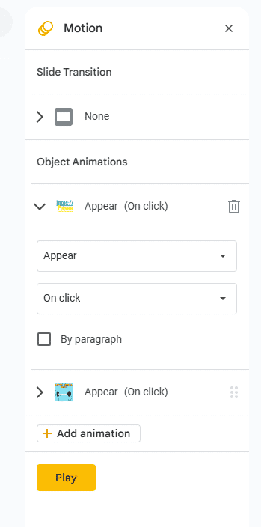
Figure 9 The Animation pane in Google Slides.
Note: Always check and play your animations before a presentation to ensure that none of the content is flashing or flickering.

Knowledge Check 4: Transitions and Animations
Answer the following question to self-check your knowledge (answers are at the end of the document).
- Why is it recommended to avoid using slide transitions in presentations?
  - They can make the presentation look unprofessional.
  - They may trigger epileptic seizures or vertigo attacks.
  - They are difficult to implement correctly.
  - They can distract from the content of the presentation.

Summary
Animations can be visually appealing, but they do require some care to ensure they are done accessibly.
Here are some key takeaways:
- Avoid flashy slide transitions. They can pose health risks like seizures.
- Use subtle animations for object appearances. Ensure no flickering occurs.
- Access the Animations ribbon to add effects. Select the desired object first.
- Customize animation timing. Use the animation pane for specific settings.

Tables

Tables in Google Slides
Tables provide a means of presenting complex information in a manner that makes it easy to comprehend and identify relationships between the data.
That being said, tables in Google Slides are not accessible. The header cells/row cannot be identified, which means a screen reader cannot accurately navigate the content.
In order to share accessible slides, the content developed in Google Slides will need to be exported to Microsoft PowerPoint or a PDF, which can be remediated to be accessible.
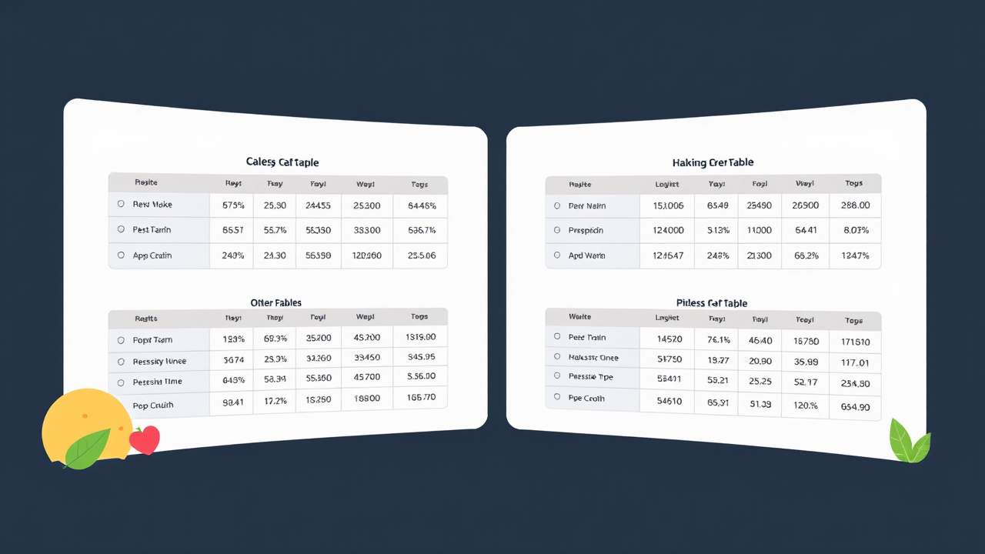

Inaccessible Table Formats
To minimize the amount of content remediation needed when Google Slides are exported to another format, there are some common formatting mistakes that you want to avoid:

Avoid merging, nesting, and splitting cells
When tables contain merged cells and nested tables, each cell must be uniquely identified and associated with the appropriate header cell. It is recommended that you keep your tables simple- for the sake of clear communication as well as for accessibility.
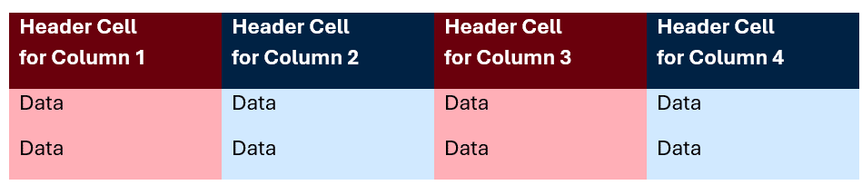
Figure 10 A sample of a simply formatted header. Each header cell contains a descriptive label.

Avoid fixed width tables
Setting tables with a fixed width can make it difficult for anyone using magnification tools to read the data.

Do not control spacing in your table with blank rows or columns
When blank spaces are added in a table, some screen readers will "read" each line break to the user. That can take up a lot of their time and be disorienting for someone listening in. It is better to adjust line spacing with the Paragraph options on the Home tab.

Do not leave cells blank
Each cell needs to have content. If a cell absolutely does not have any possible content, it is better to include a note like "N/A" or "Intentionally Blank" into the cell.

Remediating Exported Content
Once your slides are complete, you will need to export your content to Microsoft PowerPoint or a PDF in order to remediate it and make it accessible. Training is available regarding how to complete these remediations

Basic PDF Accessibility
Learn more about making PDFs accessible.

Basic PowerPoint (PPT) Accessibility
Learn more about making PPT's accessible.

Knowledge Check 5 Answers: Tables
Answer the following question to self-check your knowledge (answers are at the end of the document).
- Why are tables in Google Slides not always worth using?
  - They cannot be exported to other formats.
  - They cannot identify header cells.
  - They are difficult to create.
  - They cannot contain hyperlinks.

Summary
Tables can be incredibly important for presenting complex data clearly, yet it does require additional work to address accessibility issues in Google Slides.
Here are some key takeaways:
- Tables simplify complex information. Use them to enhance understanding of data relationships.
- Avoid merging and nesting cells. This keeps tables clear and accessible for all users.
- Ensure all cells contain content. Use 'N/A' or 'Intentionally Blank' for empty cells to maintain clarity.
- Use descriptive hyperlink text. This improves navigation and comprehension for screen reader users.

Color Contrast
Color contrast is essential to presentations because it significantly enhances readability and accessibility.
High contrast between text and background colors ensures that your content is easily readable, even for individuals with visual impairments or color blindness. It also helps to draw attention to key elements, guiding the audience’s focus to the most important parts of your slide.
By ensuring that all elements are distinct and clear, you create a more engaging and inclusive experience for all viewers.

Figure 11 Two cats sitting side by side. One is in full color and the other is in greyscale with poor color contrast.

Check Your Contrast
All Google Slides presentations need to be manually checked for color contrast by content creators. The WebAim Color Contrast Checker(opens in a new tab) is a good tool for this work.
Note: according to the Web Content Accessibility Guidelines (WCAG)(opens in a new tab) Level AA, the contrast ratio between the foreground and background of text must be at least 4.5:1 for normal text (font sizes below 14 pt) and 3:1 for large text (font sizes 14 pt or above).
WebAim's tool will break down what the contrast ratio is based on the foreground and background colors you're testing, and it will note whether the ratio passes or fails.
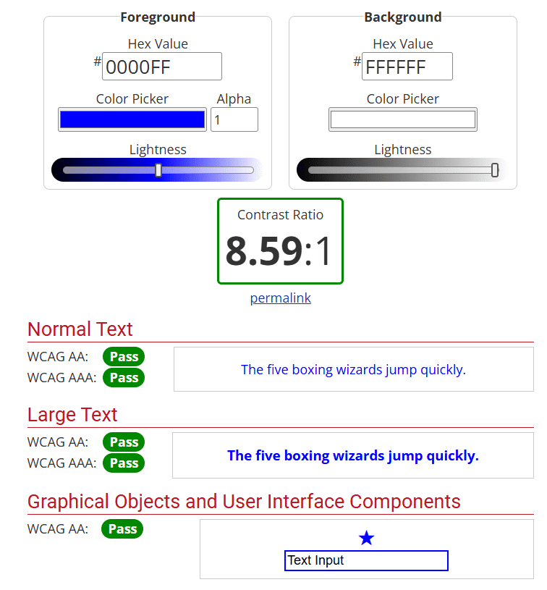
Figure 12 The WebAim Color Contrast Checker, showing selected colors to check at the top, the contrast ratio of the selection in the middle, and a pass/fail report based on the WCAG success criteria.
Do no assume that the pre-designed themes will provide sufficient color contrast. It is important to verify and ensure that your font colors are providing sufficient contrast for the background colors.

Control Your Contrast
In Google Slides, you can select text and background colors as well as entire color schemes through the different built-in themes.

Change Text Colors
The Text Color tool can be accessed from the toolbar when a text box is selected.
If only a portion of the content in the box needs to change color, highlight that specific section of text so that's the only part modified.
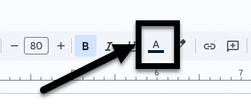
Figure 13 The toolbar of Google Slides, the Text Color picker is noted with an arrow.

Change Background Colors
To change the background color of a specific slide, select the background of the slide.
On the toolbar will be a Background button, which will open a pop-up menu to make any changes.
It is best to avoid using images as backgrounds because it can be difficult to consistently create sufficient contrast with your text color.
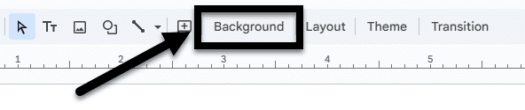
Figure 14 The toolbar of Google Slides, the Background button is noted with an arrow.

Knowledge Check 6 Answers: Color Contrast
Answer the following question to self-check your knowledge (answers are at the end of the document).
- Why is it important to manually check color contrast in Google Slides presentations?
  - To match the color scheme of the company's branding.
  - To ensure the presentation is accessible to individuals with visual impairments.
  - To enhance the aesthetic appeal of the slides.
  - Because there is no built-in tool to check color contrast in Google Slides.

Summary
It's key to consistently check for sufficient color contrast in presentations to enhance the readability and accessibility of it for all.
Here are some key takeaways:
- Prioritize a manual check for color contrast. Ensure high contrast between text and background for better readability of all slides (including those from built-in themes).
- Use tools for checking. Manually verify color contrast with resources like the WebAim Color Contrast Checker.
- Customize your colors. Adjust text and background colors in Google Slides to maintain clarity.
- Avoid busy backgrounds. Steer clear of images behind text to ensure sufficient contrast.

Conclusion
You have completed the Basic Google Slides Accessibility for Students course!
Please fill out the following feedback form to record your completion of this course and to provide feedback for improvements.

Knowledge Check Answer Key

Knowledge Check 1 Answers: Layouts, Groups, and Reading Order
- B and D

Knowledge Check 2 Answers: Lists
- B

Knowledge Check 3 Answers: Images and Non-textual Content
- C

Knowledge Check 4 Answers: Transitions and Animations
- B

Knowledge Check 5 Answers: Tables
- B

Knowledge Check 6 Answers: Color Contrast
- B and D

