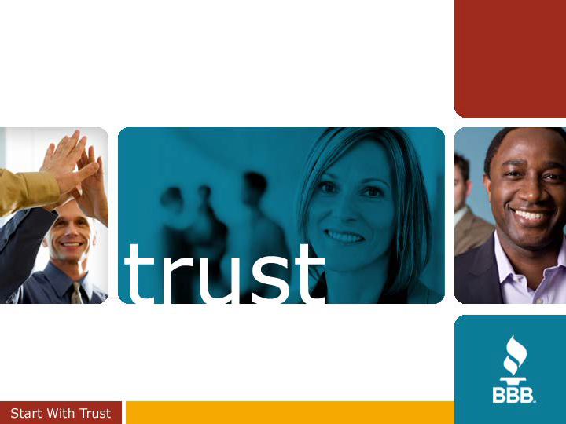
THE ART & SCIENCE OF SUPERIOR CUSTOMER RELATIONS
STONY BROOK SBDC
MAY 22, 2019

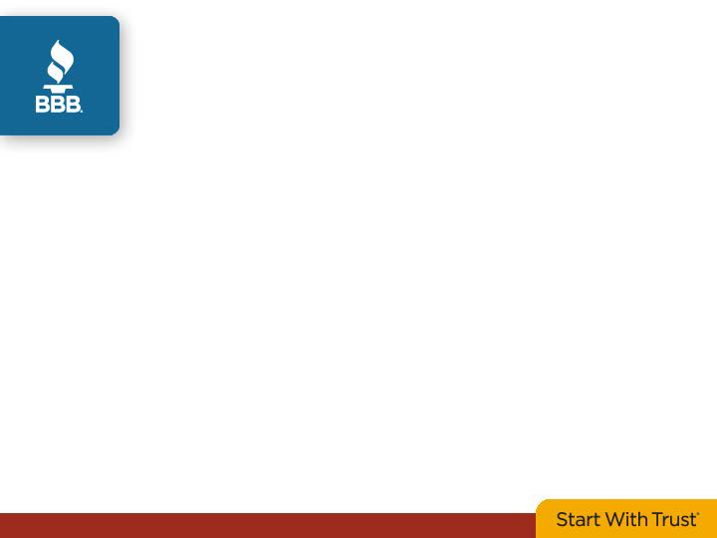
BBB At A Glance…






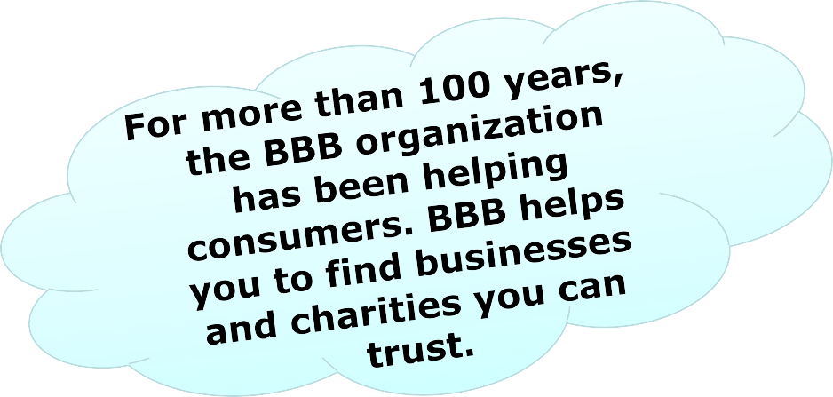



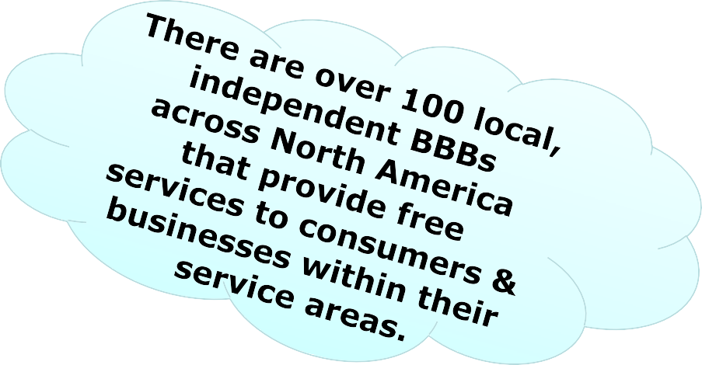

An unbiased non-profit organization that sets and upholds high standards for fair and honest business behavior.

MARKETPLACE ADAPTION
In today’s marketplace, expectations have notably changed.
Businesses must earn - and maintain - customer loyalty by recognizing that the relationship does not end at the time of purchase.
Develop a culture where staff are provided the tools to be expert customer care managers, invested with both dispute resolution skills and a proactive approach to customer satisfaction.
Your reputation depends on it.

THE LANDSCAPE
- In 2017, the Edelman Trust Barometer reported that trust in institutions has broadly declined in multiple sectors:
  - Government
  - Media
  - Business
  - NGOs (nongovernmental organizations)
- BBB’s own research has revealed analogous concerns:
  - While 82% of U.S. consumers convey the importance of trusting a business pre-purchase, a mere 28% of respondents find businesses to be more trustworthy in today’s marketplace than in the past
  - Fewer than half of respondents trust companies in general

Source: 2017 BBB Trust Sentiment Index℠

WHAT’S CHANGED?

- Among many factors, basic consumer expectations have changed – they have increased faster than customer service is improving.
- Technology, social media, online reviews & ratings have transformed the customer experience from simple & linear to an ongoing *circular connection with businesses that serve their needs.
- The expectation – post-purchase – is that a relationship has been formed that *continues to bind that business to its customer.

Source: 2017 BBB Trust Sentiment Index℠

FORMING THAT CRITICAL INITIAL OPINION
Consumer source reliance:
- Opinions of family & friends
- Feedback from online reviews/ratings & complaint data
- Such sources set expectations for the customer experience, instill confidence and reduce surprises (thus decreasing the likelihood of buyer’s remorse).
Impact:
When consumers evaluate products/services and research businesses, TRUST is a fundamental factor in moving forward with a purchase – or avoiding a business.

Source: 2017 BBB Trust Sentiment Index℠

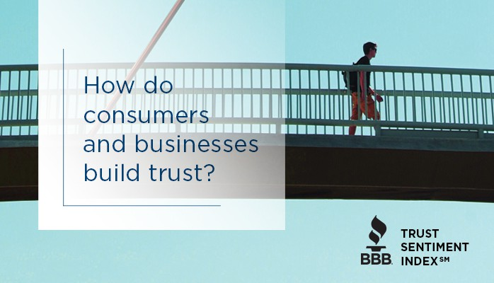

BUILDING TRUST
- Which of the following factors help you trust a business the most?
TOP RESPONSES
#1 Good Reputation 28%
#2 Competitive Prices 17%
#3 Good Customer Service 14%
#4 Reviews & Ratings 13%
#5 Recommendations from Family/Friends 12%

Source: 2017 BBB Trust Sentiment Index℠

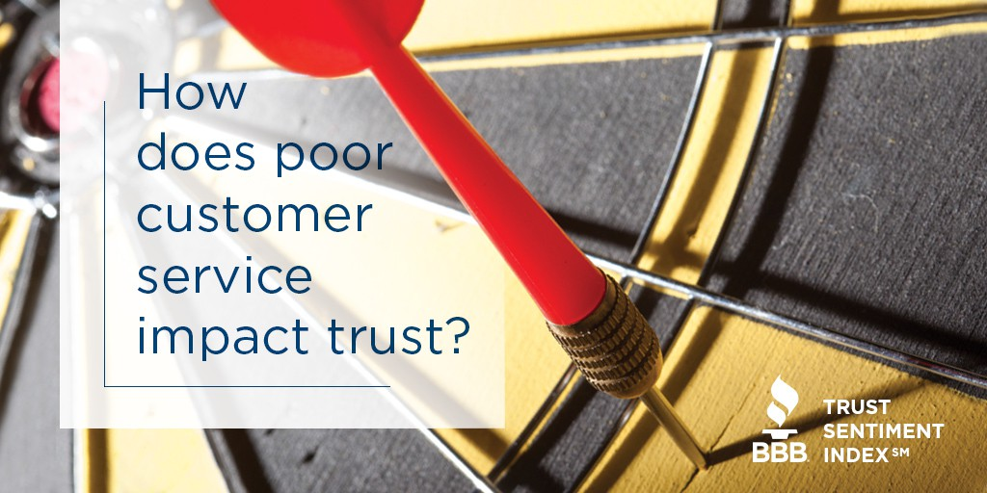

DISSECTING
THE NEGATIVE EXPERIENCE
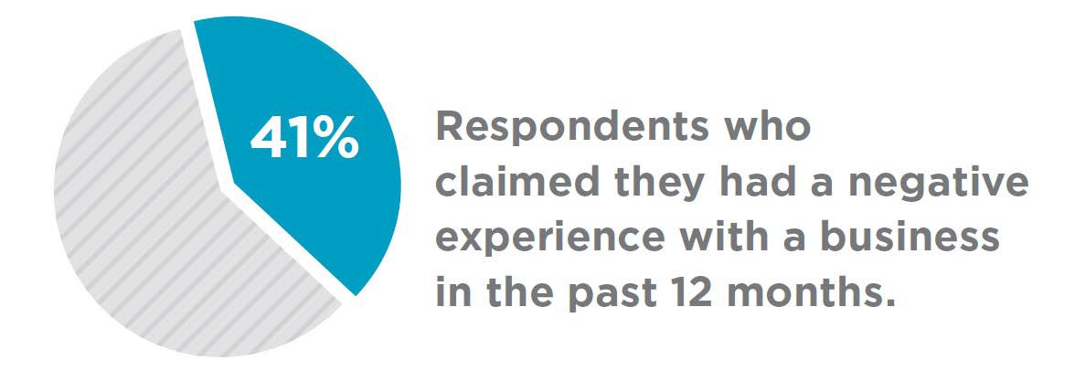
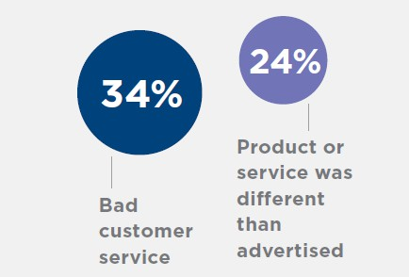
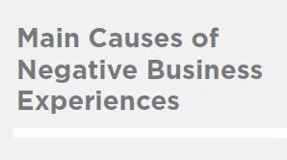
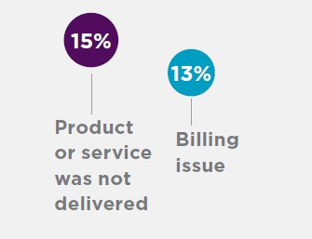

Source: Nielsen, 2017

THE CUSTOMER SERVICE EFFECT

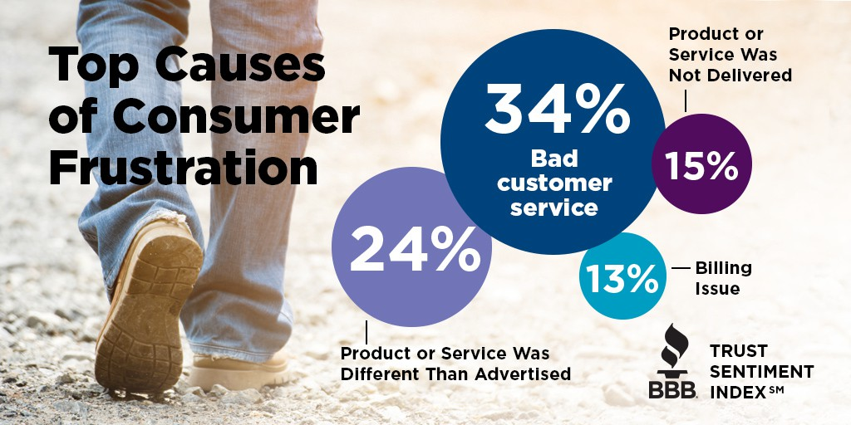

Source: Nielsen, 2017

NEGATIVE EXPERIENCE:

THE DOMINO EFFECT
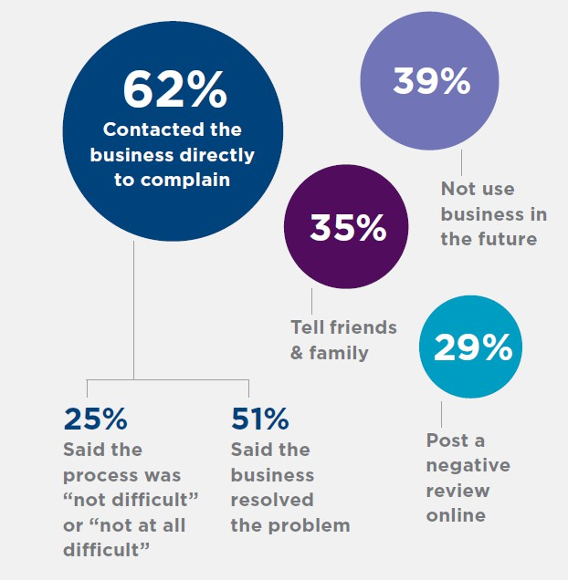
Source: Nielsen, 2017

TYPICAL BBB COMPLAINTS
Presenter
2019-06-11 13:36:51
--------------------------------------------

- MISTREATMENT
- INADEQUATE COMPLAINT HANDLING
- LACK OF CONTACT INFORMATION
- MISREPRESENTATION
- DECEPTIVE ADVERTISING
- REFUND REFUSAL
- CUSTOMER EXPECTATIONS NOT MET
- MISUSE OF CUSTOMER INFORMATION

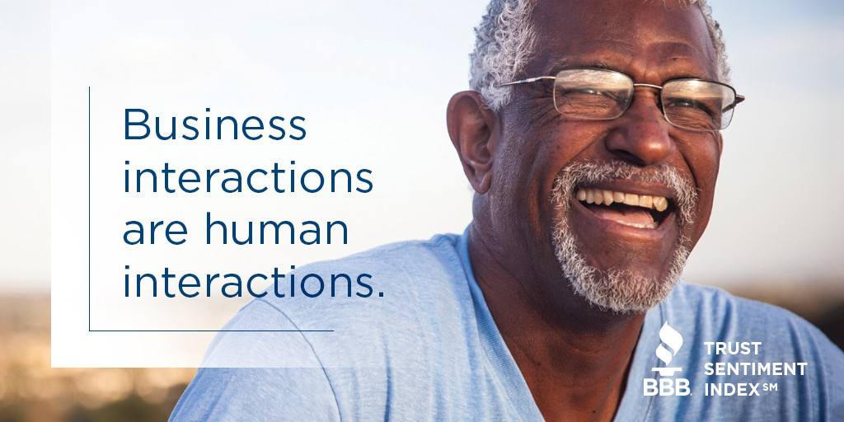

CONSUMERS’ PREFERRED METHOD OF
CUSTOMER SERVICE
- In-Person – 33%
- Telephone – 29%
- Email – 18%
- Live Online Chat – 11%
- Completing Online Form – 9%

Source: Nielsen, 2017

PERSONAL COMMUNICATION IS A KEY FACTOR
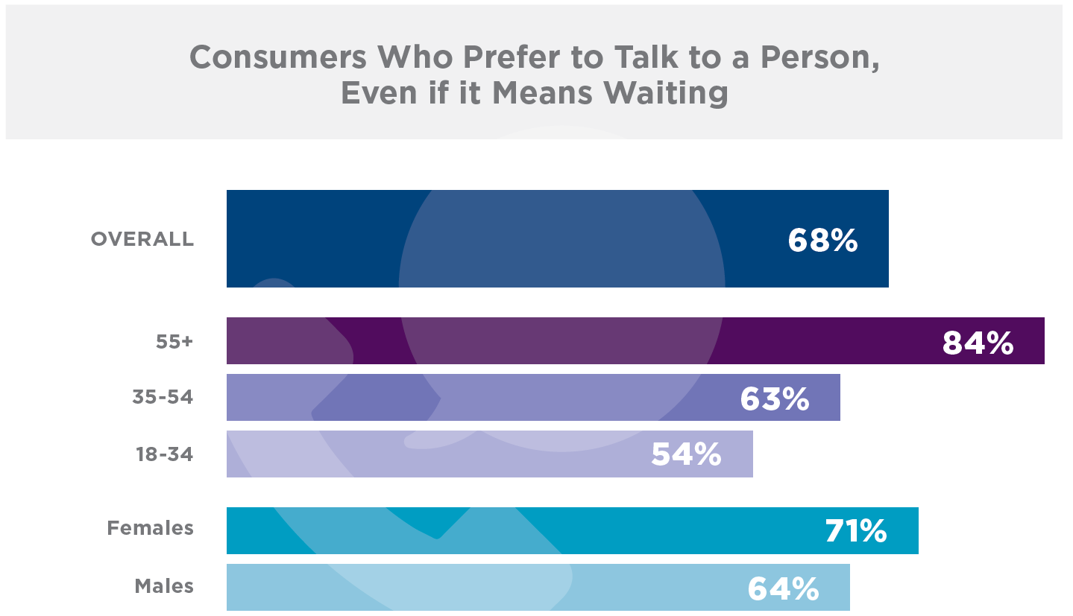
Source: Nielsen, 2017

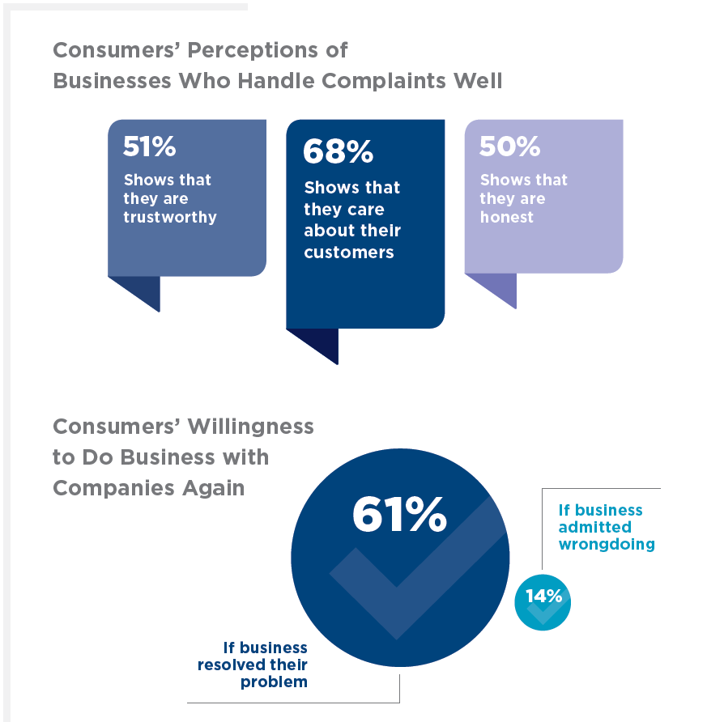

Source: Nielsen, 2017

ASK YOURSELF:

What’s one thing you do to make doing business with you a superior and loyalty-inspiring experience for your customers?

5 Gestures of TrustSM: Trust and the Customer Service Experience, 2018

GAME-CHANGING CUSTOMER SERVICE

Is there an identifiable FORMULA?
- The art and science of truly effective customer service and retention.
- Building blocks for a mutually trusted consumer-business relationship
- Continually anticipate the needs of your customer base
- Gain a better understanding of how they expect - and demand - to be treated.

WE SURVEYED
2,000
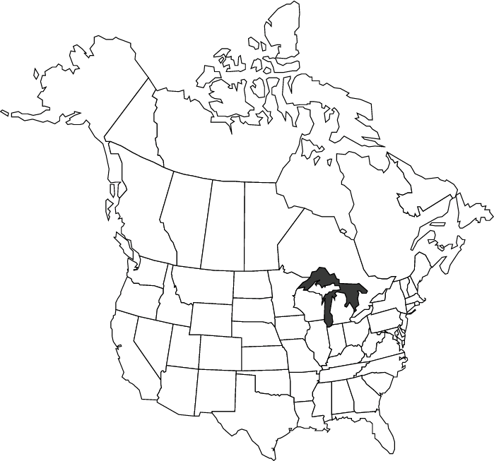
Consumers &
1,500 Businesses

across the
U.S. and Canada

5 Gestures of TrustSM: Trust and the Customer Service Experience, 2018

ASK YOURSELF:

What’s one thing that might be in the formula that customers use to evaluate their experience with you?

5 Gestures of TrustSM: Trust and the Customer Service Experience, 2018



Humble Proactive

Transparent
Honest
Equitable


Respect
5 Gestures of TrustSM: Trust and the Customer
Service Experience, 2018

CONSUMER STORIES
We listened for a MENTAL FRAMEWORK. We heard:


- Be Honest
- Be Transparent
- Be Proactive
- Be Humble
- Be Equitable
Respect

5 Gestures of TrustSM: Trust and the Customer Service Experience, 2018


Respect
= TRUST =

Organic Loyalty

5 Gestures of TrustSM: Trust and the Customer
Service Experience, 2018

5 Gestures of TrustSM

What businesses told us about being honest. . .

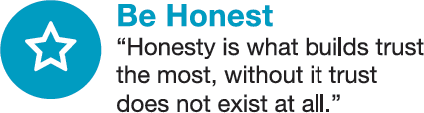

Source: BBB 5 Gestures of TrustSM

5 Gestures of TrustSM

What businesses told us about being transparent...



Source: BBB 5 Gestures of TrustSM

5 Gestures of TrustSM

What businesses told us about being proactive. . .

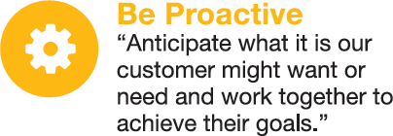

Source: BBB 5 Gestures of TrustSM

5 Gestures of TrustSM
What businesses told us about being humble. . .
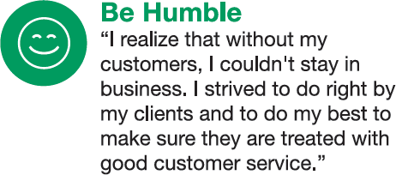

Source: BBB 5 Gestures of TrustSM

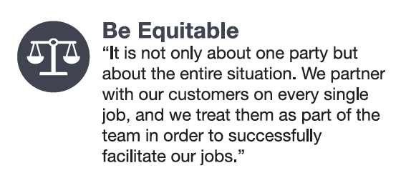
5 Gestures of TrustSM
What businesses told us about being equitable. . .

Source: BBB 5 Gestures of TrustSM

SURVEY (Partial list)

Pick a company with which you have experience: Positive or Negative?
- Trust the company?
- Loyal to the company?
- Certain practices/policies of the company?
- Say nice things?
- Write positive reviews?
- Do business with them even if it costs more?
- Are they: Honest? Transparent? Proactive? Humble? Equitable? Competent? Consistent?

5 Gestures of TrustSM: Trust and the Customer Service Experience, 2018

“To what extent do you agree or disagree that each of the following statements accurately describes the company you chose?”

10

9
8.3
8
8
7.8
8.1
2.9
2.9
3.1
2.8
3.1

8

7

6

5

4
Strongly disagree Strongly agree

3

2

1
Honest Transparent Proactive Humble Equitable
Positive Experience Negative Experience

5 Gestures of TrustSM: Trust and the Customer
Service Experience, 2018

“To what extent do you agree or disagree that each of the following statements accurately describes the company you chose?”
10

9
8.2
8.2
7.7
8
3.2
2.3
2.3
3.2

8

7

6

5

4
Strongly disagree Strongly agree

3

2

1
I trust that they will tell me the truth

They tend to focus on providing value to customers more than making a profiit

They seem to focus on treating their employees well

They make it easy for customers to get their money back if they are not happy

Positive Experience Negative Experience

5 Gestures of TrustSM: Trust and the Customer
Service Experience, 2018

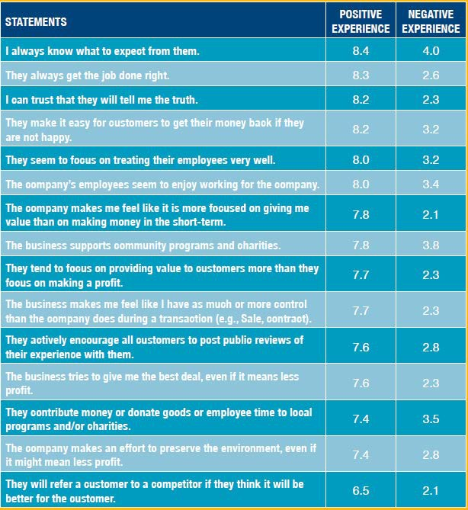
Key
Survey Findings


Source: BBB 5 Gestures of TrustSM


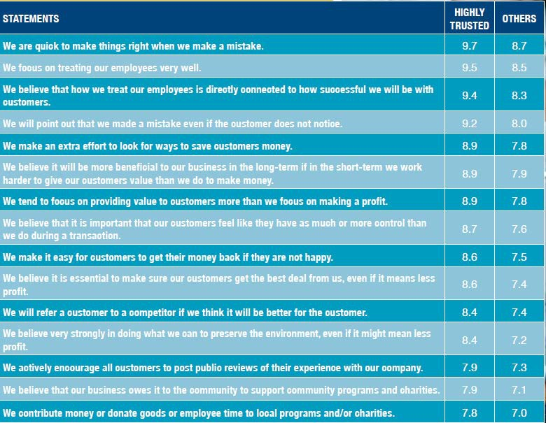
Key Survey Findings

Source: BBB 5 Gestures of TrustSM

Sonya’s Story #1:
Food Subscription Frustration
Subscription Food Service Obscures Information and Places Blame on Customer for Negative Experience
5 GesturesSM Framework Analysis
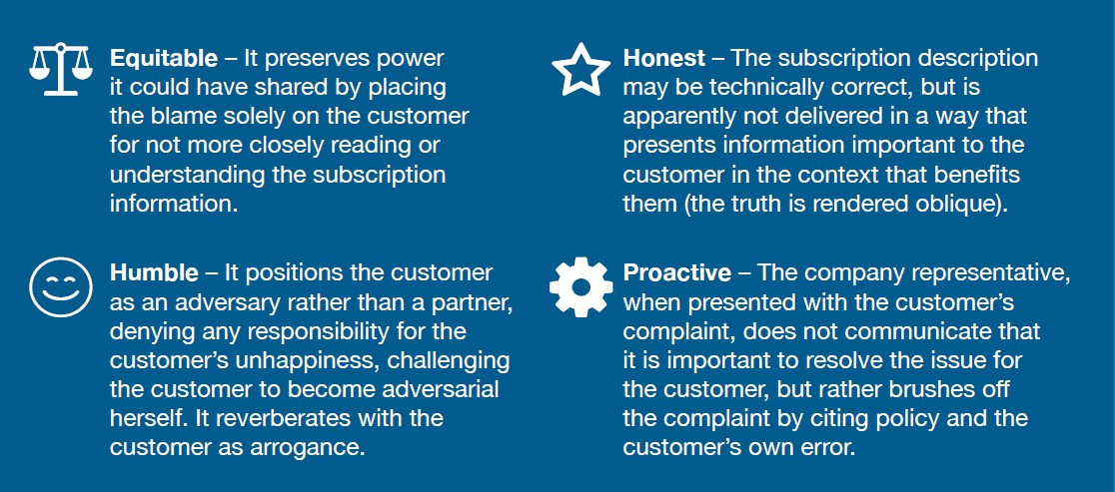

Source: BBB 5 Gestures of TrustSM

Sonya’s Story #2:
“Awesome” Clothing Purchase
Online Clothing Company Placing Complete Trust in Customer
5 GesturesSM Framework Analysis
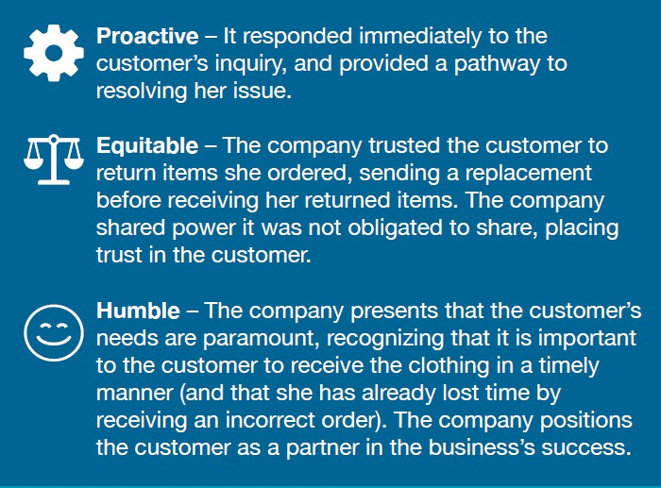
Source: BBB 5 Gestures of TrustSM

John’s Story:
“Selfless” Hardware Referral & Solution

Hardware Store Refers Customer to Local Competitor to Solve Customer’s Need
5 GesturesSM Framework Analysis
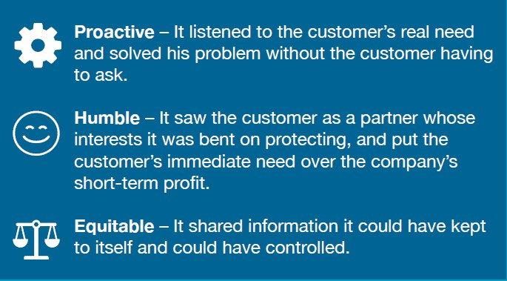

Source: BBB 5 Gestures of TrustSM

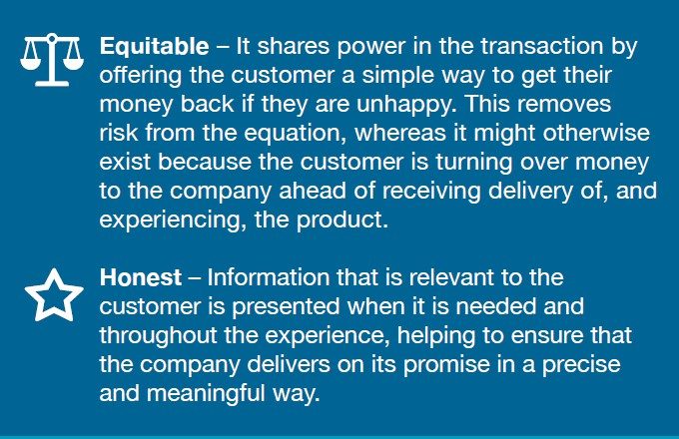
Mike’s Story:
Secure, Comfortable Online Purchase
Large Online Retailer Clearly Promotes and DELIVERS on Return Policy Promise
5 GesturesSM Framework Analysis

Source: BBB 5 Gestures of TrustSM

CUSTOMER RETENTION AT ITS CORE
THE FUNNEL EFFECT:
➔RESPECT &
RESPONSIVENESS
= REPUTATION MOMENTUM
= REPEAT BUSINESS & CUSTOMER LOYALTY
- Employ consistent employee training based upon these principles at all operational levels & regularly monitor its application
- Develop & implement formal complaint-handling procedures tailored to an array of circumstances
- Ensure transparent policies and procedures - Internal & external

PROBLEM SOLVING:
R-E-S-P-E-C-T
- Seemingly obvious core principles – but routinely lacking in practical application
- Treat the customer & dispute as
important to you
- Do not rely upon social media posts to learn of initial dissatisfaction - Be proactive, anticipate customer needs & avoid unnecessary escalation
- Be an active & reflective listener
- Identify the core problem & assess the specific resolution actually sought
- Consider an appropriate goodwill gesture

Use the 5 Gestures as a Framework to
Gesture and target where you want to be. Identify the gaps and plan how
to close them. This can further inspire special programs and advertising/ communication strategies.
Source: BBB 5 Gestures of TrustSM
Assess & Improve Your Customer Experience
  - Ask your customers about experiences they’ve had that made them like doing business with you – or alternatively, that made them less comfortable. Ask for examples and talk about them.
  - Review all customer complaints through the 5 Gestures lens to identify where the customer perceives that a Gesture is missing or has been clearly violated.
  - Plan a discussion with your employees around the 5 Gestures. Ask them to identify the Gestures (or lack thereof) in their own daily practice.
  - If you use customer surveys or solicit feedback from customers regularly, incorporate specific questions addressing the 5 Gestures that go beyond asking about generic satisfaction.
  - Use the 5 Gestures of Trust framework to strategically plan how you will approach your customer relationships. Assess where you are with each

CHECKLIST FOR THE SAVVY BUSINESS
- Make TRUST a true Strategic Priority (Proactively Manage TRUST Factors)
- Make it EASIER for people to engage and share feedback, even if negative – Continuing access and effective contact information
- Transparently IDENTIFY & explain all relevant policies (ex: refund/return)
- HUMANIZE Business Relationships as much as possible – Personalize the experience
- RESOLVE complaints professionally when they occur. At a minimum: Assume responsibility and acknowledge wrongdoing where a mistake was made.
- Actively LISTEN. Pay attention to hidden voices (of dissatisfied customers). Proactively reach out.
- Continuously FOCUS on improving the overall customer service experience - What is preventing a truly superior experience?
- EMBRACE third-party organizations for dispute resolution.
- Focus on CHARACTER/honesty, service & quality – they should define your approach and resultant customer reputation.

Source: 2017 BBB Trust Sentiment Index℠

NOTICE

This presentation/document may not be reproduced, copied or redistributed, in whole or in part, by any means or in any format without the prior express written permission of the Better Business Bureau. All rights, title and interest in and to the name Better Business Bureau/BBB, its logos and all associated marks are the sole and exclusive property of the Better Business Bureau.

As a matter of policy, the Better Business Bureau does not endorse any product, service or business. The information provided herein is believed to be reliable, but the Better Business Bureau does not guarantee its accuracy or completeness. No information provided herein or in conjunction herewith constitutes, nor shall be construed as, legal advice; it is not intended, nor may it be relied upon, as legal advice in any form.

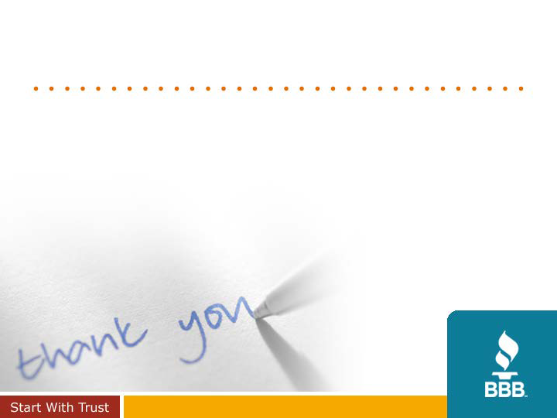
Thank You

