Modern Campus Curriculum – Originator Instructions
Creating a Proposal
- Log-in to https://stonybrook.curriculog.com/ with your Net ID and Password. The +New Proposal box will be on the right side of your homepage.
- Select the appropriate form. Undergraduate, Graduate, SPD and Health Sciences have four forms to choose from. Use the arrow box to preview and the checkmark to start. Once you start, you can save at any time.
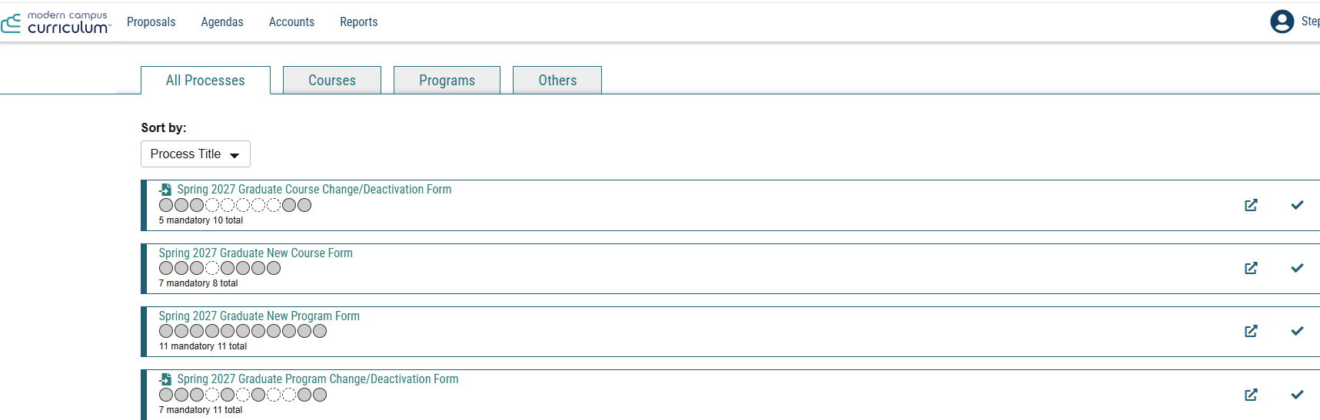

- Fill out the appropriate fields. Fields that have an asterisk (*) are required. Make sure you select the correct department, or the course cannot proceed through the workflow. To upload a course syllabus or any other required attachments, use the files tab.
  - Note: it is recommended that you type in your department name, rather than trying to find it using the drop down menu.
  - Note for School of Marine and Atmospheric Sciences originators: SoMAS is broken into 3 areas acting as departments (Atmospheric Sciences, Marine Sciences and Sustainability Studies), with the program/course code listed in parentheses. You must select one of the 3 of areas.
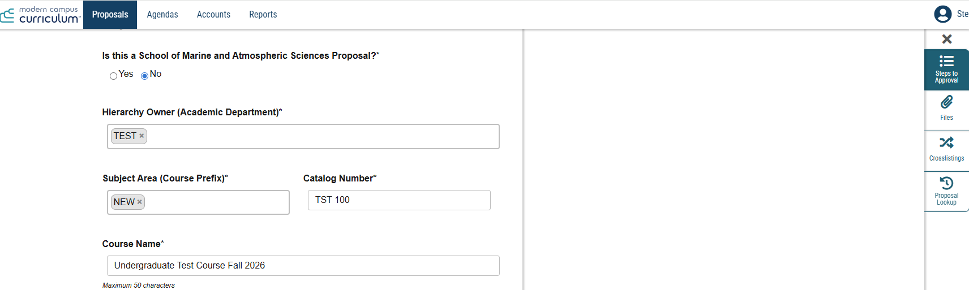
- Once you have answered all fields, select Validate and Launch Proposal.
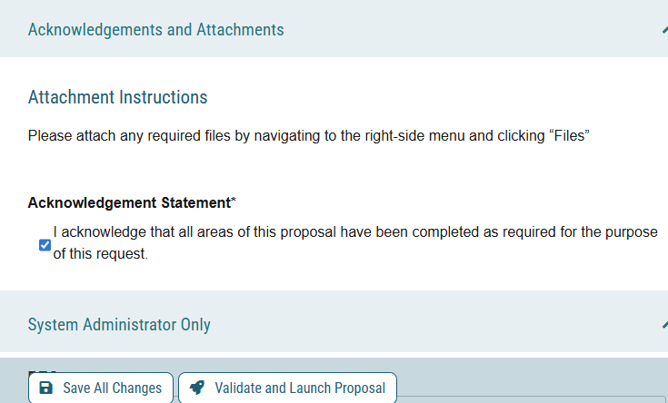

Your proposal has now entered the workflow. No immediate action is needed, unless you also serve as the Department Chair or Graduate Program Director. Select My Tasks to view if any proposals require your attention.

Tracking Your Proposal

- As of July 2026, originators no longer need to approve their own proposals. To view the status of your proposal, select My Proposals from your Curriculum homepage.
- You will be able to comment on the proposal as it progresses through the workflow and will receive notifications once the proposal has been approved at various steps (ex. Curriculum Committees, SUNY/NYSED Approval for Programs, Catalog Integration etc.). Proposals that are rejected at any step are automatically sent back to you with comments from the rejecting step. You can make the necessary edits and relaunch the form into the workflow to restart the approval process.

Resources
User tracking: You can view all edits made by any users at any step in the process by selecting the discussion bubble and “Show current with markup.”
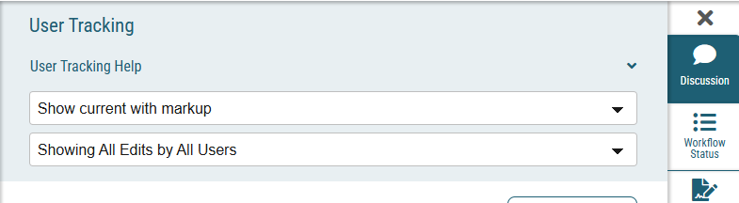
Validation Errors: If a mandatory field is not answered, you will receive an error message. Select show me to see what still must be completed.
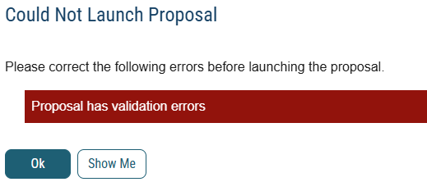

Impact Report: This feature allows you to see where the course or program is listed in the Catalog. This includes course descriptions, course requisites and programs. For the most accurate results, select the most recent catalog available. This feature will only work for existing courses/programs.
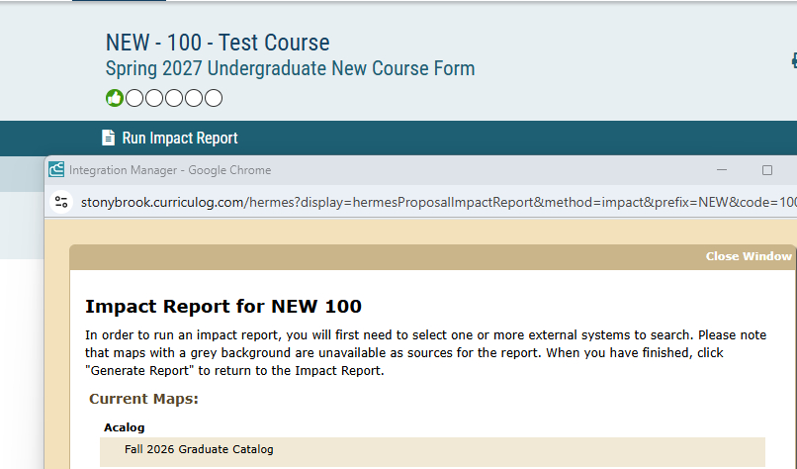

Importing: Importing is mandatory for course/program change forms and optional for new program forms. This allows several prefilled fields to transfer from the most recent catalog into Curriculum. To import successfully use the search menu and then select your course or program using the file/arrow icon. Once the prefilled fields load, you can select Build Proposal to start the process.
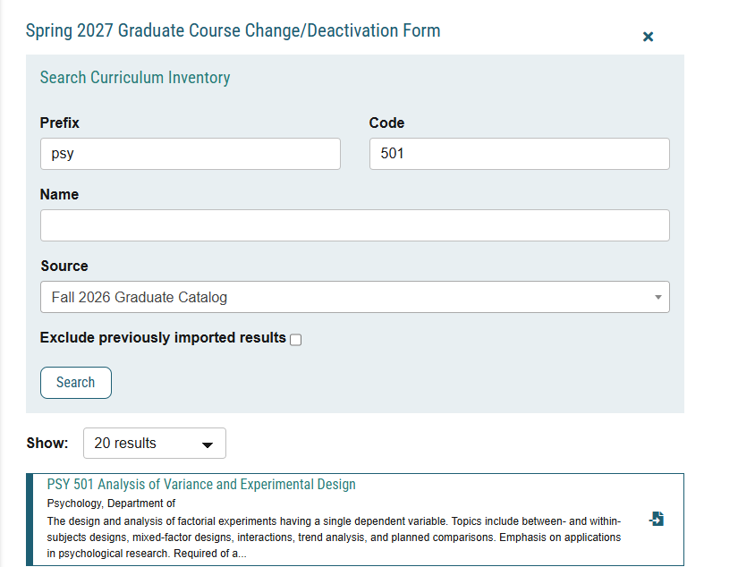

For all questions/concerns/feedback: please email Steve Fogarty (stephen.fogarty@stonybrook.edu).

