Modern Campus Curriculum – Activity Digests and Adjusting Your Settings
All Curriculum users will receive a Curriculog digest email that tracks approvals, rejections and comments on their proposals. The default setting is a weekly email digest that is sent at approximately 2:30 AM on Mondays. Users will not receive this email if they do not have an active proposal in the system. To change your settings, see below:

How to update after log-in (https://stonybrook.curriculog.com/)
1. On the right side of the page, hover over your name and select "My Settings"
2. Select your name
3. Scroll down to Email Options. The options are:

- Weekly Email Digest (default): recommended for users of the system who will be logging in frequently
- MWF or TuTh Email Digest: first of two ideal options Curriculum Committee members, GPDs and Chairs
- Daily Email Digest: second of two ideal options Curriculum Committee members, GPDs and Chairs
- All Emails: user notified anytime anything concerning an originated proposal, or a workflow step occurs; leads to frequent notifications if user has multiple active proposals
4. Save preferences once a choice is selected. Users should not change their email address in the system.
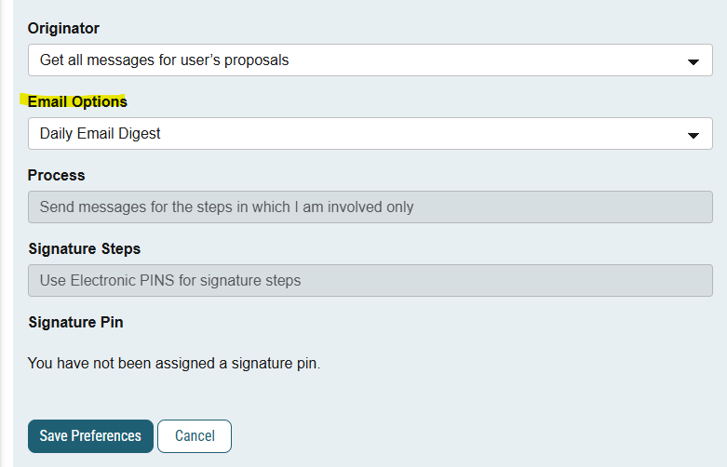

These settings can be changed at any time.

