Modern Campus Curriculum – Curriculum Committee Approval Instructions
- Log-in to https://stonybrook.curriculog.com/ with your Net ID and Password.
- When a course or program proposal reaches the Curriculum Committee Step, it will appear under My Tasks. Additionally, the Curriculum Committee Agenda Administrator (usually the Chair or a designated Committee member) can create an agenda for the week. The agenda will appear under My Recent Notifications on the right side of your homepage and will be included in the weekly/daily email digests you receive from Curriculum.
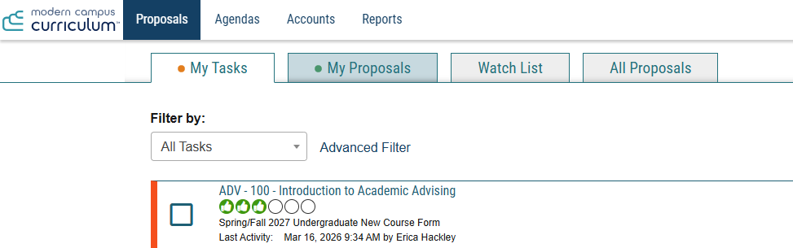
- Once you click on the proposal, you can review what has been submitted by scrolling through the fields. Any attachments, including syllabi, SUNY/NYSED forms, additional chair approvals or other supplemental information, can be found using the files icon on the right side of the page.
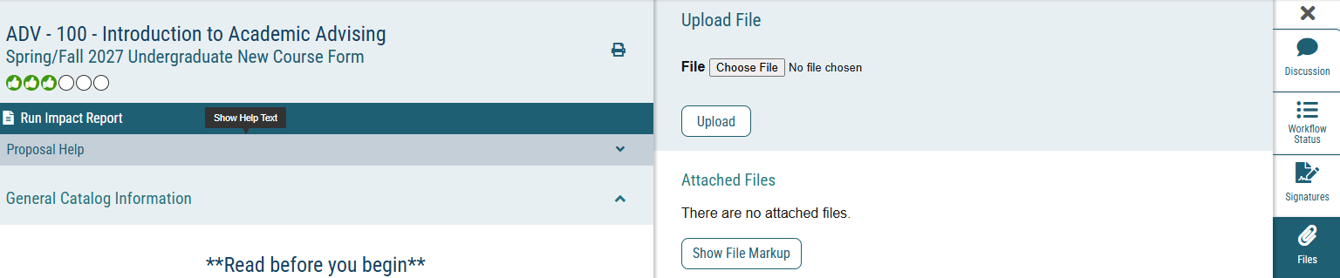
- Curriculum Committee comments are confidential, unless the proposal originator is also a committee member. To provide feedback as a committee member, use the discussion icon on the right side of the page and select Add Comment. Your comment will only be visible to your fellow committee members.
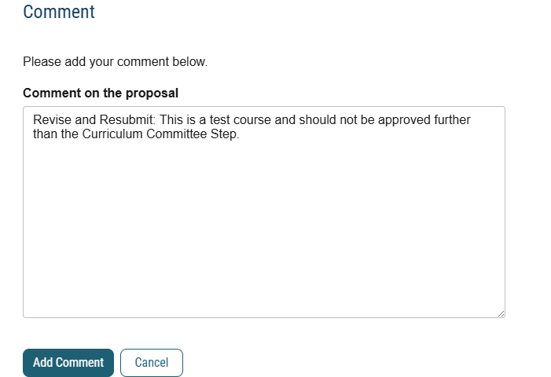
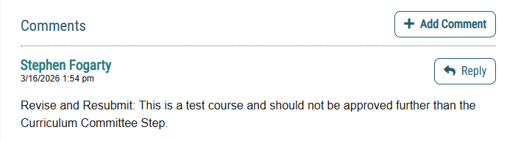
- The decision icon will allow the committee to make a ruling on the proposal. Approving moves the proposal to the next step in the workflow; rejecting the proposal sends it back to the first step. Committees must provide feedback when rejecting a proposal; it is optional for approving.
  - Originators can see when individual committee members approve or reject a proposal. As a best practice, it is recommended that only the Committee Chair and/or Agenda Administrator use the decisions step to protect confidentiality.
- Committees are unable to modify proposals. Any changes/typos that are needed for approved proposals should be indicated as part of the decision process.

