Modern Campus Curriculum – Department Chair and Program Director Instructions
Approving a Proposal
- Log-in to https://stonybrook.curriculog.com/ with your Net ID and Password.
- Any proposal that requires your approval will appear under My Tasks. You will be notified when a proposal reaches your step in the workflow. You have 30 days to decide on the proposal, otherwise it will automatically be rejected and sent back to the originator. You will receive a reminder every 10 days, and a final warning 5 days before the 30 day deadline.
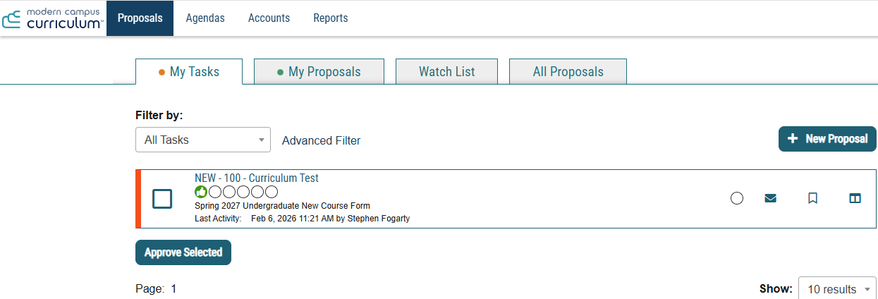
- You can automatically approve the proposal by checking the box on the left and selecting Approve Selected. Click anywhere on the proposal if you wish to view it before making a decision. Once the proposal appears you can review all questions, make comments, upload files and edit any of the initial form responses. Your comments are public.
To make a decision from this screen, select Decisions.
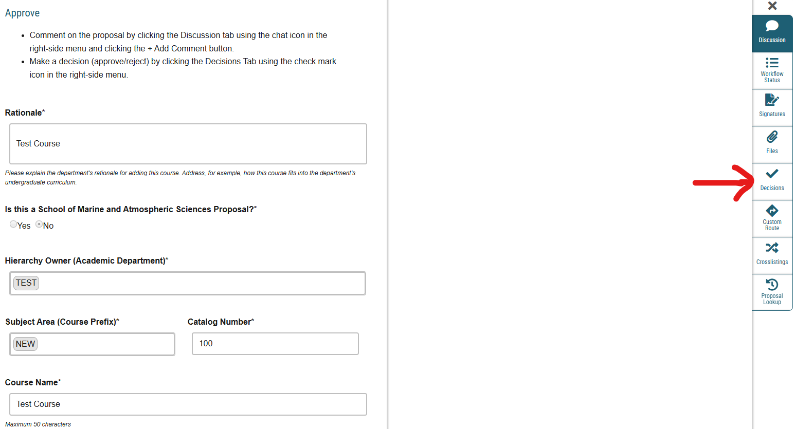
- On the decisions tab you have the option to Approve, Reject or Hold the proposal. Do not use Custom Route. Approving will move the proposal forward to the next step; rejecting it will send it back to the originator.
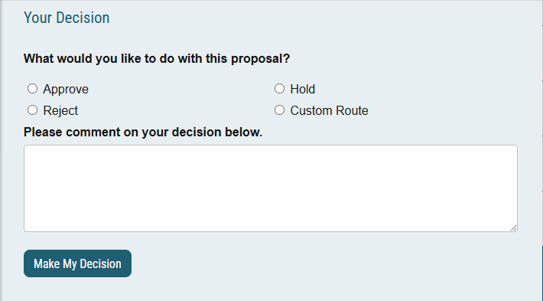
- You will be able to comment on the proposal as it progresses through the workflow and will receive notifications once the proposal has been approved at various steps (ex. Curriculum Committees, SUNY/NYSED Approval for Programs, Catalog Integration etc.). Proposals that are rejected at any step are automatically sent back to you with comments from the rejecting step. You can make the necessary edits and relaunch the form into the workflow to restart the approval process.

Resources
User tracking: You can view all edits made by any users at any step in the process by selecting the discussion bubble and “Show current with markup.”
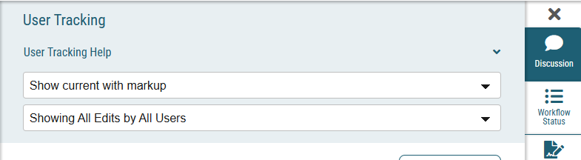
Impact Report: This feature allows you to see where the course or program is listed in the Catalog. This includes course descriptions, course requisites and programs. For the most accurate results, select the most recent catalog available. This feature will only work for existing courses/programs.

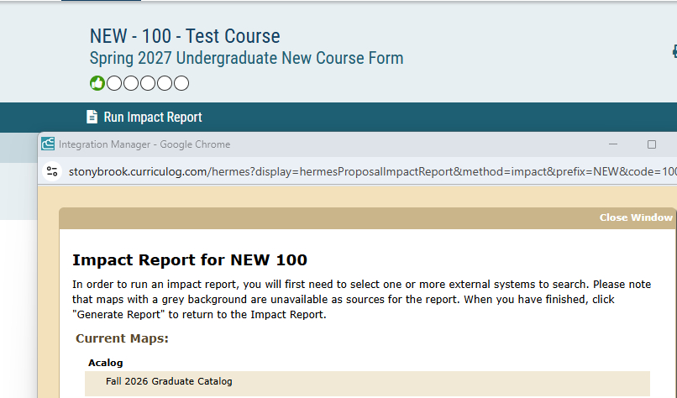

For all questions/concerns/feedback: please email Steve Fogarty (stephen.fogarty@stonybrook.edu).

