Center for Excellence in Learning and Teaching | celt@stonybrook.edu | www.stonybrook.edu/celt | W-3519 Melville Library

Learning Objectives
Resource Guide

Goal, Objective, Outcome?
These statements are used in education to specify what students should be able to do as a result of instruction. The terms goals, objectives, and outcomes are often used interchangeably.
Goals refer to a broader view of what you want your students to achieve.
Objectives refer to the steps students need to reach the learning goal
Outcomes are what students actually achieve based on assessment evidence (Barkley & Major, 2016).

You will come across different definitions for these terms. It can be confusing but our best advice is to not get caught up in semantics. Until there is a better consensus among educators, you can call these statements learning objectives or learning outcomes.

Learning objectives (LO) contain a measurable verb, knowledge and/ or skill and additional supporting/clarifying details as needed. Creating
LOs is an iterative process and you may you need to refine them as you develop your instruction. This guide provides a step by step process.

Creating Learning Objectives: Step-by-Step Process

Basic Structure of a Learning Objective
measurable verb- knowledge/skill- additional details
measurable verb- what students will do knowledge/skill- what students are expected to acquire additional details- supporting/clarifying language

Step 1: Identify the knowledge/skill students are expected to learn.

Types of Knowledge

Factual
Conceptual
Procedural Metacognitive

Basic terminology students must know in a discipline

Parts of a cell, parts of the brain colors of the rainbow, branches of government, elements in the periodic table, names of historical figures
examples
Interrelationships among basic elements; knowledge of classifications, categories, principles, generalizations, theories, models

Supply and demand, principles of design, climate change, laws of physics, American foreign trade policies, function of the hippocampus
examples
How to do something or methods of inquiry; knowledge of discipline specific skills, techniques, methods; when to use appropriate procedures

Lab skills, painting technique, research methods, methods to solve algebraic equations, counseling skills, coding skills
examples
Awareness of one’s own thought processes; strategic knowledge, self-knowledge

Learning strategies, elaboration, organizational and planning strategies, comprehension monitoring strategies,
examples
means-end analysis

References:
Anderson, L. W., & Krathwohl, D. R. (2001). A taxonomy for learning, teaching, and assessing: A revision of Bloom’s taxonomy of educational objectives. Longman. Barkley, E. F., & Major, C. H. (2016). Learning assessment techniques: A handbook for college faculty. John Wiley & Sons.
Nilson, L. B. (2016). Teaching at its best: A research-based resource for college instructors. John Wiley & Sons.


Creating Learning Outcomes Guide by Dr. Kristin Hall is licensed under a Creative Commons Attribution-NonCommercial-ShareAlike 4.0 International License.


Center for Excellence in Learning and Teaching

Step 2: Select a measurable verb to describe what you want students to engage in.

Can the Student...
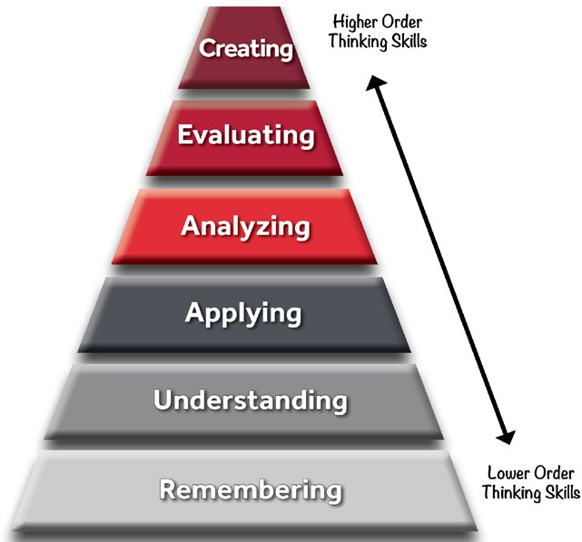
...create a new product or point of view?

...justify a stand or decision, explain which options are better?

...distinguish between the different parts and how they are connected?

...use the info in a new context?

...explain ideas or concepts?
Creating
Evaluating Analyzing Applying Understanding
...recall or remember information?
Remembering
Bloom’s Taxonomy Framework

Remembering Understanding Applying Analyzing Evaluating Creating
Measurable Verbs
arrange, define,
detail, duplicate, find, identify, indicate, label, list, locate, order, pronounce, recall, recognize, recite, state
associate, categorize, apply, calculate, carry analyze, break down, argue, assess, assemble, assimilate,
clarify, classify, out, compute, conduct, categorize, classify, choose, conclude, build, change, decipher, describe, demonstrate, compare, contrast, convince, critique, combine, compose, examine, explain, determine, discover, differentiate, debate, defend, construct, create, generalize, employ, execute, discern, dissect, discredit, evaluate, design, develop, paraphrase, graph, implement, distinguish, judge, justify, formulate, generate, summarize, translate operate, perform, investigate, question persuade, rate, hypothesize, invent,
solve, use, utilize recommend, solve, produce, synthesize, validate, verify theorize, write

Step 3: Include additional supporting details to provide context.

You can add additional or supporting details to your learning objective but this is not required. See examples.
Examples: Students will be able to...
...create a measurable learning outcome using Bloom’s Taxonomy as a framework.
...evaluate organizational decisions based on business ethical principles.
...compare works of art from the Impressionism and Post-Impressionism eras.
...apply the quadratic equation to an algebra word problem.
...describe the basic theories in developmental psychology.
...identify elements in the periodic table.

Best Practices in Writing Learning Objectives

Do This... Avoid This...

Use one specific and measurable verb. Use student centered language.
Use specific but language that is also concise.
Make sure your outcomes are achievable for the given time frame, ie. semester.
Using more than one verb
Students may be able to achieve one part but not the other.
Words/phrases that are not measurable.
ie. understand, know, demonstrate an understanding, learn, be familiar with, be aware of, appreciate, have knowledge of
Vague or ambiguous words or phrases.
References to course activities and specific assessments.
ie.“Students will be able to achieve a passing grade on the exam.”

