NATIONAL CENTER FOR EDUCATION STATISTICS



SUNY AT STONY BROOK

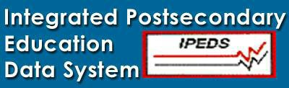
The Integrated Postsecondary Education Data System (IPEDS) is the core postsecondary education data collection program for the NCES. It is a single, comprehensive system designed to encompass all institutions and educational organizations whose primary purpose is to provide postsecondary education. For additional information see http://nces.ed.gov/ipeds.

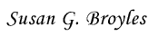
September 02, 2005

Dear Institutional Executive:

The National Center for Education Statistics is pleased to provide you with the second annual IPEDS Data Feedback Report, which is customized for your institution. This report includes data, provided in 2004-05 through the Integrated Postsecondary Education Data System, for your institution and a comparison group of institutions. This year, you had the opportunity to select your own comparison group or, if you did not submit your own group, IPEDS identified a comparison group for you.

IPEDS continually makes improvements to the data collection, the analysis tools, and the Data Feedback Reports based on suggestions from users. We encourage you to continue to help us improve IPEDS and these reports by sending your comments to datafeedback@ed.gov.

Thank you for all of your efforts throughout the data collection process. Without your support and the high quality data that you provide, these reports would not be possible.

Best regards,
Susan G. Broyles IPEDS Program Director

What Is The Purpose Of This Report?
The IPEDS Data Feedback Report is intended to provide institutions a context for examining the data they submitted to the Integrated Postsecondary Education Data System (IPEDS). Our goal is to produce a report that is useful to institutional executives and that may help improve the quality and comparability of IPEDS data.

What Is In This Report?
The figures provided in this report are those suggested by the IPEDS Technical Review Panel. They were developed to provide selected indicators and data elements for your institution and a comparison group of institutions. The figures are based on data collected during the 2004–05 IPEDS collection cycle and are the most recent data available. Additional information about these indicators is provided in the Methodological Notes at the end of the report. Following the figures is a list of the institutions in your comparison group and the criteria used for their selection. Please refer to "Comparison Group" in the Methodological Notes for more information.

What Is IPEDS?
The Integrated Postsecondary Education Data System (IPEDS) is a system of survey components that collects data from all institutions in the United States and other jurisdictions, such
as Puerto Rico, whose primary purpose is to provide postsecondary education. IPEDS collects institution-level data on students (enrollment and graduation rates), student charges, program completions, faculty, staff, and finances. Each year nearly 6,700 postsecondary institutions provide information to the
U.S. Department of Education through IPEDS. These data are used at the federal and state level for policy analysis and development; at the institutional level for benchmarking and peer analysis; and by students and parents, through College Opportunities On-Line (IPEDS COOL at http://nces.ed.gov/ipeds/cool/), to aid in the college search process. For more information about IPEDS, see http://nces.ed.gov/ipeds.

Would You Like To Do More Analysis Of Your IPEDS Data?
The information in this report can be produced for a different comparison group using the IPEDS Executive Peer Tool (ExPT) at http://nces.ed.gov/ipedspas/expt. If you would like to make comparisons on a wider range of IPEDS variables, the more comprehensive IPEDS Peer Analysis System (PAS) is available at http://nces.ed.gov/ipedspas. In both systems, you may select your own comparison group by institution name or by using selected variables. Through the ExPT, you may also print additional copies of this report.

SELECTED FIGURES
These figures are based on 2004–05 IPEDS data submitted by your institution, SUNY AT STONY BROOK, and the comparison group listed later in this report.

Figure 1. Unduplicated 12-month headcount, total FTE enrollment (academic year 2003–04), and full- and part-time fall enrollment (Fall 2004)
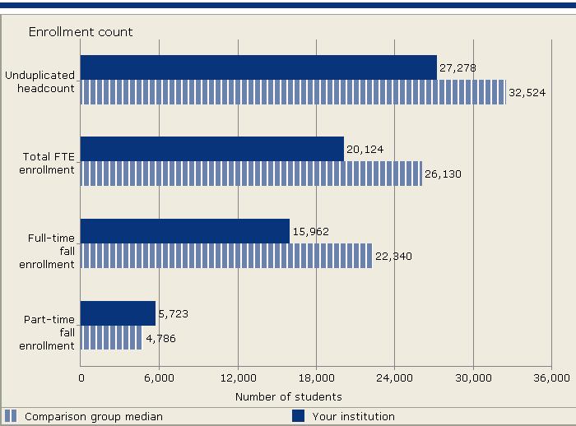
NOTE: For details on calculating full-time equivalent (FTE) enrollment, see “Calculating FTE” in the Methodological Notes at the end of this report. Headcounts, FTE, and full- and part-time fall enrollment include both undergraduate and postbaccalaureate students, when applicable.
SOURCE: U.S. Department of Education, National Center for Education Statistics, Integrated Postsecondary Education Data System (IPEDS): Spring 2005.
Figure 2. Percent of all students enrolled, by race/ethnicity: Fall 2004

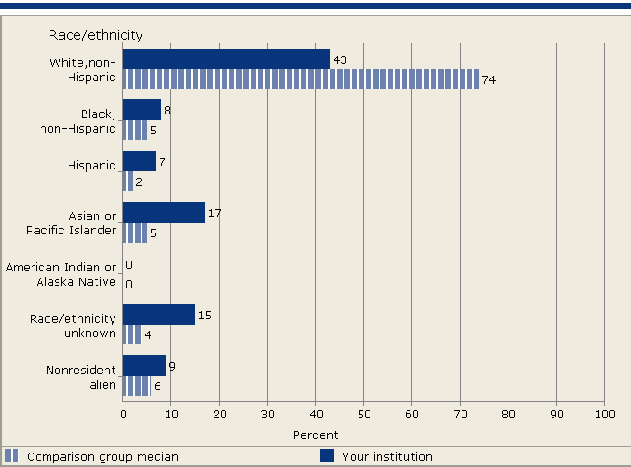
NOTE: Median values for the comparison may not add to 100 percent. See "Use of Median Values for Comparison Group" for how median values are determined.
SOURCE: U.S. Department of Education, National Center for Education Statistics, Integrated Postsecondary Education Data System (IPEDS): Spring 2005.

Figure 3. Academic year tuition and required fees for full-time, first-time degree/certificate-seeking undergraduates: 2002–03—2004–05
Figure 4. Percent of full-time, first-time, degree/certificate-seeking undergraduate students receiving financial aid, by type of aid: 2003–04

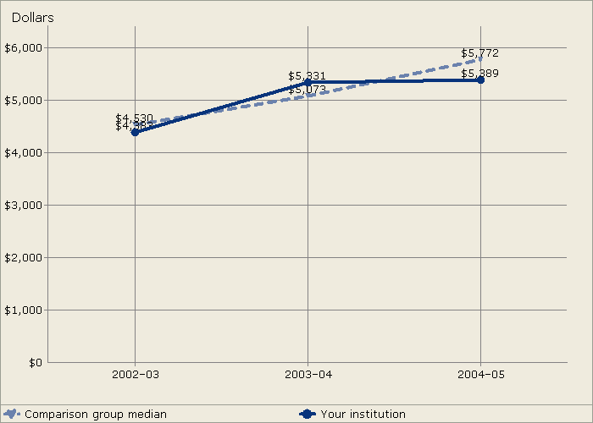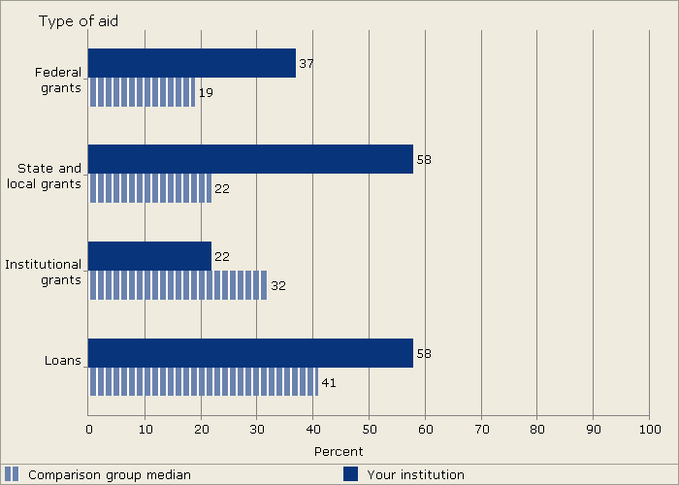

SOURCE: U.S. Department of Education, National Center for Education Statistics, Integrated Postsecondary Education Data System (IPEDS): Fall 2004.
NOTE: For details on how students are counted for financial aid reporting, see “Student Counts for Financial Aid Reporting” in the Methodological Notes at the end of this report.
SOURCE: U.S. Department of Education, National Center for Education Statistics, Integrated Postsecondary Education Data System (IPEDS): Spring 2005.

Figure 5. Types and average amounts of financial aid received by full-time, first-time, degree/certificate-seeking undergraduates: 2003–04
Figure 6. Full-time, first-time, degree/certificate-seeking undergraduates (GRS cohort) as a percent of all undergraduates and as a percent of total entering students; and retention rates of full- and part-time first-time, degree/certificate-seeking students: Fall 2004

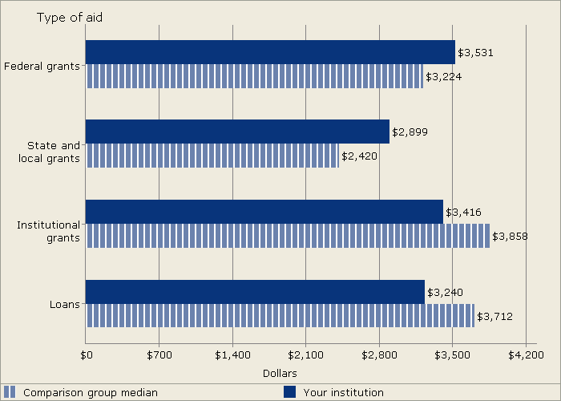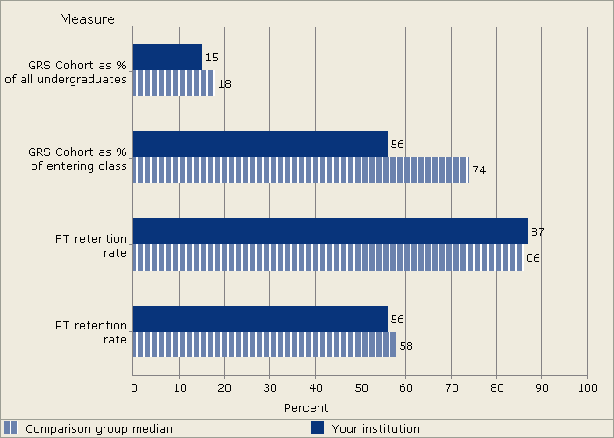

NOTE: Average grant (or loan) values were calculated by dividing the total grants (or loans) awarded by the total number of recipients.
SOURCE: U.S. Department of Education, National Center for Education Statistics, Integrated Postsecondary Education Data System (IPEDS): Spring 2005.
NOTE: Total entering students include all students coming to the institution for the first time. For 4-year schools, retention rates are reported for students seeking a bachelor's degree only. For more information see "Retention Rates" in the Methodological Notes at the end of this report.
SOURCE: U.S. Department of Education, National Center for Education Statistics, Integrated Postsecondary Education Data System (IPEDS): Spring 2005.

Figure 7. Graduation rates of full-time, first-time degree/certificate-seeking undergraduates by race/ethnicity: 1998 cohort
Figure 8. Number of degrees awarded, by level: Academic year 2003–04

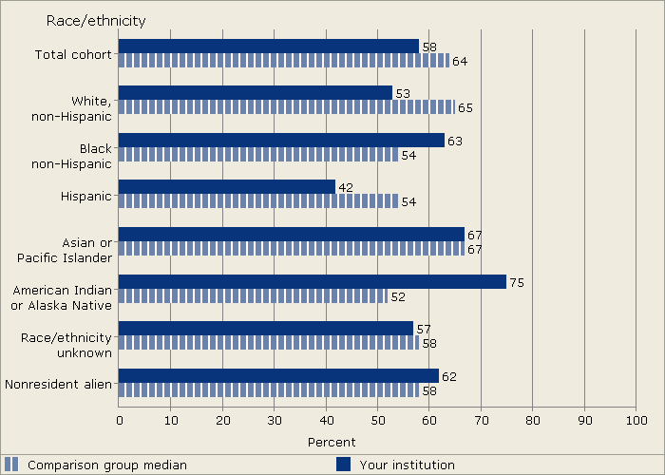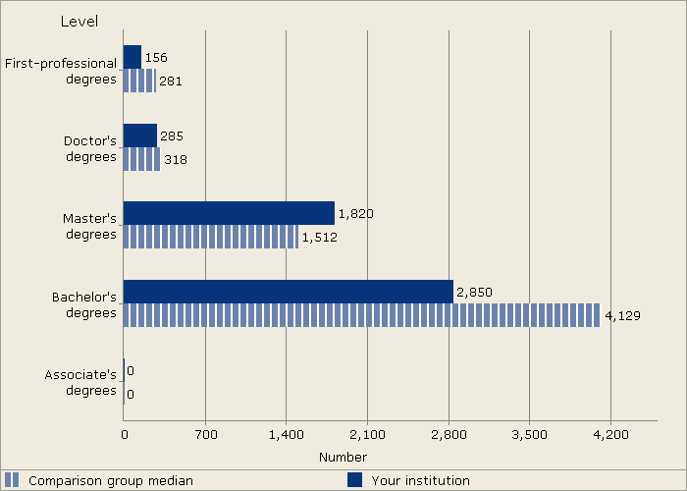

NOTE: The graduation rates are the Student Right-to-Know (SRK) rates. For more information see the Methodological Notes at the end of the report.
SOURCE: U.S. Department of Education, National Center for Education Statistics, Integrated Postsecondary Education Data System (IPEDS): Spring 2005.
SOURCE: U.S. Department of Education, National Center for Education Statistics, Integrated Postsecondary Education Data System (IPEDS): Fall 2004.

Figure 9. Core revenues per FTE student, by source: Fiscal year 2004
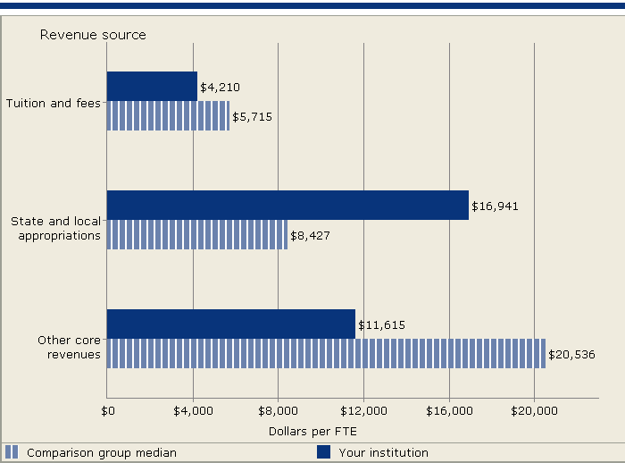
NOTE: Revenues per full-time equivalent (FTE) enrollment, particularly tuition and fees and appropriations, may be inflated because finance data include all core revenues while FTE reflects credit activity only. For details on calculating FTE enrollment and a detailed definition of core revenues see the Methodological Notes. SOURCE: U.S. Department of Education, National Center for Education Statistics, Integrated Postsecondary Education Data System (IPEDS): Spring 2005.
Figure 10. Core expenses per FTE student, by function: Fiscal year 2004
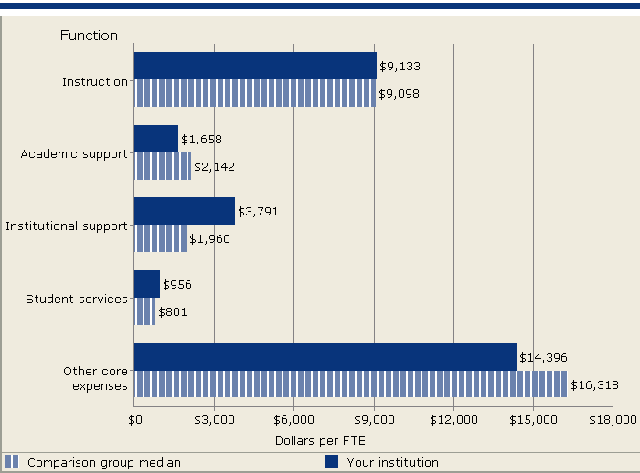
NOTE: Expenses per full-time equivalent (FTE) enrollment, particularly instruction, may be inflated because finance data include all core expenses while FTE reflects credit activity only. For details on calculating FTE enrollment and a detailed definition of core expenses see the Methodological Notes.
SOURCE: U.S. Department of Education, National Center for Education Statistics, Integrated Postsecondary Education Data System (IPEDS): Spring 2005.

Figure 11. Percent of FTE professional staff by assigned position: Fall 2004
Figure 12. Average salaries of full-time instructional faculty equated to 9-month contracts, by academic ranks: Academic year 2004–05

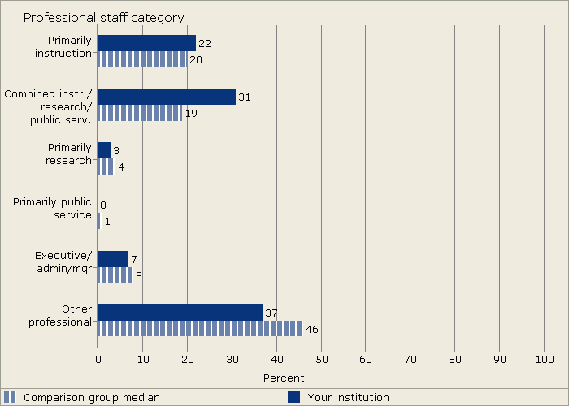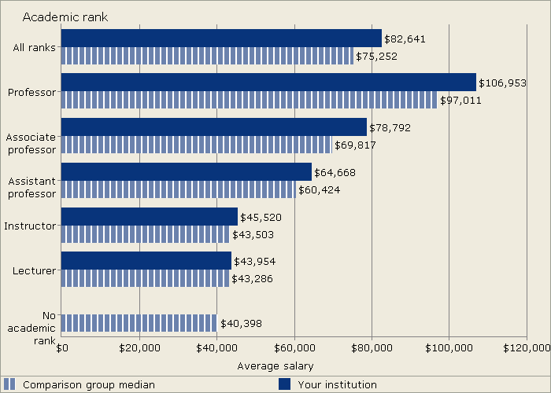

NOTE: Median values for the comparison may not add to 100 percent. See “Use of Median Values for Comparison Group” for how median values are determined. Graduate assistants are not included in this figure.
SOURCE: U.S. Department of Education, National Center for Education Statistics, Integrated Postsecondary Education Data System (IPEDS): Winter 2004–05.
NOTE: Average full-time instructional faculty salaries for 11/12-month contracts were adjusted to 9-month average salaries by multiplying the 11/12-month salary by .8182. Salaries based on less-than 9-month contracts are not included. Medical school faculty salaries are not included.
SOURCE: U.S. Department of Education, National Center for Education Statistics, Integrated Postsecondary Education Data System (IPEDS): Winter 2004–05.

COMPARISON GROUP

Using some of your institution's characteristics, a group of comparison institutions was selected for you. The characteristics include public, 4-year, degree-granting, Carnegie Classification of Doctoral/Research Universities—Extensive, research expendtitures of more than $100 million, and enrollment of a similar size. This comparison group includes the following 26 institutions:

CLEMSON UNIVERSITY (CLEMSON, SC)
NORTH CAROLINA STATE UNIVERSITY AT RALEIGH (RALEIGH, NC)
OHIO STATE UNIVERSITY-MAIN CAMPUS (COLUMBUS, OH)
OREGON STATE UNIVERSITY (CORVALLIS, OR)
PENNSYLVANIA STATE UNIVERSITY-MAIN CAMPUS (UNIVERSITY PARK, PA)
PURDUE UNIVERSITY-MAIN CAMPUS (WEST LAFAYETTE, IN)
SUNY AT ALBANY (ALBANY, NY)
SUNY AT BUFFALO (BUFFALO, NY)
TEXAS A & M UNIVERSITY (COLLEGE STATION, TX)
THE UNIVERSITY OF TENNESSEE (KNOXVILLE, TN)
THE UNIVERSITY OF TEXAS AT AUSTIN (AUSTIN, TX)
UNIVERSITY OF ALABAMA AT BIRMINGHAM (BIRMINGHAM, AL)
UNIVERSITY OF ARIZONA (TUCSON, AZ)
UNIVERSITY OF CALIFORNIA-BERKELEY (BERKELEY, CA)
UNIVERSITY OF CINCINNATI-MAIN CAMPUS (CINCINNATI, OH)
UNIVERSITY OF NEW MEXICO-MAIN CAMPUS (ALBUQUERQUE, NM)
UNIVERSITY OF NORTH CAROLINA AT CHAPEL HILL (CHAPEL HILL, NC)
UNIVERSITY OF PITTSBURGH-MAIN CAMPUS (PITTSBURGH, PA)
UNIVERSITY OF UTAH (SALT LAKE CITY, UT)
UNIVERSITY OF VIRGINIA-MAIN CAMPUS (CHARLOTTESVILLE, VA)
UNIVERSITY OF WASHINGTON-SEATTLE CAMPUS (SEATTLE, WA)
UNIVERSITY OF WISCONSIN-MADISON (MADISON, WI)
UTAH STATE UNIVERSITY (LOGAN, UT)
VIRGINIA COMMONWEALTH UNIVERSITY (RICHMOND, VA)
VIRGINIA POLYTECHNIC INSTITUTE AND STATE UNIV (BLACKSBURG, VA)
WASHINGTON STATE UNIVERSITY (PULLMAN, WA)

METHODOLOGICAL NOTES

Overview
The statistics and indicators in this report are based on data supplied by institutions to IPEDS during the 2004–05 survey year. Once the data submissions were locked by the institution’s keyholder (and others), they were reviewed by the Help Desk and migrated to the IPEDS Peer Analysis System. Response rates for 2004–05 exceeded 99 percent for most surveys. Detailed response tables are included in the appendices to the IPEDS E.D. TABs. See http://nces.ed.gov/ipeds under "publications."

Comparison Groups
Comparison group data are included to provide a context for interpreting your institution’s statistics. If your institution did not predefine a Custom Comparison Group for this report (by June 15, 2005), NCES selected a comparison group for you based on the institutional characteristics detailed immediately above the listing of the comparison group institutions. The comparison group used in this report may not reflect your institution’s peer group or you may wish to compare your institution to multiple groups of institutions. The Executive Peer Tool (ExPT) (see http://nces.ed.gov/ipedspas/expt) can be used to produce the figures in this report for different groups of institutions.

Use of Median Values for Comparison Group
The value for the focus institution is compared to the median value for the comparison group for each statistic included in the figure. If more than one statistic is presented in a figure, the median values are determined separately for each indicator or statistic. Where percent distributions are presented, median values may not add to 100 percent. Through the ExPT, you have access to all of the data used to create the figures included in this report.

Missing Statistics
If a statistic is not reported for your institution, the omission indicates that one of the following conditions exists: (1) the value of that statistic is not relevant to your institution and the data were not collected; or (2) the data required to compute the statistic for your institution were reported combined with data from another institution.

Use of Imputed Data
All IPEDS data are subject to imputation for nonresponse—both total (institutional) nonresponse and partial (item) nonresponse. Imputed values are included for both your institution and any institutions in your comparison group. For example, if an institution in your comparison group did not complete the Salaries component, NCES imputed the data for that institution AND the imputed data were used in determining the median values for each comparison group statistic.

Data Perturbation and Confidentiality
Four laws cover protection of the confidentiality of individually identifiable information collected by NCES—the Privacy Act of 1974, as amended; the E-Government Act of 2002; the Education Sciences Reform Act of 2002; and the USA Patriot Act of 2001.
Under law, public use data collected and distributed by NCES may be used only for statistical purposes. Any effort to determine the identity of any reported case is prohibited by law. In order to preserve individuals’ confidentiality, data in the Graduation Rates, Student Financial Aid, Salaries, and Fall Staff components of IPEDS are perturbed. Only perturbed data are available in the Peer Analysis System and the ExPT; the perturbed data were used in creating this report.

Descriptions of Statistics Used in the Figures Calculating FTE Enrollment
The full-time-equivalent (FTE) enrollment used in this report is the sum of the institutions’ FTE undergraduate enrollment and FTE graduate enrollment (as calculated from or reported on the 2004 Enrollment component) plus the estimated FTE of first-professional students. Undergraduate and graduate FTE are estimated using 12-month instructional activity (credit and/or contact hours). First-professional FTE is estimated by calculating the ratio of full-time to part-time first-professional students from the fall counts (part A) and applying this ratio to the 12-month unduplicated headcount of first-professional students. The estimated number of full-time students is added to one-third of the estimated number of part-time students. See “Calculation of FTE Students (using instructional activity)” in the IPEDS Glossary at http://nces.ed.gov/ipeds/glossary/.

Calculating FTE for Professional Staff
The full-time-equivalent (FTE) of professional staff is calculated by summing the total number of full-time professional staff from the Employees by Assigned Position (EAP) component and adding one-third of the total number of part-time professional staff.

Cohort Determination for Reporting Student Financial Aid and Graduation Rates
Student cohorts for reporting Student Financial Aid and Graduation Rates data are based on the reporting type of the institution. For institutions that report based on an academic year (those operating on standard academic terms), student counts and cohorts are based on fall term data. Student counts and cohorts for program reporters (those that do not operate on standard academic terms) are based on unduplicated counts of students enrolled during a full 12-month period.

Core Expenses
Core expenses for public institutions reporting under GASB standards include expenses for instruction, research, public service, academic support, student services, institutional support, operation and maintenance of plant, depreciation, scholarships and fellowships, and other expenses. Core expenses for FASB (primarily private, not-for-profit and for-profit) institutions include expenses on instruction, research, public service, academic support, student services, institutional support, net grant aid to students, and other expenses.

SUNY AT STONY BROOK

Core Revenues
Core revenues for public institutions (using the Governmental Accounting Standards Board (GASB) standards) include tuition and fees; government appropriations (federal, state, and local); government grants and contracts; private gifts, grants, and contracts; investment income; and other operating and nonoperating sources. Core revenues for private, not-for-profit and public institutions reporting under the Financial Accounting Standards Board (FASB) standards include tuition and fees; government appropriations (federal, state, and local); government grants and contracts; private gifts, grants, and contracts; investment return; sales and services of educational activities; and other sources. Core revenues for private, for-profit institutions reporting under FASB standards include tuition and fees; government appropriations (federal, state, and local); government grants and contracts; private grants and contracts; net investment income; sales and services of educational activities; and other sources. In general, core revenues exclude revenues from auxiliary enterprises (e.g., bookstores, dormitories), hospitals, and independent operations.

Equated Faculty Salaries (Salaries Equated to 9-Month Contracts)
Total salary outlays for full-time faculty (by rank) on 11/12-month contracts were adjusted to 9/10-month outlays by multiplying the outlay for 11/12-month contracted faculty by .8182. The “equated” outlays were then added to the outlays for 9/10-month faculty to determine an average salary for each rank. Salaries for faculty on less than-9-month contracts are not included.

Graduation Rates
Graduation rates are those developed to satisfy the requirements of the Student Right-to-Know (SRK) Act and are defined as the total number of individuals from a given cohort of full-time, first-time, degree/certificate-seeking undergraduates who complete a degree or certificate within 150 percent of normal time (for the degree or certificate), divided by the entire cohort of full-time, first-time, degree/certificate-seeking undergraduates minus any allowable exclusions. Institutions are permitted to exclude from the initial cohort students who died or were totally and permanently disabled; those who left school to serve in the armed forces; those who left to serve with a foreign aid service of the federal government, such as the Peace Corps; and those who left to serve on an official church mission.

Retention Rates
Full-time retention rates are defined as the number of full-time, first-time, degree/certificate-seeking undergraduate students who enter the institution for the first time in the fall and who return to the same institution the following fall (as either full or part time), divided by the total number of full-time, first-time, degree/certificate-seeking undergraduates in the fall of first entrance. Part-time retention rates are similarly defined. For 4-year institutions offering a bachelor’s degree, this rate is reported only for those students seeking a bachelor’s degree. For less-than-4-year institutions, the rate is calculated for all degree- or certificate-seeking students.

Total Entering (undergraduate-level) Students
Total entering (undergraduate-level) students are all students coming into the institution for the first time. This includes students who initially attended the prior summer term and returned again in the fall; all first-time, first-year students; students transferring into the institution at any undergraduate level for the first time; both full-time and part-time students; and all degree/certificate-seeking as well as non-degree/certificate seeking students.

Tuition and Required Fees
Tuition is defined as the amount of money charged to students for instructional services; required fees are those fixed sum charges to students for items not covered by tuition that are required of such a large proportion of all students that the student who does not pay the charge is an exception. The amounts used in this report are for full-time first-time degree/certificate-seeking undergraduates and are those used by the financial aid office to determine need. For institutions that have differential tuition rates for in-district or in-state students, the lowest tuition rate is used in the figure.

Additional Methodological Information
Additional methodological information on the IPEDS components can be found in the publications available at http://nces.ed.gov/pubsearch/getpubcats.asp?sid=010#011.
Additional definitions of variables used in this report can be found in the IPEDS online glossary available at http://nces.ed.gov/ipeds/glossary/.

SHIRLEY STRUM KENNY, PRESIDENT SUNY AT STONY BROOK (ID: 196097)

STONY BROOK, NY 11794

