WHAT IS SPIR?

The Strategic Partnership for Industrial Resurgence (SPIR) was established in 1994 by New York State to utilize the extensive engineering resources of the state university system to help local industry compete more effectively.

SPIR fills a critical gap in existing state industrial assistance programs by providing technically advanced multidisciplinary assistance on a fast turnaround basis.

SPIR helps companies improve their market posture, retain existing employees and create new jobs.

CONTACTS

Lisa Chichura, Ph.D.
Director
(631) 216-7112
lisa.chichura@stonybrook.edu

Yan Yu, Ph.D.
Associate Director (631) 632-9360
yan.yu@stonybrook.edu

Angiee Pineda Mora (CAPM)® PMI
Project Coordinator (631) 216-7466
angiee.pinedamora@stonybrook.edu

SPIR

Strategic Partnership
For Industrial Resurgence



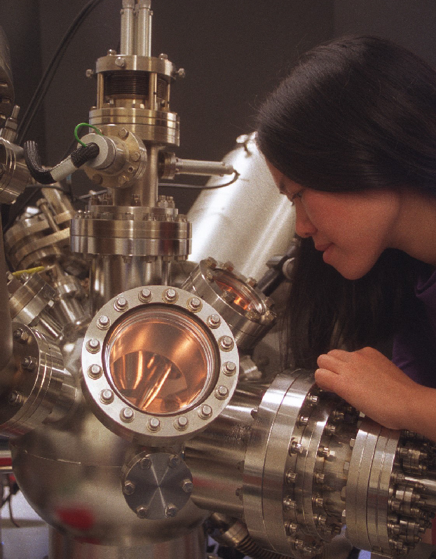
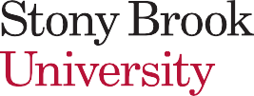

www.stonybrook.edu/spir

Stony Brook University CEWIT, R&D Park
1500 Stony Brook Road Stony Brook, NY 11794-6040 Phone (631) 216- 7112

Stony Brook University/SUNY is an equal opportunity educator and employer. If you need an accessibility-related accommodation, please call (631) 216-7114.

October 2023




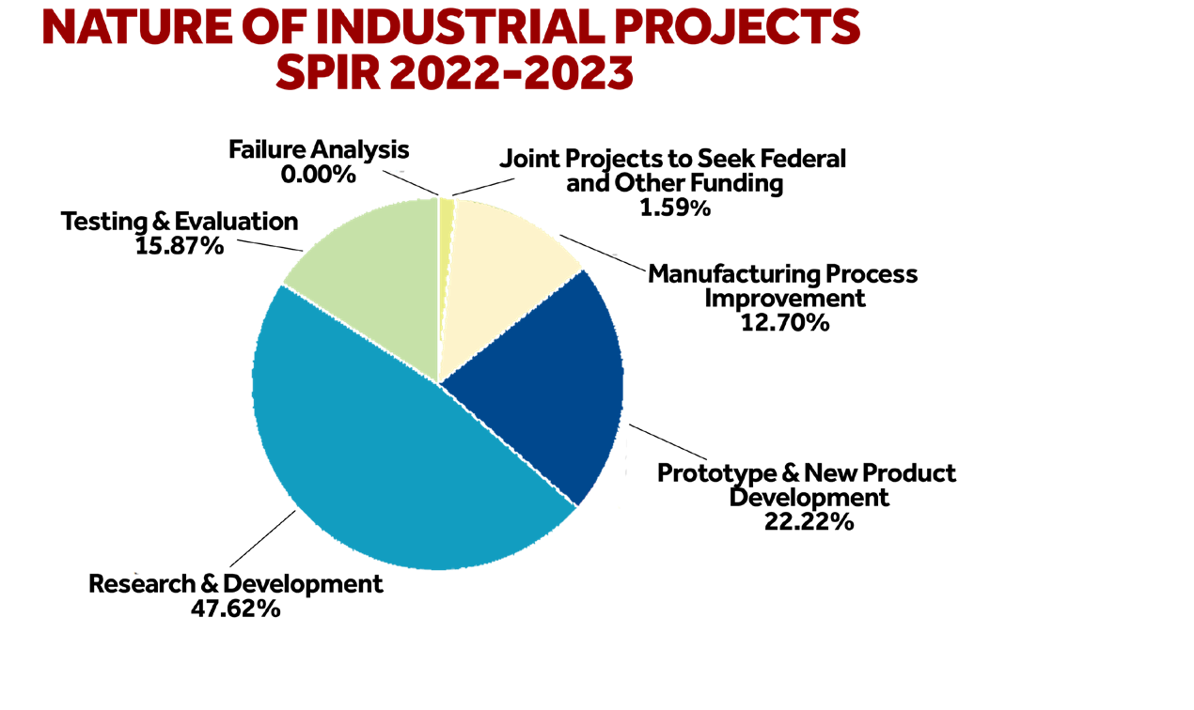


WHAT CAN SPIR DO FOR YOU

In today’s rapidly changing business environment, it’s essential that businesses stay current with technological advances. Keeping pace with these developments, however, can be difficult and costly. That’s where SPIR can help.
By leveraging the resources in the engineering programs of the State University of New York (SUNY), SPIR assists in the revitalization and redirection of New York industry.
Whether you are a small firm looking to streamline your manufacturing processes, a large high-tech company seeking to expand your international horizons, or a company exploring ways to adapt to new environmental regulations, SPIR’s goal
is to help you make your business more competitive.

NATURE OF SPIR PROJECTS

The success of the SPIR program is built on the relationship between academic engineers and industry.
SPIR provides local industries with:
- the expertise of more than 500 engineers and applied scientists
- experience with more than 500 companies in New York State
- access to top engineering and applied science students
- access to advanced manufacturing and high technology facilities
- a host of other resources to help your business become more competitive

CUMULATIVE HIGHLIGHTS

State Funding
Finished 29th year with cumulative state contribution of $19.7 million.

Federal Funding
Won $122.2M in joint federal funding awards.

Projects
Completed 3,865 projects with more than 599 companies.

Job Impact
Created and/or retained more than 17,098 jobs.

