Personalized Support for Every Stage of Business
SBDC business advisors provide personalized support to entrepreneurs and small to medium-sized businesses. From start-up guidance to export assistance, our services are designed to help your business thrive with:

- Business plan development
- Small business start-up guidance
- Accounting guidance
- Loan information
- Packaging assistance
- Organizational structure advice
- Productivity enhancement advice
- Marketing assistance
- Financial planning
- Cost-analysis assistance
- Training programs
- Export assistance
- Construction management assistance

nysbdc.org


New York Small Business Development Centers (SBDC) provide no-cost, confidential one-on-one business advisement, training, and research to small business owners and entrepreneurs across New York State.
“The SBDC's assistance was
absolutely essential in us securing the appropriate funding and in the formulation and execution of
our start-up plan.
- Dr. Jonathan Halpert
“

Our experienced advisors help businesses in every industry, region, and stage turn goals into growth because we serve ALL New Yorkers. Whether you’re starting, growing, or refreshing your business, we’re here to help you move forward with confidence.


Connect to learn more about the New York SBDC, make a no-cost business advising appointment, or register for upcoming workshops!

Funded in part through a Cooperative Agreement with the
U.S. Small Business Administration. Full funding disclosures are available at https://nysbdc.org/funding-disclosures/.




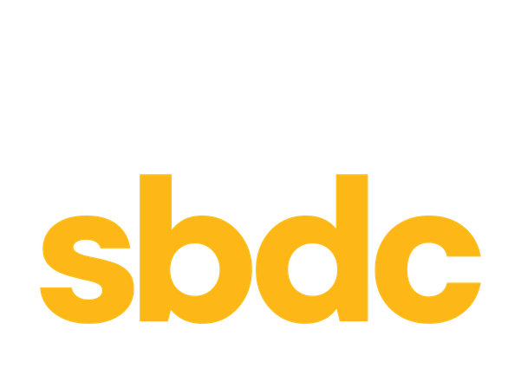



New York SBDC
Planning Your Business
1/2026


ADVISORY SERVICES

Since 1984,
New York's SBDCs have supported over
617K
Entrepreneurs &
Small Business Owners

Our full suite of no-cost expert services, from business plan development and marketing strategies to financial planning and cost analysis, offers you the guidance you need to run a more efficient, profitable business.



CONTACT INFORMATION
New York Small Business Development Centers (NYSBDC)
Central Office
SUNY System Administration
H. Carl McCall SUNY Building 353 Broadway
Albany, NY 12246

(800) 732-7232 l (518) 944-2840
nysbdc.org

ABOUT THE NEW YORK SBDC

New York SBDC advisement is customized for each business owner or entrepreneur based on their unique goals. Business assistance services – counseling, training, and customized business research – are available to all New Yorkers who request them. Our statewide network of 20 regional centers and over 70 satellite locations makes these services available in your community.

Full-time professional SBDC business advisors staff each center. We recruit individuals with excellent education and experience and then provide exceptional professional development to update their business skills, expand their knowledge, and polish their counseling skills. Our advisors are here to help you navigate challenges and move forward with confidence.

Core Services
- Business Plan Development
- Compliance & Certifications
- Marketing
- Financial Planning
- Cost-Analysis
- Legal Business Structures
- Loan Packaging
- E-Commerce
- Procurement
- Employee Management
- Other Business Support

Specialty Programs
- Artificial Intelligence
- Cybersecurity & Technology
- Disaster Recovery
- Government Contracts
- International Trade
- Manufacturing & Onshoring Hub

Community Initiatives
- Childcare Provider Program
- Rural/Agribusiness
- Veterans Assistance
- Spanish Language Services
- Certifications

