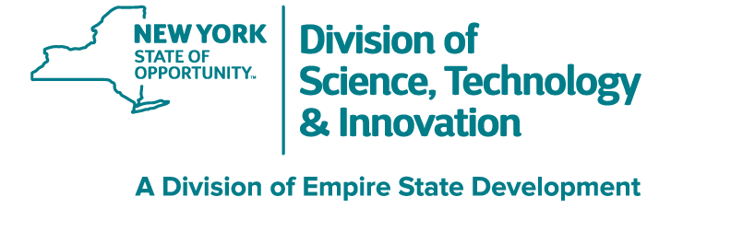

UNLEASH INNOVATION,
TRANSFORM TOMORROW

Overview
The New York State Center of Excellence in Wireless and Information Technology (CEWIT) was created in 2003 to provide technical assistance to our industry partners, large and small, as well as many startup companies. The Center is a next generation research facility focused on accelerating technology development and commercialization; support entrepreneurs in the innovation ecosystem; and offer workforce development opportunities through internships, hackathons, conferences, webinars, and other programs. CEWIT has created a powerful intellectual property portfolio
resulting in numerous patents and licensing agreements. Since its inception, the Center has developed strategic alliances and extensive collaborations among the academic, scientific, and business communities worldwide. Our partners include some of the world’s best-known and most respected companies in technology, telecommunications and other industries. CEWIT’s research and engineering teams are building on these achievements and will continue to serve the role of a valuable technical resource and dependable innovation partner for companies in a wide range of industries.
CEWIT’s 100,000-square-foot facility, the anchoring building in SUNY Stony Brook University’s Research and Development Park, is home to 40 laboratories, a data center with multiple high-performance clusters, an optical network infrastructure, and world-class facilities for data modeling and visualization research, including the SMART Cluster (a hardware-accelerated GPU cluster for machine learning and real-time cinematic-quality rendering); the Silo (a cylindrical immersive stereo
display with 600 million pixels), and the Reality Deck (a 416-screen surround-view display with over 1.5 billion pixels). These unique resources support the Center’s project teams and our collaborators in conducting applied research and technology development in artificial intelligence, machine learning, medical imaging, climate modeling, smart grids, distributed robotics, cybersecurity, edge computing, and many other application areas.

Our Mission
- Drive innovation through applied research and industry collaboration
- Develop and commercialize university research projects
- Cultivate the next generation workforce and foster tech entrepreneurship

Technical Highlights
- More than 90 Stony Brook University faculty researchers and greater than 250 students/interns
- Expertise in AI, machine learning, natural language processing, visual computing, medical imaging, AR/VR/XR, IoT, edge computing, mobile networking, cybersecurity, etc.
- Partners in technology, communications, healthcare, energy, defense, aerospace, manufacturing, supply chain, finance,
and other industries

VISIT OUR WEBSITE FOR MORE INFORMATION


cewit.org

Stony Brook University Research and Development Park • 1500 Stony Brook Road, Stony Brook, NY 11794-6040 Phone: (631) 216-7100 • Email: info@cewit.org

CEWIT Home of Innovation

WORLD-CLASS RESEARCH FACILITIES

OUTREACH PROGRAMS

Reality Deck
World’s largest immersive display with 1.5 billion pixels.


SILO
Cylindrical immersive 600 million pixels stereo display.
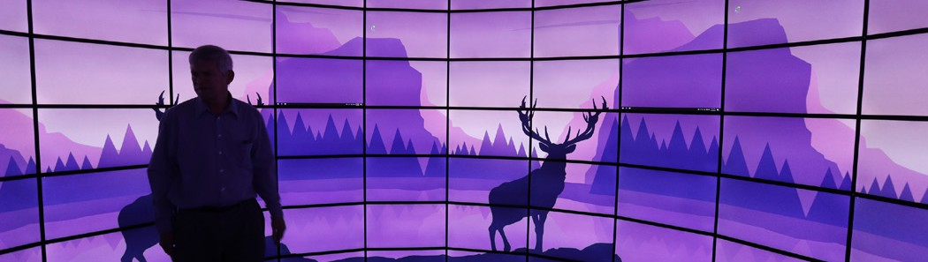

SMART Cluster
One of the fastest NVIDIA GPU clusters in academia; dual use for
machine learning and immersive visualization.
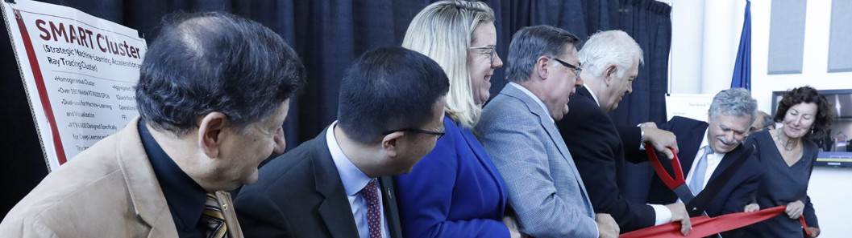

Home of the Future
Developing and testing smart home technologies for aging in place.
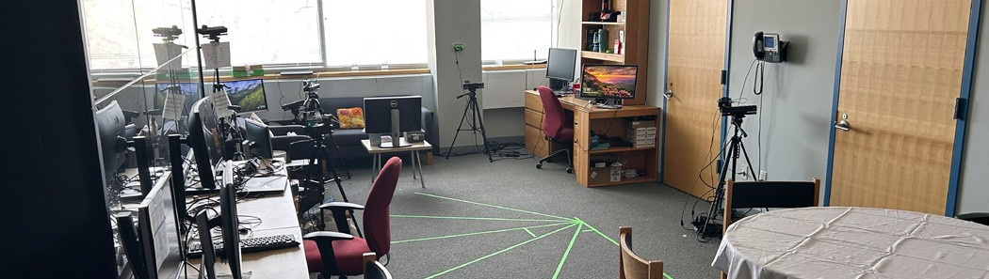

Electrical Grid Monitoring and Control
System Laboratory
Pioneering novel wireless dynamic microgrid solutions for a safer, more resilient, and sustainable future.

CEWIT Conference
International annual conference for industry leaders, researchers, innovators and entrepreneurs, across borders and disciplines.
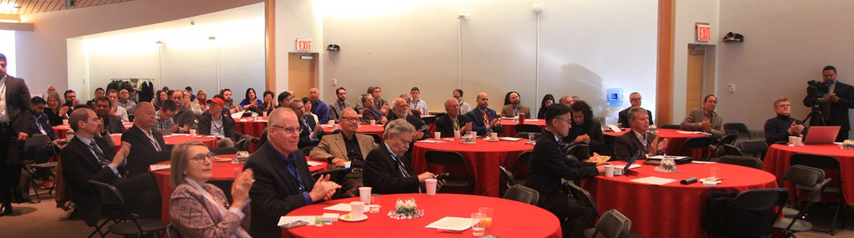

Webinar and Podcast Series
Podcast series with industry experts and deep dive tech talks in collaboration with IEEE.
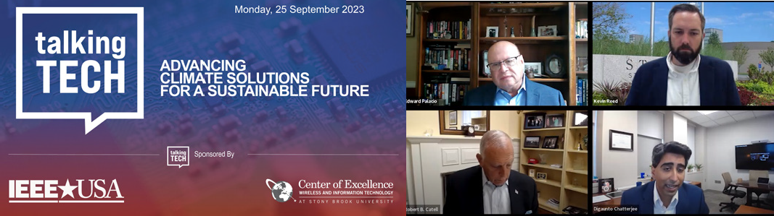

Startup Showcase
Exhibit for startup companies to demonstrate their technologies, projects, and research.
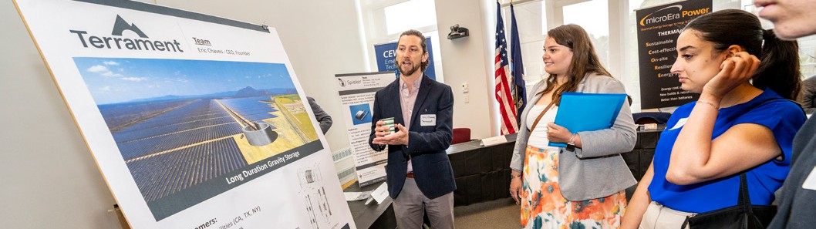

Hack@CEWIT
One of the most popular annual student hackathons
in the Northeast.
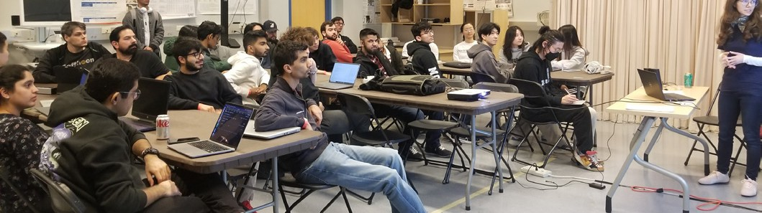

Next Generation Workforce
Local high school visits aimed to engage the next generation of workers in emerging areas of research.

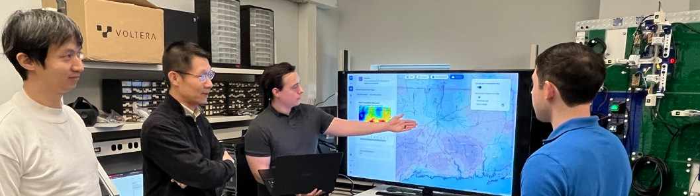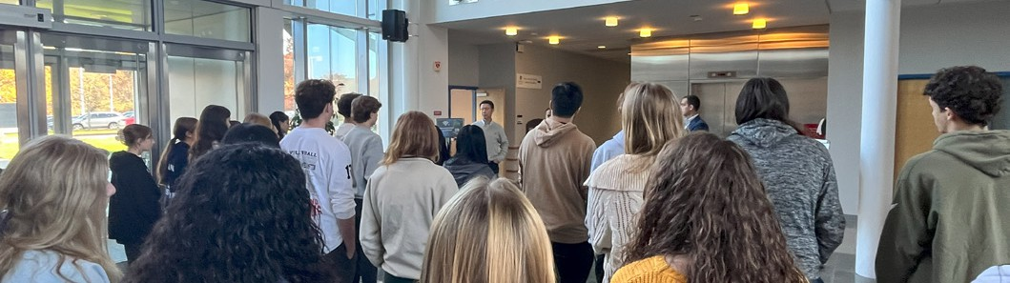

Stony Brook University is an equal opportunity educator and employer. This publication can be made available in an alternative format upon request.

