ADVANCED ENERGY™
Research and Technology Center

AT STONY BROOK UNIVERSITY

A New York State designated Center of Excellence
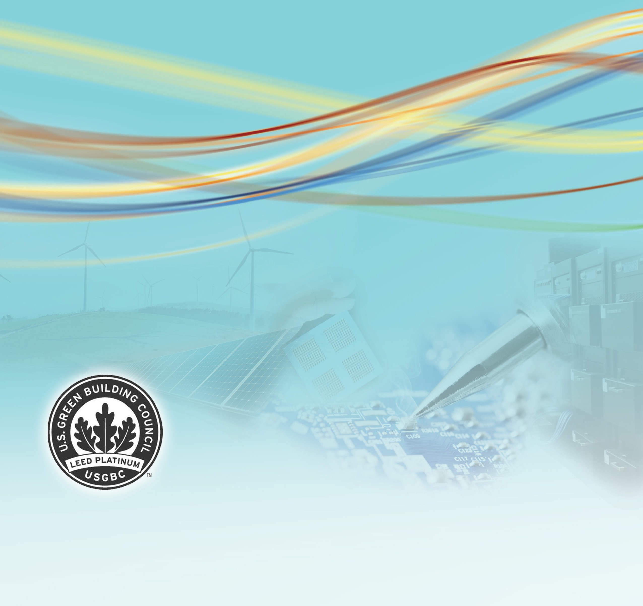
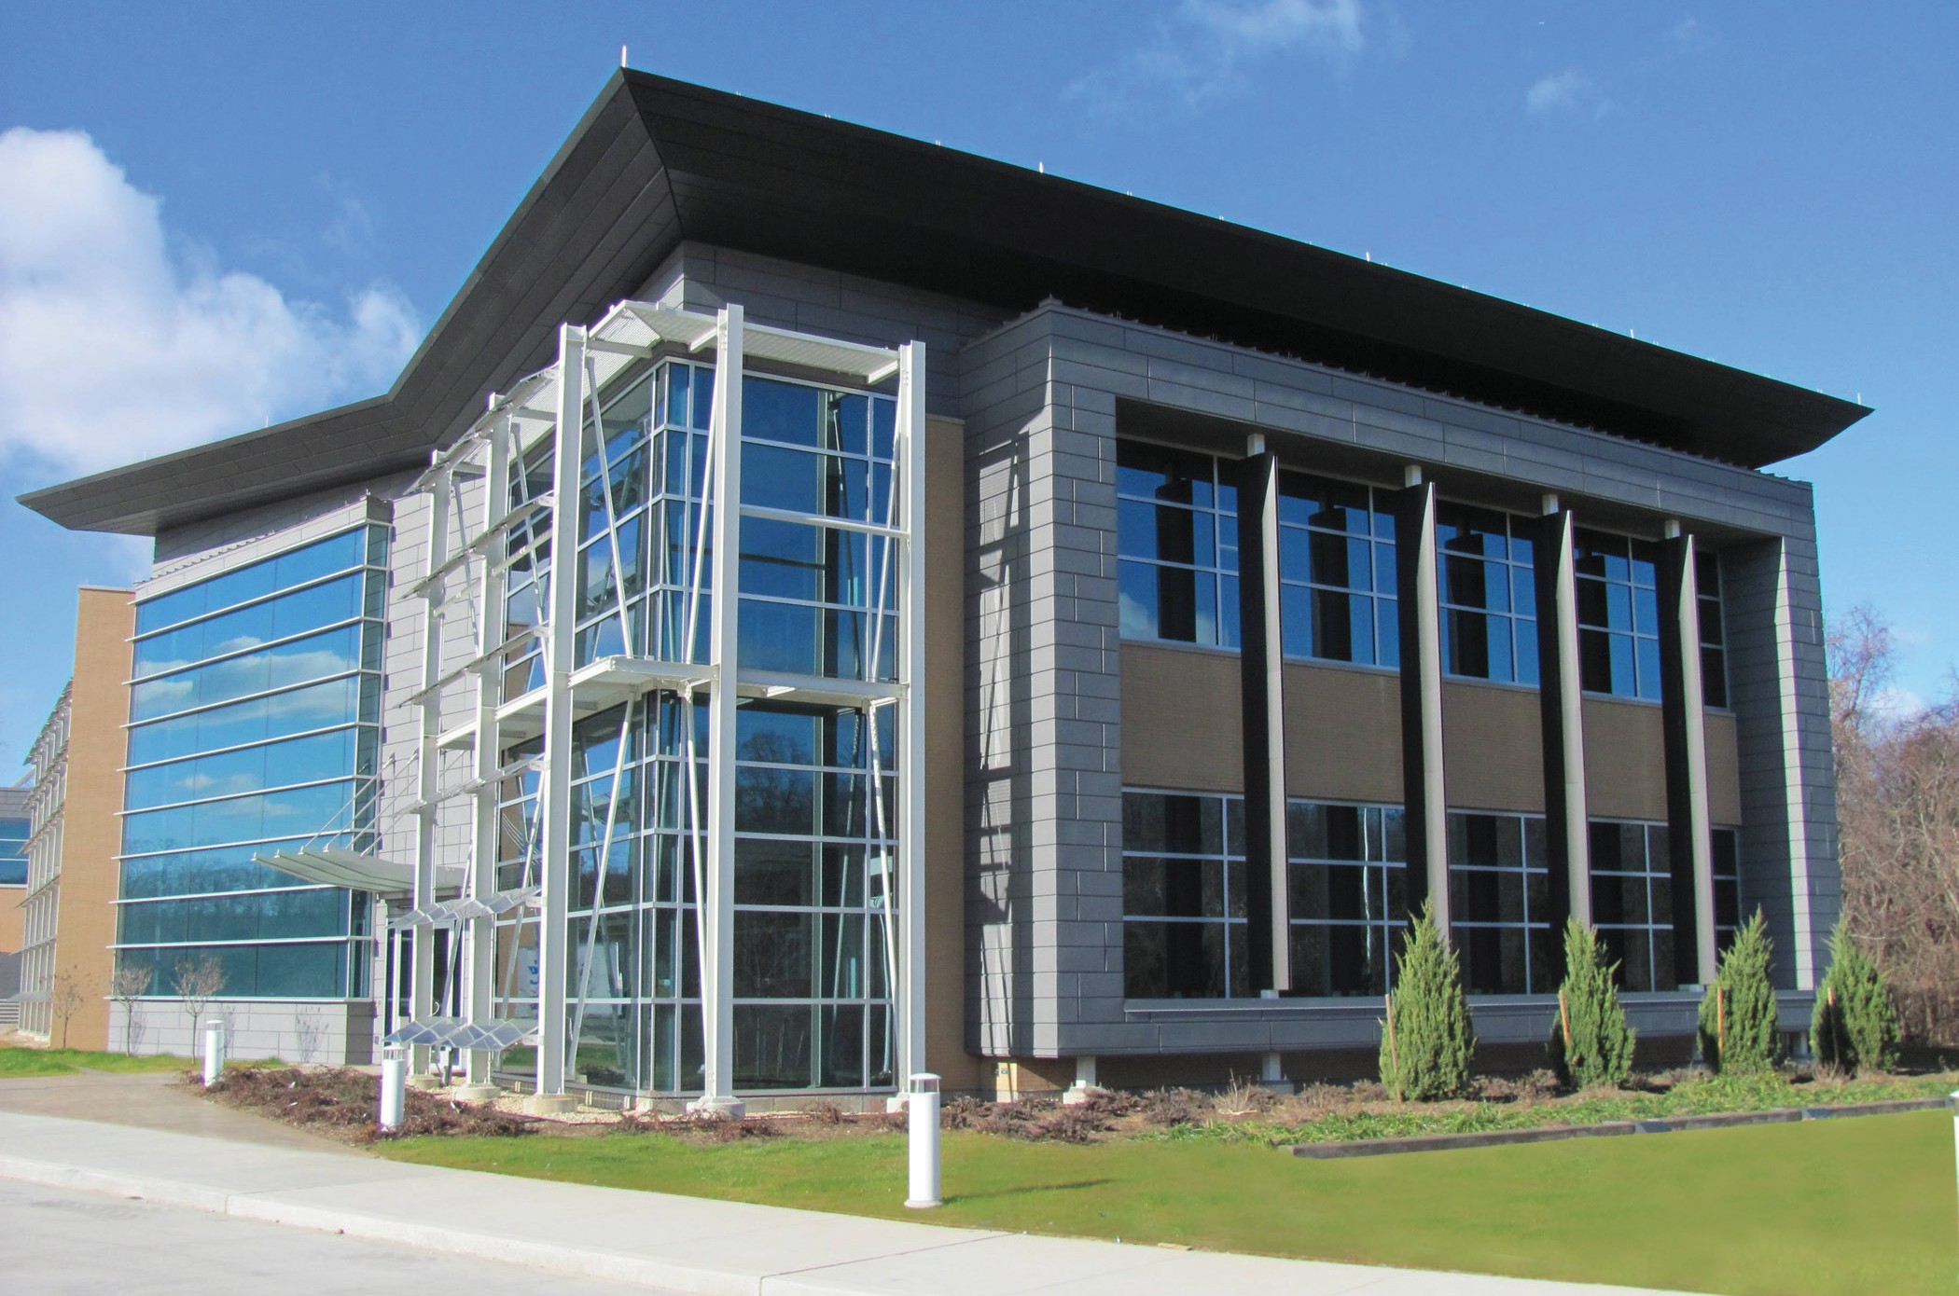

W EL C OME GUIDE

www.aertc.org
Stony Brook University



A New York State designated Center of Excellence www.aertc.org

WELCOME
The Advanced Energy Center™ (www.aertc.org), located at Stony Brook University, is at the
forefront of energy research and technology. The Center partners with other universities and research institutions, energy providers, private industry, and our national Department of Energy to develop advanced, cutting-edge technologies that explore ways of producing and promoting clean energy.
Consistent with that mission, the focus and construction of the facility is to incorporate multiple energy-sustainable design principles.
This LEED® Platinum-designed building is organized around core and flexible laboratories which support the main energy research thrusts known today. Flexible labs allow a diversity of research and are easy to convert for the future. Specifically designed to meet ever-changing research needs and agendas, the Center will provide space for the university and its research partners far into the future.
The Center’s traditional labs, the high-bay lab, and the outdoor spaces support research at different stages from nano-scale to pilot plant to real-life simulation; all in an energy-forward building. From site selection and stormwater runoff control, building construction management and the materials used, to water usage reduction and energy efficient lighting, the Center promotes energy efficiency at its maximum. This guide is developed to highlight those innovative energy-sustainable technologies incorporated in the building’s design.

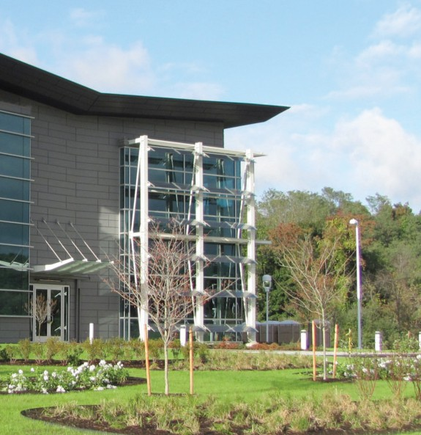
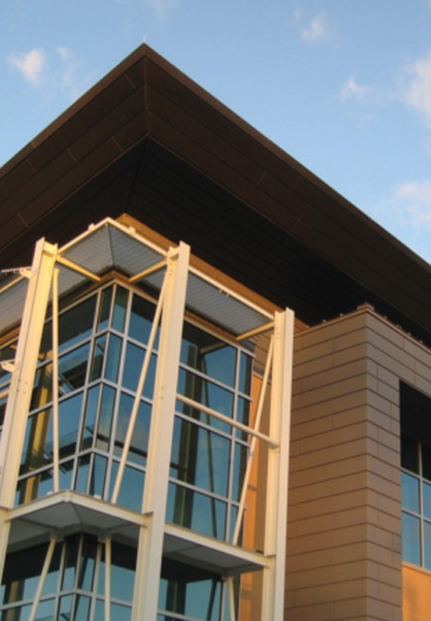
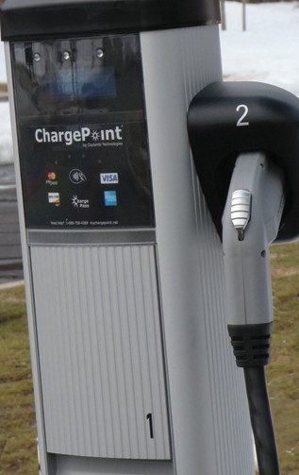
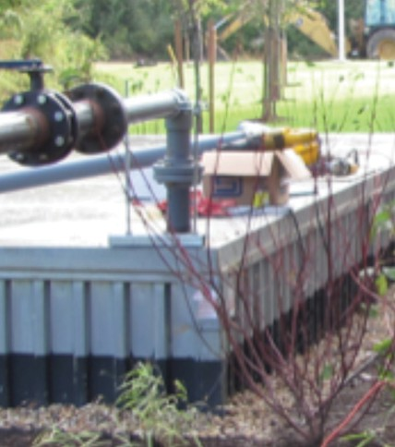
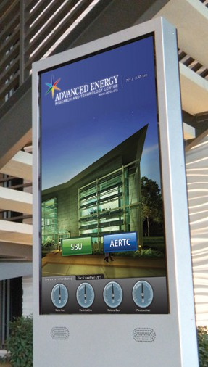
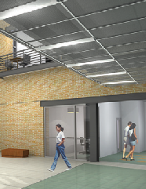
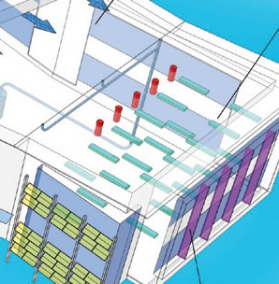
4
Plantings
Rain Garden Stormwater
Runoff Solar Shading

5
Thin Film PVC
Polycrystalline PVC

6
EV Charging
Stations
Alternate Fuel
Vehicles
Light Pollution

7
Thermal
Storage Tanks
Chilled Beams Solar Lighting

8
Kiosk
Hot Water Stormwater
Reuse
Energy Recovery

9
Reducing
CO2
Renewable & Recycled Materials

10
Floor Plans

CENTER GUIDE 3

SUS T AINABILIT Y PL AN

GOALS
- Site planning to minimize heat gain and glare
- Cooling through hydronic distribution
- Recover energy from exhaust streams
- The use of thermal energy storage
- Roof design to collect rainwater
- Water efficient landscaping
- ‘Cool’ roof design
Solar Hot Water Heater

4552
GROSS SQUARE METERS IN THE CENTER
(49,000 SQ. FT.)

Thermal Storage Tanks Chilled Beams

650
SQUARE METERS ALLOCATED INCUBATOR / INDUSTRIAL PARTNER SPACE
(7,000 SQ. FT.)

Energy Recovery Units
Butterfly
roof Channels

Rainwater
Solar Tubes Daylight

Chilled Beams

External Solar Shading

Natural Areas Infiltrate Stormwater Runoff from Hardscapes and roof

Native Plantings for Biodiversity
Polycrystalline Photovoltaics Gather Energy and Shade Offices, Mitigating Heat

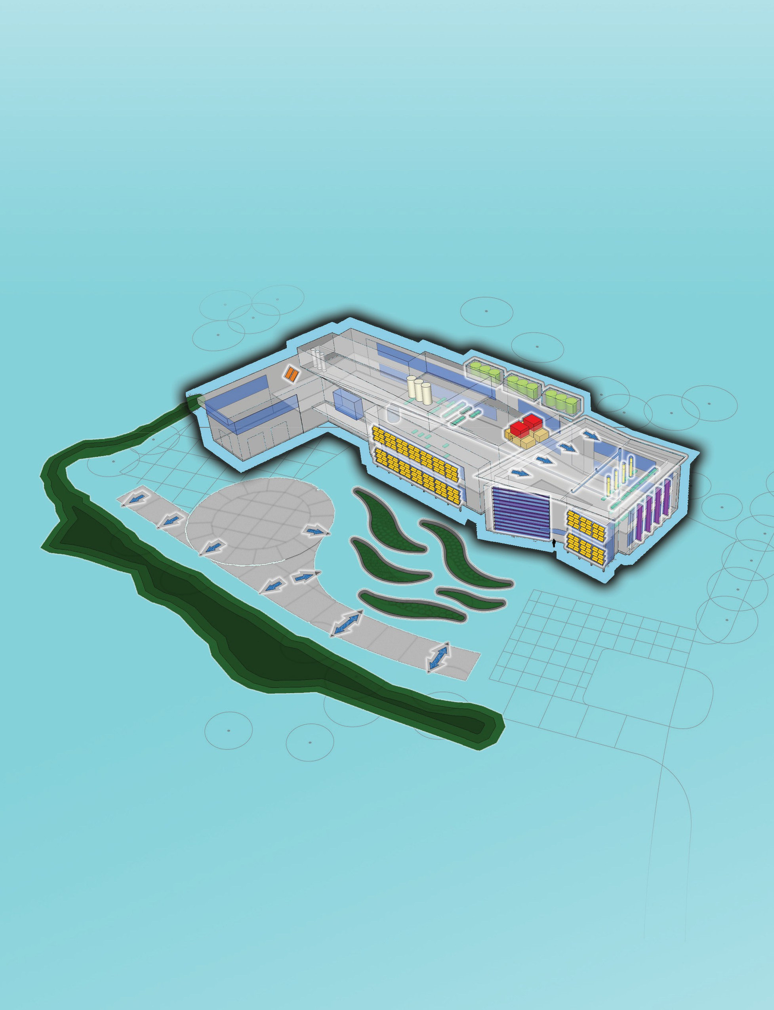
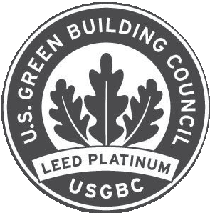

B U I L D I N G G R E E N
AND WHAT LEED® MEANS
Leadership in Energy and Environmental Design (LEED) certification is the recognized standard for measuring building sustainability. Achieving LEED certification is the best way for you to demonstrate that your building project is truly “green.” The LEED green building rating system program—developed and administered by the United States Green Building Council, a nonprofit coalition of building industry leaders—is designed to promote design and construction practices that increase profitability while reducing the negative environmental impacts of buildings and improving occupant health and well-being.

4 ADVANCED ENERGY CENTER™

GREEN FEA TURE S

NATIVE AND ADAPTIVE PLANTINGS
The native and adaptive plantings used at the Advanced Energy Center™ not only enhance the site but also promote biodiversity and do not require irrigation. Much of the disturbed site is envisioned
to return to its once native state through the application of seed mixes with native grasses and forbs. There are only small areas of manicured lawn on the entire project site.

RAIN GARDEN
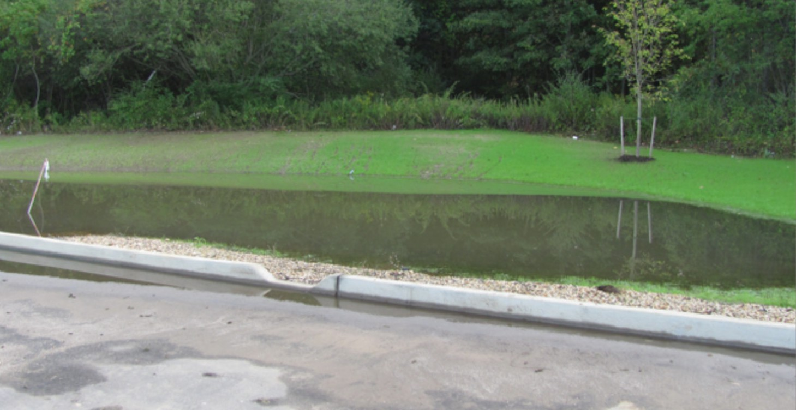
Rain Garden areas were designed to accept stormwater run off from adjacent hardscape surfaces. Contaminants are picked up from these hard surfaces and are cleansed by hearty vegetation and soil allowing storm water run-off to percolate back to the ground water table.

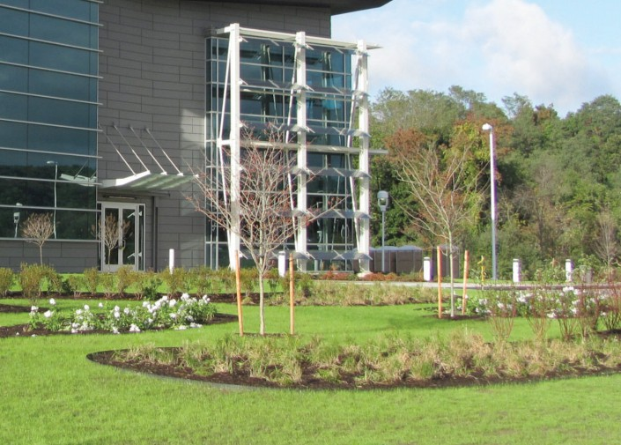
91%
OF CONSTRUCTION WASTE WAS RECYCLED

541
TONS OF CONSTRUCTION WASTE WAS DIVERTED FROM LANDFILLS

O%
POTABLE WATER USED FOR LANDSCAPE IRRIGATION

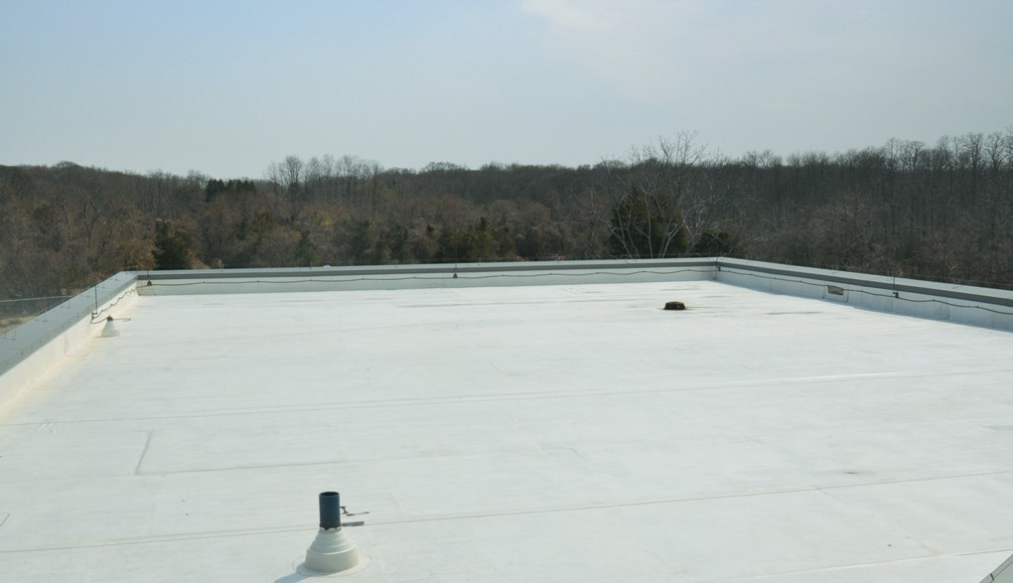
COOL ROOF DESIGN
A cool roof is one that reflects the sun’s heat and emits absorbed radiation back into the atmosphere. The roof’s temperature may stay around 38°C (100°F) which reduces the amount of heat transferred to the building below, keeping the building at a cooler and more constant temperature.

WELCOME GUIDE 5

POLYCRYSTALLINE PHOTOVOLTAICS
Supported by the PSEG-LI the 10kW array of polycrystalline photovoltaic panels gather energy while shading the south-facing windows. This mitigates heat gain while diffusing harsh southern daylight within the directly adjacent spaces.


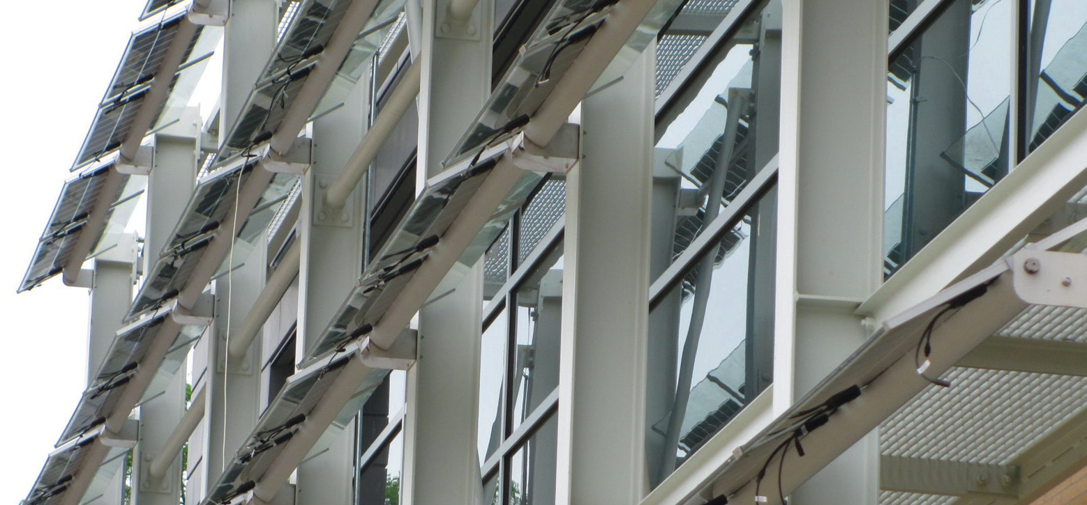
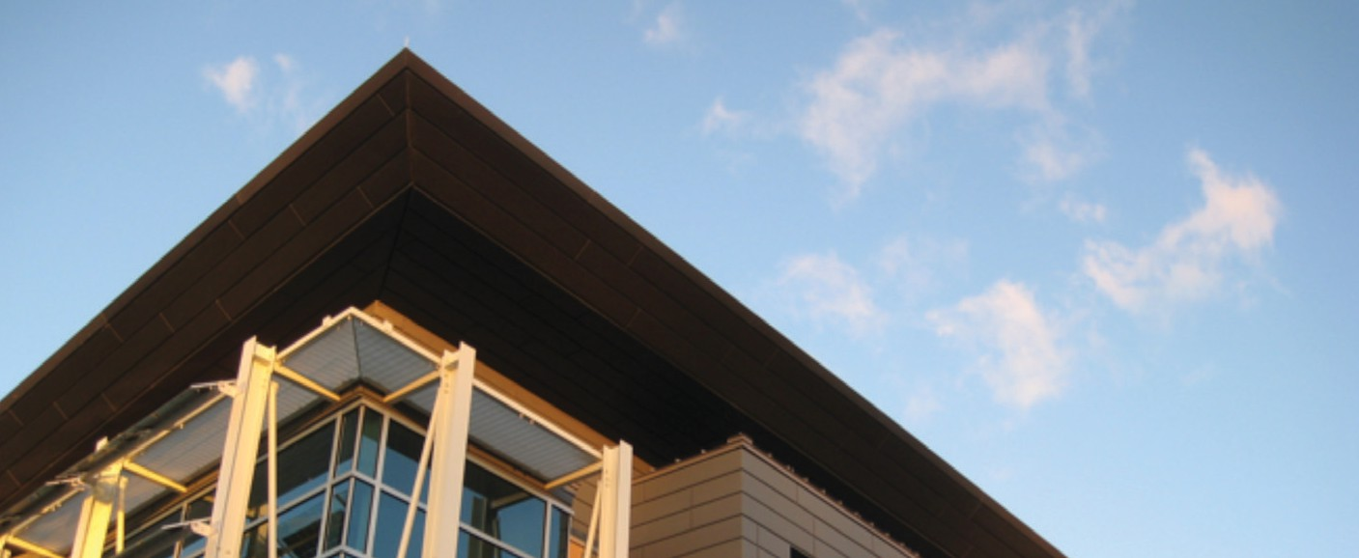

External PASSIVE SOLAR SHADING
External passive solar shading was employed to block glare and heat gain while diffusing daylight. Vertical shading is effective for east-facing windows, and horizontal shading was utilized for southern exposures. The building’s orientation uses daylighting to reduce artificial lighting loads and shading devices to minimize heat gain. Shading devices are composed of photovoltaic cells that capture the sun’s energy to produce electricity.

10kW
OUTPUT POWER FROM POLYCRYSTALLINE PHOTOVOLTAIC PANELS

>20%
OF CONSTRUCTION MATERIALS CONTAIN RECYCLED CONTENT

6 ADVANCED ENERGY CENTER™

GREEN FEA TURE S

ELECTRIC VEHICLE CHARGING STATIONS
Four ChargePoint electric vehicle charging stations are located in the parking lot. ChargePoint also reports on electricity consumption for accounting purposes and green-house gas emission reductions for each user.
Charging stations courtesy of the Department of Energy (DOE).

35
CURRENT NUMBER OF
ALL-ELECTRIC VEHICLES ON CAMPUS (PLUS DOZENS OF HYBRIDS)

50MILES
RANGE AN AVERAGE BUS GETS
ON A SINGLE ELECTRIC CHARGE

ALTERNATE-FUELED VEHICLES
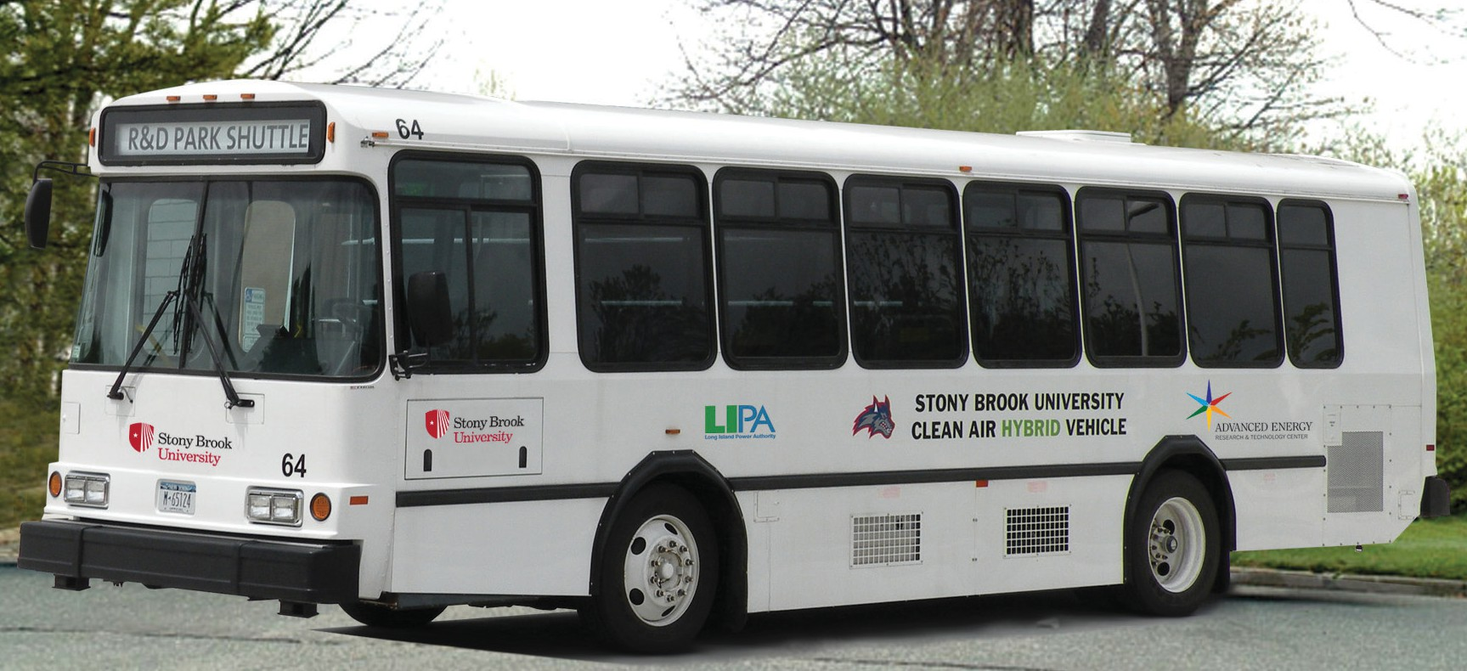
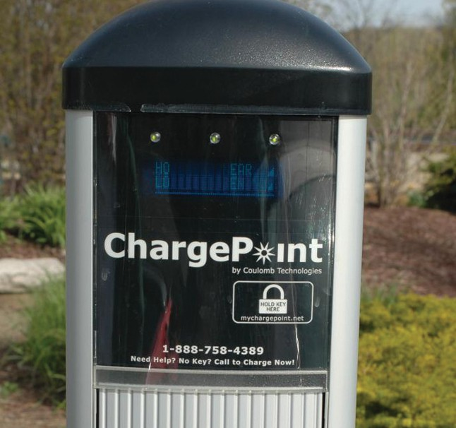
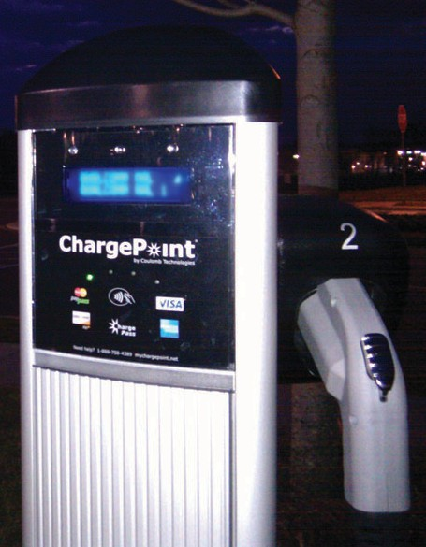
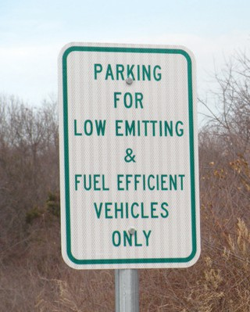
Hybrid electric buses are used to connect both the main campus and the Advanced Energy Center (located at Stony Brook University Research and Development Park). The University operates 16 alternate fueled
vehicles, and the entire bus fleet has been operating on a BioDiesel blend since April of 2005. The buses are recharged nightly (up to 50kWh).
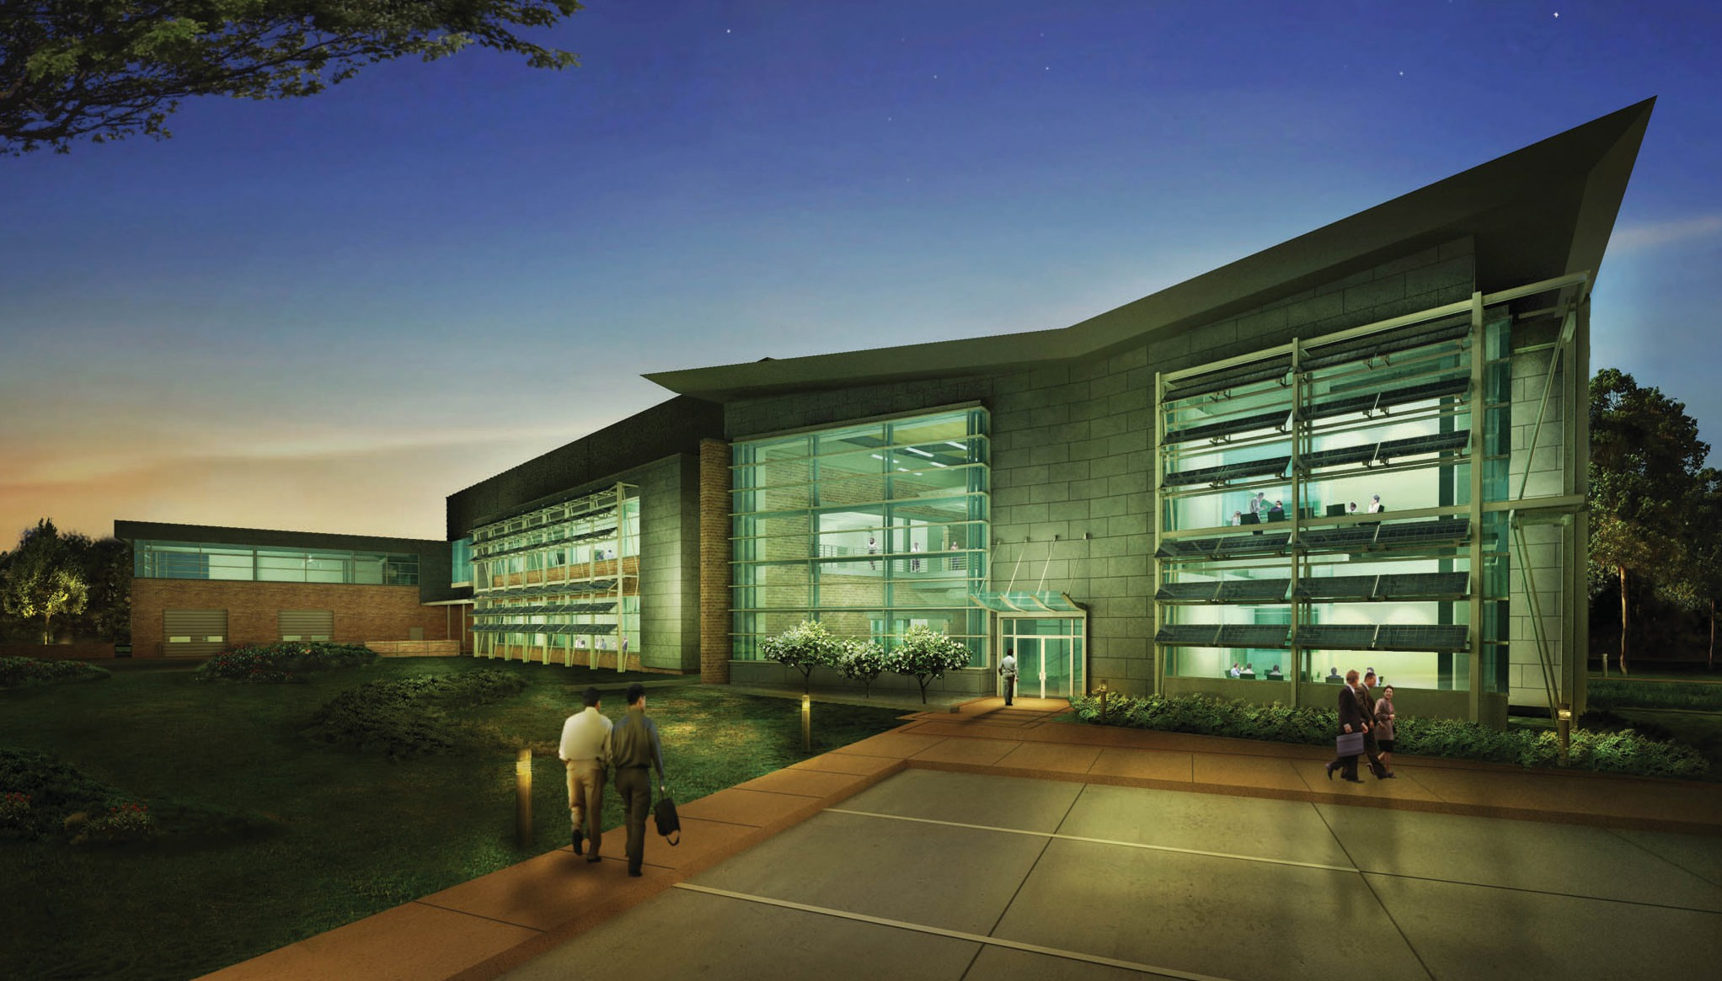

MINIMIZING LIGHT POLLUTION
With LED lighting in parking areas, walkways and common spaces, lighting at night is minimized outside the building. Light pollution into the night sky is prevented by full outdoor cutoff fixtures and by preventing light from exiting the building directly at night (light trespassing). By using light fixtures that are shielded to reflect light down, and that are of low wattage, lighting was designed within parameters outlined by the International Dark Sky Association’s
Dark Sky Initiative.

WELCOME GUIDE 7


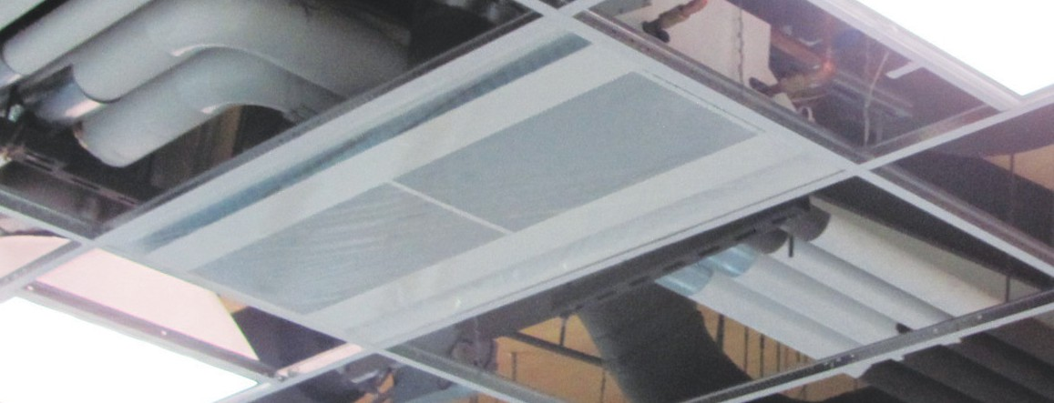
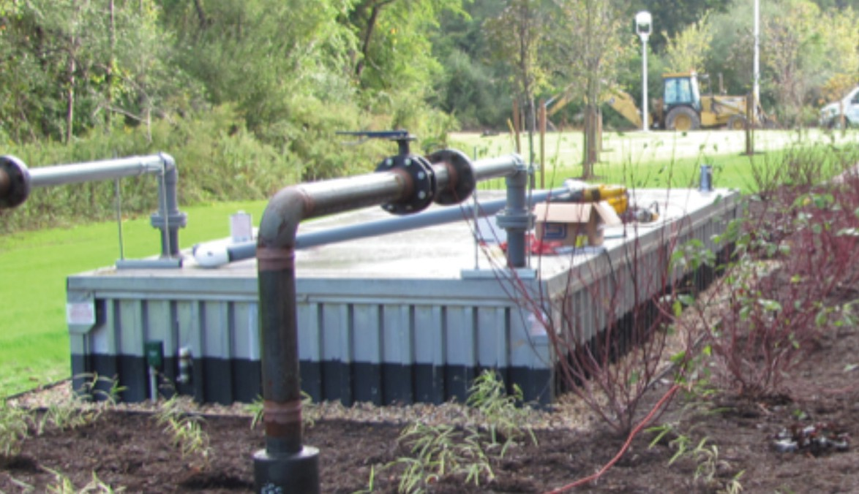
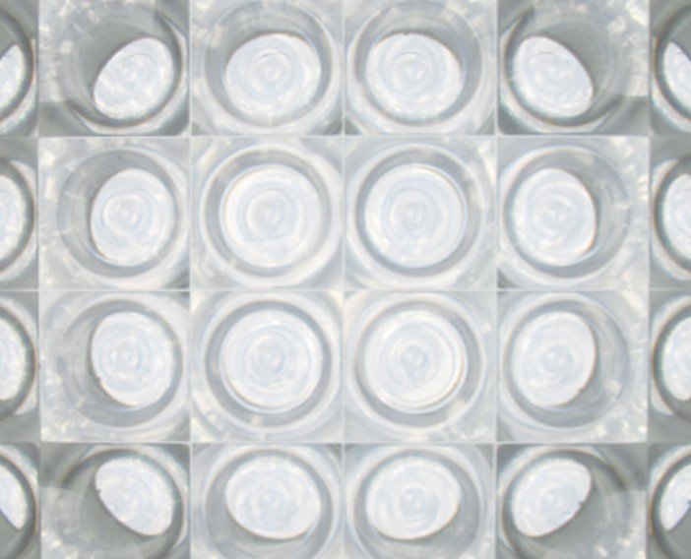
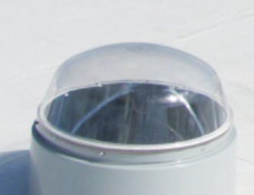
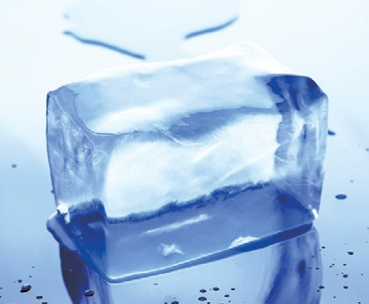
CHILLED BEAMS
Chilled beams are an efficient European technology that has caught on in recent years here in the U.S. Incorporating a water cooling coil with an air diffuser, chilled beams induce room air across the cooling coil thus reducing the amount of air from the central air system. This project has 74 linear meters (244 linear feet) of chilled beams in offices and labs reducing the primary air flow by 30%. This saves 48,000kWh per year
or about $11,700.

THERMAL ENERGY STORAGE TANKS

Thermal Energy Storage tanks are used to store cooling energy in the form of ice. Ice is generated at night and weekends when electric rates are much lower. This cooling energy is then used during the weekdays when electrical rates are higher. Ice was selected as the energy storage
medium because 0.45 kilograms (1 pound) of ice can store 14.4 times more than liquid H₂O. Thus the first cost and area required is greatly reduced compared to water storage tanks. The extra energy used to make ice is offset by cooler nighttime temperatures. Estimated cooling dollars saved is $37,400 annually.

SOLAR TUBE DAYLIGHTING
Solar tube skylights pull a dramatic amount of “ducted daylight” into the second floor open office space producing up to 20,500 lumens each. In this regularly occupied space, the solar tubes minimize the need for artificial lighting during normal daytime occupancy.

74
LINEAR METERS OF CHILLED BEAMS REDUCE AIR FLOW BY 30%
(244 Linear Feet)

UP TO 80% REDUCTION IN ENERGY USAGE WITH SOLAR TUBE DAYLIGHTING

$11,700
ESTIMATED ANNUAL SAVINGS USING CHILLED BEAMS

$37,400
ESTIMATED ANNUAL SAVINGS USING OFF-PEAK THERMAL ENERGY STORAGE

8 ADVANCED ENERGY CENTER™

GREEN FEA TURE S

SOLAR HOT WATER HEATER
The solar hot water heater located above the High Bay Lab is used
to offset natural gas use for heating domestic hot water. Although it might seem small, this is intended as a demonstration; the hot
water that occupants come in direct contact with is primarily heated by the sun.

ENERGY RECOVERY UNITS (ERU)
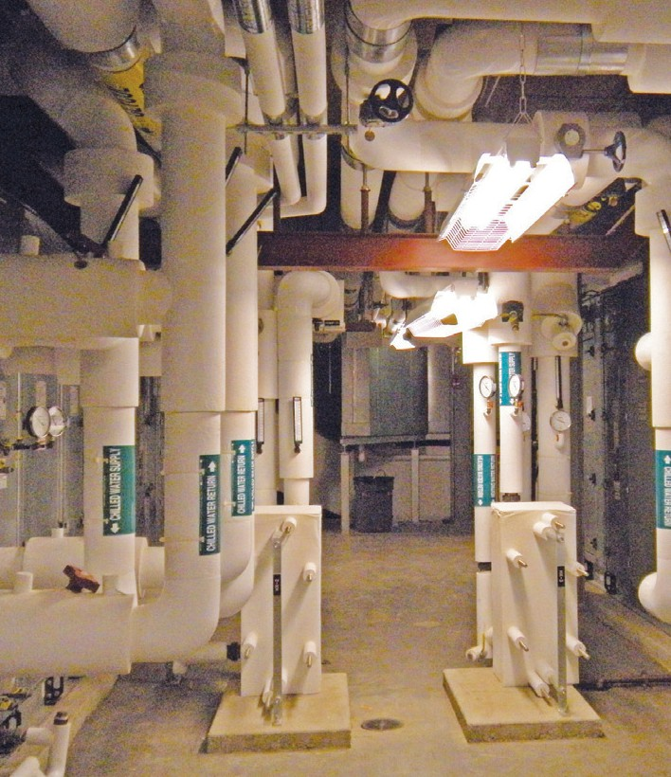
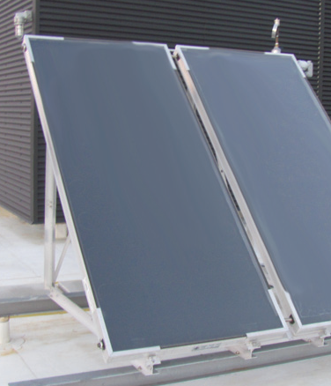
The Energy Recovery Unit (ERU) is a wheel that passes between the exhaust air and outside airstreams to transfer heat and moisture without transferring harmful chemicals. Its molecular sieve technology selectively transfers only water vapor and heat. Heat is recovered from exhaust air and is used to precondition (heat, cool, humidify, dehumidify) outside air that is drawn in to replace the exhaust air.

10
DAYS WORTH OF GREY WATER IS HELD IN THE STORMWATER REUSE TANKS

870MILLION BTUs OF POWER ARE SAVED EACH YEAR BY THE
ENERGY RECOVERY UNITS (ERU)

$16,400
SAVED EACH YEAR BY THE ENERGY RECOVERY UNITS (ERU)

KIOSK
On the right as you enter the lobby, the Kiosk is your link to live data that show in real-time how much water, electrical, natural gas and photovoltaic is currently being used throughout the building. The green conversion center and historical data charts can put energy usage and savings into perspective. Visit us at www.aertc.org

STORMWATER REUSE
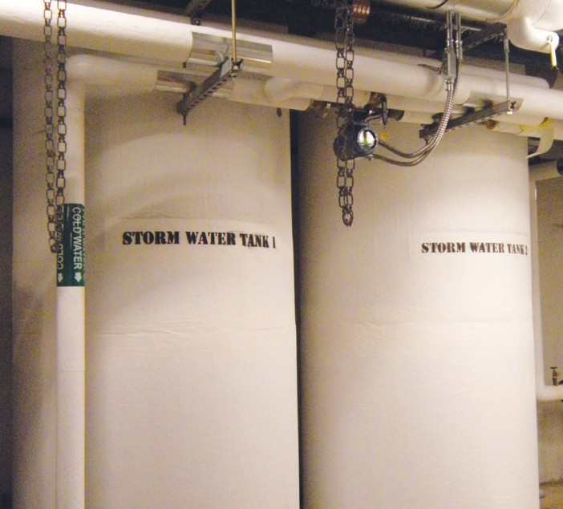
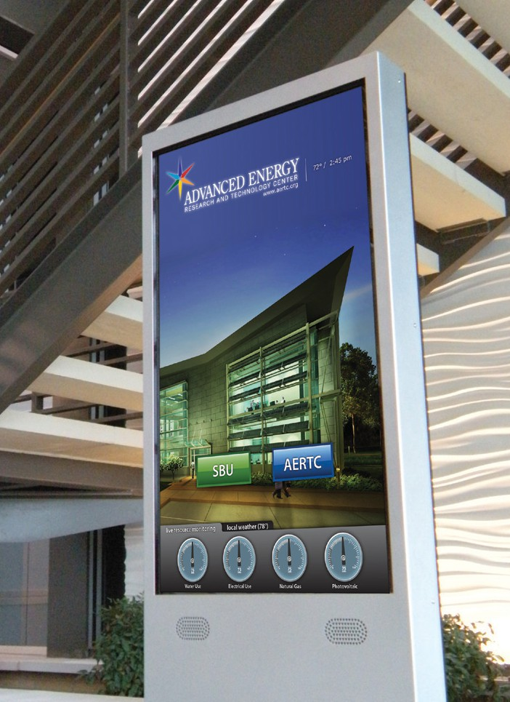
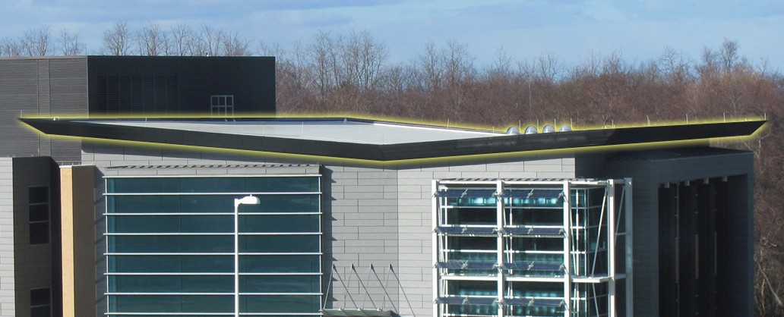
All storm water that hits the roof is collected in large storage tanks in the basement. This non-potable ‘grey’ water is filtered and dyed blue, then used to flush plumbing fixtures. The “butterfly roof” aids in the collection of stormwater. The collection tanks hold an estimated
10 days worth of water usage which guarantees significant reserves.

WELCOME GUIDE 9

GREEN CONS TRUCTION

REDUCING EMBODIED AND OPERATIONAL CO2
The embodied CO₂ of a building (the CO₂ released during the manufacture of the building materials, their transport to the site and the actual building process) can be equivalent to thirty years of operational CO₂! This means that even for most environmentally sound and sustainable buildings, it takes 30 years to offset the CO₂ released during their construction. The Advanced Energy Center used more than 1,300 pages of complex building design and construction specifications to reduce both embodied and operational carbon. CO₂ occupancy sensors in laboratories and offices control the use of lighting, ventilation and exhaust systems. When occupancy is low lighting, ventilation and exhaust levels are automatically reduced to the minimum allowed by environmental and health and safety standards.

4,000
METRIC TONS (8,000,000 POUNDS) TOTAL BUILDING MASS


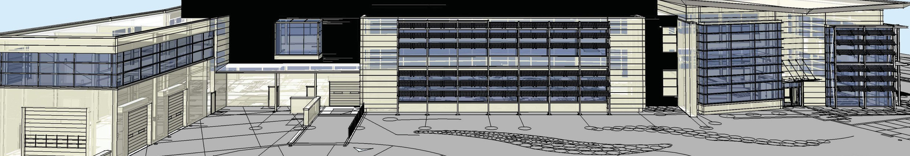
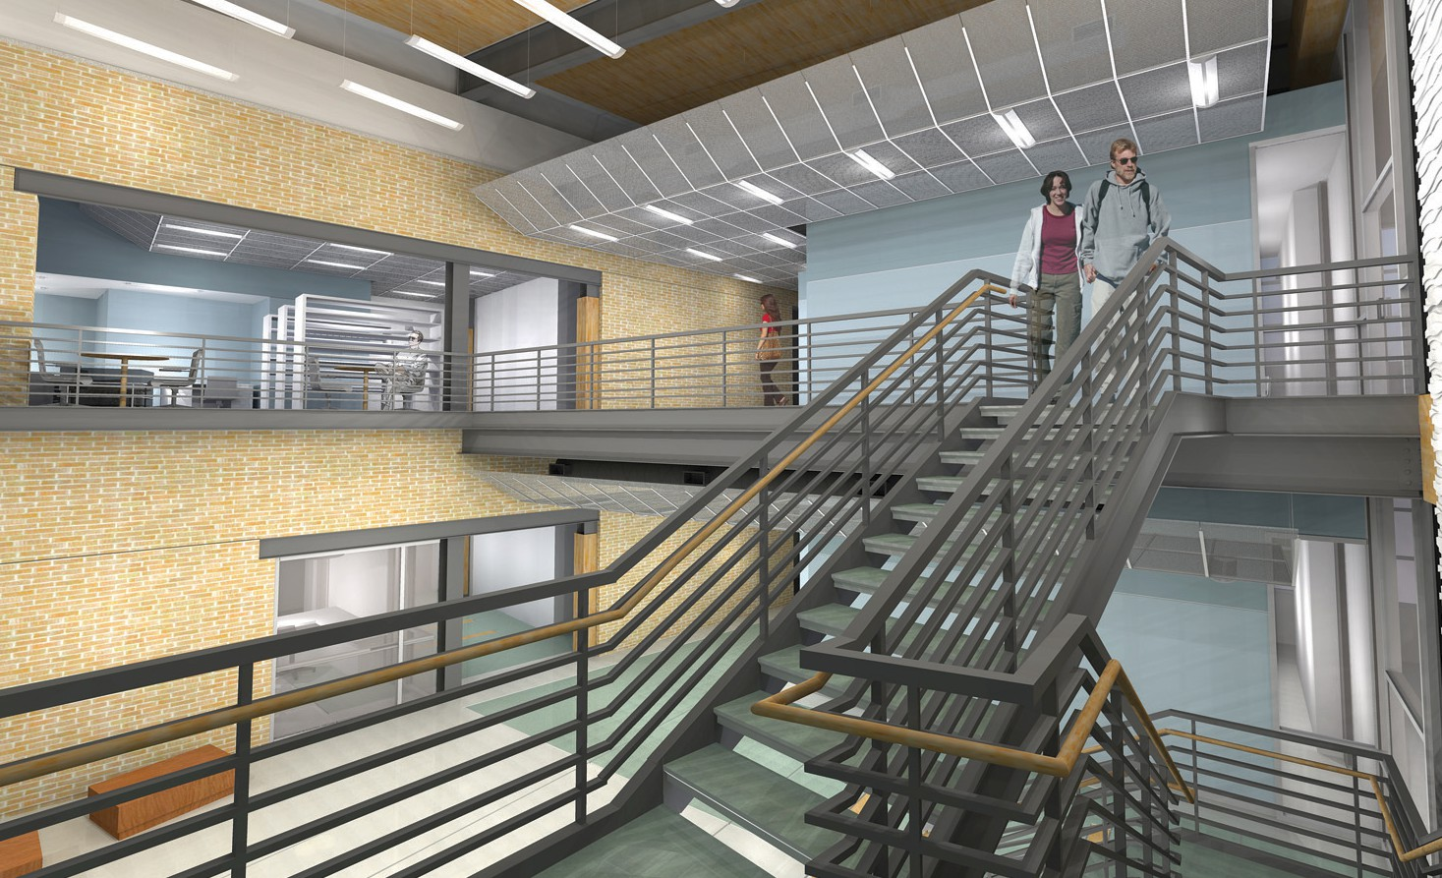
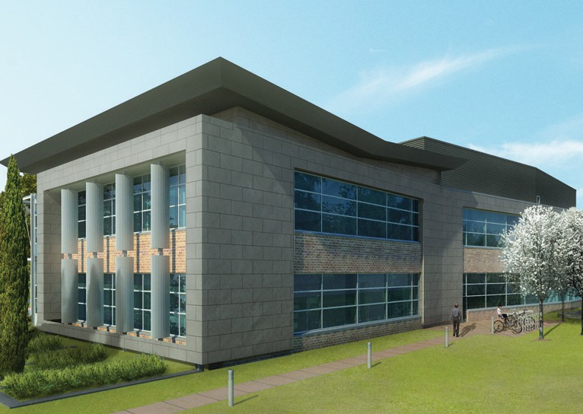
RENEWABLE AND RECYCLED MATERIALS
Significant portions of the office spaces, hallways, gallery and lobby use rapidly renewable materials like bamboo and wood from certified and sustainable forests. More than 20% of the construction materials contain recycled content, and more than 20% originated locally (<500 miles), reducing embodied CO₂. Of the 2,642 tons (5,284,000 pounds) of concrete used in construction with 476 tons (952,000 pounds) of embodied CO₂, 53 tons (106,000 pounds) were abated using concrete with high-fly ash content. Center construction utilized 533 tons (1,066,000 pounds) of steel, which embodied 480 tons (960,000 pounds) of CO₂.
Operational energy savings of the Center are estimated at 2,000 tons (4,000,000 pounds) of CO₂ per year.
2,000
METRIC TONS (4,000,000 POUNDS)
CO2 EMISSIONS REDUCED PER YEAR

40%
REDUCED ENERGY CONSUMPTION COMPARED TO CODE

10 ADVANCED ENERGY CENTER™

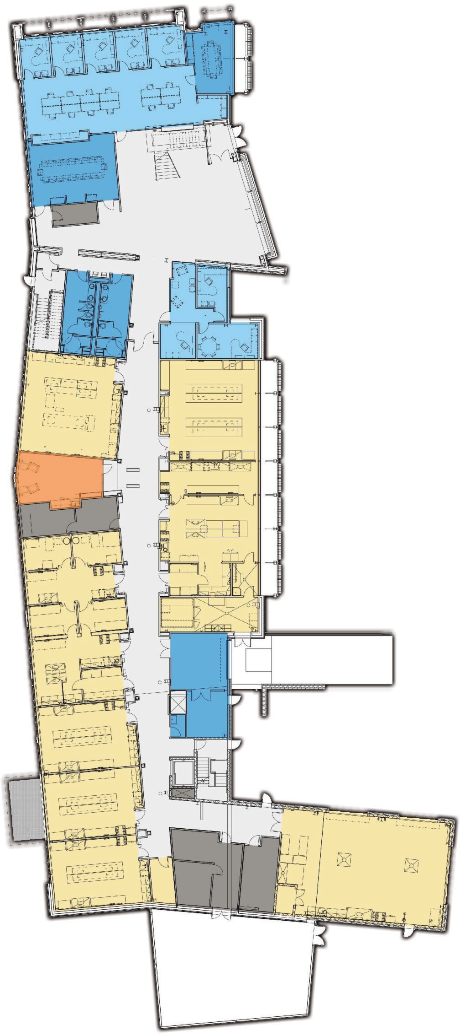

FIRS T FL OOR

executive
office

conference room

Energy Harvesting Laboratory

Energy Efficiency Laboratory

Energy Incubator Tenant

it room

Scanning Electron Microscope

Transmission Electron Microscope
Microscopy prep area atomic force Microscope
Ultraviolet Visible Spectroscopy Laboratory

X-ray Scanning Center Confocal Microscope

Advanced Power Sources Laboratory

Advanced Power Sources Laboratory

Battery Characterization Laboratory
office Suites

Lobby Gallery

directors
Suite

multi-user Research
Facility

multi-user Research Facility

multi-user Research Facility

multi-user Research Facility

Loading Dock

Recycle
area

Advanced Transportation Laboratory

RESEARCH AREAS
- Batteries
- Smart Grid
- Microgrid
- Biotechnology
- Conventional fuels
- Advanced combustion
- Energy conservation
- Energy policy
- Fuel cells
- Hydrogen energy
- Modeling & Simulation
- Photovoltaics
- Power management
- Renewable energy
- Thermal transfer optimization

Legend
Building Support Circulation Laboratory Laboratory Support Mechanical
Office Incubator

Advanced Combustion Laboratory

Building Automation
System room

WELCOME GUIDE 11

SE COND FL OOR

Conference room

Breakroom

Nano energy Technology Laboratory

Sensor cat Laboratory

Energy Incubator Tenant
IT room

Energy Incubator Tenant

Energy Incubator Tenant

Energy Incubator Tenant

Energy Incubator Tenant
Office Suites

library/ lounge

Low Carbon
Energy Laboratory

Low Carbon
Energy Laboratory

Biofuels Laboratory

Laser Solar Photovoltaic Laboratory

Chemical Storage
Glass Washer/ Deionized H20
Energy Incubator
Tenant

Smart Grid Test Validation Laboratory

CORE SPACES
  - Analytical chemistry
  - Biofuels
  - Chemical synthesis
  - Microscopy
  - Nanotechnology

CENTERS
  - Advanced Energy Training Institute
  - Center for Bioenergy Research and Development
  - Center for Emergent Superconnectivity
  - Center for Mesoscale Transport Properties: m2M
  - Clean Energy Business Incubation Program
  - New York Energy Policy Institute
  - New York State
Smart Grid Consortium
  - Thermomechanical and Imaging Nanoscale Characterization: ThINC

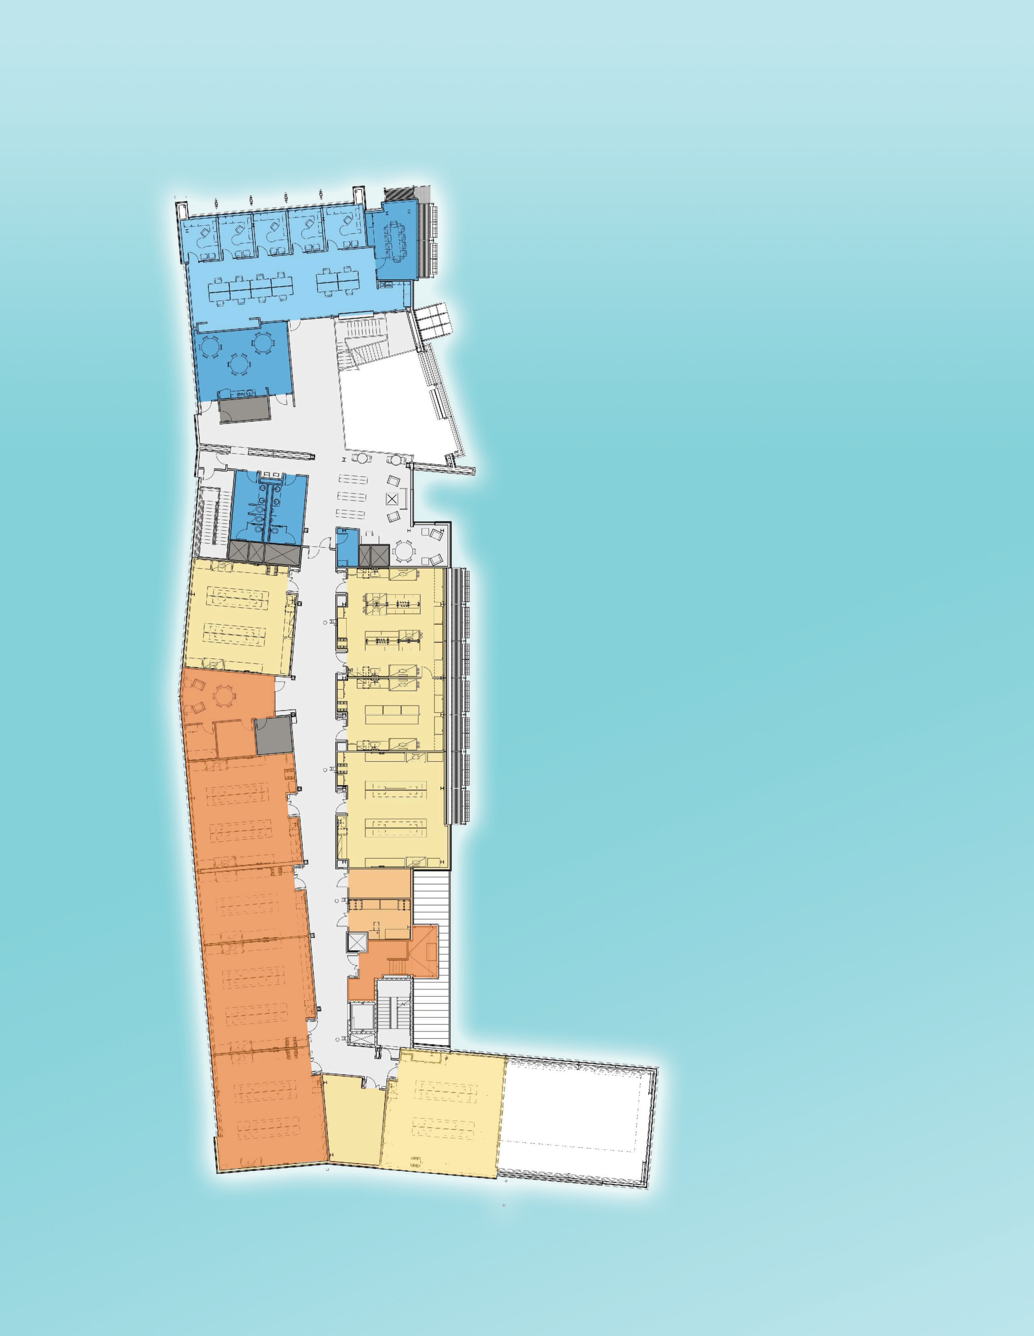

Smart Grid Cybersecurity Laboratory

SUPPORTERS

For more information on sponsorship opportunities at the Advanced Energy Center™ visit www.aertc.org

For additional information contact David Hamilton
www.aertc.org
david.hamilton@stonybrook.edu





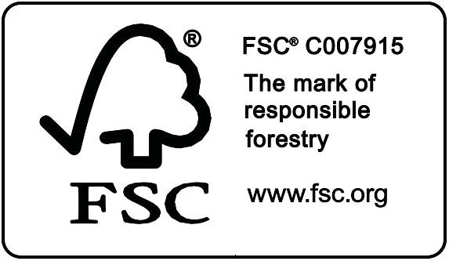
This guide is printed on FSC-certified paper with 50% recycled and 25% post-consumer content, using vegetable-based inks.



















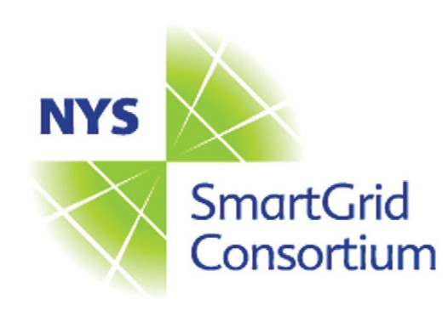


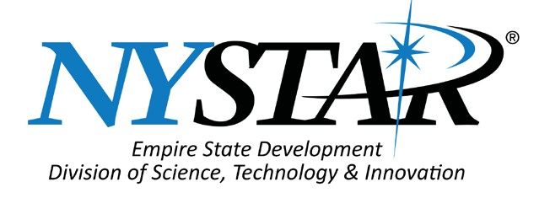
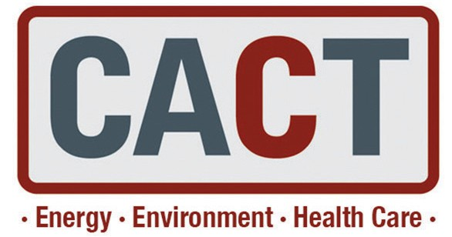

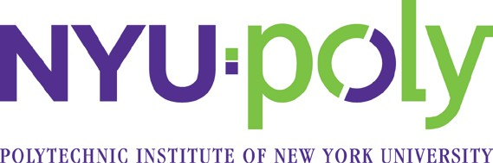


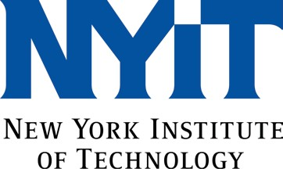




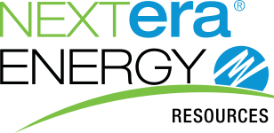
A New York State designated Center of Excellence

Advanced Energy Center™ Stony Brook University
Research and Development Park 1000 Innovation Road
Stony Brook, NY 11794-6044

Stony Brook is an affirmative action/ equal opportunity educator and employer. This publication is available in alternative format upon request.
Stony Brook University

