Graduate Program in Genetics


Stony Brook University College of Arts & Sciences
Doctoral Dissertation Defense

Dietary and epigenetic regulation of intestinal epithelial regeneration and differentiation

Onur Eskiocak
Advisor: Dr. Semir Beyaz
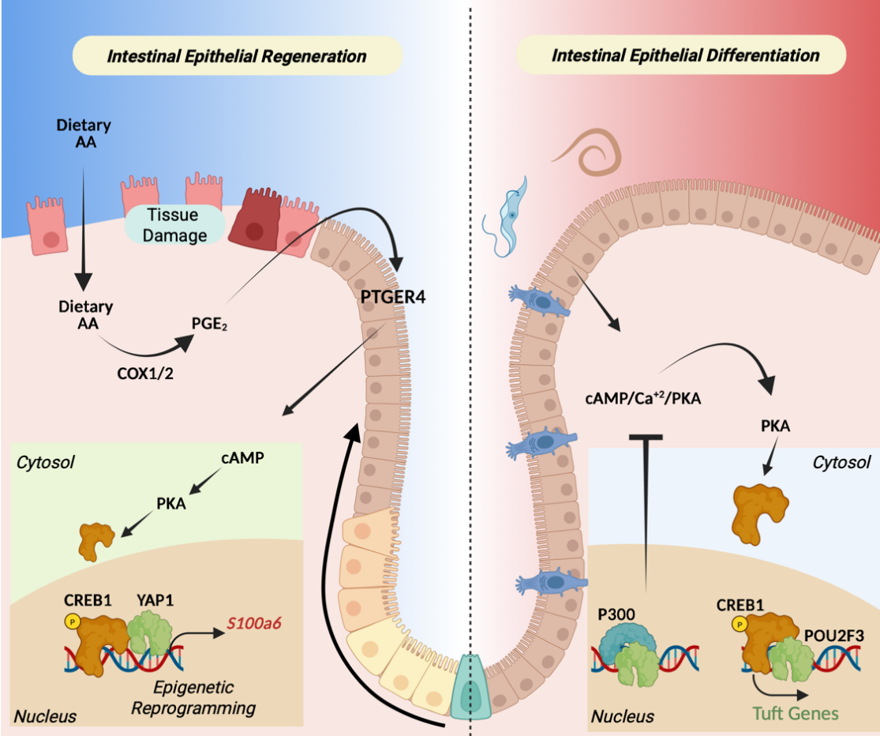
June 11, 2026 1:00 p.m.
Bush Auditorium, Cold Spring Harbor Laboratory
To join virtually: https://us06web.zoom.us/j/88033462355?pwd=gO9IJoEwk4LbRWCgjvfPmvnizG80b2.1
Meeting ID: 880 3346 2355; Passcode: 606598

Stony Brook University Cold Spring Harbor Laboratory Brookhaven National Laboratory

